Additional file 9. Contour-enhanced funnel plot of studies.
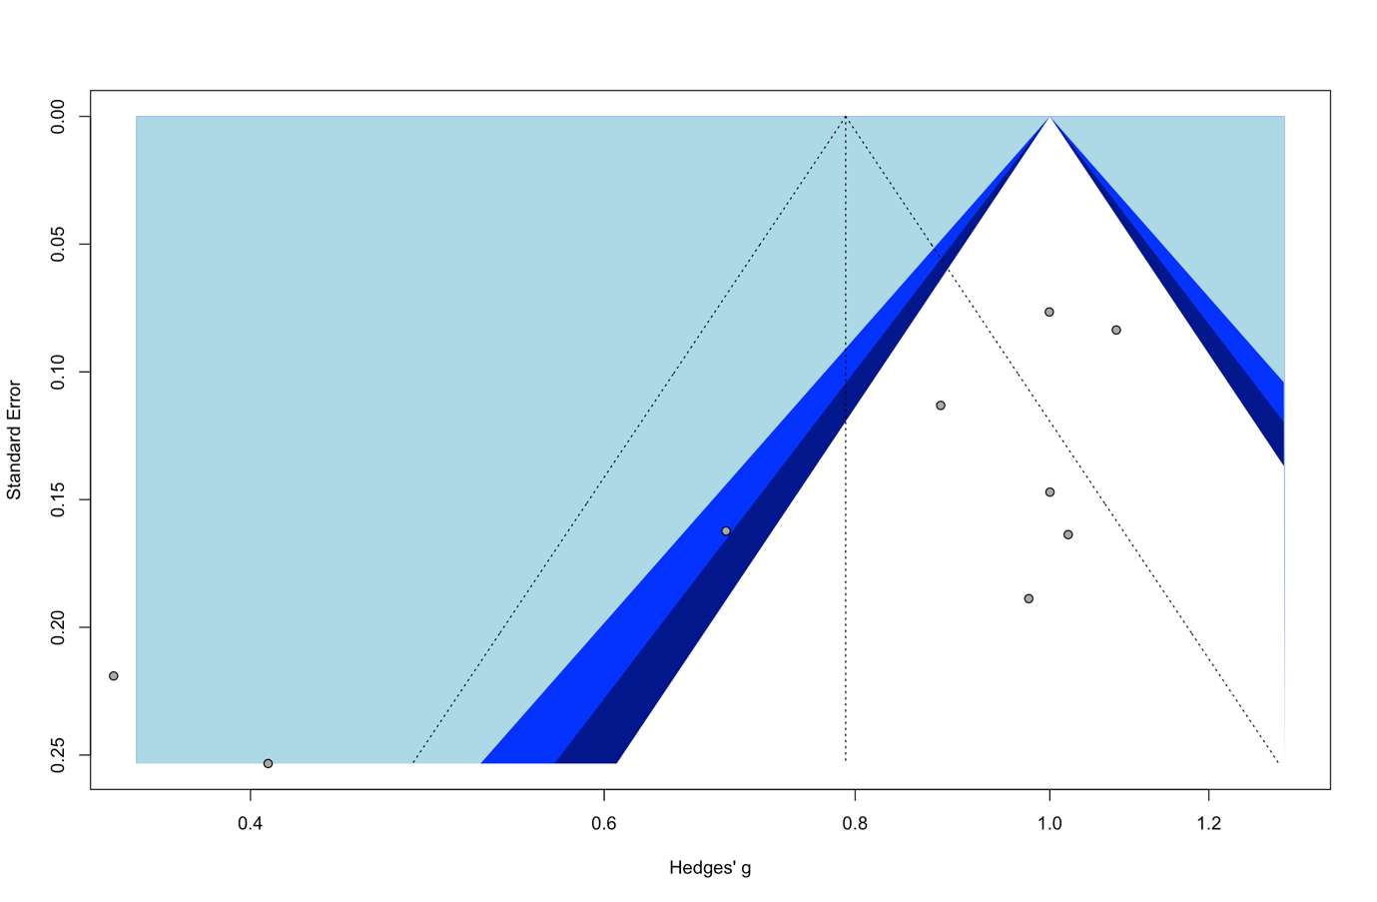

Hedges’g is a measure of effect size. The funnel is centred at one, i.e., at the value under the null hypothesis of no effects. The shaded regions indicate various levels of statistical significance of studies. White region in the middle corresponds to a p-value greater than 0.05; dark blue-shaded to a p-values between 0.025 and 0.05; light blue-shaded to a p-value between 0.01 to 0.025; the region outside the funnel to a p-value below 0.01.

