Supplementary Figure 1. The identified wells represent Caspase-3, Cleaved Caspase-3 and B-actin and other wells are related to another studies. The blots are cropped from the marked location with the down arrow.

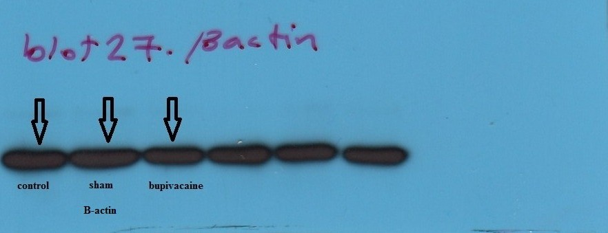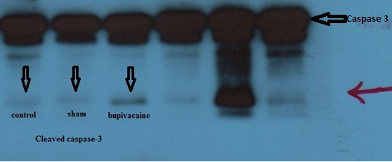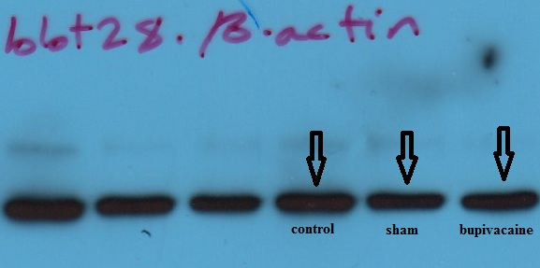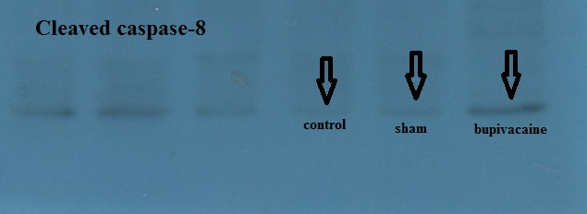

Supplementary Figure 2. The identified wells represent cleaved Caspase-8 and B-actin and other wells are related to another studies. The blots are cropped from the marked location with the down arrow.

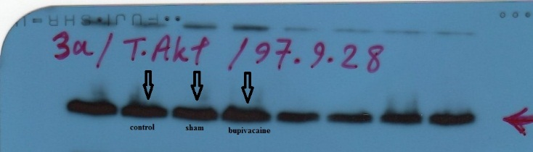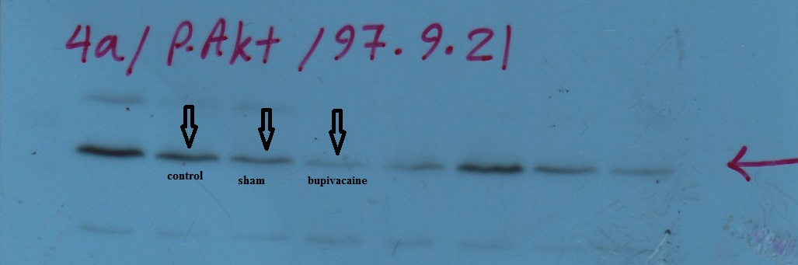

Supplementary Figure 3. The identified wells represent T.Akt and P.Akt and other wells are related to another studies. The blots are cropped from the marked location with the down arrow.