The ARRIVE Guidelines Checklist
Animal Research: Reporting In Vivo Experiments
Carol Kilkenny¹, William J Browne², Innes C Cuthill³, Michael Emerson⁴ and Douglas G Altman⁵
¹The National Centre for the Replacement, Refinement and Reduction of Animals in Research, London, UK, ²School of Veterinary Science, University of Bristol, Bristol, UK, ³School of Biological Sciences, University of Bristol, Bristol, UK, ⁴National Heart and Lung Institute, Imperial College London, UK, ⁵Centre for Statistics in Medicine, University of Oxford, Oxford, UK.

 |  | ITEM | RECOMMENDATION | Section/  Paragraph
 |  |  |  | Title
 |  |  |  | Abstract
 | INTRODUCTION
 | 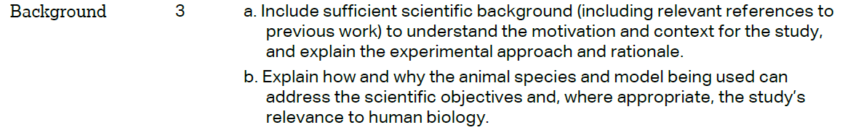 |  |  | Paragraphs 1-3
 |  |  |  | Paragraphs 3
 | METHODS
Paragraphs 1
& Declarations
Ethics approval and consent to participate
 | 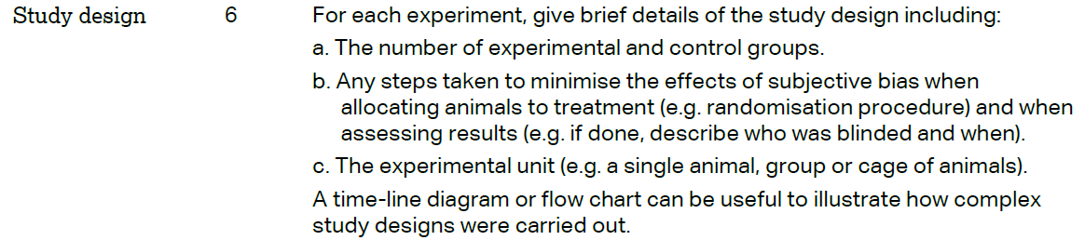 |  |  | Paragraphs 1-2,4-5
 | 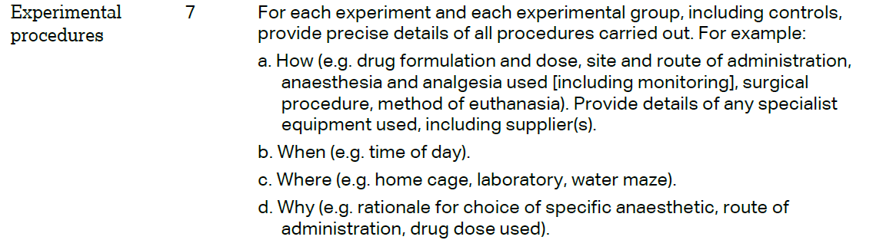 |  |  | Paragraphs 1
 | 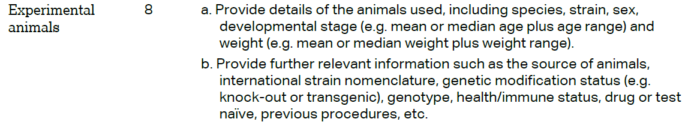 |  |  | Paragraphs 1
The ARRIVE guidelines. Originally published in PLoS Biology, June 2010¹
 | 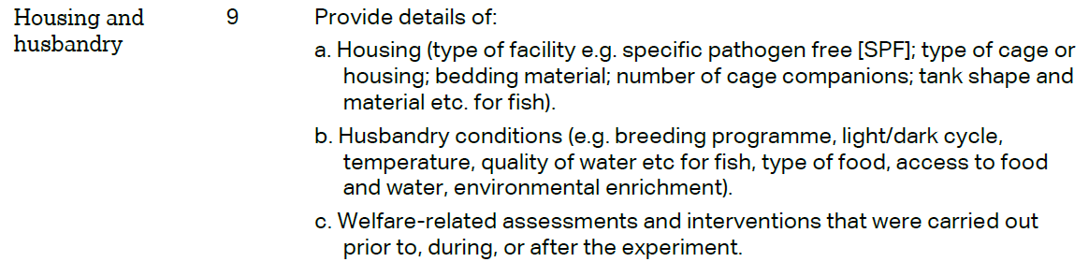 | Paragraphs 1
 | 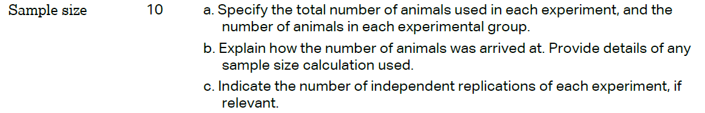 | Paragraphs 1
 | 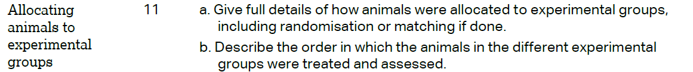 | Paragraphs 1
 |  | Paragraphs 5
 | 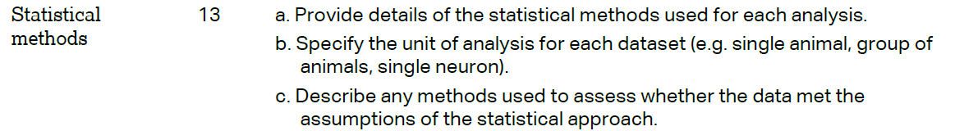 | Paragraphs 6
 | RESULTS
 |  | Methods paragraph 1
 |  | paragraph 1
 |  | paragraph 2-4
 |  | paragraph 1
 | DISCUSSION
 | 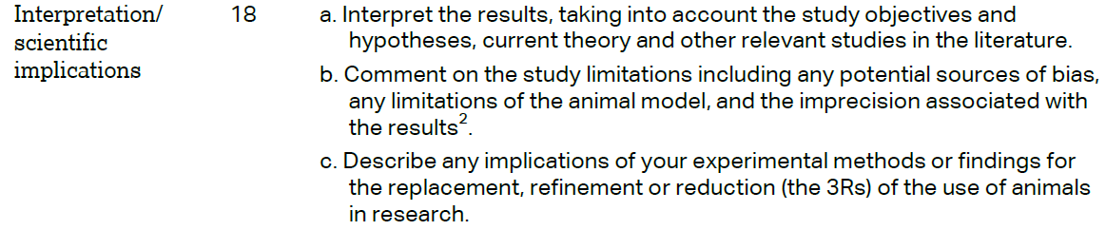 | paragraph 1-5
 |  | paragraph 5
Declarations
Funding
