Supplementary Materials
- Supplementary Figures and Tables
  - Supplementary Figures

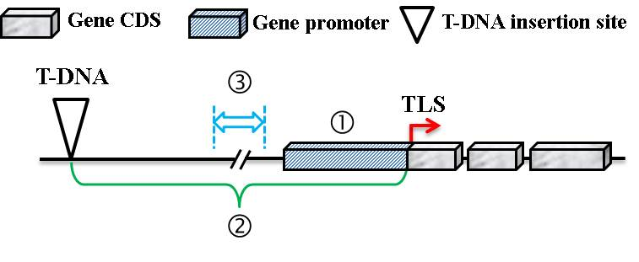
Figure S1. A schematic view of the target gene sequence retrieval. Fragment 1 is the 1500-bp upstream sequence relative to the TLS, which is referred to as the Promoter region. Fragment 2 consists of a 300-bp region centered between the 35S enhancer region and the TLS, which is referred to as the Middle region.

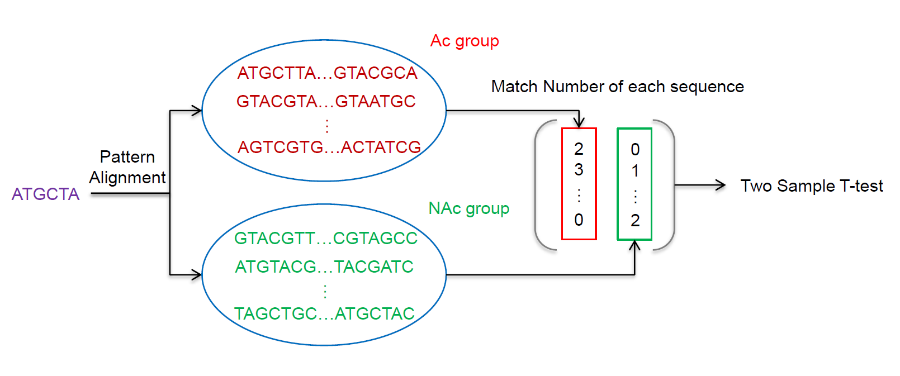
Figure S2. Analysis of significant sequence fragments. The purple sequence represents a specific fragment from Motif, Kmer or RevKmer, which is compared to each sequence between the Ac and NAc genes, respectively. The number of specific fragments that were matched in each sequence was divided into two groups according to the expression state of each gene. The results from the t-test indicate whether this specific fragment has a significant difference with respect to its frequency of occurrence among Ac and NAc genes.

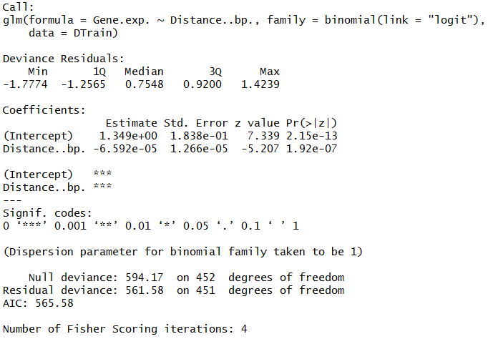
Figure S3. Logistic regression analysis report in R language. Distance..bp. is the distance between the CaMV 35S enhancer and the TLS; Pr(> |z|) represents the P-value if the distance is not associated with gene activation.

Supplementary Tables
Table S1. The number of different interval region is divided into two expression states.
(kb)  Status | 0~2 | 2~5 | 5~10 | 10~15 | 15~20 | 20~25 | 25~ | Total
Ac | 38 | 49 | 78 | 56 | 38 | 23 | 6 | 288
NAc | 8 | 19 | 35 | 33 | 34 | 17 | 19 | 165
Total | 46 | 68 | 113 | 99 | 72 | 40 | 25 | 453
Table S2. The number of significant sequences from Kmer, RevKmer and Motif.
Feature |  | Promoter region |  |  |  |  |  |  | Middle region
 | kª | 3−6 | 3−7 | 3−8 | 3−9 |  |  | 3−6 |  | 3−7 | 3−8 | 3−9
Kmer |  | 466 | 1991 | 8307 | 27135 |  |  | 412 |  | 1882 | 6555 | 11734
RevKmer |  | 231 | 966 | 4023 | 16108 |  |  | 208 |  | 859 | 3765 | 9088
 | Length (nt)^{b} | 6 | 7 | 8 | 9 | 10
Motif |  | 181 | 170 | 156 | 142 | 120
ªk Indicates the number of nucleic acids for Kmer and RevKmer
^{b}Length means that the length of Motif fragments was longer than or equal to the specified number of nucleic acids
Table S3. Performance of Kmer, RevKmer and Motif in five-fold cross-validation.
Feature | Length (nt)ª | Promoter region |  |  |  |  |  |  | Middle region
 |  | Sp | Sn | Acc | MCC | AUC |  | Sp |  | Sn |  | Acc |  | MCC |  | AUC
Kmer
 | 3−6 | 0.727 | 0.660 | 0.693 | 0.388 | 0.790 |  | 0.900 |  |  | 0.667 |  | 0.783 |  | 0.583 | 0.874
 | 3−7 | 0.867 | 0.733 | 0.800 | 0.605 | 0.891 |  | 0.947 |  |  | 0.773 |  | 0.860 |  | 0.731 | 0.941
 | 3−8 | 0.753 | 0.353 | 0.553 | 0.116 | 0.653 |  | 0.920 |  |  | 0.847 |  | 0.883 |  | 0.769 | 0.942^{b}
 | 3−9 | 0.847 | 0.853 | 0.850 | 0.700 | 0.932 |  | 0.940 |  |  | 0.773 |  | 0.857 |  | 0.723 | 0.949
RevKmer
 | 3−6 | 0.713 | 0.607 | 0.66 | 0.322 | 0.727 |  | 0.780 |  |  | 0.593 |  | 0.687 |  | 0.380 | 0.732
 | 3−7 | 0.847 | 0.760 | 0.803 | 0.609 | 0.879 |  | 0.873 |  |  | 0.693 |  | 0.783 |  | 0.576 | 0.867
 | 3−8 | 0.773 | 0.327 | 0.550 | 0.112 | 0.649 |  | 0.853 |  |  | 0.727 |  | 0.790 |  | 0.585 | 0.882
 | 3−9 | 0.747 | 0.880 | 0.813 | 0.632 | 0.906 |  | 0.947 |  |  | 0.740 |  | 0.843 |  | 0.702 | 0.932
Motif
 | 6+ | 0.693 | 0.353 | 0.523 | 0.050 | 0.604
 | 7+ | 0.767 | 0.720 | 0.743 | 0.487 | 0.830
 | 8+ | 0.727 | 0.733 | 0.730 | 0.460 | 0.829
 | 9+ | 0.753 | 0.747 | 0.750 | 0.500 | 0.825
 | 10+ | 0.747 | 0.693 | 0.720 | 0.441 | 0.800
Kmer
+ Motif
 | 6 + 7 | 0.793 | 0.773 | 0.783 | 0.567 | 0.881
 | 7 + 8 | 0.833 | 0.787 | 0.810 | 0.621 | 0.897
 | 8 + 9 | 0.833 | 0.847 | 0.840 | 0.680 | 0.936
 | 9 + 10 | 0.867 | 0.853 | 0.860 | 0.720 | 0.937
RevKmer
+ Motif
 | 6 + 7 | 0.780 | 0.773 | 0.777 | 0.553 | 0.857
 | 7 + 8 | 0.793 | 0.773 | 0.783 | 0.567 | 0.881
 | 8 + 9 | 0.840 | 0.800 | 0.820 | 0.641 | 0.915
 | 9 + 10 | 0.840 | 0.847 | 0.843 | 0.687 | 0.929
ªLength indicates the fragment length in nucleotides for each feature. Given a number of nucleotides k, the length in Motif is shown as k+, as motifs that are ≥k nucleotides to are encoded. The lengths in Kmer and RevKmer are shown as k−k’, which indicates the subsequence range of neighboring nucleic acids analyzed for Kmer and RevKmer. In Kmer + Motif and RevKmer + Motif, length is represented as k + ’, and k means that Kmer and RevKmer used the subsequences of length 3−k combined with a motif length ≥k’.
^{b}Gray shading indicates the selected combination for the second-layer training model.

Table S4. Feature encoding of two pattern sequences.
Feature encoding |  | Sequences
 |  | PROMOTER | MIDDLE
CGIs | ● |  | ●
Kmer | ○ |  | ●
RevKmer | ○ |  | ●
*Kmer / RevKmer + Motif | ● |  | ○
DNP | ● |  | ●
TNP | ● |  | ●
DACC | ● |  | ●
TACC | ● |  | ●
PseKNC | ● |  | ●
● Indicates that the feature was present in the sequence.
○ Indicates that the feature was not present in the sequence.
* It means Kmer or RevKmer plus Motif feature encoding.
Table S5. Performance of PseKNC in five-fold cross-validation.
k | PROMOTER |  |  |  |  |  |  | MIDDLE
 | Sp | Sn | Acc | MCC | AUC |  | Sp |  | Sn | Acc | MCC | AUC
2 | 0.651 | 0.527 | 0.589 | 0.179 | 0.615 |  | 0.564 |  | 0.527 | 0.595 | 0.191 | 0.617
3 | 0.624 | 0.653 | 0.639 | 0.278 | 0.674 |  | 0.456 |  | 0.580 | 0.518 | 0.037 | 0.493
4 | 0.638 | 0.713 | 0.676 | 0.352 | 0.733 |  | 0.503 |  | 0.533 | 0.518 | 0.037 | 0.531
5 | 0.785 | 0.640 | 0.712 | 0.430 | 0.779 |  | 0.463 |  | 0.427 | 0.445 | −0.110 | 0.431
6 | 0.899 | 0.607 | 0.753 | 0.529 | 0.845 |  | 0.477 |  | 0.473 | 0.475 | −0.050 | 0.471
7 | 0.705 | 0.733 | 0.719 | 0.438 | 0.797 |  | 0.376 |  | 0.527 | 0.452 | −0.099 | 0.466
Table S6. Feature composition optimization on second layer model.
Feature  selection tool | Amount  of features | Acc | Sn | Sp | AUC | MCC
SVM | 13 | 0.950 | 0.940 | 0.960 | 0.982 | 0.900
IG | 11 | 0.950 | 0.940 | 0.960 | 0.984 | 0.900
mRMR | 33 | 0.957 | 0.960 | 0.953 | 0.986 | 0.913
ChiSquared | 12 | 0.950 | 0.940 | 0.960 | 0.984 | 0.900
Filter | 12 | 0.950 | 0.940 | 0.960 | 0.982 | 0.900
GainRatio | 13 | 0.950 | 0.933 | 0.966 | 0.985 | 0.900
OneR | 10 | 0.950 | 0.933 | 0.966 | 0.984 | 0.900
ReliefF | 34 | 0.957 | 0.953 | 0.960 | 0.988 | 0.913
Symmetrical Uncertainty | 45 | 0.950 | 0.947 | 0.953 | 0.978 | 0.900

Table S7. Second-layer evaluation with 65 machine learning approaches.
Algorithm |  | Cross-validation |  |  |  |  |  | Independent-testing
 |  | Sn | Sp | Acc | MCC |  | Sn |  | Sp | Acc |  | MCC
Bayes | BayesNet | 0.927 | 0.966 | 0.946 | 0.894 |  | 0.884 |  | 0.733 |  | 0.869 |  | 0.482
 | DMNBtext | 0.927 | 0.926 | 0.926 | 0.853 |  | 0.906 |  | 0.600 |  | 0.876 |  | 0.429
 | NaiveBayes | 0.907 | 0.940 | 0.923 | 0.847 |  | 0.913 |  | 0.600 |  | 0.882 |  | 0.443
 | NaiveBayesLogisticRegression | 0.947 | 0.973 | 0.960 | 0.920 |  | 0.920 |  | 0.600 |  | 0.889 |  | 0.459
 | NaiveBayesSimple | 0.913 | 0.940 | 0.926 | 0.853 |  | 0.913 |  | 0.600 |  | 0.882 |  | 0.443
 | NaiveBayesUpdateable | 0.907 | 0.940 | 0.923 | 0.847 |  | 0.913 |  | 0.600 |  | 0.882 |  | 0.443
Functions | LIBSVM | 0.960 | 0.953 | 0.957 | 0.913 |  | 0.949 |  | 0.600 |  | 0.882 |  | 0.534
 | Logistic | 0.987 | 0.987 | 0.987 | 0.973 |  | 0.935 |  | 0.533 |  | 0.895 |  | 0.443
 | MultilayerPerceptron | 1.000 | 0.987 | 0.993 | 0.987 |  | 0.928 |  | 0.600 |  | 0.895 |  | 0.476
 | RBFNetwork | 0.933 | 0.953 | 0.943 | 0.886 |  | 0.920 |  | 0.600 |  | 0.889 |  | 0.459
 | SimpleLogistic | 0.980 | 0.980 | 0.980 | 0.960 |  | 0.928 |  | 0.600 |  | 0.895 |  | 0.476
 | SMO | 0.973 | 0.973 | 0.973 | 0.946 |  | 0.935 |  | 0.600 |  | 0.902 |  | 0.494
 | SPegasos | 0.987 | 0.993 | 0.990 | 0.980 |  | 0.920 |  | 0.600 |  | 0.889 |  | 0.459
 | VotedPerceptron | 0.933 | 0.960 | 0.946 | 0.893 |  | 0.942 |  | 0.533 |  | 0.902 |  | 0.462
Lazy | IB1 | 1.000 | 0.993 | 0.997 | 0.993 |  | 0.899 |  | 0.600 |  | 0.869 |  | 0.415
 | IBk | 1.000 | 0.993 | 0.997 | 0.993 |  | 0.899 |  | 0.600 |  | 0.869 |  | 0.415
 | Kstar | 1.000 | 0.993 | 0.997 | 0.993 |  | 0.928 |  | 0.600 |  | 0.895 |  | 0.476
 | LWL | 0.900 | 0.966 | 0.933 | 0.868 |  | 0.877 |  | 0.667 |  | 0.856 |  | 0.424
Meta | AdaBoostM1 | 0.953 | 0.993 | 0.973 | 0.947 |  | 0.884 |  | 0.667 |  | 0.863 |  | 0.436
 | AttributeSelectedClassifier | 0.953 | 0.973 | 0.963 | 0.927 |  | 0.891 |  | 0.600 |  | 0.863 |  | 0.402
 | Bagging | 0.960 | 0.960 | 0.960 | 0.920 |  | 0.891 |  | 0.600 |  | 0.863 |  | 0.402
 | ClassificationViaClustering | 0.867 | 0.913 | 0.890 | 0.780 |  | 0.862 |  | 0.733 |  | 0.850 |  | 0.446
 | ClassificationViaRegression | 0.980 | 0.987 | 0.983 | 0.967 |  | 0.928 |  | 0.600 |  | 0.895 |  | 0.476
 | CVParameterSelection | 1.000 | 0.000 | 0.502 | 0.000 |  | 1.000 |  | 0.000 |  | 0.902 |  | 0.000
 | Dagging | 0.927 | 0.960 | 0.943 | 0.887 |  | 0.928 |  | 0.600 |  | 0.895 |  | 0.476
 | Decorate | 0.993 | 0.987 | 0.990 | 0.980 |  | 0.913 |  | 0.533 |  | 0.876 |  | 0.394
 | END | 1.000 | 0.966 | 0.983 | 0.967 |  | 0.877 |  | 0.667 |  | 0.856 |  | 0.424
 | FilteredClassifier | 0.953 | 0.980 | 0.967 | 0.933 |  | 0.920 |  | 0.667 |  | 0.895 |  | 0.507
 | Grading | 1.000 | 0.000 | 0.502 | 0.000 |  | 1.000 |  | 0.000 |  | 0.902 |  | 0.000
 | LogitBoost | 0.980 | 0.987 | 0.983 | 0.967 |  | 0.891 |  | 0.733 |  | 0.876 |  | 0.495
 | MultiBoostAB | 0.887 | 0.946 | 0.916 | 0.834 |  | 0.884 |  | 0.667 |  | 0.863 |  | 0.436
 | MultiClassClassifier | 0.987 | 0.987 | 0.987 | 0.973 |  | 0.935 |  | 0.533 |  | 0.895 |  | 0.443
 | MultiScheme | 1.000 | 0.000 | 0.502 | 0.000 |  | 1.000 |  | 0.000 |  | 0.902 |  | 0.000
 | OrdinalClassClassifier | 1.000 | 0.966 | 0.983 | 0.967 |  | 0.877 |  | 0.667 |  | 0.856 |  | 0.424
 | RacedIncrementalLogitBoost | 1.000 | 0.000 | 0.502 | 0.000 |  | 1.000 |  | 0.000 |  | 0.902 |  | 0.000
 | RandomCommittee | 1.000 | 0.993 | 0.997 | 0.993 |  | 0.920 |  | 0.533 |  | 0.882 |  | 0.409
 | RandomSubSpace | 0.940 | 0.960 | 0.950 | 0.900 |  | 0.928 |  | 0.533 |  | 0.889 |  | 0.425
 | RotationForest | 1.000 | 0.987 | 0.993 | 0.987 |  | 0.935 |  | 0.533 |  | 0.895 |  | 0.443
 | Stacking | 1.000 | 0.000 | 0.502 | 0.000 |  | 1.000 |  | 0.000 |  | 0.902 |  | 0.000
 | StackingC | 1.000 | 0.000 | 0.502 | 0.000 |  | 1.000 |  | 0.000 |  | 0.902 |  | 0.000
 | ThresholdSelector | 0.000 | 1.000 | 0.498 | 0.000 |  | 0.000 |  | 1.000 |  | 0.098 |  | 0.000
 | Vote | 1.000 | 0.000 | 0.502 | 0.000 |  | 1.000 |  | 0.000 |  | 0.902 |  | 0.000
Misc | HyperPipes | 1.000 | 0.711 | 0.856 | 0.744 |  | 0.942 |  | 0.467 |  | 0.895 |  | 0.409
 | VFI | 0.900 | 0.993 | 0.946 | 0.897 |  | 0.819 |  | 0.667 |  | 0.804 |  | 0.344
Rules | ConjunctiveRule | 0.867 | 0.960 | 0.913 | 0.830 |  | 0.862 |  | 0.667 |  | 0.843 |  | 0.401
 | DecisionTable | 0.927 | 0.980 | 0.953 | 0.908 |  | 0.899 |  | 0.667 |  | 0.876 |  | 0.462
 | DTNB | 0.927 | 0.987 | 0.957 | 0.915 |  | 0.899 |  | 0.667 |  | 0.876 |  | 0.462
 | JRip | 0.900 | 0.987 | 0.943 | 0.890 |  | 0.855 |  | 0.533 |  | 0.824 |  | 0.299
 | NNge | 0.993 | 1.000 | 0.997 | 0.993 |  | 0.928 |  | 0.600 |  | 0.895 |  | 0.476
 | OneR | 0.887 | 0.940 | 0.913 | 0.827 |  | 0.884 |  | 0.600 |  | 0.856 |  | 0.389
 | PART | 0.993 | 0.987 | 0.990 | 0.980 |  | 0.928 |  | 0.600 |  | 0.895 |  | 0.476
 | Ridor | 0.933 | 0.966 | 0.950 | 0.900 |  | 0.877 |  | 0.600 |  | 0.850 |  | 0.378
 | ZeroR | 1.000 | 0.000 | 0.502 | 0.000 |  | 1.000 |  | 0.000 |  | 0.902 |  | 0.000
Trees | ADTree | 0.987 | 0.993 | 0.990 | 0.980 |  | 0.891 |  | 0.600 |  | 0.863 |  | 0.402
 | BFTree | 1.000 | 0.980 | 0.990 | 0.980 |  | 0.906 |  | 0.533 |  | 0.869 |  | 0.379
 | DecisionStump | 0.887 | 0.946 | 0.916 | 0.834 |  | 0.884 |  | 0.667 |  | 0.863 |  | 0.436
 | FT | 0.993 | 0.980 | 0.987 | 0.973 |  | 0.957 |  | 0.600 |  | 0.922 |  | 0.557
 | J48 | 1.000 | 0.966 | 0.983 | 0.967 |  | 0.877 |  | 0.667 |  | 0.856 |  | 0.424
 | J48graft | 1.000 | 0.966 | 0.983 | 0.967 |  | 0.877 |  | 0.667 |  | 0.856 |  | 0.424
 | LADTree | 0.993 | 0.993 | 0.993 | 0.987 |  | 0.891 |  | 0.533 |  | 0.856 |  | 0.353
 | LMT | 1.000 | 0.993 | 0.997 | 0.993 |  | 0.899 |  | 0.667 |  | 0.876 |  | 0.462
 | NBTree | 0.987 | 0.993 | 0.990 | 0.980 |  | 0.906 |  | 0.467 |  | 0.863 |  | 0.329
 | RandomForest | 0.993 | 1.000 | 0.997 | 0.993 |  | 0.913 |  | 0.533 |  | 0.876 |  | 0.394
 | RandomTree | 1.000 | 0.993 | 0.997 | 0.993 |  | 0.891 |  | 0.667 |  | 0.869 |  | 0.449
 | REPTree | 0.927 | 0.946 | 0.936 | 0.873 |  | 0.899 |  | 0.533 |  | 0.863 |  | 0.366
 | SimpleCart | 0.993 | 0.966 | 0.980 | 0.960 |  | 0.899 |  | 0.533 |  | 0.863 |  | 0.366
- Supplementary Methods
  - Logistic regression
$$π\left(x\right)=\frac{exp^{\left(\text{1.349}-\text{6.592}e-05x\right)}}{1+exp^{\left(\text{1.349}-\text{6.592}e-05x\right)}}$$ (S1)
The linear regression of distance and gene activation was expressed as 1.349 – (6.592×10⁻⁵)x, where x represents the distance variable (independent variable), π(x) is the dependent variable of the linear regression after the logistic conversion, representing the possibility of gene activation. The biggest difference with traditional linear regression is that the dependent variable is discrete; in addition, the resulting values range between 0 and 1.

