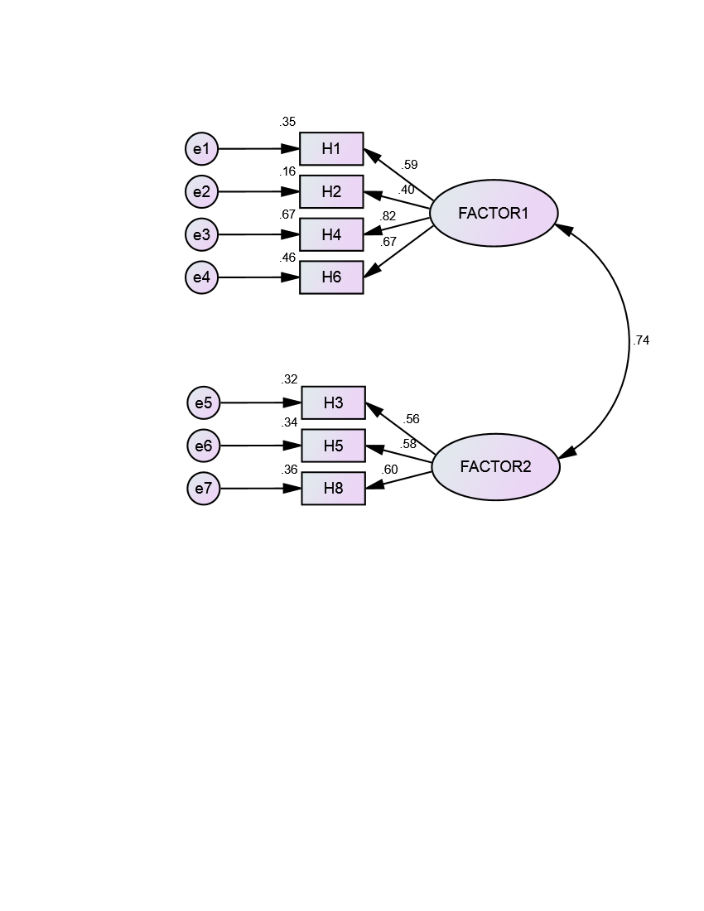
Parameter estimates are standardized regression weights.

