Additional file 5

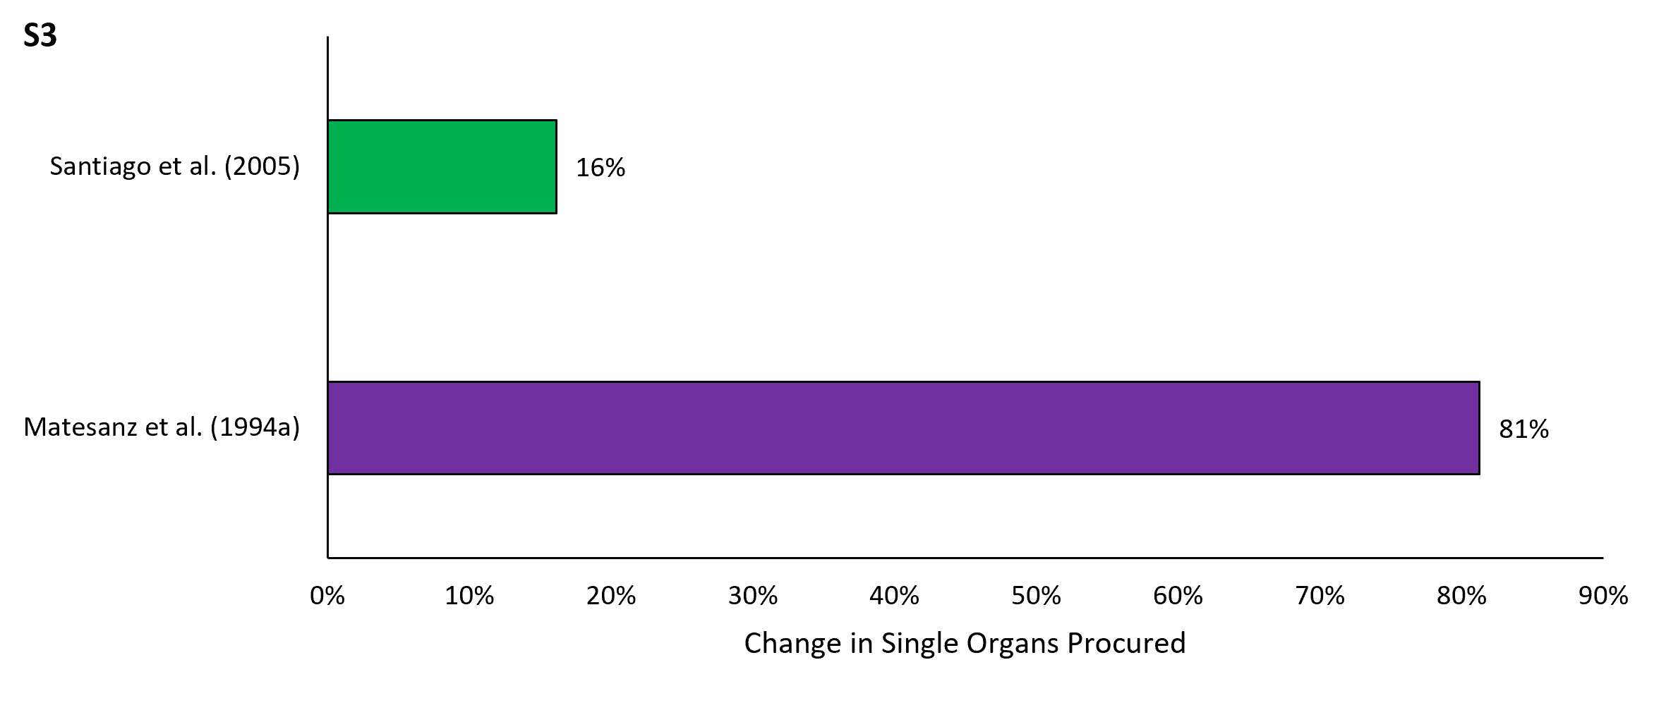
Figure S3. Percent change in single organs procured for before-and-after studies.

