Extended Data

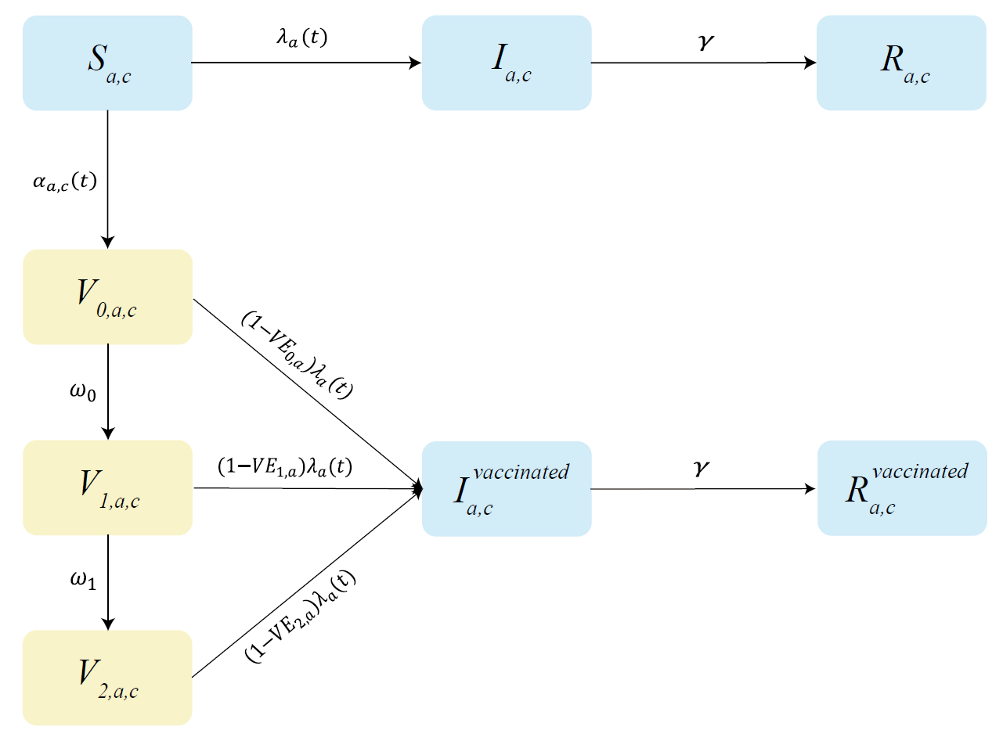
Extended Data Fig. 1 Schematic representation of the baseline model.
Blue, and yellow rectangles describe the SARS-CoV-2 transmission model, and vaccination model, respectively. Transitions occur within each population class defined by a and c, where a represents the age group and c identifies the absence/presence of underlying conditions, the latter associated with higher risk of sever outcomes of SARS-CoV-2 infections. S denotes susceptible individuals; I infected individuals; R recovered/removed individuals. Parameters of the transmission model include$:$the time- and age-dependent force of infection${ λ}_{a}\left(t\right)$ and the recovery rate from infection ($γ)$. V₀ denotes individuals vaccinated with the 1st dose (never experienced infection with SARS-CoV-2); V₁ denotes vaccinated with the 2nd dose (no protection yet); V₂ denotes vaccinated with the 2nd dose (protected). Parameters of the vaccination model include: the time-, age- and group-dependent probability of being vaccinated $(α_{a,c}\left(t\right))$; the interval between administration of the first and second dose (1/$ω_{0}$); the delay of ramp-up of the 2nd dose (${1/ω}_{1}$); the age-dependent vaccine efficacy after the 1st dose of vaccination (${VE}_{0,a })$, which is assumed to be 0; the age-dependent efficacy right after administration of the 2nd dose (${VE}_{1,a }),$which is assumed to be 0; the vaccine efficacy after ramp-up of the 2nd dose (${VE}_{2,a})$.

Extended Data Table 1. Description of key parameters used in the model.
Description of parameter | Values in the baseline analysis | Sensitivity analyses
Epidemiology
Generation time (1/$γ)$ | 5.5 days (95%CI 1.7, 11.6)³⁴ | /
Relative susceptibility to infection at age $a$ ($r_{a}$) | $r_{a}=0.58$ (95%CI 0.34-0.98) when $a<15$; $r_{a}=1$ for $15≤a<65$; $r_{a}=1.65$ (95%CI 1.03-2.65) when $a≥65$ ³⁴ | Homogenous susceptibility (SE1)
Age-group-specific contact matrix ($C_{a,\tilde{a}}$) | Contact matrix for Shanghai ⁷ | /
Effective reproductive number (R_{t}) | 1.1, 1.3, 1.5, and 2.5 ^{11,35,36} | /
Vaccination
Interval between the administration of 1st dose and 2nd dose (1/$ω_{0}$) | 21 days ³⁷ | 14 days (SE12) ³⁷
Delay between administration of the 2nd dose of vaccination and the achievement of the expected VE (1/$ω_{1}$) | 14 days ³⁷ | /
Expected vaccine efficacy for adults aged 20-59 years (${VE}_{2,a}$) | 80% ^{37,38} for a vaccine with partial protections | 60% (SE13) and 90% (SE14); and for an all-or-nothing vaccine (SE19)
Expected vaccine efficacy reduction for <20 and ≥60 years | 50% ^{37,38} | 0%, indicating the same vaccine efficacy (SE15)
Vaccination capacity (daily doses administered) | 6 million (Assumed based on 2009 influenza pandemic vaccination) ²² | 1.3 (SE4), 10 (SE5), 15 (SE6) and 30 million (SE7)
Vaccine coverage | 70% ³⁹ | 50% (SE8) or 90% (SE9) ³⁹
Duration of immunity (1/$ω_{2}$) | Lifelong (i.e., the immunity lasts more than the time horizon considered: 730 days)  (Assumed) | 6 months (SE16), or 1 year (SE17)
Delay between start of simulations and start of vaccination | 15 days (Assumed) | 30 days prior- (SE2) or post-start (SE3) of simulations
Disease burden
Proportion of infections that develop symptoms ($π$) | 18.1%, 22.4%, 30.5%, 35.5%, and 64.6% separately for 0-19, 20-39, 40-59, 60-79, and 80+ years⁸ | /
Proportion of laboratory-confirmed symptomatic cases requiring hospitalization ($σ$) | Overall: 40.0%, 29.2%, 33.3%, and 33.8% separately for 0-19, 20-39, 40-59, and 60+ years⁹; estimates for individuals with/without underlying conditions shown in Supplementary Information File 1 | /
Proportion of hospitalized cases requiring ICU ($ρ$) | 0, 2.2%, 7.2%, 20.9% separately for 0-14, 15-49, 50-64, and 65+ years¹³ | /
Fatality ratio among laboratory-confirmed symptomatic cases ($μ$) | Overall: 0.51%, 0.65%, 2.38%, and 10.52% separately for 0-19, 20-39, 40-59, and 60+ years⁹; estimates for individuals with/without underlying conditions shown in Supplementary Information File 1 | /

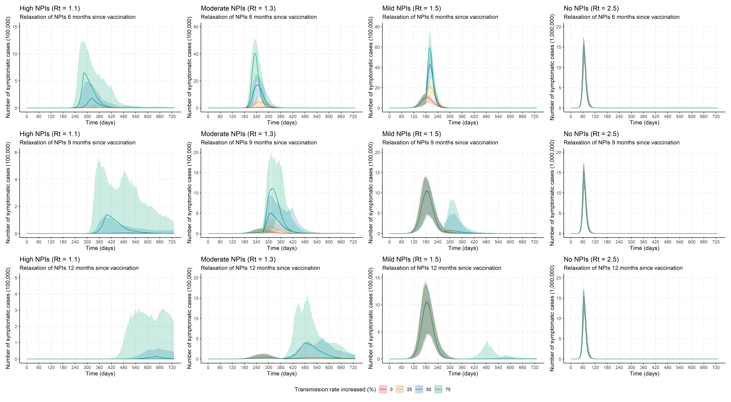
Extended Data Figure.2 Time series of symptomatic cases given relaxation of NPIs 6, 9 and 12 months since vaccination.
We assumed a 0% (i.e., baseline analysis, no relaxation of NPIs during study periods), 25%, 50% and 75% increase of transmission rate, respectively. Line denotes median, and shadow denotes quantiles 0.025 and 0.975.
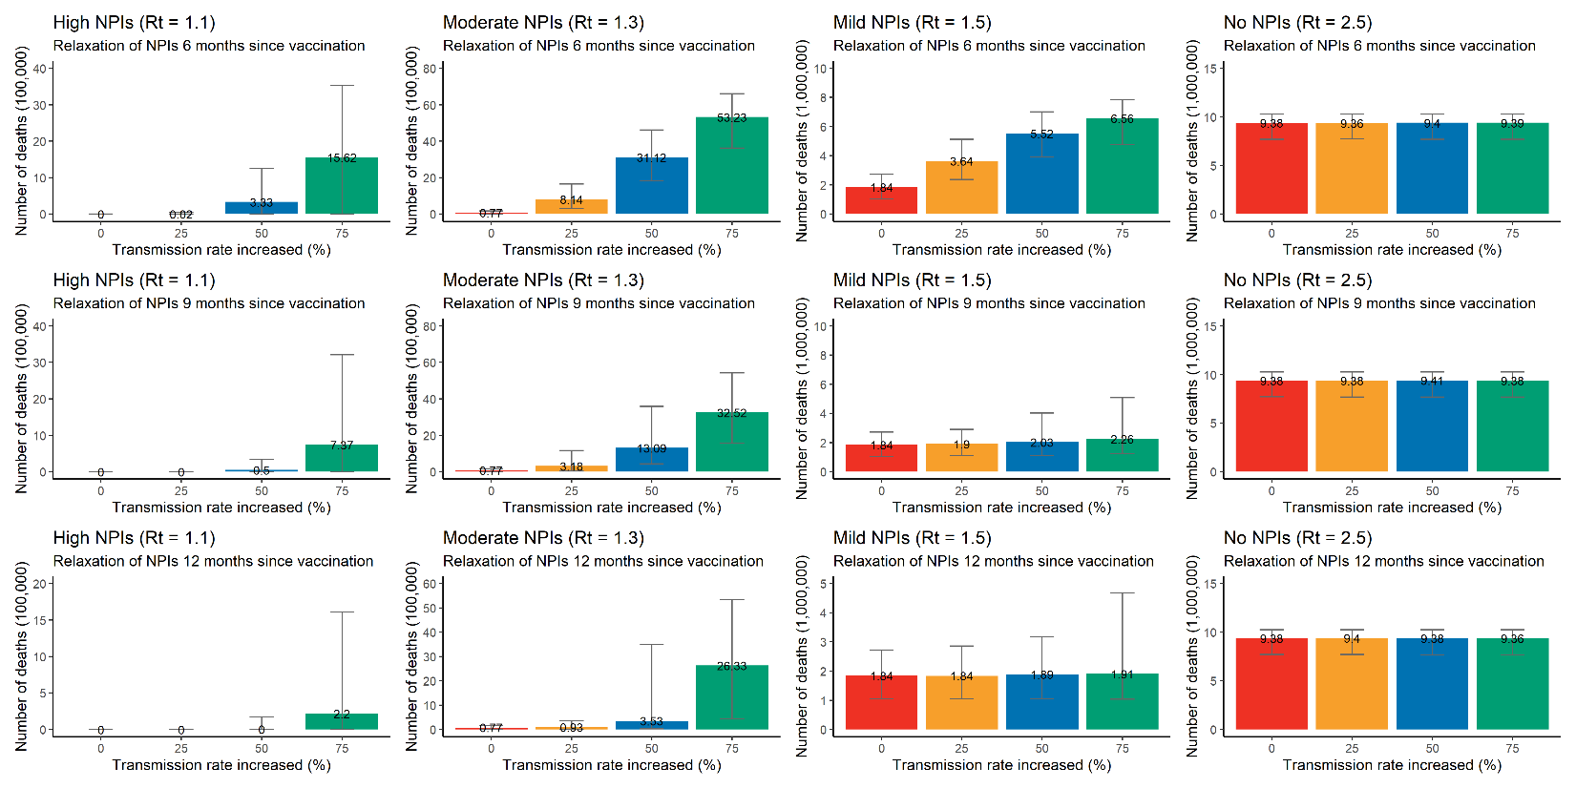
Extended Data Figure.3 Cumulative number of COVID-19 deaths given relaxation of NPIs 6, 9 and 12 months since vaccination.
We assumed a 0% (i.e., baseline analysis, no relaxation of NPIs during study periods), 25%, 50% and 75% increase of transmission rate, respectively. Number denotes median, and error bars denote quantiles 0.025 and 0.975.

Extended Data Figure.4 Impact of daily doses administered on COVID-19 symptomatic cases.
A) Cumulative number of COVID-19 symptomatic cases as estimated in the different scenarios under progressively increasing values of the daily vaccination capacity; B) Proportion of symptomatic cases averted compared to the reference scenario, i.e., no vaccination + no NPIs with initial R_{t}=2.5. Number denotes median, and error bars denote quantiles 0.025 and 0.975.
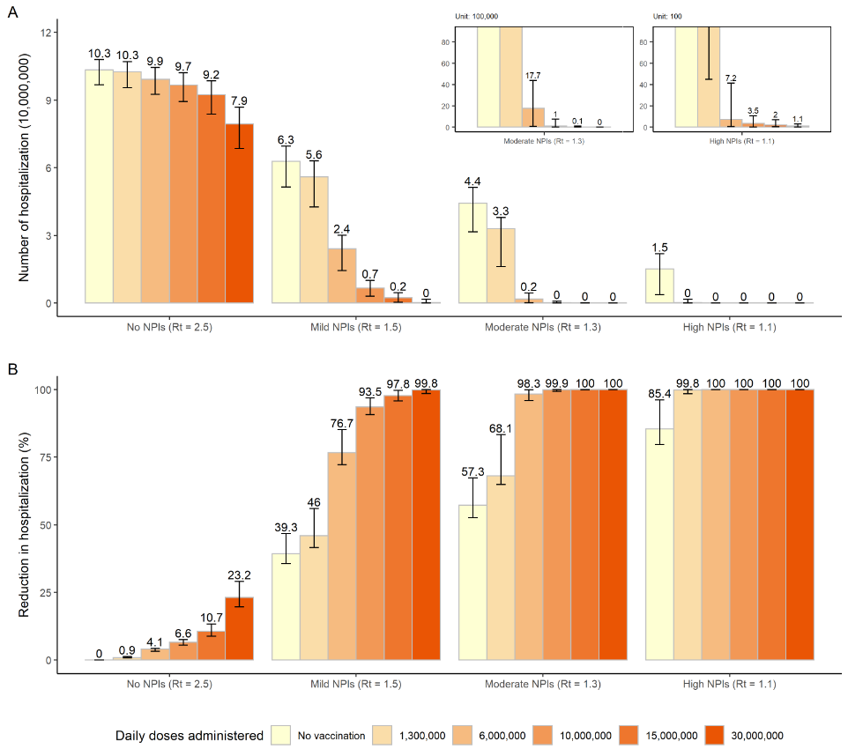

Extended Data Figure.5 Impact of daily doses administered on COVID-19 hospitalizations.
A) Cumulative number of COVID-19 hospitalizations as estimated in the different scenarios under progressively increasing values of the daily vaccination capacity; B) Proportion of hospitalizations averted compared to the reference scenario, i.e., no vaccination + no NPIs with initial R_{t}=2.5. Number denotes median, and error bars denote quantiles 0.025 and 0.975.
Extended Data Figure.6 Impact of daily doses administered on COVID-19 ICU admissions.
A) Cumulative number of COVID-19 ICU admissions as estimated in the different scenarios under progressively increasing values of the daily vaccination capacity; B) Proportion of ICU admissions averted compared to the reference scenario, i.e., no vaccination + no NPIs with initial R_{t}=2.5. Number denotes median, and error bars denote quantiles 0.025 and 0.975.
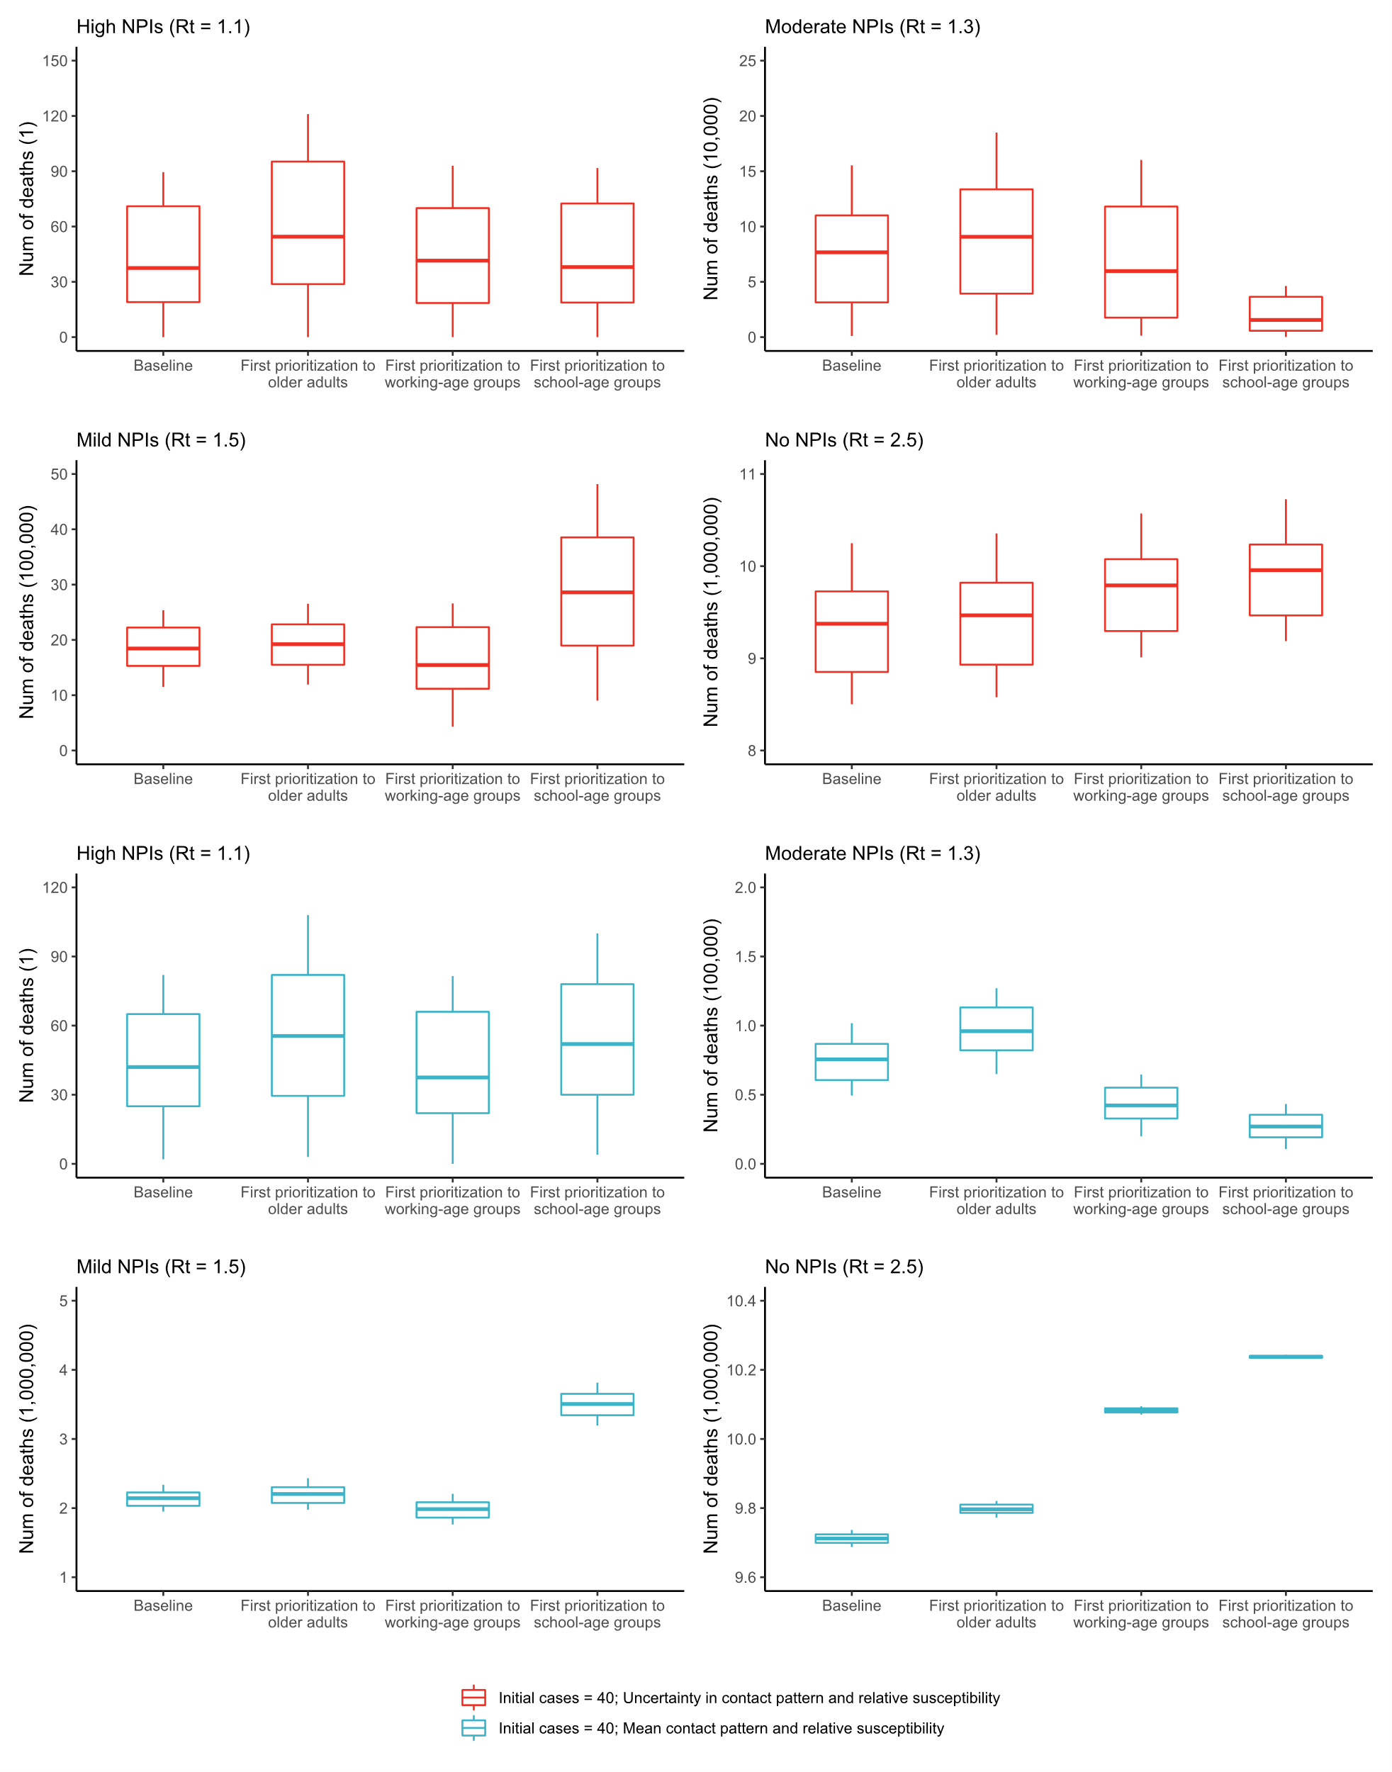
Extended Data Figure.7 Overall impact of vaccination prioritizations on cumulative COVID-19 deaths provided 6 million doses administered/day and 40 initial cases.
The baseline scenario means first prioritizing older adults and individuals with underlying conditions.
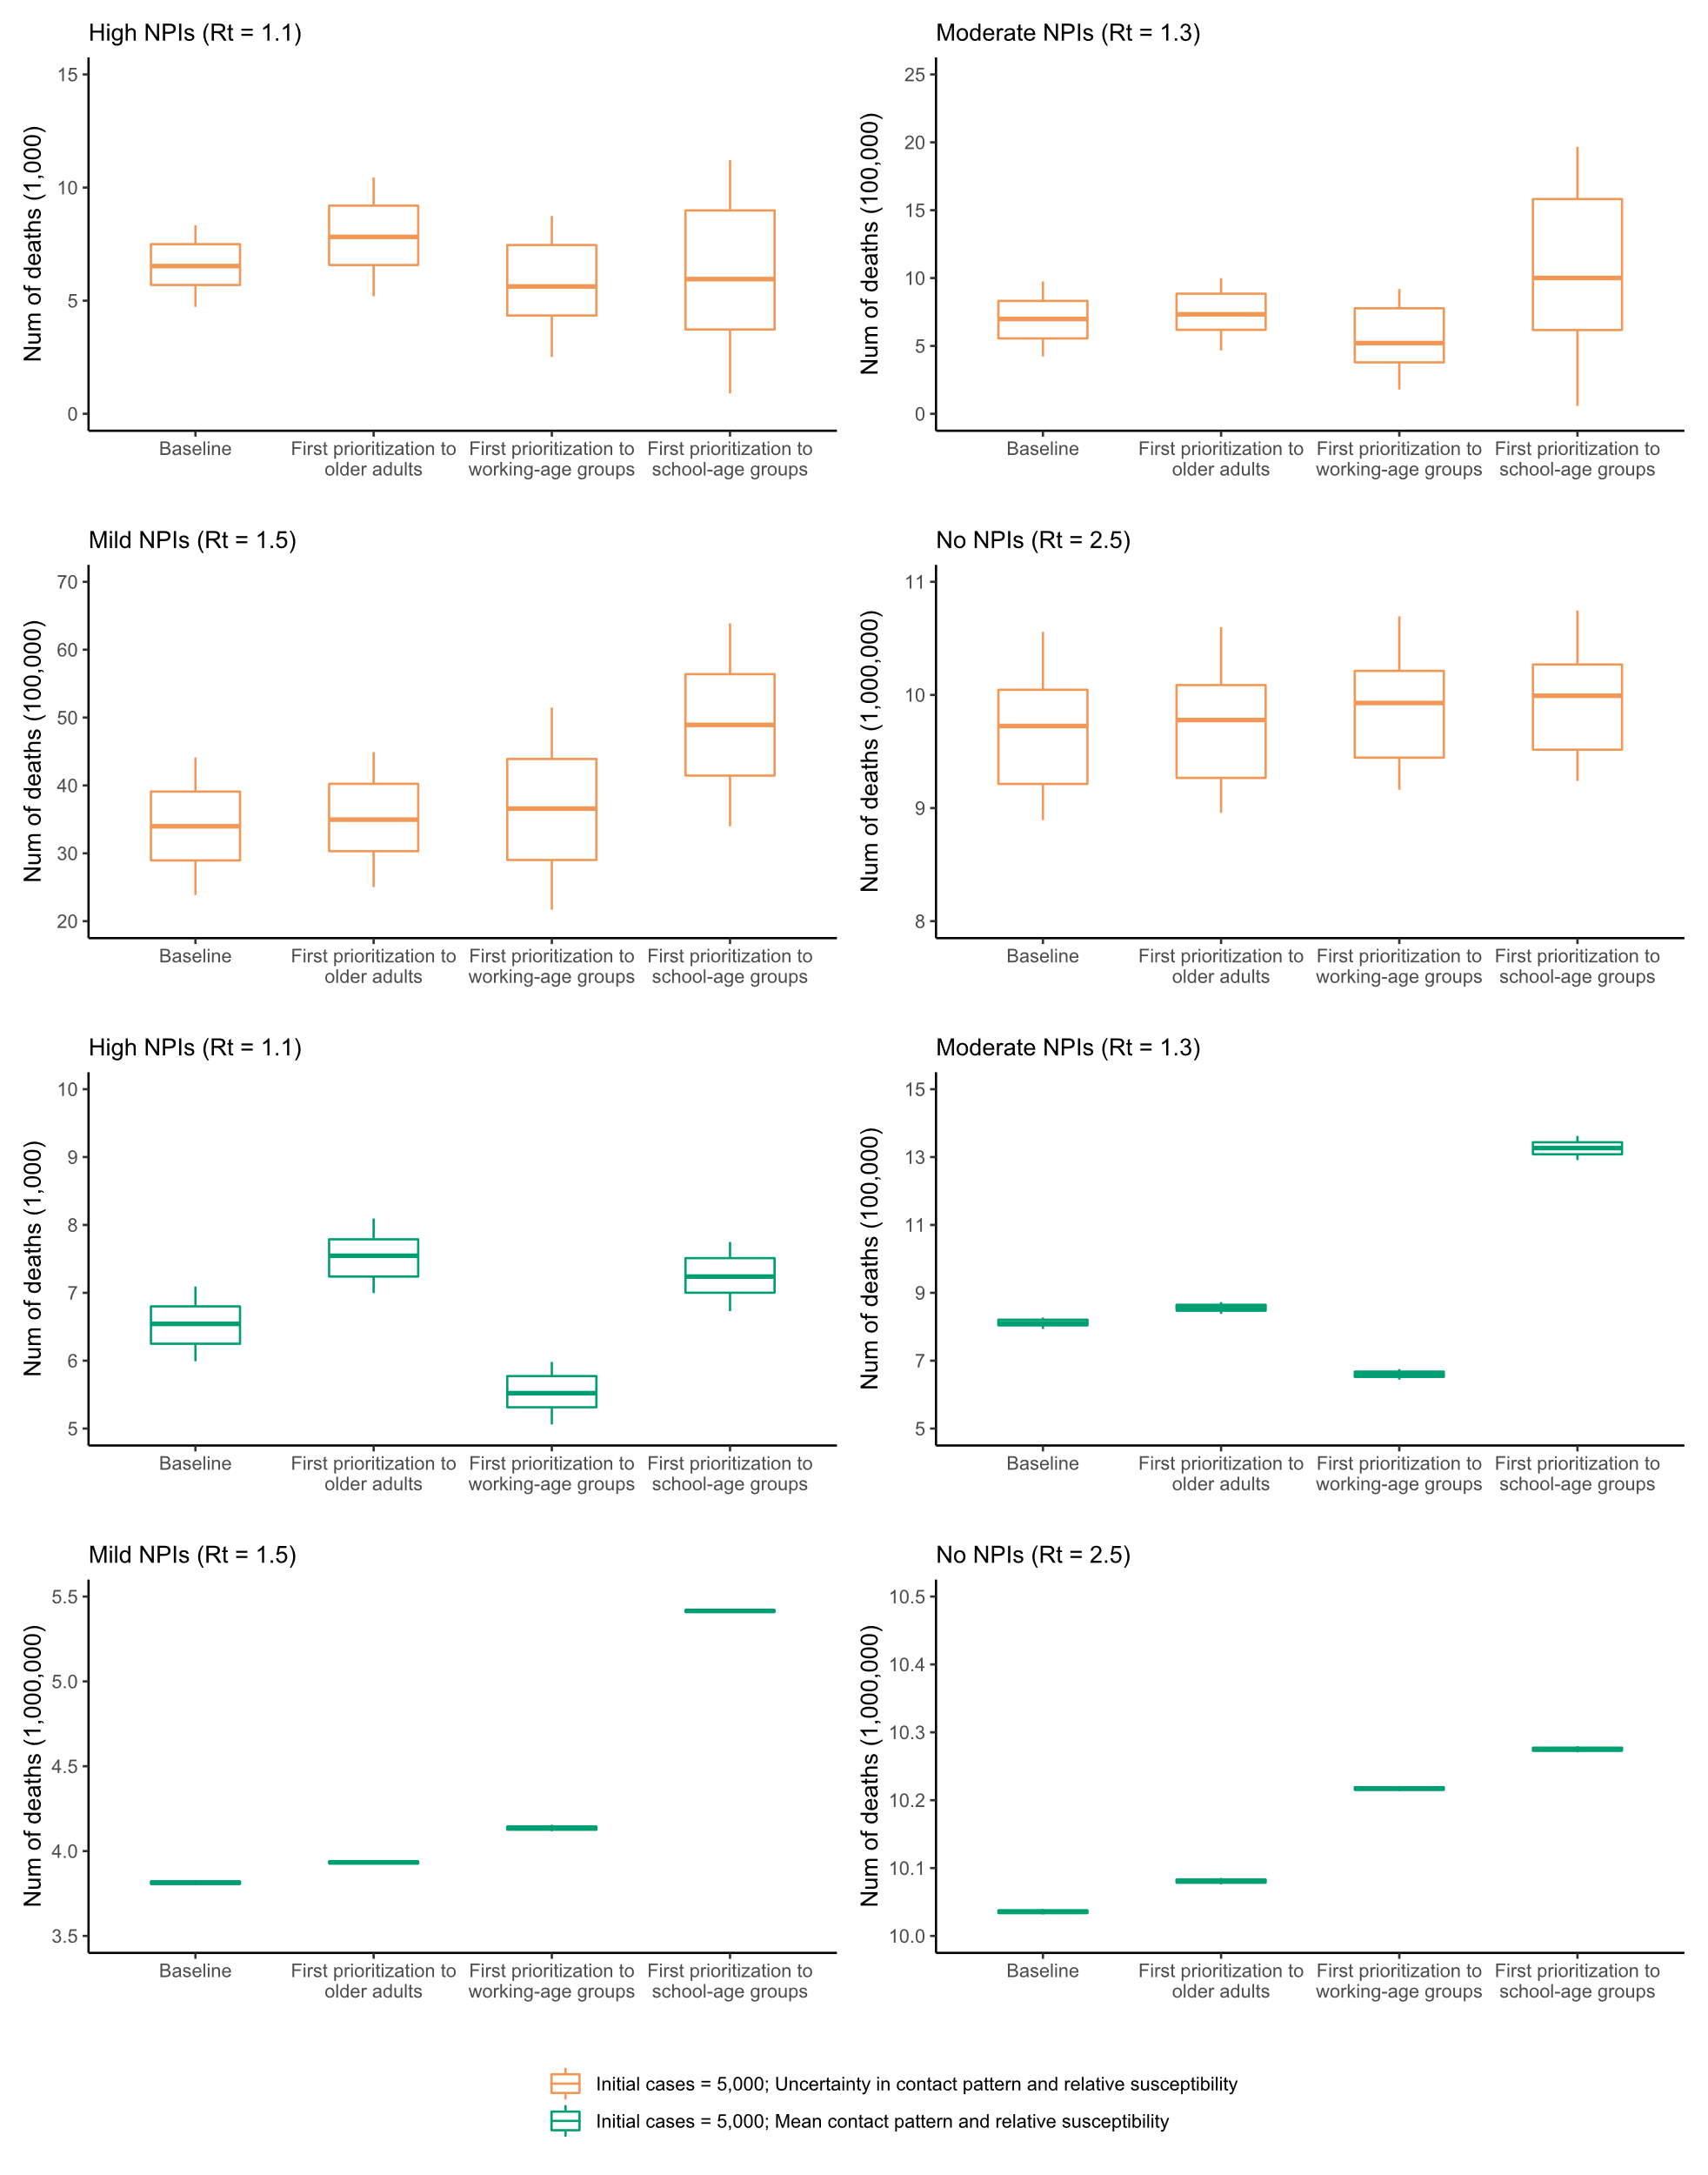
Extended Data Figure.8 Overall impact of vaccination prioritizations on cumulative COVID-19 deaths provided 6 million doses administered/day and 5,000 initial cases.
The baseline scenario means first prioritizing older adults and individuals with underlying conditions.

Extended Data Figure.9 Changes of the cumulative number of COVID-19 deaths estimated in the different sensitivity analyses, compared to the main analysis in the presence of moderate NPIs (R_{t}=1.3).
Number denotes median, and error bars denote quantiles 0.025 and 0.975.

Extended Data Figure.10 Changes of the cumulative number of COVID-19 symptomatic cases estimated in the different sensitivity analyses and in the main analysis in the presence of moderate NPIs (initial Rt=1.3)
SE: sensitivity analysis. Number denotes median, and error bars denote quantiles 0.025 and 0.975.

