Table S1: Information on the gender, size, location of capture, and reference number of the snakes whose venom was used in this study
Species name | Common name | Family | Reference number | Size/age | Gender | Location of capture
Naja ashei | Large brown spitting cobra | Elapidae | BK16189  BK16648  BK17678 | Adult  Adult  Adult | Female  Female  Male | Watamu  Kilifi  Watamu

Table S2: Details of the antivenoms used in svPLA₂ and brine shrimp lethality neutralization assays of Naja ashei venom
Brand | Manufacturer | Characteristics | Label claim
Snake Venom Antiserum African HIS  (Antivenom I) | Vins Bioproducts Limited,  Telangana, India | Lyophilized  Equine F(ab’)₂  Batch number: 07AS18001  Date of manufacture: 01/2018  Expiry date:12/2021 | Each ml has the capacity to neutralize 20 LD_{50’s} of the venoms of N. melanoleuca, N. nigricollis and 25 LD_{50’s} of the venoms of N. haje, D. polylepis, D. viridis, D. jamesoni, B. gabonica, B. arietans, and E. ocellatus
PAN AFRICA Inoserp®  (Antivenom II) | Veteria Labs SA de C.V  Juarez Colony, Mexico City,  Mexico | Lyophilized  Equine F(ab’)₂  Batch number: 9 IT06001  Date of manufacture: 06/2019  Expiry date:06/2022 | Each ml neutralizes 500DL₅₀ of the venom of E. ocellatus, B. arietans, N. nigricollis, D. polylepis and is recommended in the event of envenomation by E. ocellatus, E. leucogaster, E. pyramidum, B. arietans, B. rhinoceros, B. nascicornis, B. gabonica, D. polylepis, D. viridis, D. angusticeps, D. jamesoni, N. nigricollis, N. melanoleuca, N. haje, N. pallida, N. nubiae, N. katiensis, and N. senegalensis

Table S3: Determination of the protein content of Naja ashei venom, Vins bioproducts and Pan Africa Inoserp antivenoms by using UV-Visible spectrophotometric readings of bovine serum albumin protein standard
Concentration (mg/ml) of bovine serum albumin | Absorbance | Protein content (mg/ml)
0.05 | 0.030±0.003 | -
0.1 | 0.055±0.002 | -
0.2 | 0.101±0.007 | -
0.4 | 0.161±0.011 | -
0.8 | 0.272±0.011 | -
1.2 | 0.358±0.008 | -
1.6 | 0.434±0.013 | -
2 | 0.500±0.034 | -
N. ashei | 0.215±0.008 | 0.69
Vins Bioproducts antivenom | 0.160±0.005 | 0.47
PAN African Inoserp antivenom | 0.710±0.004 | 0.10
SD: Standard deviation
Table S4: Absorbance readings of different treatments in svPLA₂ neutralization assays of Naja ashei venom
Time | 0 minutes |  |  |  | 30 minutes |  |  |  | D
Sample | A₁ | A₂ | A₃ | Mean±SD | A₁ | A₂ | A₃ | Mean±SD
V only | 0.978 | 0.980 | 0.995 | 0.983±0.006 | 0.769 | 0.841 | 0.829 | 0.813±0.039 | 0.17
V+25µlAV₁ | 1.206 | 1.190 | 1.185 | 1.194±0.011 | 1.091 | 1.068 | 1.068 | 1.076±0.013 | 0.118
V+50µlAV₁ | 0.968 | 0.980 | 1.017 | 0.988±0.026 | 0.806 | 0.842 | 0.848 | 0.832±0.023 | 0.156
V+100µlAV₁ | 0.970 | 0.983 | 0.995 | 0.983±0.013 | 0.836 | 0.840 | 0.821 | 0.832±0.010 | 0.151
V+200µlAV₁ | 0.980 | 0.965 | 0.967 | 0.971±0.008 | 0.893 | 0.902 | 0.919 | 0.905±0.005 | 0.066
V+400µlAV₁ | 0.972 | 1.000 | 0.972 | 0.981±0.016 | 0.925 | 0.959 | 0.906 | 0.93±0.027 | 0.051
V+25µlAV₂ | 1.008 | 0.992 | 0.964 | 0.988±0.022 | 0.856 | 0.839 | 0.801 | 0.832±0.028 | 0.156
V+50µlAV₂ | 0.981 | 0.966 | 0.995 | 0.981±0.015 | 0.837 | 0.813 | 0.842 | 0.831±0.016 | 0.150
V+100µlAV₂ | 0.970 | 0.993 | 0.995 | 0.986±0.014 | 0.820 | 0.843 | 0.871 | 0.845±0.026 | 0.141
V+200µlAV₂ | 0.969 | 0.968 | 0.962 | 0.966±0.004 | 0.872 | 0.894 | 0.885 | 0.884±0.008 | 0.082
V+400µlAV₂ | 0.975 | 1.003 | 0.975 | 0.984±0.016 | 0.907 | 0.916 | 0.899 | 0.907±0.009 | 0.077
V: Venom; AV₁: Antivenom I; AV₂: Antivenom II; A₁: Absorbance reading 1; A₂: Absorbance reading 2; A₃: Absorbance reading 3; SD: Standard deviation; D: Differences in the mean absorbance (absorbance at 30 minutes-absorbance at 0 minutes/background absorbance)

Data output 1: Descriptive statistics and comparison of the mean protein content of Naja ashei venom, Vins Bio products and PAN Africa Inoserp antivenoms by analysis of variance and Tukey’s post hoc tests (Genstat15th edition)
Summary statistics for Protein_ content: (Naja ashei)
Number of values = 3
Mean = 0.693
Median = 0.686
Minimum = 0.665
Maximum = 0.728
Range = 0.0624
Lower quartile = 0.670
Upper quartile = 0.717
Standard deviation = 0.0318
Summary statistics for Protein_ content: Vins bio products
Number of values = 3
Mean = 0.465
Median = 0.474
Minimum = 0.441
Maximum = 0.482
Range = 0.0416
Lower quartile = 0.449
Upper quartile = 0.480
Standard deviation = 0.0220
Summary statistics for Protein_ content: Pan Africa Inoserp
Number of values = 3
Mean = 0.0939
Median = 0.0869
Minimum = 0.0828
Maximum = 0.112
Range = 0.0291
Lower quartile = 0.0838
Upper quartile = 0.106
Standard deviation = 0.0158

Analysis of variance

Variate: Protein_content

Source of variation d.f. s.s. m.s. v.r. F pr.
Sample 2 0.5485432 0.2742716 472.25 <.001
Residual 6 0.0034846 0.0005808
Total 8 0.5520279

Tables of effects

Variate: Protein_content

Sample effects, e.s.e. 0.01391, rep. 3

Sample 1 2 3
0.2754 0.0481 -0.3235

Tables of means

Variate: Protein_content

Grand mean 0.4174

Sample 1 2 3
0.6928 0.4655 0.0939

Standard errors of differences of means

Table Sample
rep. 3
d.f. 6
s.e.d. 0.01968

Tukey's 95% confidence intervals
Sample

Difference Lower 95% Upper 95% Significant
Comparison
3 vs 2 -0.3716 -0.4320 -0.3112 yes
3 vs 1 -0.5990 -0.6593 -0.5386 yes
2 vs 1 -0.2274 -0.2877 -0.1670 yes

Mean
3 0.0939 a
2 0.4655 b
1 0.6928 c

Data output 2: Evaluation of the outliers in the svPLA₂ activity data of Naja ashei venom (SPSS v20.0).
Case Processing Summary
 | Cases
 | Valid |  | Missing |  | Total
 | N | Percent | N | Percent | N | Percent
svPLA2 Response | 66 | 100.0% | 0 | 0.0% | 66 | 100.0%
svPLA2% response | 66 | 100.0% | 0 | 0.0% | 66 | 100.0%

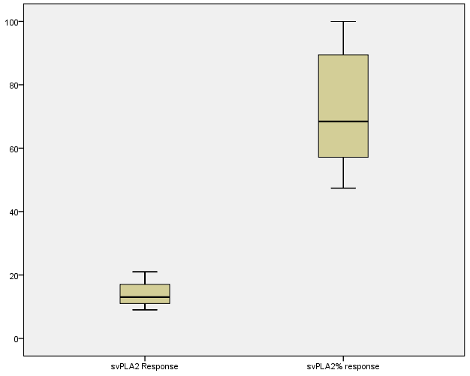
Figure S1: Box and whisker plots to check for outliers in the svPLA₂ assay study data

Data output 3: Regression analysis of the %svPLA₂ activity on log concentration of Naja ashei venom (SPSS v20.0)

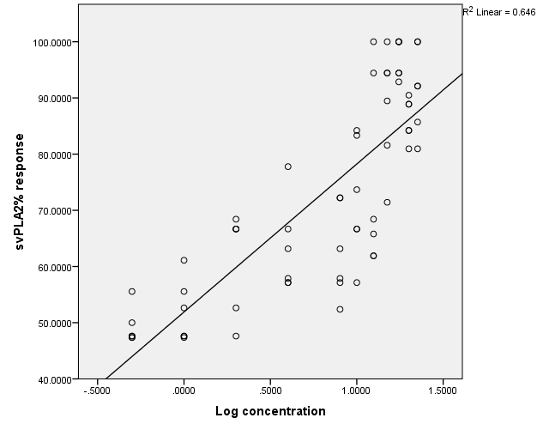
Figure S2: Regression curve of the %svPLA₂ activity against log concentration of Naja ashei venom
Descriptive Statistics
 | Mean | Std. Deviation | N
svPLA2% response | 72.676364 | 17.7320028 | 66
Log concentration | .788582 | .5410521 | 66

Correlations
 |  | svPLA2% response | Log concentration
Pearson Correlation | svPLA2% response | 1.000 | .804
 | Log concentration | .804 | 1.000
Sig. (1-tailed) | svPLA2% response | . | .000
 | Log concentration | .000 | .
N | svPLA2% response | 66 | 66
 | Log concentration | 66 | 66

Variables Entered/Removedª
Model | Variables Entered | Variables Removed | Method
1 | Log concentration^{b} | . | Enter
a. Dependent Variable: svPLA2% response
b. All requested variables entered.

Model Summary^{b}
Model | R | R Square | Adjusted R Square | Std. Error of the Estimate | Durbin-Watson
1 | .804ª | .646 | .640 | 10.6339480 | 1.063
a. Predictors: (Constant), Log concentration
b. Dependent Variable: svPLA2% response

ANOVAª
Model |  | Sum of Squares | df | Mean Square | F | Sig.
1 | Regression | 13200.381 | 1 | 13200.381 | 116.734 | .000^{b}
 | Residual | 7237.174 | 64 | 113.081
 | Total | 20437.555 | 65
a. Dependent Variable: svPLA2% response
b. Predictors: (Constant), Log concentration

Coefficientsª
Model |  | Unstandardized Coefficients |  | Standardized Coefficients | T | Sig. | 95.0% Confidence Interval for B
 |  | B | Std. Error | Beta |  |  | Lower Bound | Upper Bound
1 | (Constant)` | 51.906 | 2.326 |  | 22.318 | .000 | 47.260 | 56.552
 | Log concentration | 26.339 | 2.438 | .804 | 10.804 | .000 | 21.469 | 31.209
a. Dependent Variable: svPLA2% response

Residuals Statisticsª
 | Minimum | Maximum | Mean | Std. Deviation | N
Predicted Value | 43.977989 | 87.521439 | 72.676364 | 14.2507115 | 66
Residual | -23.3126450 | 19.2002449 | 0E-7 | 10.5518313 | 66
Std. Predicted Value | -2.014 | 1.042 | .000 | 1.000 | 66
Std. Residual | -2.192 | 1.806 | .000 | .992 | 66
a. Dependent Variable: svPLA2% response

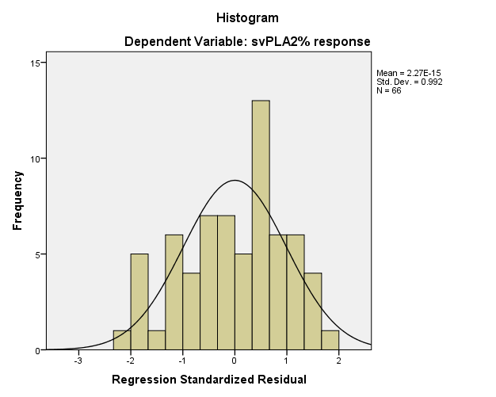
Figure S3: Curve showing the distribution of the %svPLA2 activity data of Naja ashei venom

Data output 4: Descriptive statistics and comparison of the dose-dependent mean svPLA₂ responses of Naja ashei venom by analysis of variance and Tukey’s post hoc test (Genstat15th edition)
Summary statistics for svPLA2_Response: Log_ concentration -0.301
Number of values = 6
Mean = 9.5
Median = 9.5
Minimum = 9
Maximum = 10
Range = 1
Standard deviation = 0.548
Variance = 0.3
Summary statistics for svPLA2_Response: Log_ concentration 0.000
Number of values = 6
Mean = 10
Median = 10
Minimum = 9
Maximum = 11
Range = 2
Standard deviation = 0.632
Variance = 0.4
Summary statistics for svPLA2_Response: Log_ concentration 0.301
Number of values = 6
Mean = 11.83
Median = 12
Minimum = 10
Maximum = 14
Range = 4
Standard deviation = 1.602
Variance = 2.567

Summary statistics for svPLA2_Response: Log_ concentration 0.602
Number of values = 6
Mean = 12.17
Median = 12
Minimum = 11
Maximum = 14
Range = 3
Standard deviation = 0.983
Variance = 0.967
Summary statistics for svPLA2_Response: Log_ concentration 0.903
Number of values = 6
Mean = 12
Median = 12
Minimum = 11
Maximum = 13
Range = 2
Standard deviation = 0.894
Variance = 0.8
Summary statistics for svPLA2_Response: Log_ concentration 1.000
Number of values = 6
Mean = 13.83
Median = 14
Minimum = 12
Maximum = 16
Range = 4
Standard deviation = 1.602
Variance = 2.567
Summary statistics for svPLA2_Response: Log_ concentration 1.097
Number of values = 6
Mean = 14.42
Median = 13
Minimum = 12.5
Maximum = 18
Range = 5.5
Standard deviation = 2.417
Variance = 5.842

Summary statistics for svPLA2_Response: Log_ concentration 1.176
Number of values = 6
Mean = 17.08
Median = 17
Minimum = 15
Maximum = 21
Range = 6
Standard deviation = 2.108
Variance = 4.442
Summary statistics for svPLA2_Response: Log_ concentration 1.243
Number of values = 6
Mean = 18.75
Median = 19
Minimum = 17
Maximum = 21
Range = 4
Standard deviation = 1.541
Variance = 2.375
Summary statistics for svPLA2_Response: Log_ concentration 1.301
Number of values = 6
Mean = 16.67
Median = 16
Minimum = 16
Maximum = 19
Range = 3
Standard deviation = 1.211
Variance = 1.467
Summary statistics for svPLA2_Response: Log_ concentration 1.352
Number of values = 6
Mean = 17.67
Median = 17.75
Minimum = 17
Maximum = 18
Range = 1
Standard deviation = 0.408
Variance = 0.167

Summary statistics for svPLA2%_response: Log_ concentration -0.301
Number of values = 6
Mean = 49.25
Median = 47.62
Minimum = 47.36
Maximum = 55.55
Range = 8.19
Standard deviation = 3.247
Variance = 10.54
Summary statistics for svPLA2%_response: Log_ concentration 0.000
Number of values = 6
Mean = 51.98
Median = 50.12
Minimum = 47.36
Maximum = 61.11
Range = 13.75
Standard deviation = 5.585
Variance = 31.19
Summary statistics for svPLA2%_response: Log_ concentration 0.301
Number of values = 6
Mean = 61.45
Median = 66.67
Minimum = 47.62
Maximum = 68.42
Range = 20.8
Standard deviation = 8.937
Variance = 79.88
Summary statistics for svPLA2%_response: Log_ concentration 0.602
Number of values = 6
Mean = 63.30
Median = 60.52
Minimum = 57.14
Maximum = 77.78
Range = 20.64
Standard deviation = 8.077
Variance = 65.24

Summary statistics for svPLA2%_response: Log_ concentration 0.903
Number of values = 6
Mean = 62.50
Median = 60.52
Minimum = 52.38
Maximum = 72.22
Range = 19.84
Standard deviation = 8.268
Variance = 68.36
Summary statistics for svPLA2%_response: Log_ concentration 1.000
Number of values = 6
Mean = 71.95
Median = 70.18
Minimum = 57.14
Maximum = 84.21
Range = 27.07
Standard deviation = 10.56
Variance = 111.6
Summary statistics for svPLA2%_response: Log_ concentration 1.097
Number of values = 6
Mean = 75.41
Median = 67.11
Minimum = 61.9
Maximum = 100
Range = 38.1
Standard deviation = 17.17
Variance = 294.7
Summary statistics for svPLA2%_response: Log_ concentration 1.176
Number of values = 6
Mean = 88.56
Median = 91.95
Minimum = 71.43
Maximum = 100
Range = 28.57
Standard deviation = 10.42
Variance = 108.6

Summary statistics for svPLA2%_response: Log_ concentration 1.243
Number of values = 6
Mean = 96.96
Median = 97.22
Minimum = 92.86
Maximum = 100
Range = 7.14
Standard deviation = 3.383
Variance = 11.45
Summary statistics for svPLA2%_response: Log_ concentration 1.301
Number of values = 6
Mean = 86.27
Median = 86.55
Minimum = 80.95
Maximum = 90.48
Range = 9.53
Standard deviation = 3.694
Variance = 13.65
Summary statistics for svPLA2%_response: Log_ concentration 1.352
Number of values = 6
Mean = 91.81
Median = 92.11
Minimum = 80.95
Maximum = 100
Range = 19.05
Standard deviation = 7.609
Variance = 57.90

Analysis of variance

Variate: svPLA2_Response

Source of variation d.f. s.s. m.s. v.r. F pr.
Log concentration 10 606.788 60.679 30.49 <.001
Residual 55 109.458 1.990
Total 65 716.246

Tables of effects

Variate: svPLA2_Response

Log_ concentration effects, e.s.e. 0.576, rep. 6

Log_concentration -0.301 0.000 0.301 0.602 0.903 1.000
-4.49 -3.99 -2.16 -1.83 -1.99 -0.16

Log_concentration 1.097 1.176 1.243 1.301 1.352
0.42 3.09 4.76 2.67 3.67

Tables of means

Variate: svPLA2_Response

Grand mean 13.99

Log_concentration -0.301 0.000 0.301 0.602 0.903 1.000
9.50 10.00 11.83 12.17 12.00 13.83

Log_concentration 1.097 1.176 1.243 1.301 1.352
14.42 17.08 18.75 16.67 17.67

Standard errors of differences of means

Table Log_concentration
rep. 6
d.f. 55
s.e.d. 0.814
Tukey's 95% confidence intervals
Log_ concentration

Difference Lower 95% Upper 95% Significant
Comparison
-0.301 vs 0.000 -0.500 -3.235 2.235 no
-0.301 vs 0.301 -2.333 -5.068 0.401 no
-0.301 vs 0.903 -2.500 -5.235 0.235 no
-0.301 vs 0.602 -2.667 -5.401 0.068 no
-0.301 vs 1.000 -4.333 -7.068 -1.599 yes
-0.301 vs 1.097 -4.917 -7.651 -2.182 yes
-0.301 vs 1.301 -7.167 -9.901 -4.432 yes
-0.301 vs 1.176 -7.583 -10.318 -4.849 yes
-0.301 vs 1.352 -8.167 -10.901 -5.432 yes
-0.301 vs 1.243 -9.250 -11.985 -6.515 yes
0.000 vs 0.301 -1.833 -4.568 0.901 no
0.000 vs 0.903 -2.000 -4.735 0.735 no
0.000 vs 0.602 -2.167 -4.901 0.568 no
0.000 vs 1.000 -3.833 -6.568 -1.099 yes
0.000 vs 1.097 -4.417 -7.151 -1.682 yes
0.000 vs 1.301 -6.667 -9.401 -3.932 yes
0.000 vs 1.176 -7.083 -9.818 -4.349 yes
0.000 vs 1.352 -7.667 -10.401 -4.932 yes
0.000 vs 1.243 -8.750 -11.485 -6.015 yes
0.301 vs 0.903 -0.167 -2.901 2.568 no
0.301 vs 0.602 -0.333 -3.068 2.401 no
0.301 vs 1.000 -2.000 -4.735 0.735 no
0.301 vs 1.097 -2.583 -5.318 0.151 no
0.301 vs 1.301 -4.833 -7.568 -2.099 yes
0.301 vs 1.176 -5.250 -7.985 -2.515 yes
0.301 vs 1.352 -5.833 -8.568 -3.099 yes
0.301 vs 1.243 -6.917 -9.651 -4.182 yes
0.903 vs 0.602 -0.167 -2.901 2.568 no
0.903 vs 1.000 -1.833 -4.568 0.901 no
0.903 vs 1.097 -2.417 -5.151 0.318 no
0.903 vs 1.301 -4.667 -7.401 -1.932 yes
0.903 vs 1.176 -5.083 -7.818 -2.349 yes
0.903 vs 1.352 -5.667 -8.401 -2.932 yes
0.903 vs 1.243 -6.750 -9.485 -4.015 yes
0.602 vs 1.000 -1.667 -4.401 1.068 no
0.602 vs 1.097 -2.250 -4.985 0.485 no
0.602 vs 1.301 -4.500 -7.235 -1.765 yes
0.602 vs 1.176 -4.917 -7.651 -2.182 yes
0.602 vs 1.352 -5.500 -8.235 -2.765 yes
0.602 vs 1.243 -6.583 -9.318 -3.849 yes
1.000 vs 1.097 -0.583 -3.318 2.151 no
1.000 vs 1.301 -2.833 -5.568 -0.099 yes
1.000 vs 1.176 -3.250 -5.985 -0.515 yes
1.000 vs 1.352 -3.833 -6.568 -1.099 yes
1.000 vs 1.243 -4.917 -7.651 -2.182 yes
1.097 vs 1.301 -2.250 -4.985 0.485 no
1.097 vs 1.176 -2.667 -5.401 0.068 no
1.097 vs 1.352 -3.250 -5.985 -0.515 yes
1.097 vs 1.243 -4.333 -7.068 -1.599 yes
1.301 vs 1.176 -0.417 -3.151 2.318 no
1.301 vs 1.352 -1.000 -3.735 1.735 no
1.301 vs 1.243 -2.083 -4.818 0.651 no
1.176 vs 1.352 -0.583 -3.318 2.151 no
1.176 vs 1.243 -1.667 -4.401 1.068 no
1.352 vs 1.243 -1.083 -3.818 1.651 no

Mean
-0.301 9.50 a
0.000 10.00 a
0.301 11.83 ab
0.903 12.00 ab
0.602 12.17 ab
1.000 13.83 b
1.097 14.42 bc
1.301 16.67 cd
1.176 17.08 cd
1.352 17.67 d
1.243 18.75 d
Data output 5: Evaluation of outliers in the data set on neutralization of svPLA₂ by antivenom I (Vins Bio products)
Case Processing Summary
 | Cases
 | Valid |  | Missing |  | Total
 | N | Percent | N | Percent | N | Percent
svPLA2 absorbance | 15 | 100.0% | 0 | 0.0% | 15 | 100.0%
svPLA2% response | 15 | 100.0% | 0 | 0.0% | 15 | 100.0%

svPLA₂% response
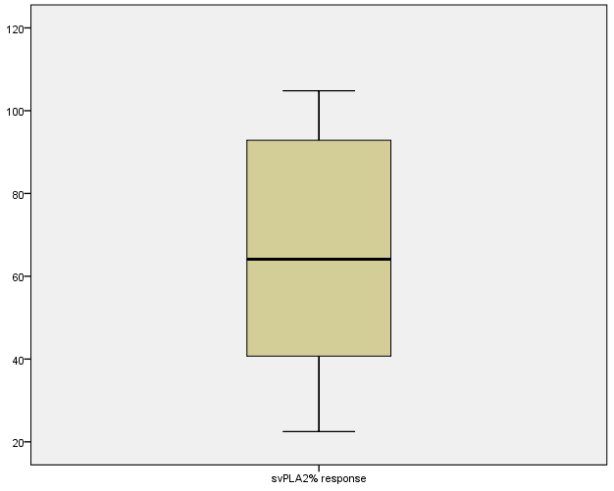
Figure S4: Box and whisker plot to check for outliers in the data on neutralization of svPLA₂ activity in Naja ashei venom by Vins bioproducts antivenom (antivenom I)
Data output 6: Regression analysis of the %svPLA₂ activity on log concentration of a mixture of a fixed dose of Naja ashei venom and variable doses of Vins bio products antivenom; antivenom I (SPSS software v20.0)

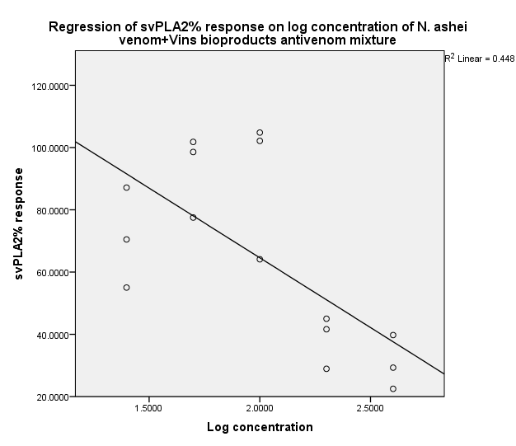
Figure S5: Regression curve showing negative correlation between the %svPLA₂ response and the log concentration of the mixture of a fixed dose of N ashei venom and varied doses of Vins bio products antivenom (antivenom I)

Descriptive Statistics
 | Mean | Std. Deviation | N
svPLA2% response | 64.579333 | 29.5062539 | 15
Log concentration | 2.000000 | .4406774 | 15

Correlations
 |  | svPLA2% response | Log concentration
Pearson Correlation | svPLA2% response | 1.000 | -.669
 | Log concentration | -.669 | 1.000
Sig. (1-tailed) | svPLA2% response | . | .003
 | Log concentration | .003 | .
N | svPLA2% response | 15 | 15
 | Log concentration | 15 | 15

Variables Entered/Removedª
Model | Variables Entered | Variables Removed | Method
1 | Log concentration^{b} | . | Enter
a. Dependent Variable: svPLA2% response
b. All requested variables entered.

Model Summary^{b}
Model | R | R Square | Adjusted R Square | Std. Error of the Estimate | Durbin-Watson
1 | .669ª | .448 | .405 | 22.7595188 | 1.065
a. Predictors: (Constant), Log concentration
b. Dependent Variable: svPLA2% response

ANOVAª
Model |  | Sum of Squares | df | Mean Square | F | Sig.
1 | Regression | 5454.722 | 1 | 5454.722 | 10.530 | .006^{b}
 | Residual | 6733.944 | 13 | 517.996
 | Total | 12188.666 | 14
a. Dependent Variable: svPLA2% response
b. Predictors: (Constant), Log concentration

Coefficientsª
Model |  | Unstandardized Coefficients |  | Standardized Coefficients | t | Sig. | 95.0% Confidence Interval for B
 |  | B | Std. Error | Beta |  |  | Lower Bound | Upper Bound
1 | (Constant) | 154.164 | 28.225 |  | 5.462 | .000 | 93.188 | 215.140
 | Log concentration | -44.792 | 13.803 | -.669 | -3.245 | .006 | -74.612 | -14.972
a. Dependent Variable: svPLA2% response
Residuals Statisticsª
 | Minimum | Maximum | Mean | Std. Deviation | N
Predicted Value | 37.610004 | 91.548660 | 64.579333 | 19.7388708 | 15
Residual | -36.5286598 | 40.2406654 | 0E-7 | 21.9316210 | 15
Std. Predicted Value | -1.366 | 1.366 | .000 | 1.000 | 15
Std. Residual | -1.605 | 1.768 | .000 | .964 | 15
a. Dependent Variable: svPLA2% response

Charts
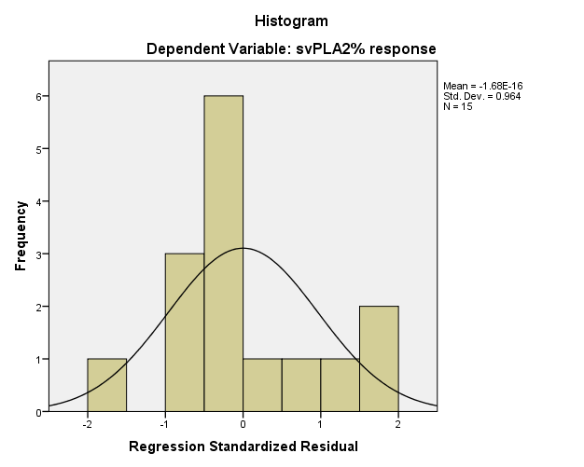
Figure S6: Curve showing the distribution of the %svPLA₂ activity data of a mixture of the fixed dose of Naja ashei venom and varied concentrations of Vins bioproducts antivenom (antivenom I)
Data output 7: Evaluation of outliers in the svPLA₂ activity data of a mixture of the fixed dose of Naja ashei venom and varied concentrations of Pan Africa Inoserp antivenom (antivenom II) (SPSS software v20.0).
Case Processing Summary
 | Cases
 | Valid |  | Missing |  | Total
 | N | Percent | N | Percent | N | Percent
svPLA2% response | 15 | 100.0% | 0 | 0.0% | 15 | 100.0%
svPLA2 absorbance | 15 | 100.0% | 0 | 0.0% | 15 | 100.0%
svPLA₂% response
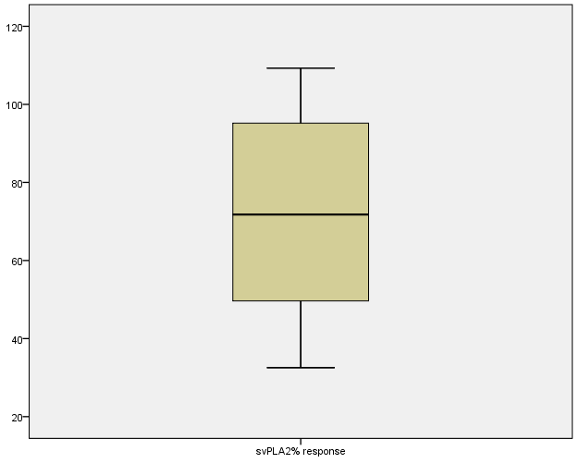
Figure S7: Box and whisker plot to check for outliers in the data on neutralization of svPLA₂ activity in Naja ashei venom by Pan Africa Inoserp antivenom (antivenom II)
Data output 8: Regression analysis of the %svPLA₂ activity on log concentration of a mixture of a fixed dose of Naja ashei venom and variable doses of PAN Africa Inoserp antivenom; antivenom II (SPSS software v20.0)
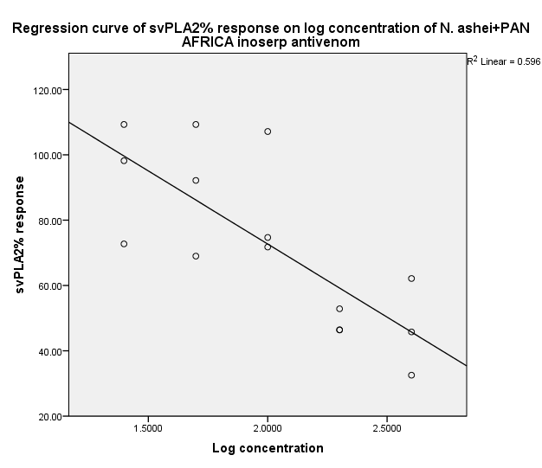
Figure S8: Regression curve showing negative correlation between the %svPLA₂ response and the log concentration of the mixture of a fixed dose of N ashei venom and varied doses of Pan Africa Inoserp antivenom (antivenom II)
Descriptive Statistics
 | Mean | Std. Deviation | N
svPLA2% response | 72.6933 | 25.54712 | 15
Log concentration | 2.000000 | .4406774 | 15

Correlations
 |  | svPLA2% response | Log concentration
Pearson Correlation | svPLA2% response | 1.000 | -.772
 | Log concentration | -.772 | 1.000
Sig. (1-tailed) | svPLA2% response | . | .000
 | Log concentration | .000 | .
N | svPLA2% response | 15 | 15
 | Log concentration | 15 | 15

Variables Entered/Removedª
Model | Variables Entered | Variables Removed | Method
1 | Log concentration^{b} | . | Enter
a. Dependent Variable: svPLA2% response
b. All requested variables entered.

Model Summary^{b}
Model | R | R Square | Adjusted R Square | Std. Error of the Estimate | Durbin-Watson
1 | .772ª | .596 | .565 | 16.84490 | 2.012
a. Predictors: (Constant), Log concentration
b. Dependent Variable: svPLA2% response

ANOVAª
Model |  | Sum of Squares | df | Mean Square | F | Sig.
1 | Regression | 5448.420 | 1 | 5448.420 | 19.201 | .001^{b}
 | Residual | 3688.758 | 13 | 283.751
 | Total | 9137.177 | 14
a. Dependent Variable: svPLA2% response
b. Predictors: (Constant), Log concentration

Coefficientsª
Model |  | Unstandardized Coefficients |  | Standardized Coefficients | t | Sig. | 95.0% Confidence Interval for B
 |  | B | Std. Error | Beta |  |  | Lower Bound | Upper Bound
1 | (Constant) | 162.226 | 20.890 |  | 7.766 | .000 | 117.096 | 207.356
 | Log concentration | -44.766 | 10.216 | -.772 | -4.382 | .001 | -66.837 | -22.696
a. Dependent Variable: svPLA2% response
Residuals Statisticsª
 | Minimum | Maximum | Mean | Std. Deviation | N
Predicted Value | 45.7396 | 99.6471 | 72.6933 | 19.72746 | 15
Residual | -26.91708 | 34.44667 | .00000 | 16.23215 | 15
Std. Predicted Value | -1.366 | 1.366 | .000 | 1.000 | 15
Std. Residual | -1.598 | 2.045 | .000 | .964 | 15
a. Dependent Variable: svPLA2% response

Charts
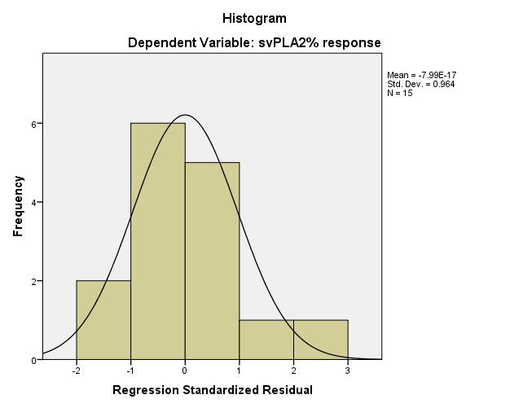
Figure S9: Curve showing the distribution of the %svPLA₂ activity data of a mixture of the fixed dose of Naja ashei venom and varied concentrations of Pan Africa Inoserp antivenom (antivenom II)

Data output 9: Regression analysis to determine the safety of Vins bio products antivenom in the 48-hour brine shrimp lethality assay (MS Excel 2013)
SUMMARY OUTPUT
Regression Statistics
Multiple R | 0.401824228
R Square | 0.161462711
Adjusted R Square | 0.096959842
Standard Error | 1.083909441
Observations | 15
ANOVA
 | df | SS | MS | F | Significance F
Regression | 1 | 2.9408929 | 2.9408929 | 2.503186517 | 0.137631291
Residual | 13 | 15.27317579 | 1.174859676
Total | 14 | 18.21406869
 | Coefficients | Standard Error | t Stat | P-value | Lower 95% | Upper 95% | Lower 95.0% | Upper 95.0%
Intercept | 3.181293333 | 0.740451112 | 4.296425899 | 0.000869009 | 1.58164596 | 4.780940707 | 1.58164596 | 4.780940707
X Variable 1 | 0.5423 | 0.342762261 | 1.582146174 | 0.137631291 | -0.198192845 | 1.282792845 | -0.198192845 | 1.282792845

Data output 10: Regression analysis to determine the safety of Vins bio products antivenom in the 72-hour brine shrimp lethality assay (MS Excel 2013)
SUMMARY OUTPUT
Regression Statistics
Multiple R | 0.458352678
R Square | 0.210087178
Adjusted R Square | 0.149324653
Standard Error | 1.65630921
Observations | 15
ANOVA
 | df | SS | MS | F | Significance F
Regression | 1 | 9.485201664 | 9.485201664 | 3.457512312 | 0.085741319
Residual | 13 | 35.66368259 | 2.743360199
Total | 14 | 45.14888425
 | Coefficients | Standard Error | t Stat | P-value | Lower 95% | Upper 95% | Lower 95.0% | Upper 95.0%
Intercept | 1.385133333 | 1.131474595 | 1.22418421 | 0.242605708 | -1.059268918 | 3.829535584 | -1.059268918 | 3.829535584
X Variable 1 | 0.97392 | 0.523770961 | 1.859438709 | 0.085741319 | -0.157618368 | 2.105458368 | -0.157618368 | 2.105458368

Data output 11: Regression analysis to determine the safety of Pan Africa Inoserp antivenom in the 48-hour brine shrimp lethality assay (MS Excel 2013)
SUMMARY OUTPUT
Regression Statistics
Multiple R | 0.131287214
R Square | 0.017236333
Adjusted R Square | -0.058360873
Standard Error | 1.20902718
Observations | 15
ANOVA
 | df | SS | MS | F | Significance F
Regression | 1 | 0.333281536 | 0.333281536 | 0.228002246 | 0.640937312
Residual | 13 | 19.00270739 | 1.461746723
Total | 14 | 19.33598893
 | Coefficients | Standard Error | t Stat | P-value | Lower 95% | Upper 95% | Lower 95.0% | Upper 95.0%
Intercept | 3.422306667 | 0.825922799 | 4.143615686 | 0.001154921 | 1.638008938 | 5.206604395 | 1.638008938 | 5.206604395
X Variable 1 | 0.18256 | 0.382327964 | 0.477495807 | 0.640937312 | -0.64340935 | 1.00852935 | -0.64340935 | 1.00852935

Data output 12: Regression analysis to determine the safety of Pan Africa Inoserp antivenom in the 72-hour brine shrimp lethality assay (MS Excel 2013)
SUMMARY OUTPUT
Regression Statistics
Multiple R | 0.263835667
R Square | 0.069609259
Adjusted R Square | -0.001959259
Standard Error | 1.284192199
Observations | 15
ANOVA
 | df | SS | MS | F | Significance F
Regression | 1 | 1.6040025 | 1.6040025 | 0.97262401 | 0.342027213
Residual | 13 | 21.43894485 | 1.649149604
Total | 14 | 23.04294735
 | Coefficients | Standard Error | t Stat | P-value | Lower 95% | Upper 95% | Lower 95.0% | Upper 95.0%
Intercept | 4.251173333 | 0.877270282 | 4.845910569 | 0.000319477 | 2.355946112 | 6.146400555 | 2.355946112 | 6.146400555
X Variable 1 | -0.4005 | 0.40609723 | -0.98621702 | 0.342027213 | -1.277819728 | 0.476819728 | -1.277819728 | 0.476819728

Data output 13: Regression analysis to determine the 24-hour toxicity of Naja ashei venom in the brine shrimp lethality assay (MS Excel 2013)
SUMMARY OUTPUT
Regression Statistics
Multiple R | 0.861737473
R Square | 0.742591472
Adjusted R Square | 0.722790816
Standard Error | 1.906960804
Observations | 15
ANOVA
 | Df | SS | MS | F | Significance F
Regression | 1 | 136.3810128 | 136.3810128 | 37.50337723 | 3.63682E-05
Residual | 13 | 47.27449359 | 3.636499507
Total | 14 | 183.6555064
 | Coefficients | Standard Error | t Stat | P-value | Lower 95% | Upper 95% | Lower 95.0% | Upper 95.0%
Intercept | -1.636066667 | 1.302702231 | -1.255902253 | 0.231254372 | -4.450383736 | 1.178250402 | -4.450383736 | 1.178250402
X Variable 1 | 3.69298 | 0.603033955 | 6.124000101 | 3.63682E-05 | 2.390204345 | 4.995755655 | 2.390204345 | 4.995755655

Data output 14: Regression analysis to determine the 48-hour toxicity of Naja ashei venom in the brine shrimp lethality assay (MS Excel 2013)
SUMMARY OUTPUT
Regression Statistics
Multiple R | 0.754457108
R Square | 0.569205527
Adjusted R Square | 0.536067491
Standard Error | 1.309374352
Observations | 15
ANOVA
 | Df | SS | MS | F | Significance F
Regression | 1 | 29.44896245 | 29.44896245 | 17.17680315 | 0.001153034
Residual | 13 | 22.28799553 | 1.714461194
Total | 14 | 51.73695798
 | Coefficients | Standard Error | t Stat | P-value | Lower 95% | Upper 95% | Lower 95.0% | Upper 95.0%
Intercept | 3.843173333 | 0.894472968 | 4.296578511 | 0.000868763 | 1.910781969 | 5.775564698 | 1.910781969 | 5.775564698
X Variable 1 | 1.71607 | 0.414060526 | 4.144490699 | 0.001153034 | 0.821546617 | 2.610593383 | 0.821546617 | 2.610593383

Data output 15: Regression analysis to determine the 72-hour toxicity of Naja ashei venom in the brine shrimp lethality assay (MS Excel 2013)
SUMMARY OUTPUT
Regression Statistics
Multiple R | 0.404065903
R Square | 0.163269254
Adjusted R Square | 0.09890535
Standard Error | 1.115153745
Observations | 15
ANOVA
 | df | SS | MS | F | Significance F
Regression | 1 | 3.154507225 | 3.154507225 | 2.536658663 | 0.135243789
Residual | 13 | 16.16638238 | 1.243567876
Total | 14 | 19.32088961
 | Coefficients | Standard Error | t Stat | P-value | Lower 95% | Upper 95% | Lower 95.0% | Upper 95.0%
Intercept | 5.054306667 | 0.761795035 | 6.634733012 | 1.62581E-05 | 3.40854855 | 6.700064783 | 3.40854855 | 6.700064783
X Variable 1 | 0.56165 | 0.352642578 | 1.592689129 | 0.135243789 | -0.200187972 | 1.323487972 | -0.200187972 | 1.323487972

Data output 16: Descriptive statistics and comparison of the 24-hour dose-dependent mortality of Naja ashei venom by analysis of variance and Tukey’s post hoc test (Genstat15th edition)

Summary statistics for Adjusted_%mortality: Concentration_ug_ml 10
Number of values = 5
Mean = 0
Median = 0
Minimum = 0
Maximum = 0
Range = 0
Lower quartile = 0
Upper quartile = 0
Standard deviation = 0

Summary statistics for Adjusted_%mortality: Concentration_ug_ml 100
Number of values = 5
Mean = 94
Median = 100
Minimum = 80
Maximum = 100
Range = 20
Lower quartile = 87.5
Upper quartile = 100
Standard deviation = 8.944
Summary statistics for Adjusted_%mortality: Concentration_ug_ml 1000
Number of values = 5
Mean = 98
Median = 100
Minimum = 90
Maximum = 100
Range = 10
Lower quartile = 97.5
Upper quartile = 100
Standard deviation = 4.472

Analysis of variance

Variate: Adjusted_%mortality

Source of variation d.f. s.s. m.s. v.r. F pr.
Concentration_ug_ml 2 30760.00 15380.00 461.40 <.001
Residual 12 400.00 33.33
Total 14 31160.00

Tables of effects

Variate: Adjusted_%mortality

Concentration_ug_ml effects, e.s.e. 2.58, rep. 5

Concentration_ug_ml 10 100 1000
-64.0 30.0 34.0

Tables of means

Variate: Adjusted_%mortality

Grand mean 64.0

Concentration_ug_ml 10 100 1000
0.0 94.0 98.0

Standard errors of differences of means

Table Concentration_ug_ml
rep. 5
d.f. 12
s.e.d. 3.65

Tukey's 95% confidence intervals
Concentration_ug_ml
Difference Lower 95% Upper 95% Significant
Comparison
10 vs 100 -94.00 -103.74 -84.26 yes
10 vs 1000 -98.00 -107.74 -88.26 yes
100 vs 1000 -4.00 -13.74 5.74 no

Mean
10 0.00 a
100 94.00 b
1000 98.00 b

Data output 17: Descriptive statistics and comparison of the 48-hour dose-dependent mortality of Naja ashei venom by analysis of variance and Tukey’s post hoc test (Genstat 15th edition)

Summary statistics for Adjusted_%mortality: Concentration_ug_ml 10
Number of values = 5
Number of observations = 5
Mean = 50
Median = 50
Minimum = 20
Maximum = 70
Range = 50
Lower quartile = 42.5
Upper quartile = 62.5
Standard deviation = 18.71
Summary statistics for Adjusted_%mortality: Concentration_ug_ml 100
Number of values = 5
Number of observations = 5
Mean = 98
Median = 100
Minimum = 90
Maximum = 100
Range = 10
Lower quartile = 97.5
Upper quartile = 100
Standard deviation = 4.472
Summary statistics for Adjusted_%mortality: Concentration_ug_ml 1000
Number of values = 5
Number of observations = 5
Mean = 98
Median = 100
Minimum = 90
Maximum = 100
Range = 10
Lower quartile = 97.5
Upper quartile = 100
Standard deviation = 4.472

Analysis of variance

Variate: Adjusted_%mortality

Source of variation d.f. s.s. m.s. v.r. F pr.
Concentration_ug_ml 2 7680.0 3840.0 29.54 <.001
Residual 12 1560.0 130.0
Total 14 9240.0

Tables of effects

Variate: Adjusted_%mortality

Concentration_ug_ml effects, e.s.e. 5.10, rep. 5

Concentration_ug_ml 10 100 1000
-32.0 16.0 16.0

Tables of means

Variate: Adjusted_%mortality

Grand mean 82.0

Concentration_ug_ml 10 100 1000
50.0 98.0 98.0

Standard errors of differences of means

Table Concentration_ug_ml
rep. 5
d.f. 12
s.e.d. 7.21

Tukey's 95% confidence intervals

Concentration_ug_ml

Difference Lower 95% Upper 95% Significant
Comparison
10 vs 100 -48.00 -67.24 -28.76 yes
10 vs 1000 -48.00 -67.24 -28.76 yes
100 vs 1000 0.00 -19.24 19.24 no

Mean
10 50.00 a
100 98.00 b
1000 98.00 b

Data output 18: Descriptive statistics and comparison of the 72-hour dose-dependent mortality of Naja ashei venom by analysis of variance and Tukey’s post hoc test (Genstat 15th edition)
Summary statistics for %72hr_adjusted_%mortality_: Concentration_ug_ml__ 10
Number of values = 5
Number of observations = 5
Mean = 66
Median = 70
Minimum = 50
Maximum = 80
Range = 30
Lower quartile = 57.5
Upper quartile = 72.5
Standard deviation = 11.40
Summary statistics for %72hr_adjusted_%mortality_: Concentration_ug_ml__ 100
Number of values = 5
Number of observations = 5
Mean = 86
Median = 80
Minimum = 80
Maximum = 100
Range = 20
Lower quartile = 80
Upper quartile = 92.5
Standard deviation = 8.944
Summary statistics for %72hr_adjusted_%mortality_: Concentration_ug_ml__ 1000
Number of values = 5
Number of observations = 5
Mean = 86
Median = 80
Minimum = 80
Maximum = 100
Range = 20
Lower quartile = 80
Upper quartile = 92.5
Standard deviation = 8.944

Analysis of variance

Variate: %72hr_adjusted_%mortality_

Source of variation d.f. s.s. m.s. v.r. F pr.
Concentration_ug_ml__ 2 1333.33 666.67 6.90 0.010
Residual 12 1160.00 96.67
Total 14 2493.33

Tables of means

Variate: %72hr_adjusted_%mortality_

Grand mean 79.3

Concentration_ug_ml__ 10 100 1000
66.0 86.0 86.0

Standard errors of differences of means

Table Concentration_ug_ml__
rep. 5
d.f. 12
s.e.d. 6.22

Tukey's 95% confidence intervals

Concentration_ug_ml__

Difference Lower 95% Upper 95% Significant
Comparison
10 vs 100 -20.00 -36.59 -3.411 yes
10 vs 1000 -20.00 -36.59 -3.411 yes
100 vs 1000 0.00 -16.59 16.589 no

Mean
10 66.00 a
100 86.00 b
1000 86.00 b

Table S5: Evaluation of the capacity of antivenoms to neutralize Naja ashei venom-induced brine shrimp lethality
 | Vins Bioproducts |  | PAN Africa Inoserp
Treatment | %Mortality | Probits | %Mortality | Probits
2LC₅₀ only  2LC₅₀ only  2LC₅₀ only  2LC₅₀ only  2LC₅₀ only | 100  100  100  100  100 | 8.9538  8.9538  8.9538  8.9538  8.9538 | 100  100  100  100  100 | 8.9538  8.9538  8.9538  8.9538  8.9538
2LC₅₀ of venom+25µL of antivenom  2LC₅₀ of venom+25µL of antivenom  2LC₅₀ of venom+25µL of antivenom  2LC₅₀ of venom+25µL of antivenom  2LC₅₀ of venom+25µL of antivenom | 100  100  100  100  100 | 8.9538  8.9538  8.9538  8.9538  8.9538 | 80  0  100  100  100 | 5.8416  1.0334  8.9538  8.9538  8.9538
2LC₅₀ of venom +50µL of antivenom  2LC₅₀ of venom +50µL of antivenom  2LC₅₀ of venom +50µL of antivenom  2LC₅₀ of venom +50µL of antivenom  2LC₅₀ of venom +50µL of antivenom | 100  100  100  100  100 | 8.9538  8.9538  8.9538  8.9538  8.9538 | 100  90  80  90  100 | 8.9538  6.2816  5.8416  6.2816  8.9538
2LC₅₀ of venom +100µL of antivenom  2LC₅₀ of venom +100µL of antivenom  2LC₅₀ of venom +100µL of antivenom  2LC₅₀ of venom +100µL of antivenom  2LC₅₀ of venom +100µL of antivenom | 100  100  100  100  100 | 8.9538  8.9538  8.9538  8.9538  8.9538 | 80  80  100  80  80 | 5.8416  5.8416  8.9538  5.8416  5.8416
2LC₅₀ of venom +200µL of antivenom  2LC₅₀ of venom +200µL of antivenom  2LC₅₀ of venom +200µL of antivenom  2LC₅₀ of venom +200µL of antivenom  2LC₅₀ of venom +200µL of antivenom | 100  100  100  100  100 | 8.9538  8.9538  8.9538  8.9538  8.9538 | 0  70  80  90  100 | 1.0334  5.5244  5.8416  6.2816  8.9538
2LC₅₀ of venom +400µL of antivenom  2LC₅₀ of venom +400µL of antivenom  2LC₅₀ of venom +400µL of antivenom  2LC₅₀ of venom +400µL of antivenom  2LC₅₀ of venom +400µL of antivenom | 100  100  100  100  100 | 8.9538  8.9538  8.9538  8.9538  8.9538 | 70  100  90  0  100 | 5.5244  8.9538  6.2816  1.0334  8.9538

Data output 19: Regression analysis to determine the capacity of antivenom II to neutralize Naja ashei venom-induced brine shrimp lethality (MS Excel 2013)

SUMMARY OUTPUT
Regression Statistics
Multiple R | 0.16989061
R Square | 0.028862819
Adjusted R Square | -0.013360536
Standard Error | 2.506960924
Observations | 25
ANOVA
 | df | SS | MS | F | Significance F
Regression | 1 | 4.296167 | 4.296167 | 0.683574743 | 0.41685384
Residual | 23 | 144.5516 | 6.284853
Total | 24 | 148.8478
 | Coefficients | Standard Error | t Stat | P-value | Lower 95% | Upper 95% | Lower 95.0% | Upper 95.0%
Intercept | 8.377375596 | 2.408094 | 3.47884 | 0.002030047 | 3.395853143 | 13.3589 | 3.395853 | 13.3589
X Variable 1 | -0.973681535 | 1.177671 | -0.82679 | 0.41685384 | -3.409879328 | 1.462516 | -3.40988 | 1.462516

