Methods
Materials. 1,1-Carbonyldiimidazole (CDI), 4-dimethylaminopyridine (DMAP), 4-hydroxy -2,2,6,6-tetramethylpiperidin-1-oxyl (Tempol), 4-(hydroxymethyl)phenylboronic acid pinacol ester (PBAP), lipopolysaccharide (LPS, O26:B6), ovalbumin (OVA), 4’,6-diamidino-2-phenylindole (DAPI), 2’,7’-dichlorofluorescin diacetate (DCFH-DA), thioglycollate, phorbol 12-myristate 13-acetate (PMA), deoxyribonuclease ǀ (DNase ǀ), dodecyl sodium sulfate (SDS), triphenylphosphine (TPP), methacholine, and Liberase TM Research Grade were obtained from Sigma-Aldrich (U.S.A.). Lecithin (from soybean) and β-cyclodextrin (β-CD) were purchased from Tokyo Chemical Industry Co., Ltd. (Tokyo, Japan). 1,2-Distearoyl-sn-glycero-3-phosphoethanolamine-N-[methoxy(polyethylene glycol)]-2000 (DSPE-PEG) was obtained from Corden Pharma (Switzerland). Cyanine5 NHS ester (Cy5) and Cyanine7.5 NHS ester (Cy7.5) were purchased from Lumiprobe, LLC. (U.S.A.). Roswell Park Memorial Institute Medium (RPMI-1640), Dulbecco’s Modified Eagle medium (DMEM), and penicillin-streptomycin solution were provided by Hyclone (Waltham, U.S.A.). Fetal bovine serum (FBS) was purchased from Gibco (U.S.A.). Sytox Green Nucleic Acid Stain, Quant-iT PicoGreen dsDNA Reagent, Amplex Red Hydrogen Peroxide/Peroxidase Assay Kit, PageRuler Prestained Protein Ladder, and Imject Alum Adjuvant (i.e., Al(OH)₃ gel) were purchased from Invitrogen (U.S.A.). Rabbit polyclonal anti-histone H3 (citrulline R2 + R8 + R17) antibody and rabbit polyclonal anti-neutrophil elastase antibody were obtained from Abcam. 12% TGX Satin-Free FastCast Kit and 4× Laemmli Sample Buffer were obtained from Bio-Rad (U.S.A.). Pierce ECL Western Blotting Substrate, the secondary antibody Alexa Fluor 568 goat anti-rat IgG, and Alexa Flour 400 donkey anti-goat IgG were provided by Thermo Fisher Scientific (U.S.A.). Anti-mouse Ly6G antibody, anti-mouse CD11b antibody, anti-mouse CD90.2 antibody, anti-mouse CD45R antibody, anti-mouse CDNK1.1 antibody, anti-mouse Ter-119 antibody, anti-mouse Ly6C antibody, anti-mouse CD90.2 antibody, anti-mouse CD4 antibody, and anti-mouse CD25 antibody were purchased from BD Bioscience (U.S.A.). Anti-mouse CD11c antibody, anti-mouse F4/80 antibody, anti-mouse CD90.2 antibody, anti-mouse CD49b antibody, anti-mouse IL-17A antibody, anti-mouse Foxp3 antibody, True-Nuclear Transcription Factor Buffer Set, Fixation Buffer, Intracellular Staining Permeabilization Wash Buffer, Ultra-LEAF Purified anti-mouse CD3 antibody, and Ultra-LEAF Purified anti-mouse CD28 antibody were provided by BioLegend (U.S.A.). EasySep Mouse Naïve CD4⁺ T Cell Isolation Kit was obtained from Stemcell Technologies (Canada). Radioimmunoprecipitation assay (RIPA) lysis buffer, horseradish peroxidase (HRP)-labeled goat anti-rabbit IgG (H+L), β-actin antibody, phenylmethylsulfonyl fluoride (PMSF), bio-labeled goat anti-mouse IgG (H+L), BCA protein assay, and Mito-Tracker Green were purchased from Beyotime Institute of Biotechnology (China). All other ELISA kits were obtained from Boster Biological Technology Co., Ltd (Wuhan, China). Recombinant human transforming growth factor (TGF)-β1 was provided by PeproTech (U.S.A.). Anhydrous dichloromethane (DCM), stearyl bromide, anhydrous dimethylsulfoxide (DMSO), and 1-(3-dimethylaminopropyl)-3-ethylcarbodiimide hydrochloride (EDC) were obtained from J&K.

Synthesis of an antioxidative and anti-inflammatory cyclodextrin material. An antioxidative and anti-inflammatory cyclodextrin material (defined as TPCD) was synthesized by sequentially conjugating Tempol and PBAP onto β-CD.¹ First a Tempol-conjugated β-CD (TCD) was synthesized. Briefly, Tempol (1.02 g, 5.9 mmol) and CDI (1.91 g, 11.8 mmol) were dissolved in anhydrous DCM (15 mL). After 45 min of reaction, the mixture was washed with 10 mL of deionized water. Before drying with Na₂SO₄ and concentration under vacuum, the organic phase was rinsed with saturated NaCl solution three times. Then CDI-activated Tempol (1.65 g), β-CD (2.35 g, 2.07 mmol), and DMAP (1.13 g, 9.30 mmol) were magnetically stirred at 30°C for 24 h in 20 mL of anhydrous DMSO under nitrogen protection. TCD was precipitated from a mixture solution of methanol and diethyl ether and collected by centrifugation.
Then CDI-activated PBAP was synthesized according to the above mentioned methods. In general, PBAP (1.11 g) and CDI (1.53 g) were reacted in anhydrous DCM (15 mL) for 45 min. The mixture was washed with deionized water once and saturated NaCl solution three times. Finally, the organic phase was dried with Na₂SO₄ and concentrated in vacuum to obtain CDI-activated PBAP (1.52 g).
Subsequently, reaction of 0.4 g TCD with 1.53 g CDI-activated PBAP was carried out in the presence of 0.8 g DMAP in 20 mL of anhydrous DMSO at 30°C under nitrogen for 48 h. The final product was acquired after precipitation with 80 mL of deionized water and centrifugation. After rinsing with water three times, the resulting product TPCD was obtained by lyophilization.

Synthesis of Cy5-conjugated TPCD. In brief, TPCD (145.5 mg, 0.05 mmol) was reacted with Cy5 carboxylic acid (5 mg, 0.01 mmol) in the presence of EDC (10 mg, 0.05 mmol) and DMAP (5 mg, 0.04 mmol) in anhydrous DMF (10 mL) in dark for 48 h. After extraction with deionized water and centrifugation at 8000g for 10 min, the obtained precipitate was rinsed with acetone three times and dried by lyophilization.

Synthesis of mitochondrial-targeting stearyl triphenylphosphine. Stearyl triphenylphosphine (defined as STPP) was synthesized according to the previously reported method.² Briefly, stearyl bromide (1.0 g, 3.0 mmol) and triphenylphosphine (0.83 g, 3.2 mmol) were dissolved in acetonitrile (25 mL) and heated at 85°C under argon overnight. The reaction solution was cooled to room temperature and then concentrated under reduced pressure. Subsequently, the organic phase was washed with hexanes (2 × 20 mL) and diethyl ether (2 × 15 mL) and dried to obtain a white solid.

Materials characterization. ¹H NMR spectrum was recorded on a spectrometer operating at 600 MHz. Fourier Transform infrared (FT-IR) spectra were recorded on a PerkineElmer FT-IR spectrometer (100S).

Preparation of different nanoparticles. TPCD nanoparticles (i.e., TPCN) were prepared by a nanoprecipitation/self-assembly method. In general, lecithin (6 mg) and DSPE-PEG (9 mg) dissolved in 0.6 mL of ethanol were added to 15 mL of deionized water and incubated at 65°C for 1 h. Subsequently, TPCD (50 mg) dissolved in methanol (5 mL) was added to the preheated lipid aqueous solution drop by drop, followed by incubation at room temperature for 2 h. After the organic solvent was removed by vacuum evaporation, TPCN was obtained by freeze-drying. By the same methods, Cy5 or Cy7.5-labeled TPCN and Cy5-conjugated TPCN were fabricated.
Mitochondrial-targeting nanoparticles, i.e., TPP-decorated TPCD nanoparticles (defined as TTPCN), were fabricated by a similar method mentioned above. Briefly, lecithin (6 mg), DSPE-PEG (9 mg), and STPP (8 mg) were dissolved in 0.6 mL of ethanol, into which 15 mL of deionized water was added. The other procedures are similar to those used for TTPCN preparation. Similarly, Cy5-conjugated TTPCN was fabricated.

Characterization of different nanoparticles. Sizes, size distribution profiles, and ζ-potential values of NPs were measured using a Malvern Zetasizer Nano ZS instrument at 25°C. Morphology of NPs was observed with transmission electron microscopy (TEM) using a TECNAI-10 microscope (Philips, Netherlands), operating at an acceleration voltage of 80 kV. Scanning electron microscopy (SEM) was also employed to characterize NPs with a FIB-SEM microscope (Crossbeam 340, Zeiss).

Animals. All animal care and experimental programs followed the regulation of the Ministry of Health of the People’s Republic of China on animal administration and the guidelines of the Army Medical University on the care and use of experimental animals. BALB/C mice (18-22 g) were purchased from the Animal Center of the Army Medical University. Animals were housed under standard conditions, with ad libitum access to water and food. All mice were acclimatized for 7 days before further experiments.

Isolation of mouse peritoneal neutrophils. BALB/C mice were intraperitoneally (i.p.) injected with 1 mL of aqueous solution containing 3 wt% thioglycolate.³ After 4 h, mice were euthanized, and 5 mL of sterile Hank’s balanced salt solution (HBSS) was i.p. injected to collect neutrophils. After centrifugation and resuspension, neutrophil counts were determined with a hemocytometer (Sigma, U.S.A.).

In vitro cellular uptake of TPCN by neutrophils. The isolated neutrophils were seeded into 12-well plates at a density of 5 × 10⁵ per well. After incubation in DMEM for 20 min, varied doses of Cy5/TPCN were added. After incubation for 1 h, cells were digested and fluorescence intensities were quantified by flow cytometry. According to the similar procedures, time-dependent experiments were performed at 50 μg/mL Cy5/TPCN.
In a separate study, neutrophils were seeded onto sterilized glass coverslips in 12-well plates at a density of 5 × 10⁵ cells per well. After incubation with various doses of Cy5/TPCN, cells were washed with PBS three times, fixed with 4% paraformaldehyde, and stained with DAPI. Similarly, time-dependent cellular internalization was conducted. In both cases, cellular internalization of Cy5/TPCN was observed by confocal laser scanning microscopy (CLSM).

In vitro antioxidative effects of TPCN in neutrophils. Mouse peritoneal neutrophils were seeded into 12-well plates at a density of 1 × 10⁶ cells per well. After incubation in DMEM for 20 min, varied doses of TPCN were added. After incubation for 2 h, cells were treated with PMA at 200 ng per well. After 1 h, cells were stained with DCFH-DA for 20 min. Subsequently, cells were digested and fluorescence intensities were measured by flow cytometry.
For fluorescence microscopy observation of reactive oxygen species (ROS) generation in neutrophils, cells were seeded onto sterilized glass coverslips in 12-well plates at 5 × 10⁵ cells per well. After ROS were stained with DCFH-DA, cells were washed with PBS, fixed with 4% paraformaldehyde, and stained with DAPI, followed by CLSM observation.

In vitro anti-inflammatory effects of TPCN in neutrophils. Mouse peritoneal neutrophils were seeded into 24-well plates at a density of 5 × 10⁵ cells per well. After incubation with different doses of TPCN for 2 h, cells were treated with PMA at 200 ng per well. After 1 h, cells were digested, and the levels of tumor necrosis factor (TNF)-α, interleukin (IL)-1β, and IL-8 in the supernatant were quantified by ELISA assay.

In vitro anti-migration activity of TPCN in neutrophils. Transwell assay was performed to examine the anti-migration activity of TPCN. In brief, freshly isolated peritoneal neutrophils were seeded in the upper side of a Transwell chamber at 5 × 10⁵ cells per well. DMEM was added to the lower chamber and TPCN at different doses was added to the upper chamber. Cells were allowed to migrate for 1 h. Then cells on the upper side of each insert were gently removed and the migrated neutrophils were observed and counted by optical microscopy.

In vitro inhibition of the formation of neutrophil extracellular traps (NETs) by TPCN. To visualize the formation of neutrophil extracellular traps (NETs), peritoneal neutrophils were stimulated with PMA for 4 h, then double-stranded DNA (dsDNA) was stained with Sytox Green dye and the formation of NETs was observed by confocal microscopy. In a separate study, neutrophils were pre-incubated with different doses of TPCN for 1 h. Subsequently, cells were stimulated with PMA for 4 h, followed by washing with HBSS three times to remove residual PMA and TPCN. Neutrophils and NETs at the bottom of the plate were collected. The levels of dsDNA or NETs were quantified by using the Quant-iT PicoGreen dsDNA reagent, mouse elastase ELISA Kit, or myeloperoxidase (MPO) ELISA Kit according to the manufacturer’s protocols.⁴
To observe the effect of TPCN treatment on the NETs formation by CLSM, neutrophils were seeded on sterilized glass coverslips in 12-well plates. According to the similar procedures as described above, the coverslips were washed in HBSS at pH 7.4 and fixed with 4% paraformaldehyde for 15 min. To observe citrullinated histones (CitH3), the fixed samples were permeabilized with Triton X-100 and blocked with BSA, then the samples were incubated with a primary anti-CitH3 antibody and a secondary Cy3-conjugated rabbit-specific antibody. DNA was stained with SYTOX Green.
For Western blotting, the cell-free supernatant was denatured and run in 12% Bis-Tris gels, followed by electroblotting on the polyvinylidene fluoride (PVDF) membrane. Then the membrane was blocked with 5% BSA in Tris-buffered saline containing Tween 20 at room temperature for 2 h. Subsequently, the membrane was incubated with primary anti-CitH3 antibody at 4°C overnight. The membrane was then incubated with appropriate HRP-associated secondary antibodies at room temperature for 1 h. The PVDF membrane was then exposed to the ECL luminescent solution in a chemiluminescence system.

The effect of NETs on regulatory T cell differentiation in vitro. Naive CD4⁺ T cells were isolated from the spleen of mice using EasySep Mouse Naïve CD4⁺ T Cell Isolation Kit according to the manufacturer’s protocol. Then naive CD4⁺ T cells at 5 × 10⁵ cells/well were added into 12-well plates seeded with freshly isolated peritoneal neutrophils (5 × 10⁵ cells/well) that were stimulated with or without PMA for 4 h.⁵ Meanwhile, anti-mouse CD3 antibody, anti-mouse CD28 antibody, and TGF-β1 were added and co-incubated for 3 days.⁶ Flow cytometry was used to detect regulatory T (Treg) cells that were stained with FITC-conjugated rat anti-mouse CD4 antibody, APC-conjugated rat anti-mouse CD25 antibody, and PE-conjugated rat anti-mouse Foxp3 antibody.
Further SEM observation was conducted to directly observe the effect of NETs on differentiation of naïve CD4⁺ T cells to Treg cells.⁷ In brief, peritoneal neutrophils (5 × 10⁵ cells/well) were stimulated with 200 ng PMA for 4 h, then NETs and neutrophils were collected. Supernatants containing NETs were collected after eliminating cells or cell debris by centrifugation. Naïve CD4⁺ T cells were seeded onto sterilized glass coverslips in 24-well plates at a density of 5 × 10⁵ cells per well, in which the freshly collected NETs or neutrophils (as control) were added. After incubation overnight, cells were fixed with glutaraldehyde and dehydrated with ethanol and isopropanol, followed by SEM observation.
To test whether TPCN can influence Treg cell differentiation by inhibiting NETs formation, neutrophils were pre-incubated with TPCN and then stimulated with PMA to induce the formation of NETs before addition of naive CD4⁺ T cells. The differentiation of Treg cells were detected by flow cytometry.
Further SEM observation was conducted to directly observe the effect of NETs formation on Treg cell differentiation with or without treatment by TPCN. In brief, peritoneal neutrophils were seeded onto sterilized glass coverslips in 24-well plates at 5 × 10⁵ cells per well. After pre-incubation with or without TPCN for 1 h, neutrophils were stimulated with 200 ng PMA for 4 h. Then the supernatant was removed and naïve CD4⁺ T cells were added at a density of 5 × 10⁵ cells per well. After incubation overnight, cells were fixed with glutaraldehyde and dehydrated with ethanol and isopropanol, followed by SEM observation.

Mitochondrial targeting by TTPCN in neutrophils and A549 cells. Mouse peritoneal neutrophils were seeded onto sterilized glass coverslips at a density of 5 × 10⁵ cells per well. After incubation in DMEM for 20 min, Cy5-conjugated TTPCN was added at 50 μg/mL. After incubation for 1 h, 200 nM MitoTracker Green was added. After nuclei were stained with DAPI, CLSM observation was conducted for all cells. Following the similar procedures, mitochondrial targeting capability of TTPCN was examined in A549 cells.

In vitro antioxidant effects of TTPCN in neutrophils. Mouse peritoneal neutrophils were seeded into 12-well plates at 1 × 10⁶ cells per well. After incubation in DMEM for 20 min, TTPCN or TPCN was added at 25 μg/mL. After incubation for 1 h, cells were treated with PMA at 200 ng per well. After 1 h, cells were stained with DCFH-DA and measured by flow cytometry. After following the above method in a separate study, cells were stained with DCFH-DA and DAPI, and then observed by CLSM.
For fluorescence microscopy observation of ROS generation in neutrophils, cells were seeded onto sterilized glass coverslips in 12-well plates at 5×10⁵ cells per well. After different treatments as mentioned above, ROS were stained with DCFH-DA. Then cells were washed with PBS, fixed with 4% paraformaldehyde, and stained with DAPI, followed by CLSM observation.

Pulmonary targeting of nanoparticles after intravenous injection or aerosol inhalation in mice with neutrophilic asthma. To induce neutrophilic asthma, BALB/C mice were sensitized by i.p. injection with 50 μg OVA emulsified with 2 mg dried Al(OH)₃ gel in 100 μL of sterilized saline, followed by intranasal (i.n.) instillation with 100 μg OVA and 10 μg LPS in 50 μL of saline on days 1 and 7, according to previously reported methods with slight modifications.⁸ On days 14 to 18, mice were consecutively challenged with 10 mL of aerosolized 1% OVA in saline. At each time point, approximately 45 min of aerosol exposure was conducted with an air-compressing nebulizer (Jiangsu Shuangsheng Medical Appliances Co., Ltd, China). Before the last challenge on day 18, Cy7.5-labeled TPCN (Cy7.5/TPCN) was intravenously (i.v.) injected via the tail vein at a dose of 20 μg Cy7.5 in each mouse. The control group was treated with the same volume of sterilized saline. At 24 h post injection, pulmonary tissues were collected. Ex vivo imaging was carried out with an IVIS Spectrum living imaging system (PerkinElmer, U.S.A.), and fluorescence intensities were analyzed by the Living Imaging software.
In a separate study, pulmonary targeting of TTPCN were investigated after i.v. injection in asthma mice. In this aspect, Cy5-conjugated TTPCN or Cy5-conjugated TPCN was i.v. injected via the tail vein in each mouse, before the last challenge on day 18. At 24 h after administration, pulmonary tissues were collected for further analyses.
To examine pulmonary distribution profiles of TPCN after aerosol inhalation, atomization inhalation of Cy7.5/TPCN (at a theoretical dose of 6.25 mg/kg Cy7.5) or saline was performed before challenge with OVA on days 17 and 18. On day 19, pulmonary tissues were collected for analysis by ex vivo imaging.

Distribution of TPCN and TTPCN in leukocytes of lung tissues in asthmatic mice after i.v. injection or aerosol inhalation. Asthma in mice was established as aforementioned. At day 18, 30 min prior to challenge, Cy5/TPCN and Cy5/TTPCN was administered via i.v. injection at 20 μg of Cy5 in each mouse. Sterilized saline was injected in the control group. On day 19, mice were euthanized and pulmonary tissues were collected. After single cell suspensions were prepared from lungs, flow cytometry was performed to detect the distribution of Cy5/TPCN or Cy5/TTPCN in different cells that were stained with the corresponding antibodies.
To examine the distribution of TPCN in leukocytes of lung tissues in asthmatic mice after aerosol inhalation, Cy5/TPCN was administered by nebulized inhalation at a theoretical dose of 62.5 μg of Cy5 in each mouse, at 30 min prior to challenge on days 17 and 18. Mice in the control group were treated with sterilized saline. At day 19, mice were euthanized and pulmonary tissues were collected for flow cytometric analysis.
In a separate study, lungs from asthmatic mice administrated with Cy5/TPCN and Cy5/TTPCN via i.v. injection or aerosol inhalation were embedded in Tissue-Tek O.C.T. Compound and frozen at -80°C for further experiments. After 7 μm-thick lung cryosections were stained with Ly6G and DAPI, images were captured by CLSM.

Targeted treatment of neutrophilic asthma in mice with TPCN or TTPCN by i.v. injection. Neutrophilic asthma in mice was induced according to the abovementioned methods, then mice were randomly assigned into different groups (n = 6). At 30 min before challenge with OVA on days 14 and 17, sterilized saline was i.v. injected in the model group, while TPCN (at 0.1 or 1 mg/kg) was separately administered by i.v. injection in the TPCN groups. Of note, mice in the normal control group received saline alone during both sensitization and challenge procedures. On day 19 (i.e., 24 h after the last challenge), mice were euthanized and bronchoalveolar lavage fluid was collected immediately. Neutrophil counts in bronchoalveolar lavage fluid were analyzed by flow cytometry, while the levels of MPO, H₂O₂, TNF-α, IL-1β, and IL-17 were quantified by ELISA.
In a separate study, lungs were embedded in paraffin and the prepared histological sections were stained with hematoxylin and eosin (H&E) or periodic acid-Schiff (PAS), followed by observation via optical microscopy. In addition, the neutrophil counts and MPO levels in lungs were analyzed by immunofluorescence. In brief, replicate sections were deparaffinized and blocked with 1% BSA and 0.3% Triton X-100 at room temperature for 30 min. Then the sections were incubated with antibodies to Ly6G and MPO at 37°C for 30 min. After 24 h, the slices were incubated with the secondary antibody Alexa Fluor 568-labeled goat anti-rat IgG (for labeling of MPO) and Alexa Fluor 488-labeled donkey anti-goat IgG (for labeling of neutrophils) for 50 min. After nuclei were stained with DAPI, the sections were imaged by CLSM.
Following the similar procedures, in vivo efficacies of TTPCN were examined after i.v. injection in asthmatic mice at 1 mg/kg. TPCN at the same dose served as a control.

Treatment of asthma in mice by aerosol inhalation of TPCN. Asthma in mice was induced according to the abovementioned method, and mice were randomly assigned into different groups (n = 6). TPCN at a theoretical dose of 0.1 or 1 mg/kg, budesonide at 0.26 mg/kg, or sterilized saline was separately administered by inhalation after 30 min of nebulization before challenge with OVA from days 14 to 18. Mice in the normal control group received saline alone during both sensitization and challenge processes. On day 19 (i.e., 24 h after the last challenge), mice were euthanized and bronchoalveolar lavage fluid was collected immediately for analysis of neutrophil counts and the levels of MPO, H₂O₂, TNF-α, IL-1β, and IL-8. The level of IgG in blood serum was also analyzed by ELISA. Likewise, different histological and immunofluorescence analyses were conducted for lungs after treatment with various formulations.

Measurement of airway hyperresponsiveness. Invasive measurement of airway hyperresponsiveness was performed using a computer-controlled small animal ventilator system (EMKA7025, France). Mice were anesthetized with pentobarbital and placed in the supine position in a whole body plethysmograph chamber connected to the ventilator via a tracheal cannula. After stabilization for 5 min, saline or various concentrations of aerosolized methacholine (0-50 mg/mL) were nebulized into mouse airway, and the individual peak value was recorded at each dose. Results are expressed as fold increase of the average respiratory system resistance (R, cm H₂O•s/mL) relative to baseline, which were calculated according to the previously reported method.⁹

Estimation of pulmonary delivery efficiency after inhalation. Asthma in mice was established as aforementioned. At day 19, Cy5/TPCN was administered by either inhalation (50 µg in each mouse) with an air-compressing nebulizer or intratracheal instillation (10 µg in each mouse) via a Microsprayer Aerosolizer. Lung tissues were excised immediately after administration for ex vivo imaging. The control group was administered with saline via inhalation.

Quantification of Treg and Th17 cells in lungs and splenic tissues of asthmatic mice after TPCN treatment. The mouse model of asthma was established according to the abovementioned methods. Mice were treated with TPCN at 1 mg/kg by i.v. injection. After single cell suspensions were prepared from lung or spleen tissues, flow cytometry was performed to detect Treg cells that were stained with FITC-conjugated rat anti-mouse CD4, PE/Cy7-conjugated rat anti-mouse CD25, and PE-conjugated rat anti-mouse Foxp3. To analyze Th17 cells, cells were stained with FITC-conjugated rat anti-mouse CD4 and APC-conjugated rat anti-mouse IL-17A, followed by detection via flow cytometry.

RNA sequencing. In separate experiments, total RNA was collected from lungs using RNeasy Mini Kit after different treatments. According to the TruSeq RNA sample preparation protocols, TruSeq RNA sample preparation kit was used to synthesize the paired-end libraries. Briefly, poly-T oligo-attached magnetic beads were used for purification of mRNA. Then, mRNA molecules were fragmented into small pieces using divalent cations at 94°C for 8 min. Reverse transcriptase and random primers were used to copy the cut RNA fragments into first-strand cDNA. The next step was to synthesize second-strand cDNA using DNA polymerase I and RNase H. These cDNA fragments then went through a terminal repair process, by adding a single ‘A’ base which was then connected to the adapter. The products were purified and enriched by PCR to create the final cDNA library. Purified libraries were quantified by a Qubit 2.0 Fluorometer and validated by an Agilent 2100 bioanalyzer to confirm the inset size and calculate the mole concentration. The cluster was generated by cBot with the library diluted to 10 pM, which was then sequenced on an Illumina NovaSeq 6000 system. The library construction and sequencing were performed by Shanghai Genomics, Inc.

Real-time PCR for quantification of mRNA in different samples. For RT-PCR analysis, total RNA was extracted from homogenized lung tissues using the TRIzol reagent. cDNA was obtained with the PrimeScript RT Reagent Kit with gDNA Eraser. qPCR was performed in duplicate with the TB Green Premix Ex Tap II and Eppendorf real-time PCR system. Primer sequences are as follows: 5’-CAGGAACTTCGTCATGTCAGC-3’ and 5’-AGCAGTTGTGATGGGTCAAAG-3’ for Elane (a gene encoding neutrophil elastase), 5’-AGGGCCGCTGATTATCTACAT-3’ and 5’-CTCACGTCCTGATAGGCACA-3’ for Mpo (MPO-encoding gene), 5’-CGTGCGTGACATCAAAGAGAAG-3’and 5’-CAAGAAGGAAGGCTGGAAAAGA-3’ for actin gene. The expression levels of Elane and Mpo were normalized relative to the actin gene.

Analysis of NETs related biomarkers in bronchoalveolar lavage fluid or pulmonary tissues of asthmatic mice after treatment with TPCN. The levels of dsDNA and elastase in the acellular fraction of bronchoalveolar lavage fluid was measured using the Quant-iT PicoGreen dsDNA reagent and mouse elastase ELISA kit according to the manufacturer’s protocols, respectively. In a separate study, lung sections were stained in a blocking buffer with rabbit antibody to CitH3 or rabbit antibody to neutrophil elastase, then secondary goat anti-rabbit IgG antibodies conjugated with Cy3 or FITC were added in the blocking buffer containing DAPI, followed by incubation in the dark. Controls were stained with secondary antibody alone. All samples were observed by CLSM. In addition, relative levels of CitH3 and elastase were detected by WB after lungs were homogenized in RIPA supplemented with a cocktail of protease inhibitors.

Hydrolysis of TPCN in neutrophils or lung homogenates. Mouse peritoneal neutrophils were seeded into 6-well plates at a density of 1 × 10⁷ cells per well. Before 5 mg TPCN was added, neutrophils were stimulated with 200 ng/mL of PMA. After incubation for 3 days, the cell supernatant was collected and lyophilized.
In a separate study, lungs from asthmatic mice were isolated, homogenized, and passed through a 70-μm nylon cell strainer to remove the tissue residue. Subsequently, 5 mg TPCN was incubated with the obtained lung homogenate for 3 days, and the supernatant was gathered and lyophilized. The hydrolyzed products were characterized by ¹H NMR spectroscopy and MALDI-TOF spectrometry.

In vivo safety of TPCN after pulmonary delivery. BALB/C mice (18-22 g) were randomly assigned into three groups (n = 6). TPCN in saline was administered by inhalation at a theoretical dose of 50 mg/kg or 100 mg/kg for 7 days, while the control group was treated with 5 mL of saline by the same way. After different treatments, mice were weighed at defined time pointes. After one week, animals were euthanized and blood samples were collected for hematological analysis (Sysmex KX-21, Japan). Major organs including heart, liver, spleen, lung, and kidney were harvested and weighed. Histological sections were prepared and stained with H&E. In addition, the levels of H₂O₂, MPO, IL-1β, and TNF-α in pulmonary tissues were analyzed by ELISA after lung homogenization.

Statistical analysis. All quantitative data are expressed as means ± standard error of the mean (s.e.m.). Statistical analyses were performed with the software of SPSS12 using a one-way ANOVA test with multiple comparisons for experiments consisting of more than two groups, and independent-samples t-test was performed for experiments with two groups. Statistical significance was assessed at P < 0.05.

References
1. Li, L. et al. A broad-spectrum ros-eliminating material for prevention of inflammation and drug-induced organ toxicity. Adv. Sci. 5, 1800781 (2018).
2. Marrache, S. & Dhar, S. Biodegradable synthetic high-density lipoprotein nanoparticles for atherosclerosis. Proc. Natl. Acad. Sci. U. S. A. 110, 9445-9450 (2013).
3. Takeda, K. et al. Enhanced th1 activity and development of chronic enterocolitis in mice devoid of stat3 in macrophages and neutrophils. Immunity 10, 39-49 (1999).
4. Toussaint, M. et al. Host DNA released by netosis promotes rhinovirus-induced type-2 allergic asthma exacerbation. Nat. Med. 23, 681-691 (2017).
5. Krishnamoorthy, N. et al. Neutrophil cytoplasts induce th17 differentiation and skew inflammation toward neutrophilia in severe asthma. Sci. Immunol. 3, eaao4747 (2018).
6. Fantini, M.C., Dominitzki, S., Rizzo, A., Neurath, M.F. & Becker, C. In vitro generation of cd4+ cd25+ regulatory cells from murine naive t cells. Nat. Protoc. 2, 1789-1794 (2007).
7. Teijeira, A. et al. Cxcr1 and cxcr2 chemokine receptor agonists produced by tumors induce neutrophil extracellular traps that interfere with immune cytotoxicity. Immunity 52, 856-871 (2020).
8. Zhao, S. et al. Lipopolysaccharides promote a shift from th2-derived airway eosinophilic inflammation to th17-derived neutrophilic inflammation in an ovalbumin-sensitized murine asthma model. J. Asthma 54, 447-455 (2017).
9. Wilson, R.H. et al. Allergic sensitization through the airway primes th17-dependent neutrophilia and airway hyperresponsiveness. Am. J. Respir. Crit. Care Med. 180, 720-730 (2009).

Acknowledgements
This study was supported by the National Natural Science Foundation of China (Nos. 81901866 and 81971727) and the Program for Distinguished Young Scholars of TMMU.

Author contributions
J.X.Z. conceived the project, and J.X.Z., Y.C.M., L.L.L., and X.J.Z. designed the experiments. Y.C.M., L.L.L., Y.H., S.L.H., and Q.H.Y. performed all the experiments. J.X.Z., Y.C.M., L.L.L., S.L.H., and W.D.P. analyzed the data and composed the manuscript. All authors discussed the results and reviewed the manuscript.

Competing interests
All authors declare no competing interests.

Additional information
Supplementary information is available for this paper.
Correspondence and requests for materials should be addressed to J.X.Z.

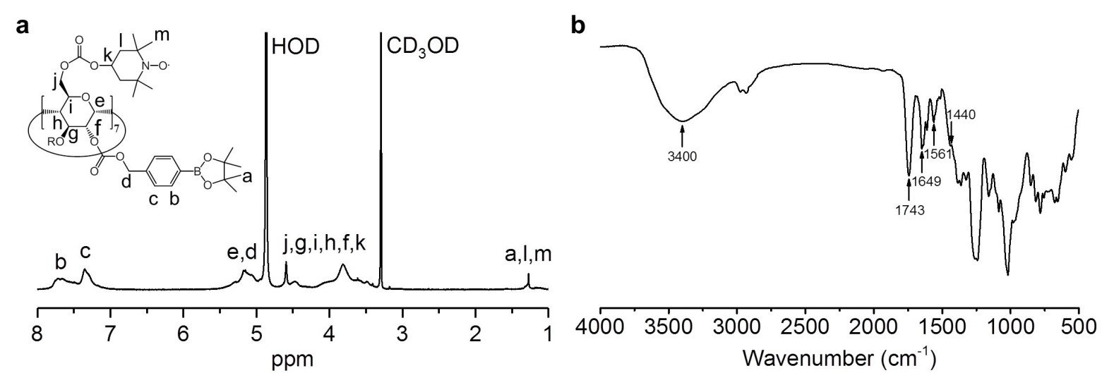

Supplementary Fig. 1 | Structural characterization of synthesized TPCD. a-b, ¹H NMR (a) and Fourier transform infrared (FT-IR) (b) spectra of TPCD. In the FT-IR spectrum, absorption at 1440 cm⁻¹ is due to C‒N stretch vibration of the piperidine ring in Tempol; absorbance between 1649-1561 cm⁻¹ are characteristic peaks of the phenyl group in PBAP; the absorption peak at 3400 cm⁻¹ is due to hydroxyl groups in β-CD; and absorption at 1743 cm⁻¹ is contributed by carbonyl groups between β-CD and Tempol/PBAP.

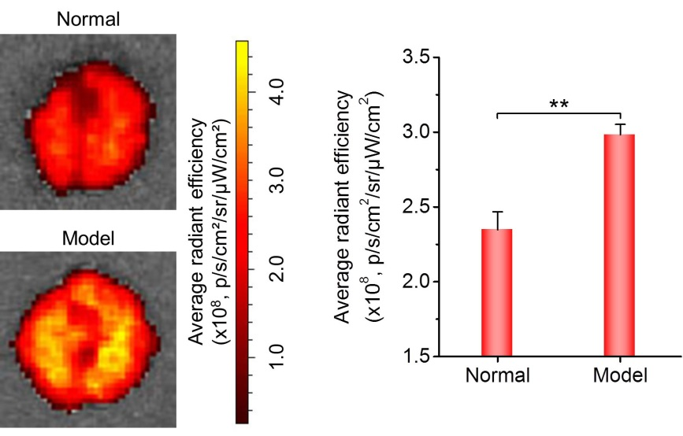

Supplementary Fig. 2 | Accumulation of Cy7.5-labeled TPCN in pulmonary tissues of healthy and asthmatic mice. Left panel, typical ex vivo images show the accumulation of Cy7.5/TPCN in the lungs of normal or asthmatic mice at 24 h after intravenous (i.v.) administration. Right panel, quantitative data. Data are mean ± s.e.m. (n = 3). Statistical significance was analysed by the independent-samples t-test. **P < 0.01.

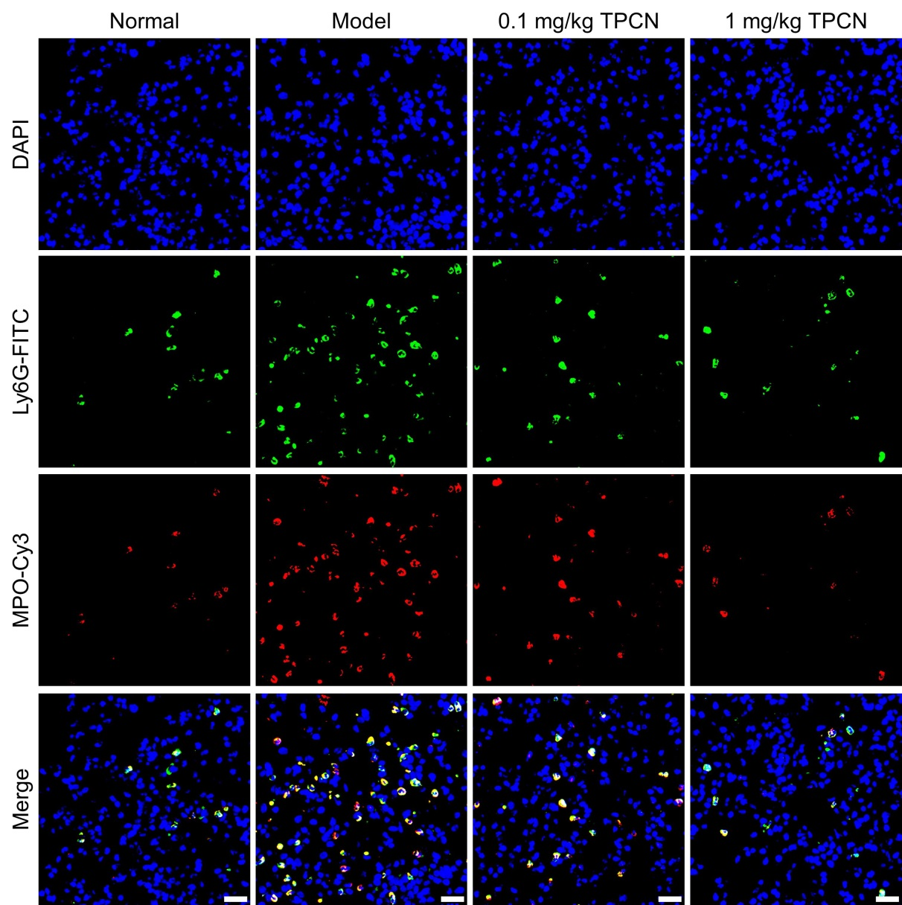

Supplementary Fig. 3 | Immunofluorescence images show the neutrophil infiltration and MPO expression in the lungs of healthy or asthmatic mice after different treatments. TPCN at 0.1 or 1 mg/kg was delivered by i.v. injection. Neutrophils were stained with FITC-labeled Ly6G antibody (Ly6G-FITC), while MPO was stained with Cy3-labeled antibody (MPO-Cy3). Scale bars, 20 μm.

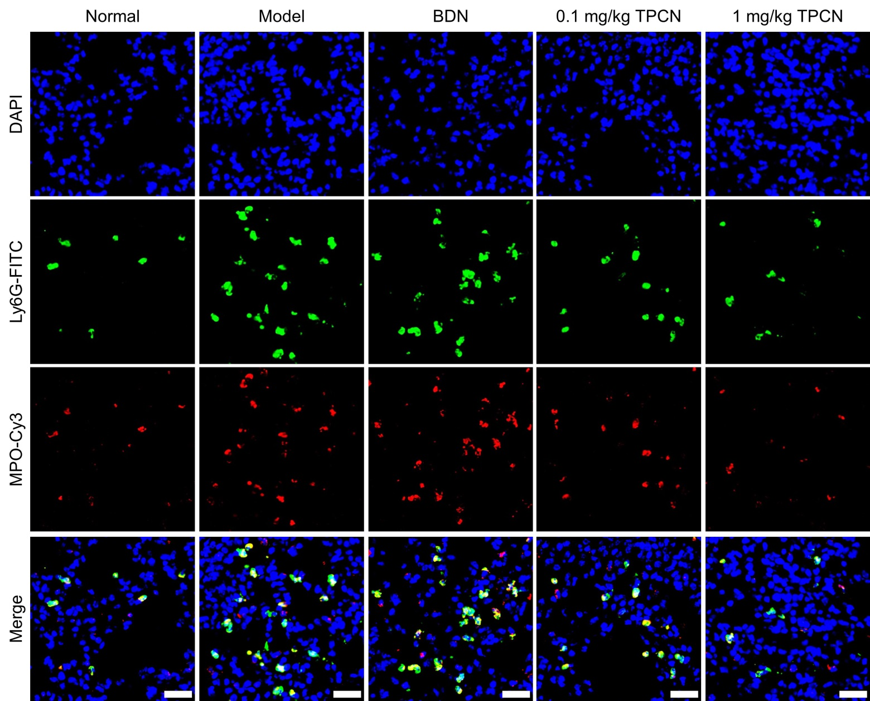

Supplementary Fig. 4 | Immunofluorescence images show the infiltration of neutrophils and expression of MPO in the lungs of healthy or asthmatic mice after aerosol inhalation of various formulations. Scale bars, 20 μm.

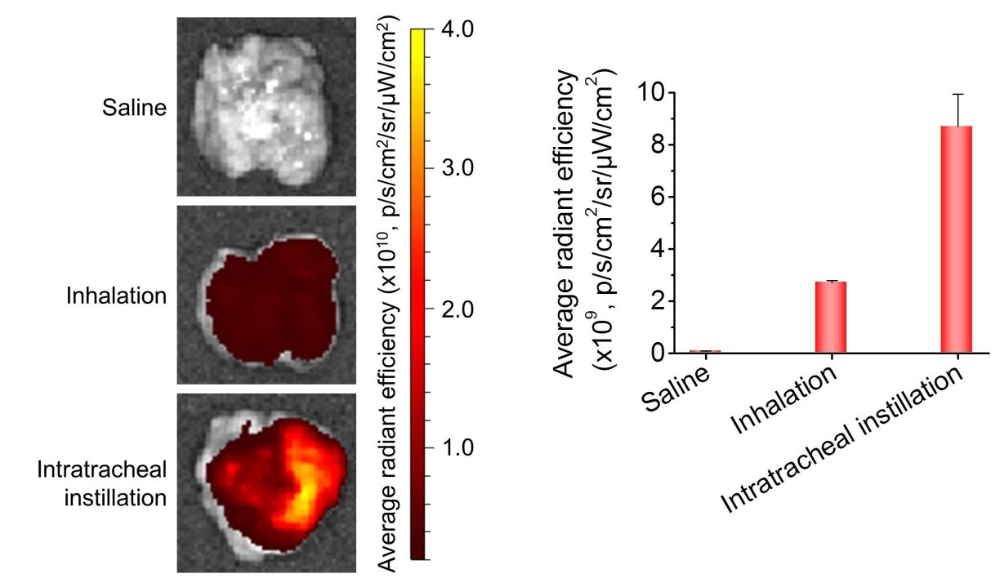

Supplementary Fig. 5 | Estimation of pulmonary delivery efficiency after inhalation. Cy5/TPCN was administered in asthmatic mice by either inhalation (50 µg in each mouse) or intratracheal instillation (10 µg in each mouse) via a Microsprayer Aerosolizer. Immediately after administration, lung tissues were excised for ex vivo imaging. For the control group, saline was administered via inhalation. Data are mean ± s.e.m. (n = 3).

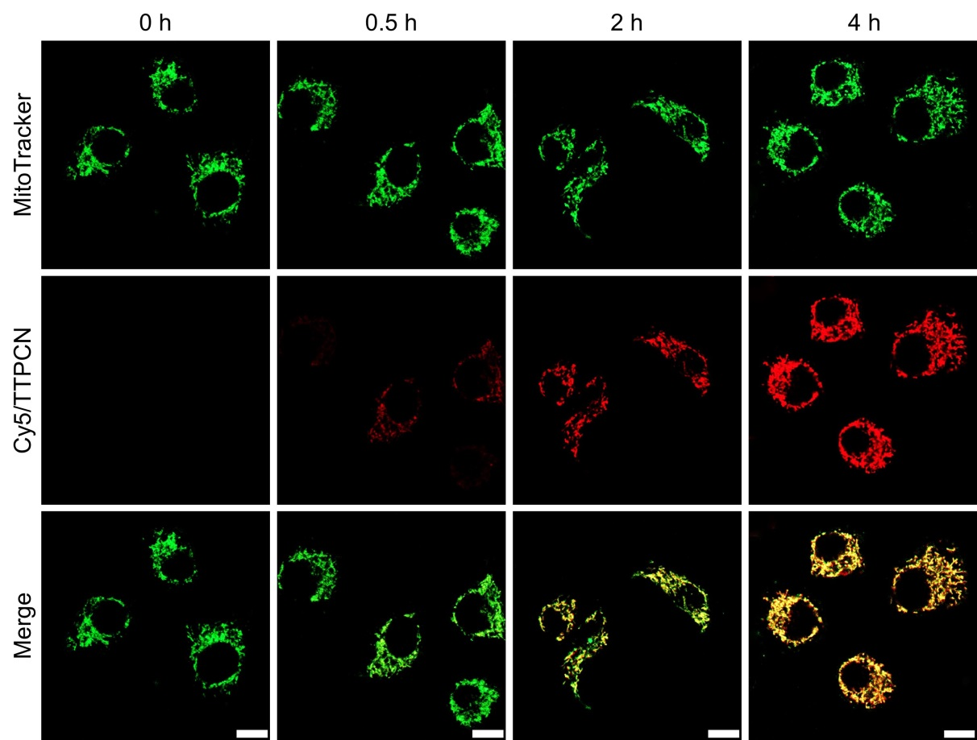

Supplementary Fig. 6 | Confocal microscopy images show mitochondrial-targeting of TTPCN in A549 human lung epithelial cells. A549 cells were incubated with 50 μg/mL of Cy5/TTPCN for varied time periods. Before observation, mitochondria were labeled with MitoTracker (Green). Scale bars, 10 μm.

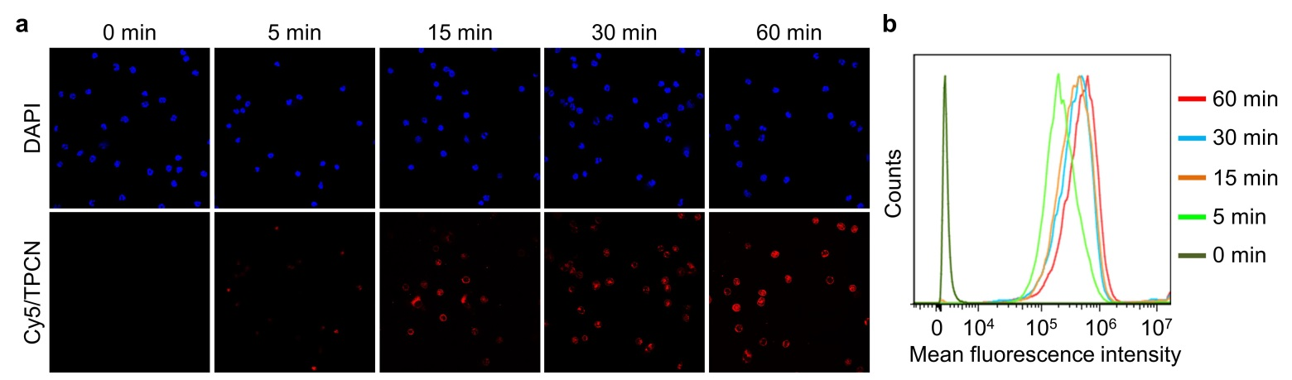

Supplementary Fig. 7 | Time-dependent cellular uptake of Cy5/TPCN in neutrophils. a, Confocal microscopic images show endocytosis of Cy5/TPCN in mouse peritoneal neutrophils after incubation for various time periods. Before observation, nuclei were stained with DAPI. b, Typical flow cytometric curves show time-dependent endocytosis of Cy5/TPCN in neutrophils. In both cases, the Cy5/TPCN dose was 50 µg/mL.

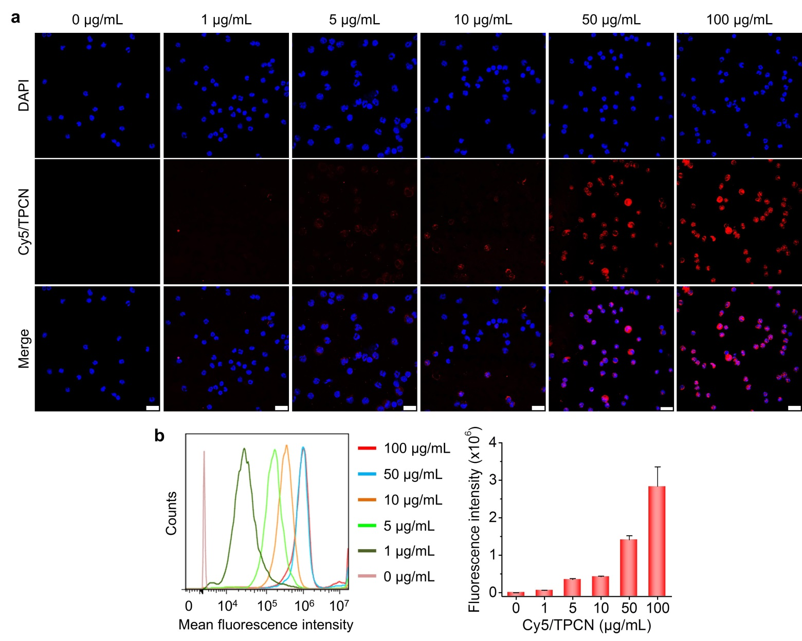

Supplementary Fig. 8 | Dose-dependent cellular uptake profiles of Cy5/TPCN in neutrophils. a, Fluorescence images showing dose-dependent cellular uptake of Cy5/TPCN in neutrophils. The incubation time was 1 h. Before observation, nuclei were stained with DAPI. Scale bars, 20 μm. b, Typical flow cytometric curves (the left panel) and quantitative analysis (the right panel) of dose-dependent endocytosis of Cy5/TPCN in neutrophils after 1 h of incubation. Data in (b, the right panel) are mean ± s.e.m. (n = 6).

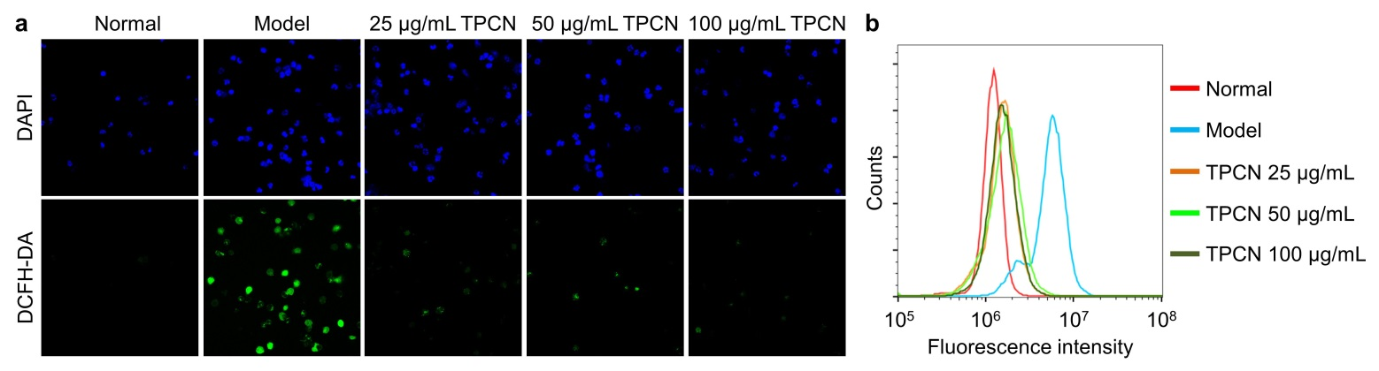

Supplementary Fig. 9 | Inhibition of PMA-induced ROS generation by TPCN. a, Fluorescence images show ROS production in neutrophils after treatment with fresh medium (normal), PMA (model), and PMA in combination with different doses of TPCN. ROS were stained with a fluorescent probe DCFH-DA, while nuclei were stained with DAPI. b, Representative flow cytometric profiles indicate ROS levels in neutrophils subjected to different treatments.

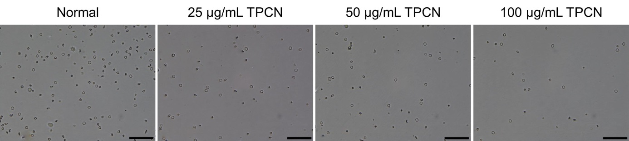

Supplementary Fig. 10 | Optical microscopy images show inhibition of peritoneal neutrophil migration by TPCN treatment. Scale bars, 50 μm.

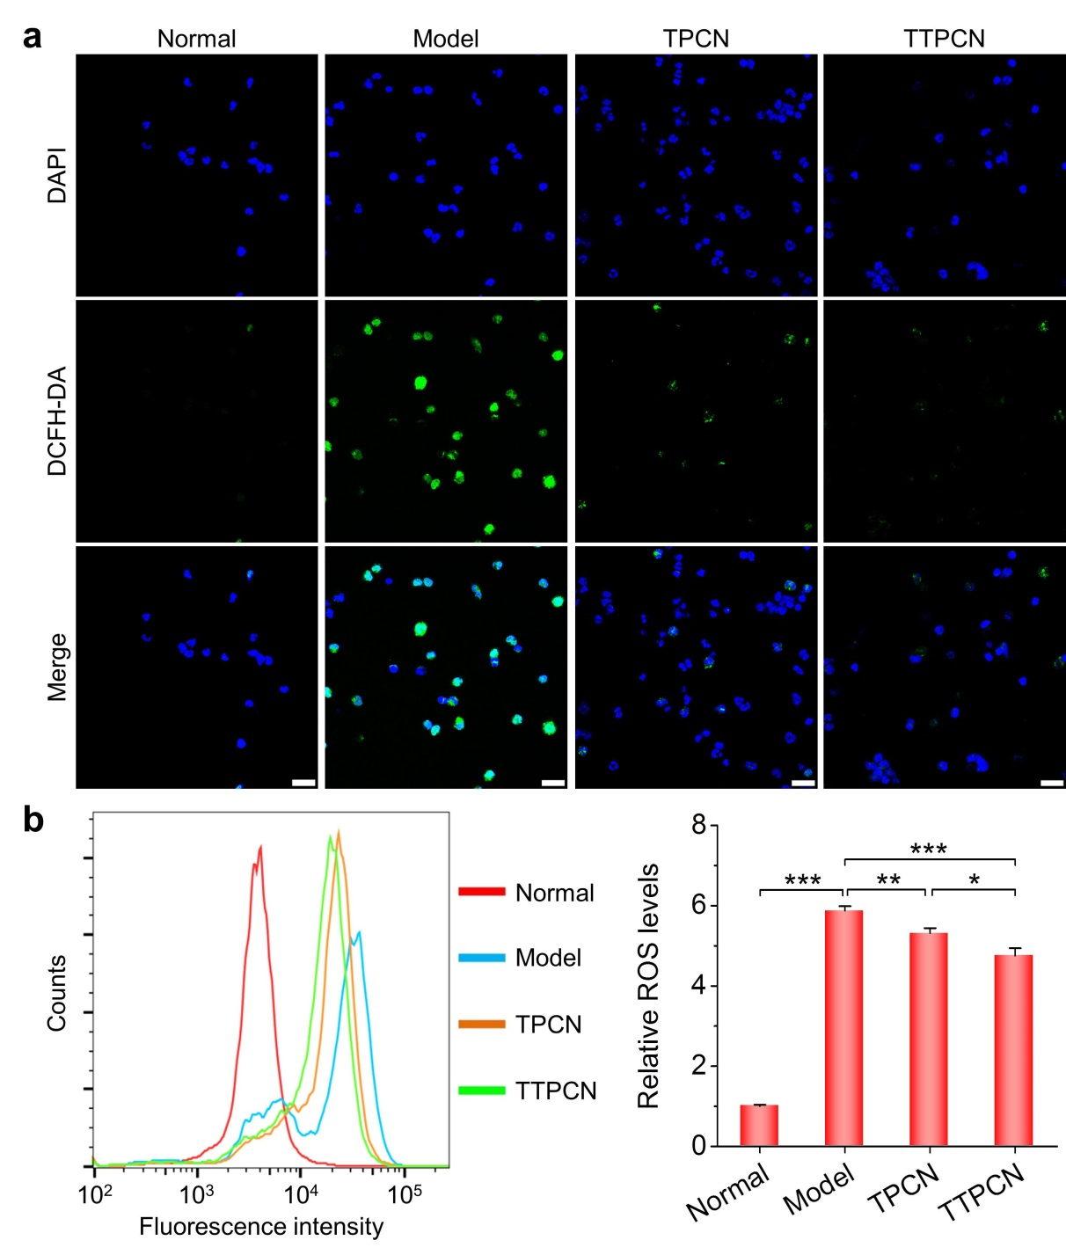

Supplementary Fig. 11 | In vitro inhibition of intracellular ROS generation in neutrophils by TPCN and TTPCN. a, Fluorescence images show ROS production in neutrophils after different treatments. ROS were stained with a fluorescent probe DCFH-DA, while nuclei were stained with DAPI. Scale bars, 20 μm. b, Representative flow cytometric profiles (left) and quantitative data (right) indicate intracellular ROS levels in neutrophils subjected to different treatments. The normal group was treated with fresh medium, while the model group was stimulated with PMA. The TPCN and TTPCN groups were simultaneously treated with PMA and TPCN or TTPCN at 25 µg/mL, respectively. Data in (b, the right panel) are mean ± s.e.m. (n = 5). Statistical significance was analysed by one-way ANOVA with post-hoc LSD tests. *P < 0.05, **P < 0.01, ***P < 0.001.

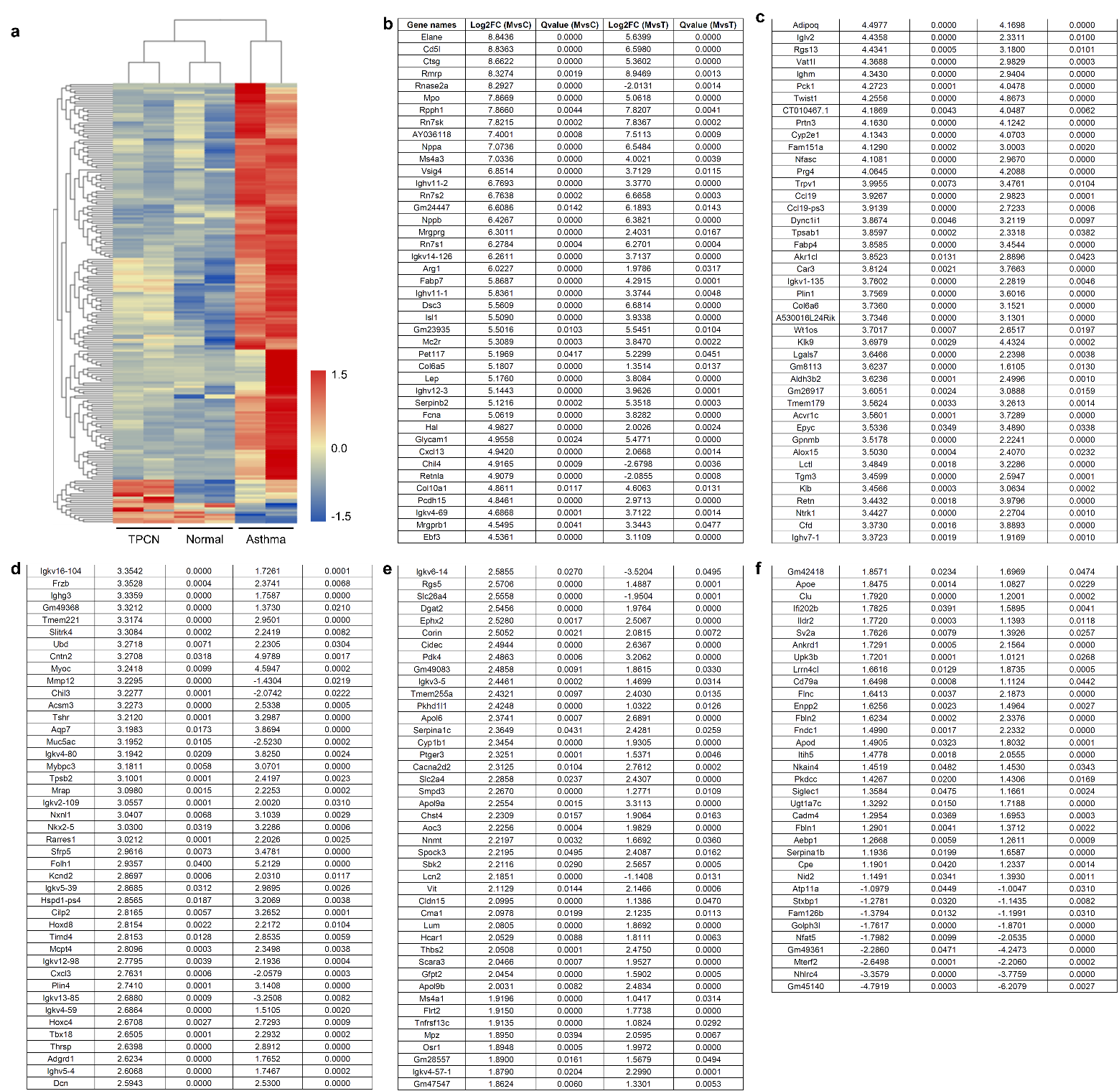

Supplementary Fig. 12 | RNA-sequencing analysis of all different genes expressed in the lungs of healthy or asthmatic mice with or without treatment with TPCN. a, The heat map shows significantly changed mRNAs in three examined groups. b-f, List of differently expressed genes in (a).

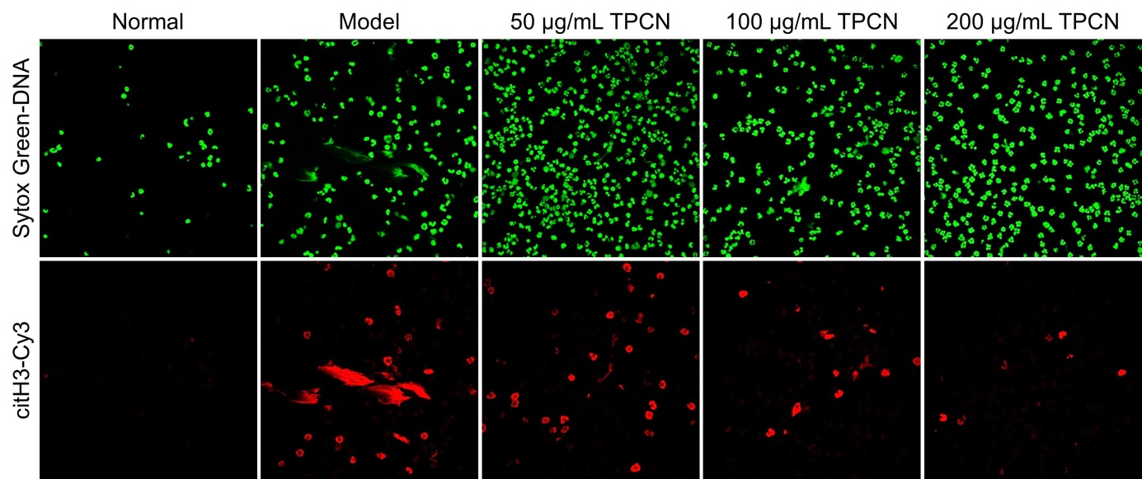

Supplementary Fig. 13 | Confocal microscopy images show the NETs formation in peritoneal neutrophils after different treatments.

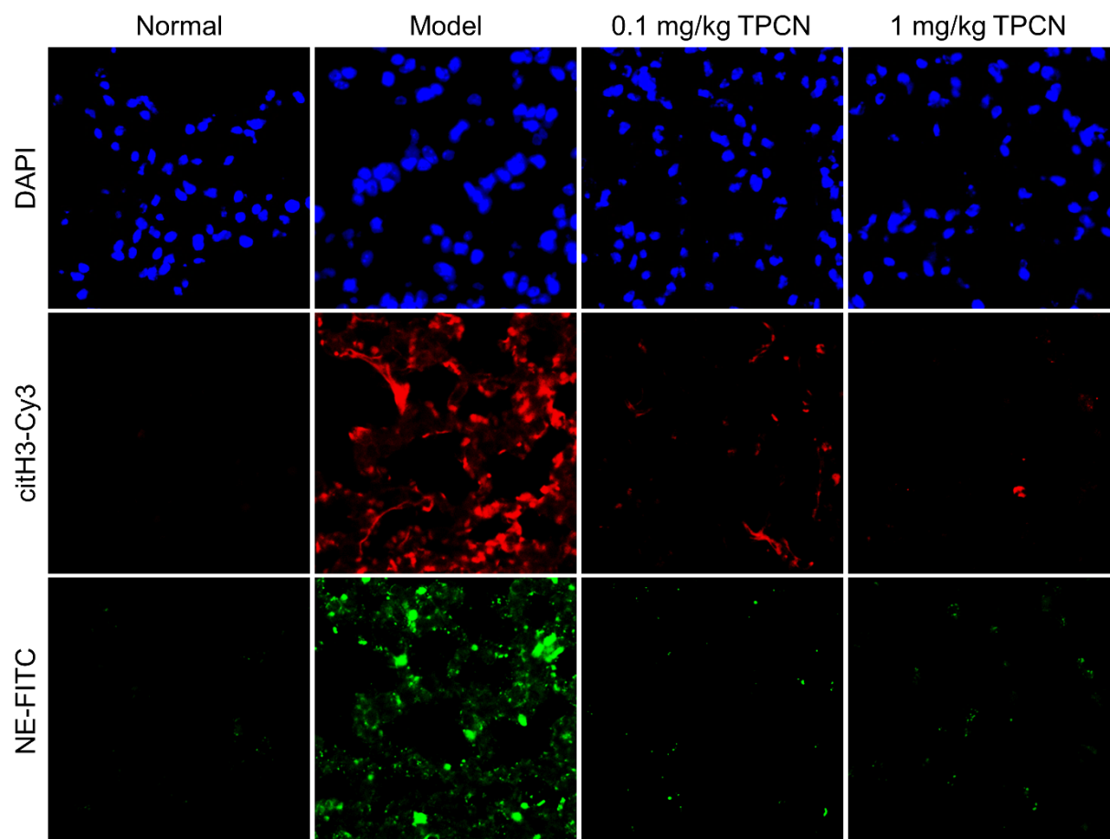

Supplementary Fig. 14 | Immunofluorescence analysis of citH3 and NE in lung sections of mice subjected to different treatments. The lung sections were stained with Cy3-labeled citH3 antibody (citH3-Cy3, red) and FITC-labeled NE antibody (NE-FITC, green) for observation of NETs.

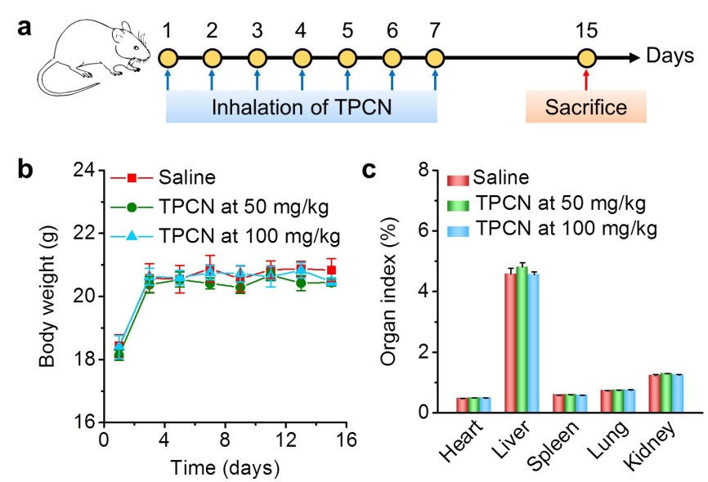

Supplementary Fig. 15 | Acute toxicity evaluation of TPCN in mice after aerosol inhalation. a, Schematic illustration of treatment regimens. b, Changes in body weight during different treatments. Mice in TPCN groups were continuously treated by inhalation of TPCN at theoretical doses of 50 or 100 mg/kg for 7 days, while the control group was treated with the same volume of saline. c, The organ index of major organs excised from mice at day 8 after the last inhalation of saline or different doses of TPCN. Data are presented as mean ± s.e.m. (n = 6).

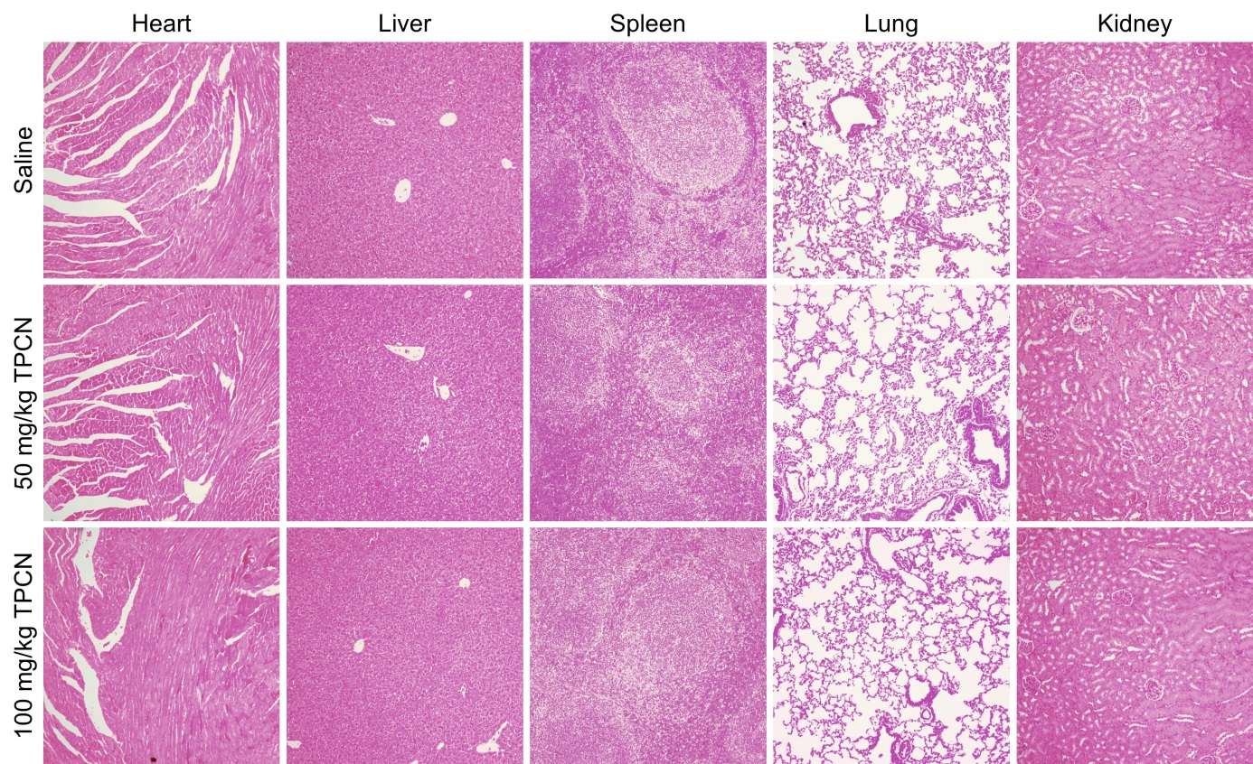

Supplementary Fig. 16 | H&E-stained histological sections of major organs from mice after inhalation of different doses of TPCN.

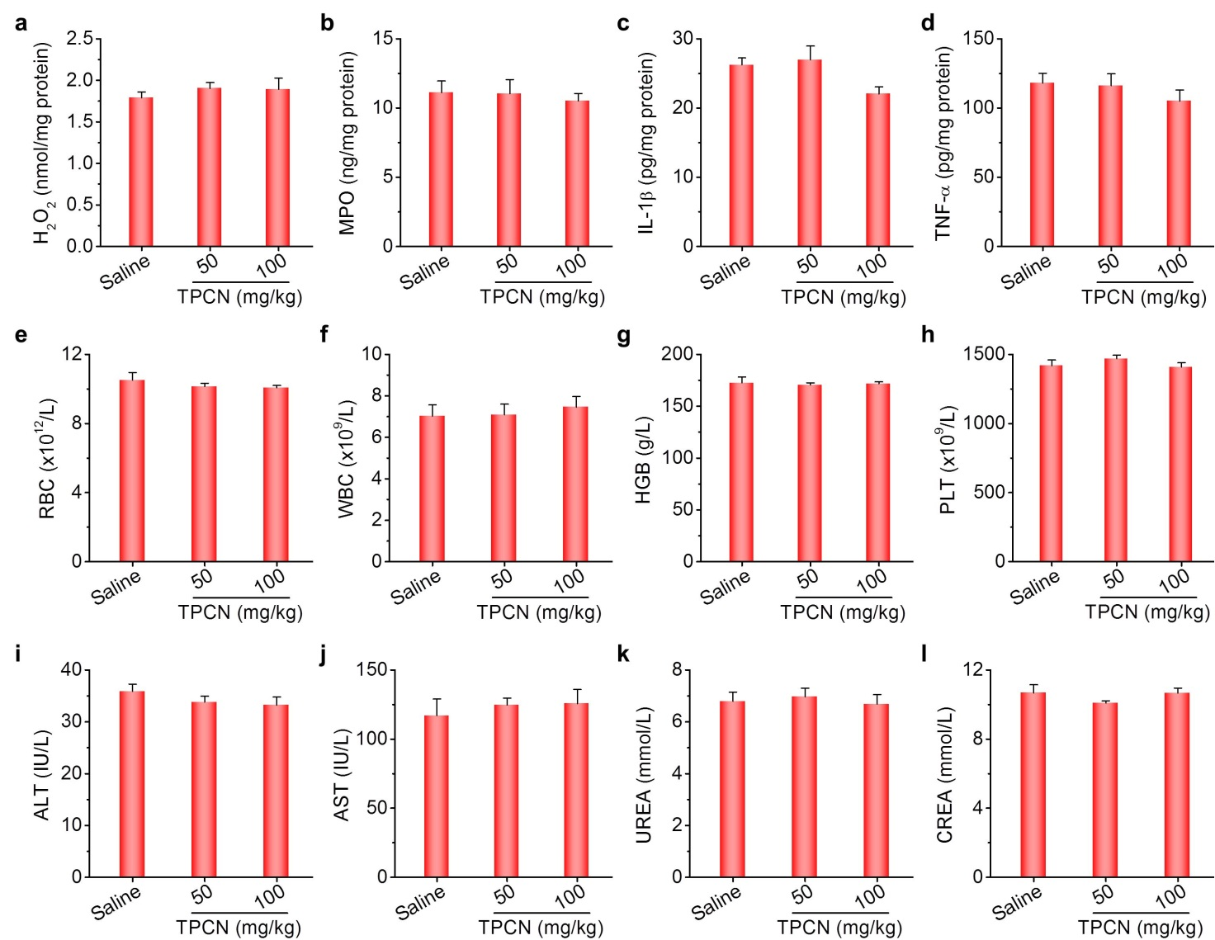

Supplementary Fig. 17 | Evaluations of inhaled TPCN on tissue and systemic toxicity. a-d, Expression levels of H₂O₂ (a), MPO (b), IL-1β (c), and TNF-α (d) in lung tissues. e-h, Levels of typical hematological parameters including RBC (e), WBC (f), HGB (g), and PLT (h). i-l, Serum levels of ALT (i), AST (j), UREA (k), and CREA (l). ALT, alanine aminotransferase; AST, aspartate aminotransferase; CREA, creatinine; HGB, hemoglobin; PLT, platelets; RBC, red blood cells; UREA, blood urea; WBC, white blood cells. Data are presented as mean ± s.e.m. (n = 6). Statistical significance was analysed by one-way ANOVA with post-hoc LSD tests.

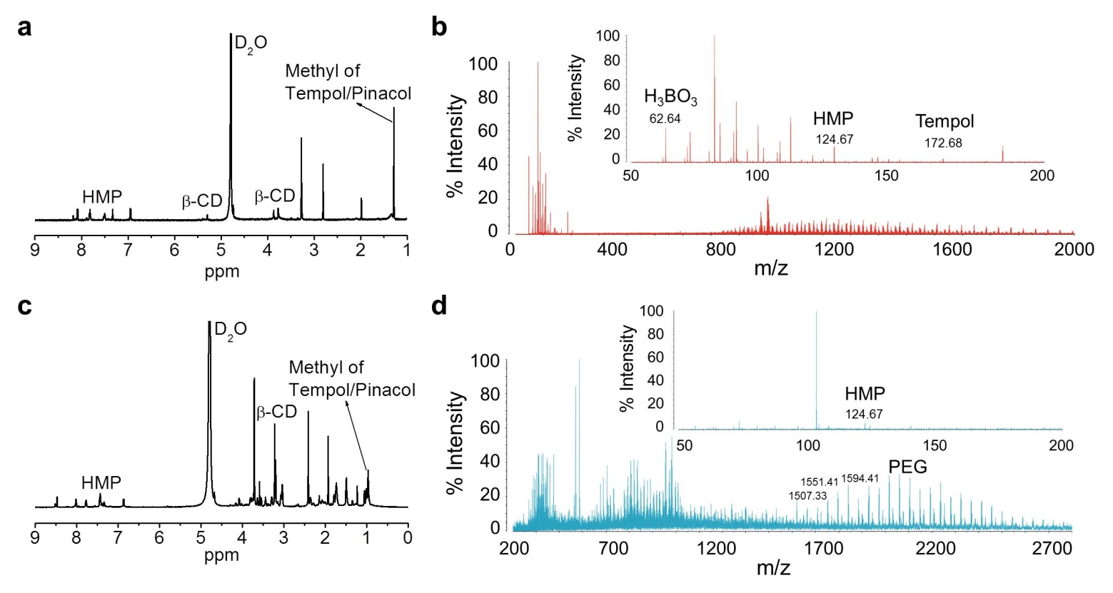

Supplementary Fig. 18 | Hydrolysis of TPCN in biological samples. a-d, ¹H NMR spectra (a,c) and MALDI-TOF mass spectra (b,d) of hydrolyzed products of TPCN after 3 days of incubation with PMA-stimulated neutrophils (a,b) or lung homogenates (c,d) from asthmatic mice. β-CD, β-cyclodextrin; HMP, p-(hydroxymethyl)phenol; PEG, polyethylene glycol.

