Supplementary Information: Figures

Identifying ENSO-related interannual and decadal variability on terrestrial water storage
S.-H. Cheon^{1,*}, B. D. Hamlington¹, J.T. Reager¹, and H. A. Chandanpurkar¹
¹Jet Propulsion Laboratory, California Institute of Technology, Pasadena, CA 91109, USA.
*shcheon95@gmail.com

Introduction
We provide three figures which can help the readers to have a clear understanding of the current paper.
Figure S1 is the map having the value of correlation coefficient between the Interannual climate index and CSEOF HF-mode at each 1x1 grid point.
Figure S2 and 3 are the loading vectors’ spatial patterns of LF-mode and HF mode of the GRACE’s CSEOF analysis over 2003-2016. To increase the readability, we provide the seasonal mean of the initial results in the paper. To give the readers a chance to see the original spatial patterns of CSEOF loading vectors, we provide these supporting figures.

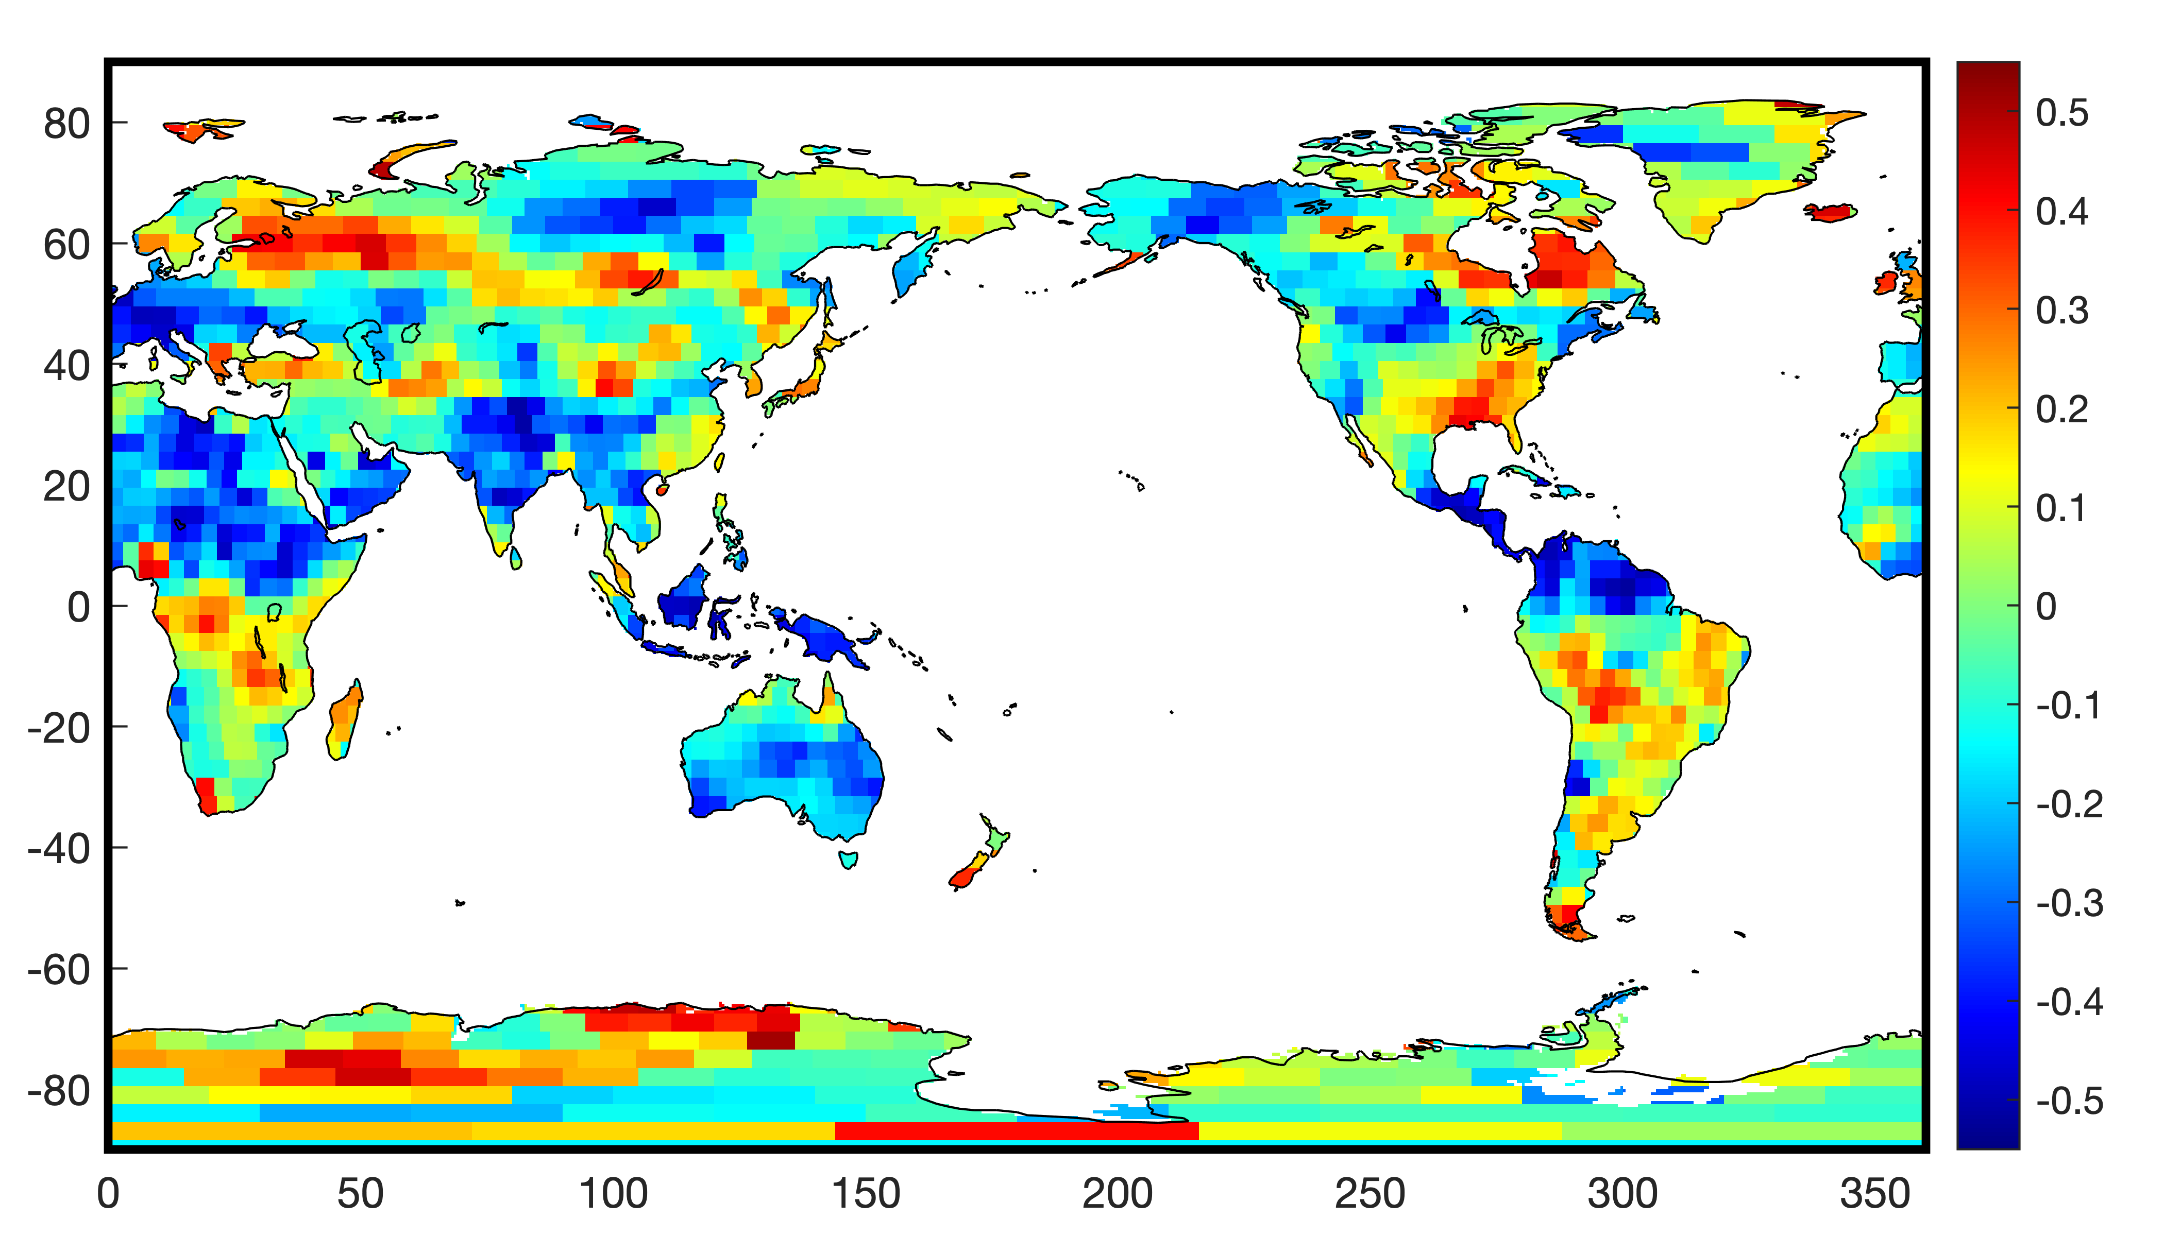

Figure S1. The correlation coefficient between the Interannual climate index and CSEOF HF-mode at each grid.

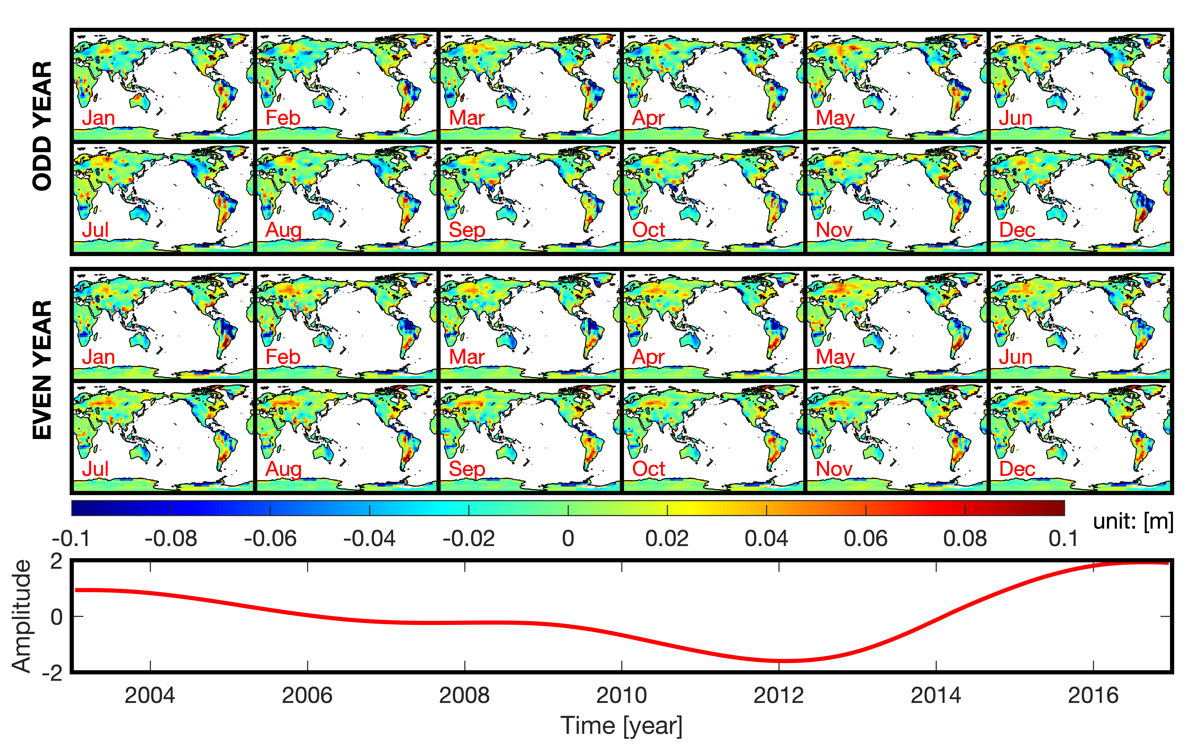

Figure S2. The LV and PCT of the LF-mode of the CSEOF analysis of GRACE.

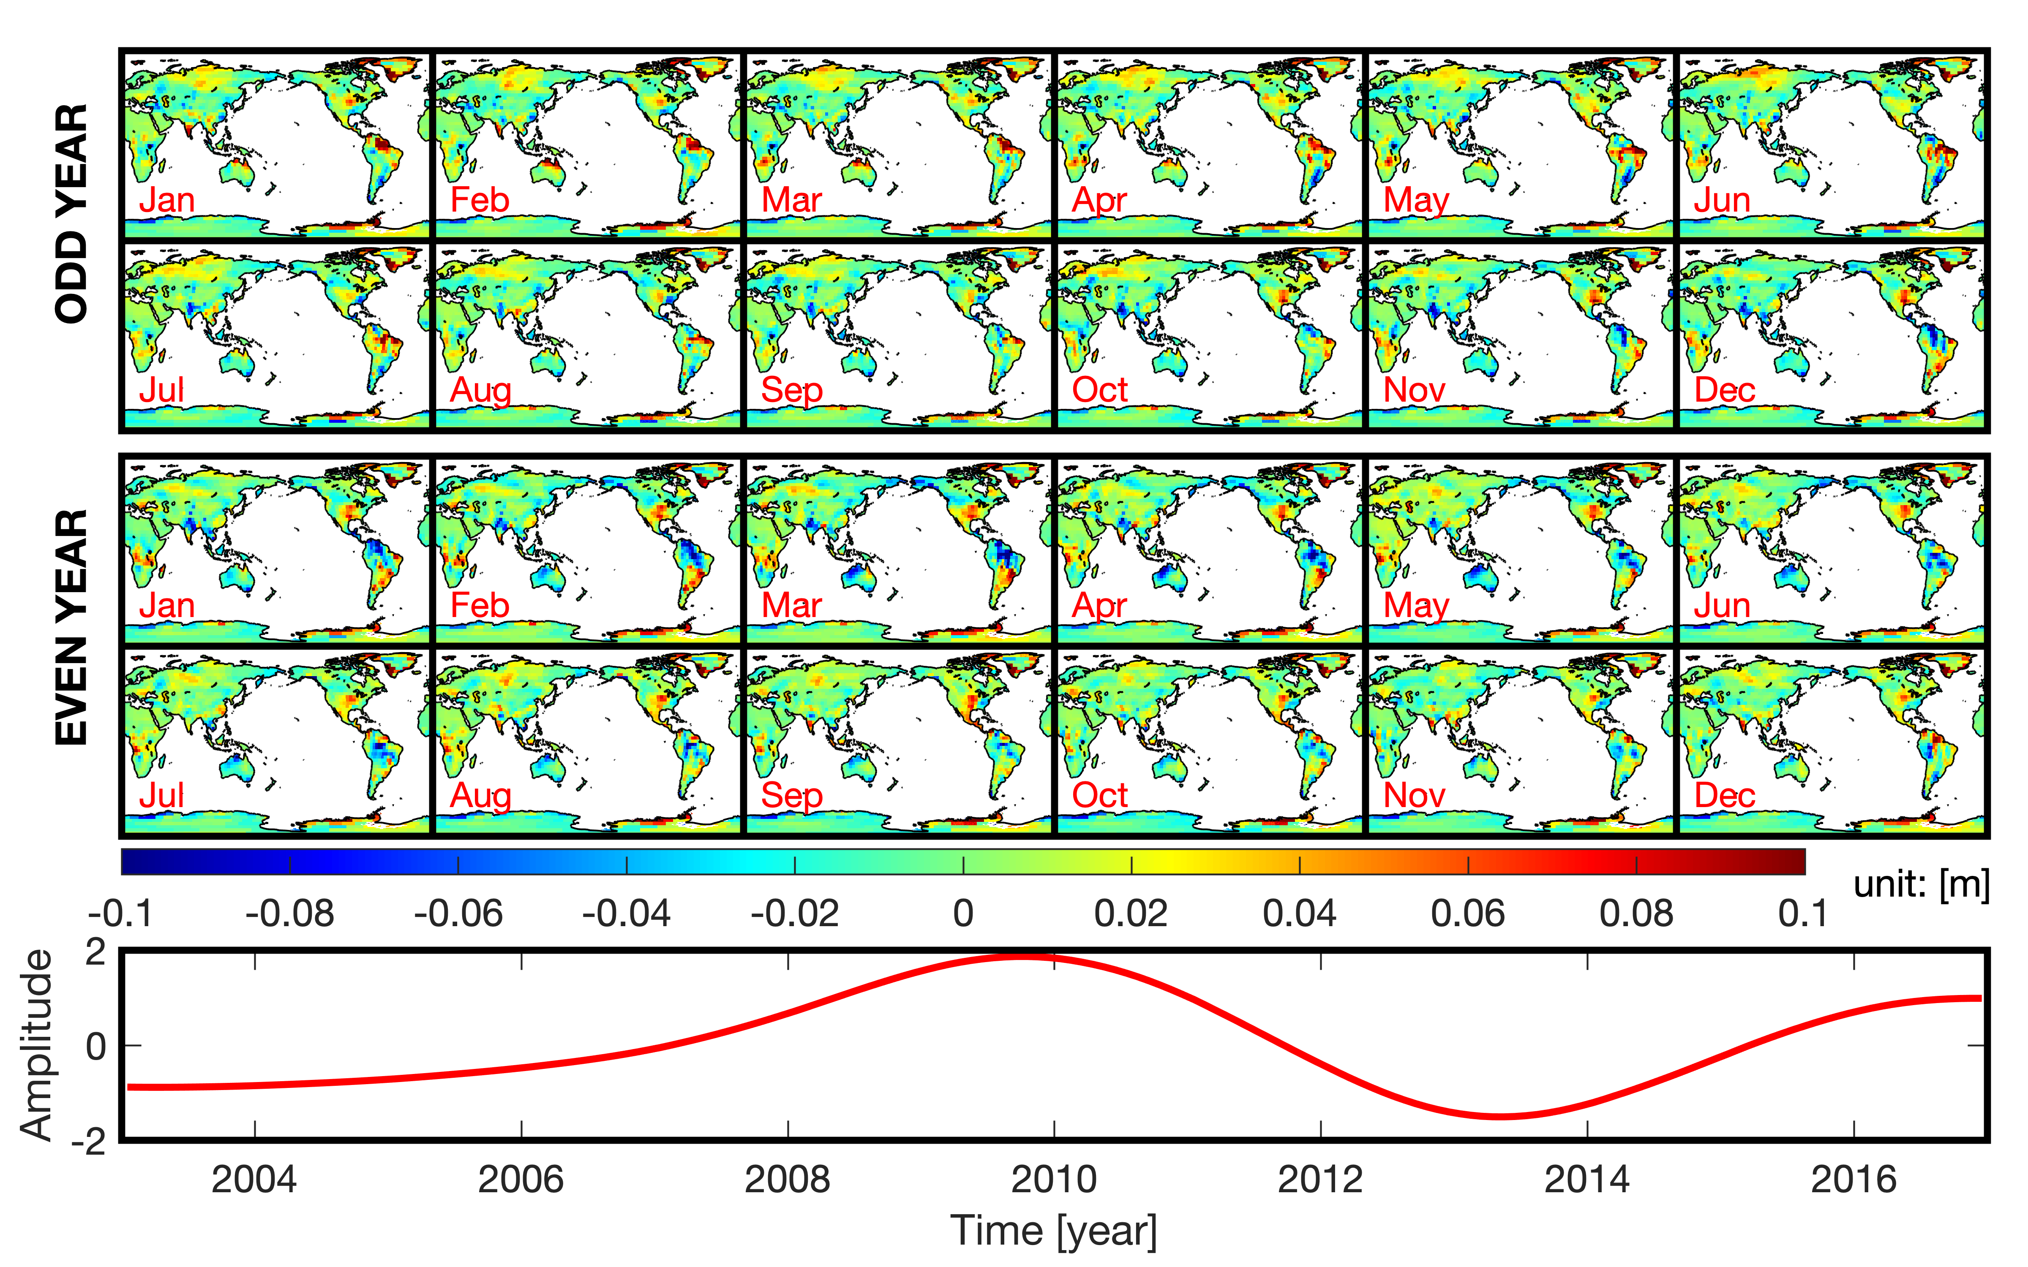

Figure S3. The LV and PCT of the HF-mode of the CSEOF analysis of GRACE.

