Heat transfer mode shift to adiabatic thermalization in near-critical carbon dioxide under terrestrial conditions- Supplementary material
Anatoly Parahovnik^{a,b} and Yoav Peles^{a,c},
ª 4000 Central Florida Blvd, Orlando, FL 32816
^{b} tolik@Knights.ucf.edu
^{c} yoav.peles@ucf.edu
Mechanical and aerospace engineering, University of central Florida, USA

Results
Flow boiling patterns
Supplementary figure 1 lists images of boiling patterns from all experiments. For Experiments 1 to 5 (i.e., reduced pressures below 0.95), the bubbles obtained a spherical shape with a well-defined boundary between the liquid and the vapor phases. The liquid phase and heater hue were constants throughout the viewing window, but varied with the flow in Experiments 6 to 8.
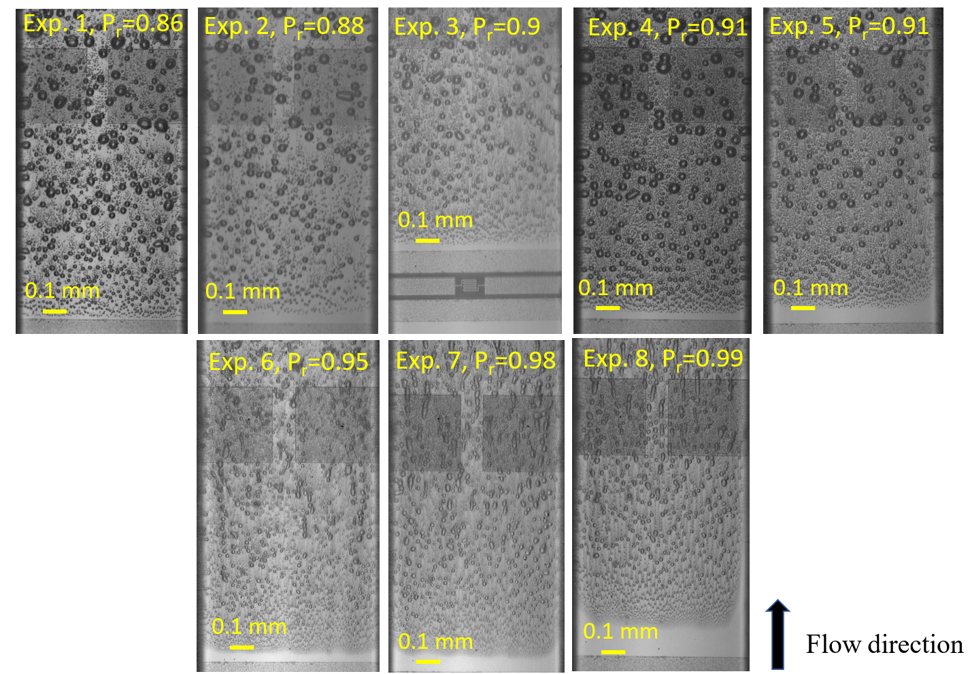
Supplementary Figure.1. Representative images from experiments. The flow patterns for reduced pressures below and above 0.95 had different characteristic features.

Derivation of the returned light intensity ratios and fluid temperature relation
Scattering ratio (R) is defined as the ratio between the scattered light intensity to the induced light intensity:
$R=\frac{I_{i}-I}{I_{i}}$ (1)
The scattered light intensity is the difference between the induced light intensity ($I_{i}$) to the returning light intensity ($I$). The induced light originated in the light source and, therefore, was always constant. In contrast, the returned light was influenced by the critical opalescence scattering, which is temperature dependent (i.e., Eq. 2 in the manuscript).
It is assumed that the scattered light intensity is considerably smaller than the induced light¹, which leads to R₁ and R₂ << 1, and since the temperature increase was up to several Kelvins, R₂=R₁+ΔR, where ΔR<<R₁ and R₂.

The ratio between the scattering light intensity ratios at Location 1 and 2 can be expressed according to:
$$\frac{{I_{r}}_{2}}{{I_{r}}_{1}}=\frac{1-R_{2}}{1-R_{1}}$$
Then:

$$\frac{{I_{r}}_{2}}{{I_{r}}_{1}}=\frac{(1-R_{2})∙R_{2}/R_{2} }{\left(1-R_{1}\right)∙R_{1}/R_{1}}=\frac{R_{2}-R_{2}^{2}}{R_{1}-R_{1}^{2}}∙\frac{R_{1}}{R_{2}}$$
Integrating R₂=R₁+ΔR, yields:

$$\frac{{I_{r}}_{2}}{{I_{r}}_{1}}=\frac{R_{2}-R_{2}^{2}}{R_{1}-R_{1}^{2}}∙\frac{R_{1}}{R_{2}}=\frac{(R_{1}+∆R-R_{1}^{2}-2∙∆R∙R_{1}-∆R^{2})}{R_{1}-R_{1}^{2} }∙\frac{R_{1}}{R_{2}}$$

$$\frac{{I_{r}}_{2}}{{I_{r}}_{1}}=[\frac{(R_{1}-R_{1}^{2}) }{R_{1}-R_{1}^{2} }+\frac{∆R-2∙∆R∙R_{1}-∆R^{2}}{R_{1}-R_{1}^{2}}]∙\frac{R_{1}}{R_{2}}$$
$$\frac{{I_{r}}_{2}}{{I_{r}}_{1}}=\left[1+\frac{∆R}{R_{1}}∙\frac{\left(1-2∙R_{1}-∆R\right)}{1-R_{1}}\right]∙\frac{R_{1}}{R_{2}}=\left[1+\frac{∆R}{R_{1}}∙\frac{\left(1-R_{1}\right)}{1-R_{1}}-\frac{∆R}{R_{1}}∙\frac{\left(R_{1}+∆R\right)}{1-R_{1}}\right]∙\frac{R_{1}}{R_{2}}$$
$$\frac{{I_{r}}_{2}}{{I_{r}}_{1}}=\left[1+\frac{∆R}{R_{1}}-\frac{∆R}{R_{1}}∙\frac{\left(R_{1}+∆R\right)}{1-R_{1}}\right]∙\frac{R_{1}}{R_{2}}$$
Since $\frac{∆R}{R_{1}}→ 0$, and $\frac{\left(R_{1}+∆R\right)}{1-R_{1}}→R_{1}$
$$\frac{{I_{r}}_{2}}{{I_{r}}_{1}}=\left[1-∆R\right]∙\frac{R_{1}}{R_{2}}=\frac{R_{1}}{R_{2}}$$
where Condition ‘2’ corresponds to the fluid at the inlet temperature (i.e., T₀) and Condition ‘1’ corresponds to the measured temperature (i.e., T). The derived relation leads to Eq. 2 in the manuscript:

$\frac{I_{To}}{I_{T}}= \frac{R_{T}}{R_{To}}=\frac{\frac{k_{B}∙π^{2}}{2∙λ_{o}^{4}}∙T∙β_{T}∙{\left(ρ∙\frac{∂ε}{∂ρ}\right)}_{T}^{2}}{\frac{k_{B}∙π^{2}}{2∙λ_{o}^{4}}∙To∙β_{To}∙{\left(ρ∙\frac{∂ε}{∂ρ}\right)}_{To}^{2}}=\frac{T∙β_{T}∙{\left(ρ∙\frac{∂ε}{∂ρ}\right)}_{T}^{2}}{To∙β_{To}∙{\left(ρ∙\frac{∂ε}{∂ρ}\right)}_{To}^{2}}$ (2)

Measurements of the returned light intensity ratio
Bitmap files used to calculate returning light intensity were produced from data recorded by the camera. The returned light intensities were averaged perpendicular to the flow (along the marked lines on the images) and created the returning light intensity data presented in supplementary Fig. 2. The background elements influenced the returning light intensity measurements, and therefore, the readings were done on top of the heater where the background was uniform, see Graph in supplementary Fig. 2. The returning light intensity, corresponding to the ambient temperature (i.e., T₀), was measured close to the heater’s edge, upstream of the boiling inception line, see the blue lines close to the heater’s edge in supplementary Fig. 2. The temperature downstream was measured before the RTD’s vias; see the blue markings near the resistive temperature detector’s via in supplementary Fig. 2. The downstream temperature reading was manually obtained from the figures. Additionally, it was verified that without the heater power, the returning light intensity did not change. No significant difference between the sampled returning light intensity for different images of the same experiment were found, further affirming the invariance of the temperature readings and presence of bubbles.

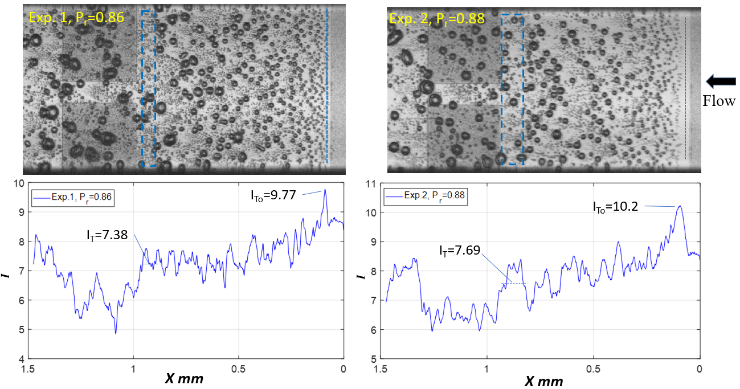
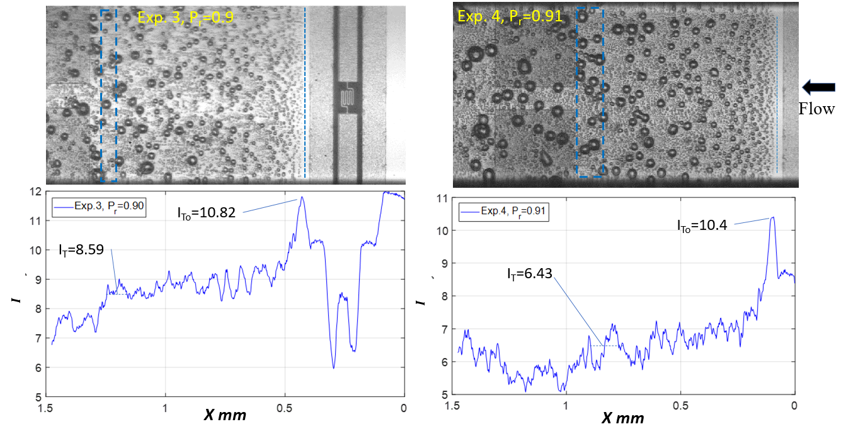
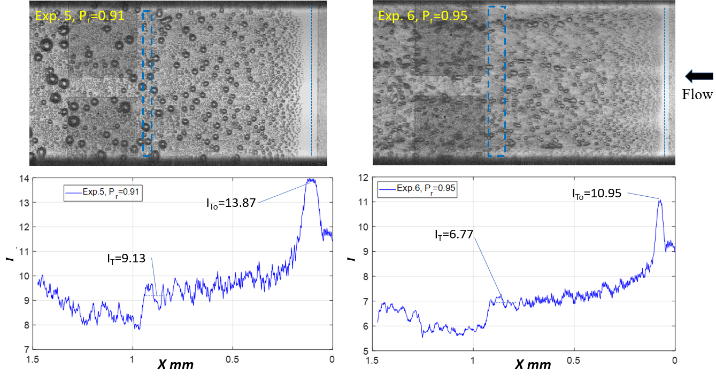
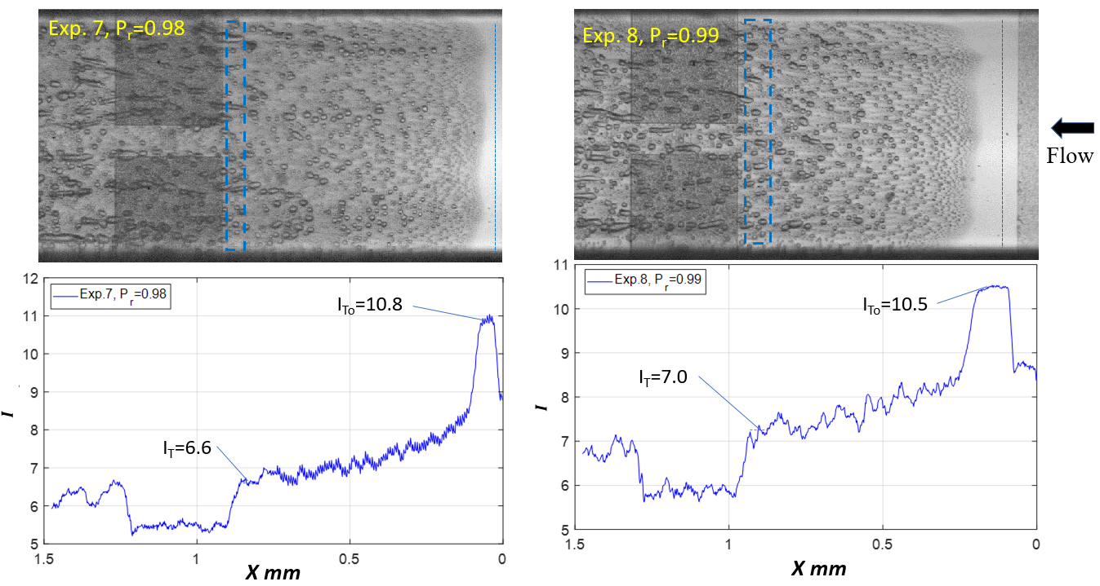

Supplementary Figure 2. Returned light intensity measurement

Bulk fluid’s temperature calculated from the scattering intensity change
Supplementary Fig. 3 presents the ratios of the light scattering ratio (i.e., $R_{T}/R_{T_{0}}$) as a function of temperature difference (i.e., $∆T_{R}=T-T_{0}$) for all experiments. By comparing the returned light intensity ratio (i.e., I_{t}/I_{T}) with the ratio of light scattering ratio (i.e., R_{T}/R_{To}), the temperature difference (i.e., $∆T_{R}$), consistent with the returned light intensity ratio, was inferred. This temperature difference corresponded to the increase in the fluid temperature as measured through the critical opalescence effect.

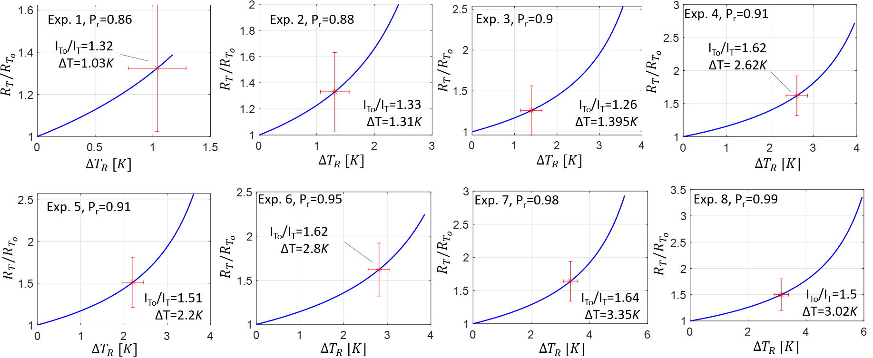
Supplementary Figure 3- The returning light intensity drops and the corresponding temperature difference of the fluid.

Reference
1. Chaikina, Yu. A. Molecular Model for Critical Opalescence of Carbon Dioxide. Russ. J. Phys. Chem. B 12, 1182–1192 (2018).

