Supplementary Materials for “A systematic genome-wide mapping of oncogenic mutation selection during CRISPR-Cas9 genome editing”

Sanju Sinha^{1,2,3,#}, Karina Barbosa Guerra^{4,#}, Kuoyuan Cheng^{1,3,#}, Mark DM Leiserson³, Prashant Jain⁴, Anagha Deshpande⁴, David M Wilson III⁵, Bríd M. Ryan², Ji Luo⁶, Ze'ev A. Ronai⁴, Joo Sang Lee^{7,*}, Aniruddha J. Deshpande^{4,*}, Eytan Ruppin^{1,*}
¹Cancer Data Science Lab, Center for Cancer Research, National Cancer Institute, National Institute of Health, Bethesda, MD 20892, USA
²Laboratory of Human Carcinogenesis, Center for Cancer Research, National Cancer Institute, National Institute of Health, Bethesda, MD 20850, USA
³Center for Bioinformatics and Computational Biology, University of Maryland, College Park, MD 20742, USA
⁴Tumor Initiation Program, Cancer Center, Sanford Burnham Prebys Medical Discovery Institute, La Jolla, CA 92037, USA
⁵Laboratory of Molecular Gerontology, National Institute on Aging, Intramural Research Program, National Institutes of Health, Baltimore, MD 21224, USA.
⁶Laboratory of Cancer Biology and Genetics, Center for Cancer Research, National Cancer Institute, National Institute of Health, Bethesda, MD 20850, USA
⁷Samsung Medical Center, Sungkyunkwan University School of Medicine, Suwon 16419, Republic of Korea.
#Co-first author
*Corresponding author

Supplementary Notes
Table of Contents
1. Testing the effects of potential confounding factors in CDE+/- identification for p53 and KRAS
2. Validations of p53/KRAS in recently published genome wide CRISPR screens from the Sanger Institute
3. CDE+ genes are differentially more essential in primary RPE1 p53 WT vs p53 null across multiple screens from different studies
4. Computation of median mutant selection levels for KRAS and p53
5. Pathways up/downregulated in p53 wildtype vs mutant cell lines in response to Cas9 induction
6. Off-Target DNA damage effect on cell fitness is dependent on CRISPR-selected cancer driver genes
7. VHL as a potential CRISPR-selected cancer driver
8. CRISPR-specific differential essentiality of the top ranked CDE+ gene: TAF8
9. Quality control of publicly available genetic screens used
10. Genetic screens reveal that CRISPR-KO but not CRISPRi of CDE+ genes induces selection for p53 mutants
11. Evidence for selection of mutant p53 based on copy number alterations in CDE+ genes in patients’ tumors
12. CRISPR-KO of KRAS CDE+ genes induces selection for KRAS mutant cells in KRAS-isogenic cell lines

1. Testing the effects of potential confounding factors in CDE+/- identification for p53 and KRAS
Since the functional role of p53 mutation status is not known, we repeated the identification of CDE genes by p53 mutation status in CRISPR-Cas9 and shRNA screens, focusing on cell lines harboring known loss-of-function p53 mutations solely (Methods, N=78). Comparing those with the WT cell-lines as controls (N=75), we observed an even higher significance in the differences of median post-KO/KD cell viability (Chi-squared test P=1.7E-292, Table S2, Methods; for KRAS chi-squared test P=3.1E-92). These findings were further corroborated by a permutation test where the cell line’s p53 mutation status was shuffled 10,000 times (P<1E-4, Methods; for KRAS P<1E-04). To exclude the possibility that this effect is due to a difference in the phenotypes resulting from mRNA transcript knockdown by shRNA as opposed to gene knockout due to CRISPR, we repeated the analysis for a subset of genes that were not expressed in any of the cell lines (i.e. read count being 0). Still, we observed lower viabilities of p53 WT vs mutant cells specifically in CRISPR screens (Wilcoxon Rank Sum P<0.001; for KRAS P<4E-09).
2. Validations of p53/KRAS in recently published genome wide CRISPR screens from the Sanger Institute
During the process of completion of this manuscript, genome-wide CRISPR-Cas9 screens in 326 cancer cell lines were generated at the Sanger Institute through an independently designed experimental pipeline [1]. Compared to the DepMap, the Sanger Institute’s screens were published with considerable difference in the pipeline, including a higher number of sgRNAs per gene and lower assay dropout length. We mined the shRNA data available for the subset of cell lines used in these screens and repeated the identification of CDE genes and CCDs. First, we indeed identified a high number of DE+ genes (N=752) compared to DE- (N=58), the majority of them being CRISPR-screen specific. In contrast, the shRNA screens again had a balanced number of DE+ and DE- genes (Chi-squared imbalance test P<1.4E-284). We next observed that both CDE+ and CDE- genes identified from both the screens were significantly overlapping (hypergeometric P< 2E-63 and <8E-07, respectively). We also observed that the overlap between the CDEs from the two screens is considerably higher than the background (J-index=0.24 and 0.02 for CDE+ and CDE-, respectively). Next, we repeated the process of CRISPR-selected cancer drivers (CCD) identification and obtained KRAS and p53 as our two hits with a similar KRAS CDE+ geneset (J-index=0.31).
3. CDE+ genes are differentially more essential in primary RPE1 p53 wild-type vs p53 null across multiple screens from different studies
We mined seven genome-wide CRISPR-Cas9 KO screens performed in isogenic-p53 cell lines [2] (two p53 mutants, five p53 wildtype). In these screens, we tested whether CDE+ genes KO is differentially more essential in p53 WT vs mutant cells in a pairwise fashion. We observed that CDE+ genes were differentially less essential in the Hart et al. [3] p53 null screen vs the rest of the p53 WT screens (P< 2.1E-11 for Zimmerman et al. [4], 4.6E-58 for Brown et al. first screen [2], 5.5E-80 for Brown et al. second screen [2], 2.5E-02 for Hart et al. [5], 5.3E-02 for Haapameini et al. [6]) in contrast to other p53 null screens (P<5.3E-01, Haapameini et al. [6]). Similarly, for the other p53 null cell lines (Haapameini et al. [6]), we observed consistent results (P< 1.5E-18 for Zimmerman et al. [4], 3.2E-90 for Brown et al. first screen [2], 5.5E-80 for Brown et al. second screen [2], 2.5E-02 for Hart et al. [3], 5.3E-02 for Haapameini et al. [6]).
4. Computation of median mutant selection levels for KRAS and p53
We calculated a median essentiality difference between the WT and mutant cell lines (for a given CRISPR-selected cancer driver) for each gene CRISPR-KO and took this metric as the CCD mutant selection potential for each gene CRISPR-KO. The median of this score across all the genes is the median mutant selection level for a CCD.
5. Pathways up/down-regulated in p53 WT vs mutant cell lines in response to Cas9 induction
Similar to the analysis performed for KRAS, we investigated the pathways differentially regulated by a p53 mutation upon Cas9 expression (40 p53 WT and 123 mutant cell lines from Enache et al. 2020) and thus might be involved in the selective advantage of p53 mutants during CRISPR-KO (Fig. S9a). Our top notable pathway hits involved kras_signaling_down, protein_secretion, unfolded_protein_response, interferon_gamma_response, G2M_checpoint, and DNA repair in that order. This is in concordance with previous reports (Ferrari et al 2020, Enache et al 2020, Schiroli et al 2019, Haapameini et al 2020).
6. Off-target DNA damage effect on cell fitness is dependent on CRISPR-selected cancer driver genes
Based on the notion that the CCDs could regulate the DNA damage response induced by Cas9, we hypothesize that the level of sgRNA off-target effect is associated with the extent of the DNA damage response and consequently cell viability after gene knockout (KO), and that this is dependent on the mutation status of CCDs. Specifically, the level of sgRNA off-target effect will be negatively correlated with post-KO cell viability, but preferentially only in the CCD-wildtype cells. Contribution of off-target to cell fitness is a combined effect of DNA damage and silencing of off-target genes. To avoid confounding by the latter, we considered only potential off-target hits in the non-coding regions and calculated an off-target score (0 to 1, where 0 represents no off-target hits) for each sgRNA by taking into account both sgRNA mismatch position and mistmatch type formulated by Doench et al. 2016. Specifically, for each sgRNA sequence, we calculated the genome-wide off-target score and list of potential off-target sites using CRISPRseek [7]. The top 100 potential off-target sites were taken into consideration to compute an overall cut-off frequency for the determination of an off-target score [8]. We observed a significantly stronger positive correlation between gene essentiality and off-target score in CCD-wildtype vs mutant cell lines (P<0.01 for p53 and P<0.01 for KRAS). This difference in correlation strength further increases if we only consider top genes ranked by off-target score inducing a higher extent of DNA damage. These results suggest that similar to p53, the CDE effects of KRAS are also likely mediated by their potential role in the DNA damage response.
Based on the above computed off-target score, we took the x top ranked genes with the highest off-target scores and tested for their enrichment for the CDE+ genes for each CCD, where the value of x is the number of the respective CDE+ genes. The fraction of CDE+ genes that were also among the top x genes with the highest off-target scores (for KRAS and p53) was used as a measure of the accountability of CDE+ genes by sgRNA off-target effects. We repeated this analysis in different settings to test the robustness of these results (considering top 50 and top 200 potential off-target sites, and only taking into account mismatch position to calculate off-target score) and observed concordant extent of enrichment.
7. VHL as a potential CRISPR-selected cancer driver
Based on the count of CDE+ genes (Fig. 5a), the third ranked CCD is VHL, where the absolute number of its CDE+ genes is smaller than that of p53, the ratio of its CDE+ to CDE- genes is strikingly higher than that observed for p53, while the parallel distribution observed in the shRNA-KD screens is balanced. Just like p53, the mutational status of VHL is significantly associated with the essentiality of CDE+ genes independent of copy number. The CDE+ genes of VHL were also enriched in chromosomal bands of CFSs (hypergeometric P<2.4e-2). Indeed, VHL can act as a positive regulator of p53 in DNA damage-induced cell cycle arrest or apoptosis [11], possibly accounting for its role as a CCD.
8. CRISPR-specific differential essentiality of the top ranked CDE+ gene: TAF8
We show the distribution of cell-lines’ p53 status and copy number with the cell-lines ordered by cell viability after CRISPR-KO of the top CDE+ gene, TAF8, as an example (Figure S11).
9. Quality control of publicly available genetic screens used
For each published genetic screen used in this study, we quantified and used a quality metric to make sure we only analyze high quality screens. To this end, we first obtained gold-standard essential and non-essential genesets from Hart et al. [3]. To test the quality of each genetic screen we computed an area under the receiving operator curve (AUROC) using the average logFC across replicates (Fig. S10). In this study, we only considered the genetic screens with an AUROC>0.6 (random model AUROC=0.5).
10. Genetic screens reveal that CRISPR-KO but not CRISPRi of CDE+ genes induces selection for p53 mutants
Given that some of these published screens [1-6] used only few sgRNAs per gene, we performed our own CRISPR screens in a pair of isogenic p53 WT and p53 R248Q mutant MOLM13 leukemia cell lines, with a focused sgRNA library targeting top p53 CDE+ and, CDE-, and non-CDE+/- genes (involving 10 guides per gene, Methods). As a control to ensure that the CDE selection effects were specific to CRISPR-KO, the same genes were also targeted by a pooled CRISPR-interference (CRISPRi) library using a catalytically inactive Cas9, fused to the KRAB repressor and the methyl CpG binding protein MeCP2 [9] (illustrated in Fig. 2a). Since our initial comparison of CDE essentiality was conducted between the CRISPR-KO and shRNA screens, we set to eliminate inherent differences between CRISPR-Cas9 and shRNA-based approaches by performing the CRISPR-KO and CRISPRi of the same genes with equal number of sgRNAs in an isogenic setting. Similar to the published screens, we used our quality control test to discard any low-quality replicates. In these screens, we identified the genes showing higher essentiality in p53-WT vs p53 mutant cells, but only in CRISPR-KO and not CRISPRi. We confirmed that these genes were enriched for the p53 CDE+ genes identified earlier in the overall analysis (hypergeometric P<1E-8, Methods). A parallel enrichment of the predicted CDE- genes was confirmed using a similar approach (hypergeometric P<2E-4). We observed that the CDE+ genes were differentially more essential in WT than mutants, specifically in CRISPR-Cas9 KO but not in CRISPRi screens (Wilcoxon P<1E-06 for CRISPR-KO, P<0.32 for CRISPRi). Such a trend of differential essentiality was also observed for the top 10% of CDE+/- genes and is depicted in Fig. 2b (Methods).
11. Evidence for selection of mutant p53 based on copy number alterations in CDE+ genes in patients’ tumors
A. p53: Given that the CRISPR-KO of CDE+ genes preferentially reduces the viability of p53 WT cells, we hypothesized that somatic copy number alterations in CDE+ genes (which could act as a possible surrogate for number of DSBs) could also reduce the fitness of p53 WT tumors. To test this hypothesis, we analyzed the absolute magnitude of somatic copy number alteration (SCNA, taking into account both amplifications and deletion events, see Methods) and patient survival data of 7,547 samples from the cancer genome atlas (TCGA) [10]. As a control, we used genes whose essentiality is not associated with p53 mutational status (Methods). We found that the absolute SCNAs of CDE+ genes were significantly lower compared to those of control genes in p53 WT but not p53 mutant tumors (Wilcoxon rank sum P=7.1E-29, effect size -0.13 for CDE+ vs P=0.13 and effect size -0.017 for the control). This suggests that copy number variations in CDE+ genes were selected against specifically in p53 WT tumors, as p53-mediated responses are detrimental to their fitness. In addition, we observe that CDE+ genes, but not the control genes, were enriched for genes whose high absolute SCNA were associated with accelerated accumulation of p53 mutation with tumor state (Fisher’s test P=0.004, odds ratio=1.84 for CDE+ vs P=0.96, odds ratio=0.62 for the controls; Methods), further supporting the notion that copy number alterations specifically in the CDE+ genes can drive the selection for p53 mutant tumors. Taken together, these observations provide further evidence for p53 mutant selection in patients’ tumors via the copy number changes in CDE+ genes.
B. KRAS: Extending KRAS mutant selection in vitro results, to the study of SCNA of KRAS CDE+ genes in the TCGA tumor patients, we also found that the KRAS CDE+ genes, but not the control genes (i.e. those not showing differential essentiality, Methods), were enriched for genes whose high absolute SCNA were associated with accelerated accumulation of KRAS mutation with tumor state (Fisher’s test P=0.002, odds ratio=1.59 for CDE+ vs P=0.46, odds ratio=1.03 for the controls; Methods), suggesting that SCNA in the KRAS CDE+ genes can drive KRAS mutations in tumors.
12. CRISPR-KO of KRAS CDE+ genes induces selection for KRAS mutant cells in isogenic setting
Next, similar to our experiments on p53, we generated a focused in-depth sgRNA library consisting of 10 sgRNAs for each of the top 186 KRAS CDE+/- genes and performed both CRIPSR-Cas9 and CRISPRi screen in a pair of WT and isogenic KRAS G12D mutant MOLM13 cell lines (Methods). We first confirmed that KRAS CDE+/CDE- genes are differentially more/less essential in wildtype than in mutant in CRISPR-Cas9 screens (Wilcoxon paired P=0.074 and 0.042 for CDE+ and CDE- genes, respectively) but not in CRISPRi screens (Wilcoxon paired P=0.22 and 0.49 for CDE+/- genes, respectively, Fig. 6a). We further confirmed that CDE+/- genes derived from this experiment were highly enriched in our previously identified KRAS CDE+/- genes from pooled screens (Methods; hypergeometric P=0.002 for CDE+ and P=0.006 for CDE-). Similar results were obtained from analyzing published genome-wide CRISPR-Cas9 [12] and shRNA genetic screens [13] performed in a different pair of KRAS isogenic cell lines (WT and G13D mutation in DLD1 cell line; Fig. 6b). Extending these in vitro results to the study of SCNA of KRAS CDE+ genes in the TCGA tumor patients, we also found that the KRAS CDE+ genes, but not the control genes (i.e. those not showing differential essentiality, Methods), were enriched for genes whose high absolute SCNA was associated with accelerated accumulation of KRAS mutation with tumor state (Fisher’s test P=0.002, odds ratio=1.59 for CDE+ vs P=0.46, odds ratio=1.03 for the controls; Methods), suggesting that SCNA in the KRAS CDE+ genes can drive KRAS mutations in tumors.
References
- Behan, Fiona M., et al. "Prioritization of cancer therapeutic targets using CRISPR–Cas9 screens." Nature 568.7753 (2019): 511-516.
- Brown, Kevin R., et al. "CRISPR screens are feasible in TP 53 wild‐type cells." Molecular systems biology 15.8 (2019): e8679.
- Hart, Traver, et al. "High-resolution CRISPR screens reveal fitness genes and genotype-specific cancer liabilities." Cell 163.6 (2015): 1515-1526.
- Zimmermann, Michal, et al. "CRISPR screens identify genomic ribonucleotides as a source of PARP-trapping lesions." Nature 559.7713 (2018): 285-289.
- Hart, Traver, et al. "Evaluation and design of genome-wide CRISPR/SpCas9 knockout screens." G3: Genes, Genomes, Genetics 7.8 (2017): 2719-2727.
- Haapaniemi, Emma, et al. "CRISPR–Cas9 genome editing induces a p53-mediated DNA damage response." Nature medicine 24.7 (2018): 927-930.
- Zhu, L. J., Holmes, B. R., Aronin, N. & Brodsky, M. H. CRISPRseek: a bioconductor package to identify target-specific guide RNAs for CRISPR-Cas9 genome-editing systems. PLoS One 9, e108424 (2014).
- Doench, J. G. et al. Optimized sgRNA design to maximize activity and minimize off-target effects of CRISPR-Cas9. Nat. Biotechnol. 34, 184–191 (2016).
- Yeo, N. C. et al. An enhanced CRISPR repressor for targeted mammalian gene regulation. Nat. Methods 15, 611–616 (2018).
- Weinstein, J. N. et al. The Cancer Genome Atlas Pan-Cancer analysis project. Nature Genetics 45, 1113–1120 (2013).
- Roe, J.-S. et al. Phosphorylation of von Hippel-Lindau protein by checkpoint kinase 2 regulates p53 transactivation. Cell Cycle 10, 3920–3928 (2011)
- Luo, Ji, et al. "A genome-wide RNAi screen identifies multiple synthetic lethal interactions with the Ras oncogene." Cell 137.5 (2009): 835-848.
- Martin, T. D. et al. A Role for Mitochondrial Translation in Promotion of Viability in K-Ras Mutant Cells. Cell Rep. 20, 427–438 (2017).

List of Supplementary Tables
Table S1. List of cell lines and genes present in both AVANA and Achilles, which has been used in this study.
Table S2.CDE+ and CDE- genes and their enriched pathways
Table S3. Chromosomal common fragile sites (CFSs) enrichment analysis
Table S4: sgRNA sequence in competition assay
Table S5. Fisher test significance of candidates from Vogelstein et al. which are mutated in at least 10 samples
Table S6. List of overlapping CDE+ genes across p53 and KRAS

Supplementary Figures

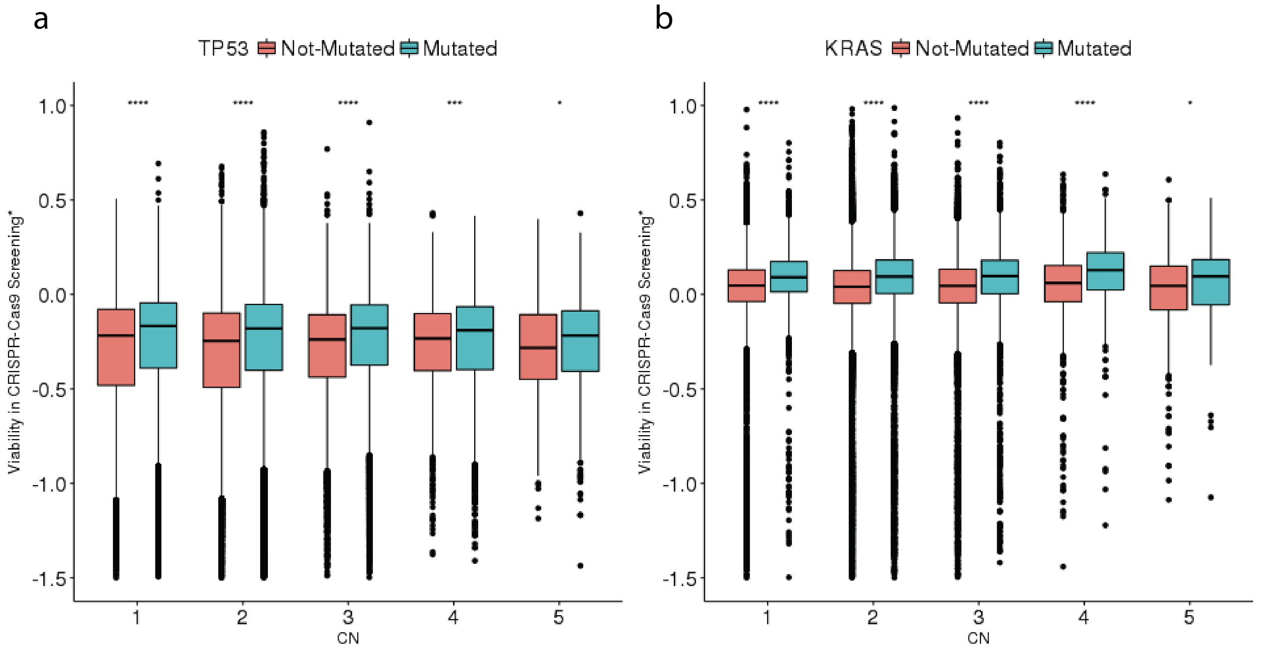
Figure S1. The effect of CRISPR-selected cancer drivers (CCDs) are independent of gene copy number. The x-axis shows the copy number and y-axis shows the cell viability after CRISPR-KO of each gene. Red bars denote the cell viability in the cell lines where the CCD is WT, and green bars denote that where the CCD is mutated for (a) TP53 and (b) KRAS. CN=1 denotes cases with copy number less than or equal to 1 and CN=5 denotes cases with copy number greater than or equal to 5. The number of stars at the top of the boxplot represents the significance which is calculated using one-sided Wilcoxon rank sum test of the difference. *P<0.05, **P<0.01, ***P<0.001, ****P<0.0001. In the boxplots, the center line, box edges and whiskers denote the median, interquartile range and the rest of the distribution in respective order, except for points that were determined to be outliers using a method that is a function of the interquartile range, as done for standard box plots.
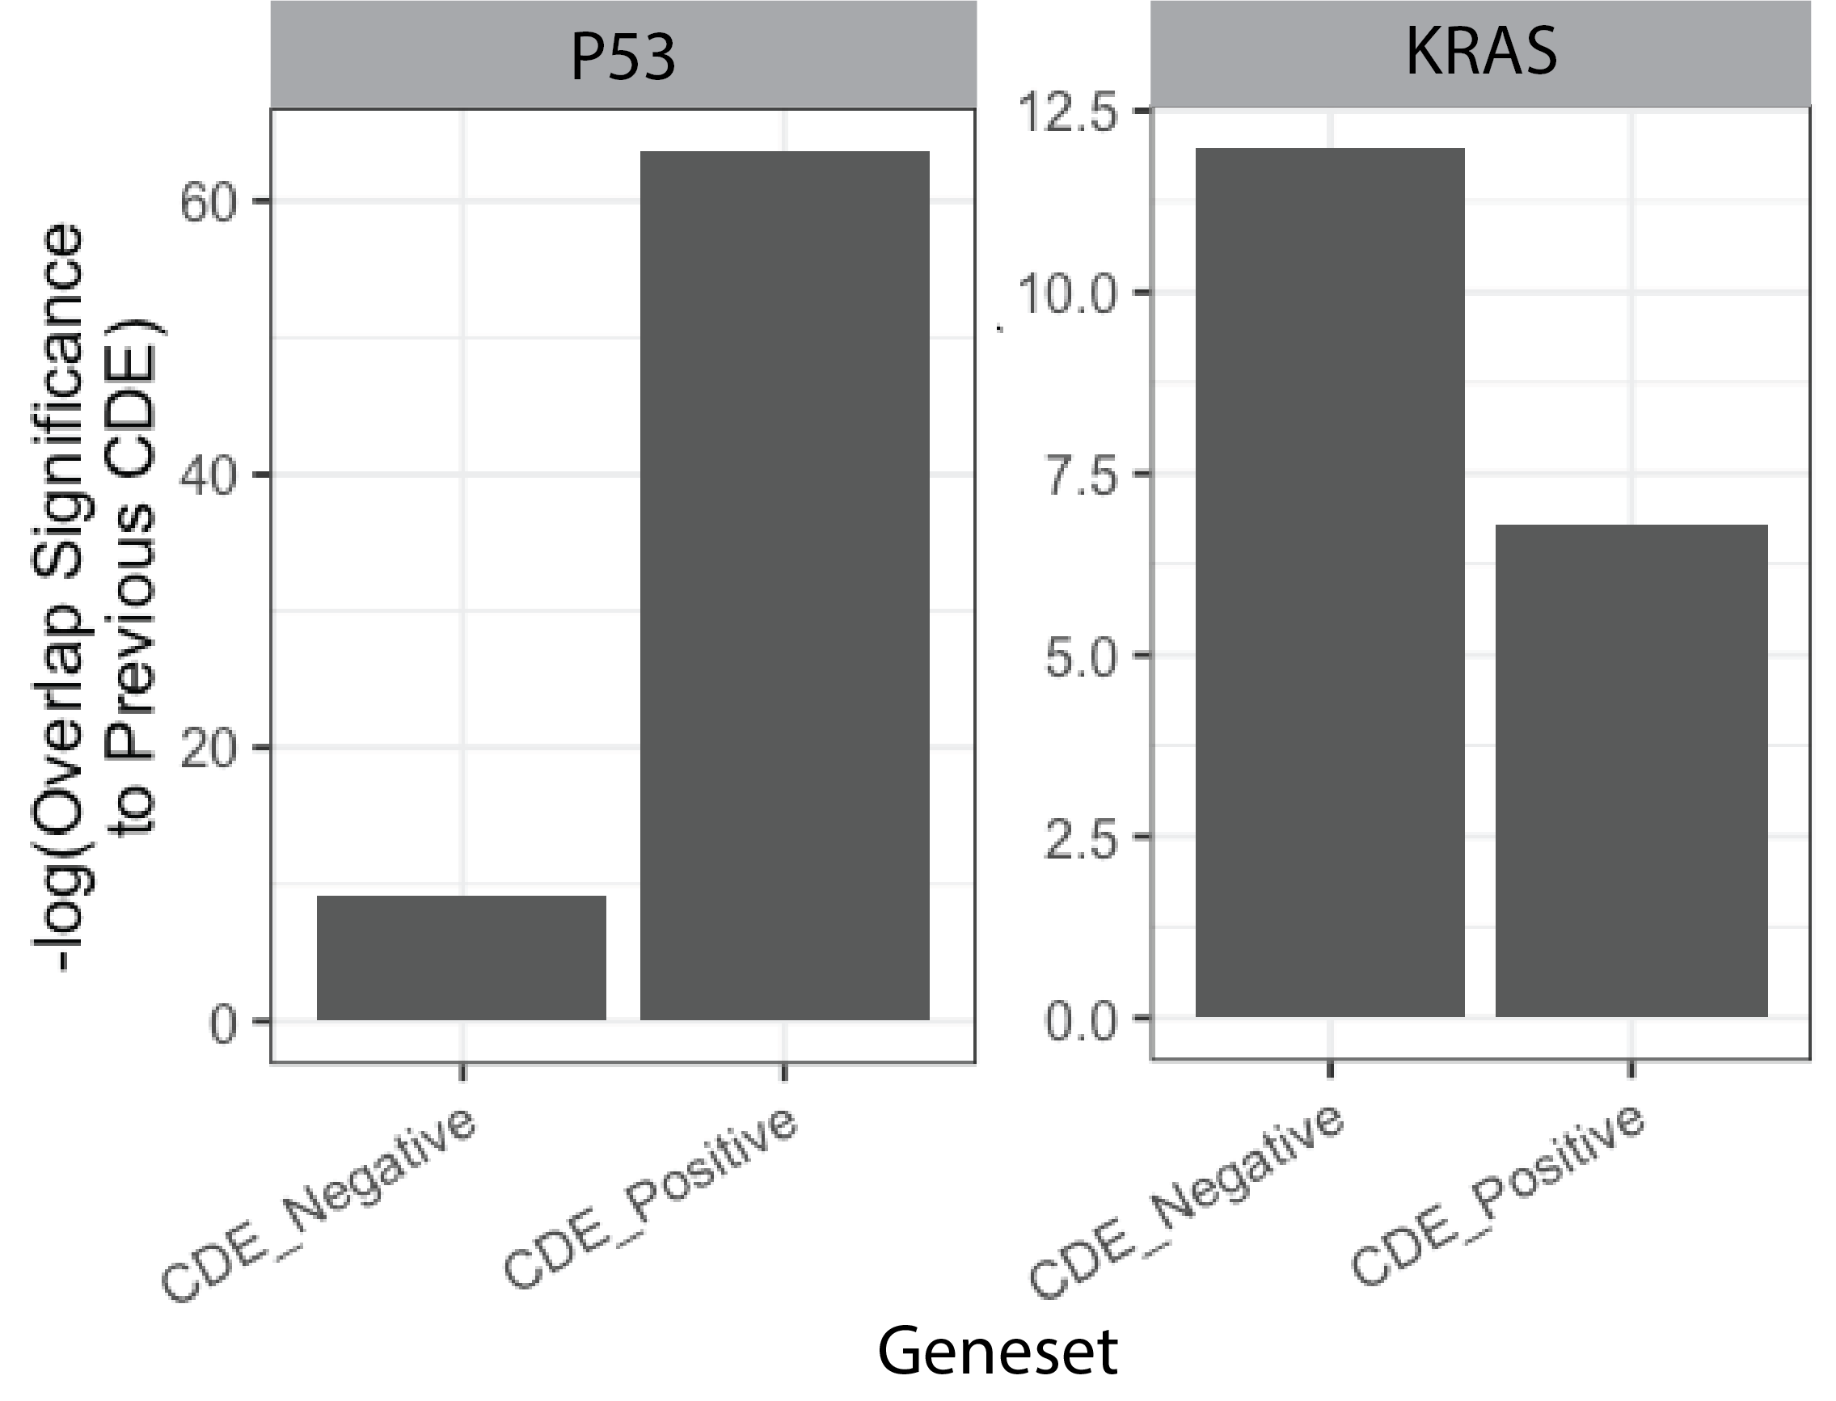
Figure S2: Independent support from large-scale CRISRP-Cas9 screen from Sanger institute. Overlap significance (y-axis) between CDE+/- (x-axis) genes identified from DepMap and Sanger screens for a) p53 and b) KRAS. P values are calculated using one-tailed hypergeometric tests.

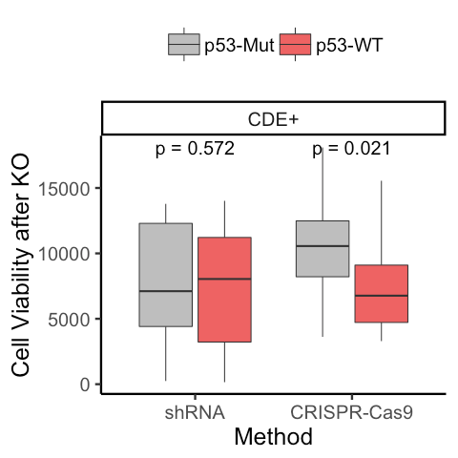
Figure S3: Validations of p53 CDE genes in published CRISPR screens in p53-isogenic cell lines. Genome wide published CRISPR-Cas9 and shRNA screens were mined where the top CDE genes knockouts were performed in isogenic WT and mutant cell lines for p53. The box plot shows that the sgRNAs of the CDE+ genes become significantly more depleted in WT cells vs mutant cells. The P value of one-tailed Wilcoxon signed-rank test is shown. The p-values were calculated using two-sided Wilcoxon Rank Sum tests. In the boxplots, the center line, box edges and whiskers denote the median, interquartile range and the rest of the distribution in respective order, except for points that were determined to be outliers using a method that is a function of the interquartile range, as done for standard box plots.
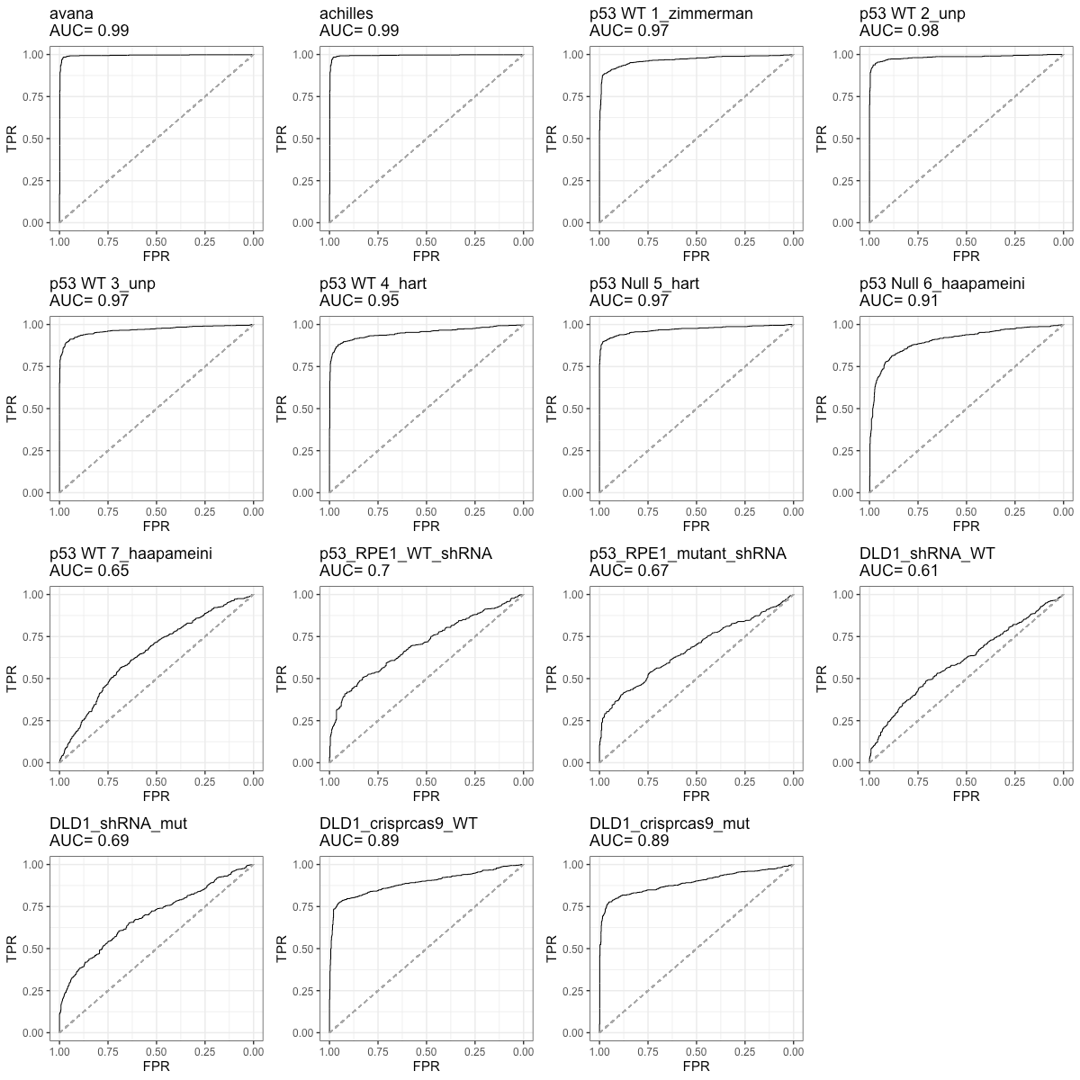
Figure S4: Quality metric of published screens: For each published screen used in this study, we computed the area under the receiving operating curve (AUROC) as a predictive power to distinguish between essential and non-essential genes (Hart et al. [46]) as a quality metric. We computed this for the following fifteen screens (panels in order) - A. DepMap CRISPR-Cas9 screen (median across cell lines, AVANA), B. DepMap shRNA screen (median across all the cell lines, Achilles), C-I. CRISPR-Cas9 screens in RPE1 (p53 WT vs mutant) cells from Zimmerman et al 2018 (zimmerman), Brown et al 2019 (unp), Hart et al. 2015 (hart), Haapameini et al. 2018 (Haapameini), J-K. shRNA screen in RPE1 (p53 WT vs mutant) from Sokolova et al. 2017, L-O. CRISPR-Cas9 and shRNA screen in DLD1 (KRAS WT vs mutant) from Sokolova et al. 2017. Each panel provides the respective ROC curve for the screen providing trade-off between false positive rate (FPR) and true positive rate (TPR). Area under the diagonal dotted line segment denotes AUROC from a random curve (0.5). The ROC is computed using pROC R package.
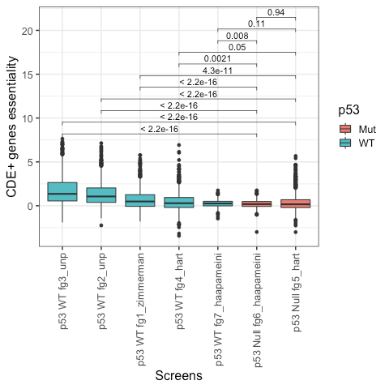
Figure S5: Comparison of CDE+ genes CRISPR-Cas9 essentiality across p53 wildtype vs mutant primary RPE1 cell lines curated by Brown et al. [2]. This dataset comprises genome-wide CRISPR-Cas9 screens from five studies - Brown et al 2019 (fg2/3_unp), Zimmerman et al 2018 (fg1_zimmerman), Hart et al. 2015 (fg3/4_hart), Haapameini et al. 2018 (fg7/6_haapameini). 2/7 screens were performed on p53 mutant/null and the rest were performed on p53 WT RPE1 cells. The p-values were calculated using two-sided Wilcoxon Rank Sum tests. In the boxplots, the center line, box edges and whiskers denote the median, interquartile range and the rest of the distribution in respective order, except for points that were determined to be outliers using a method that is a function of the interquartile range, as done for standard box plots.
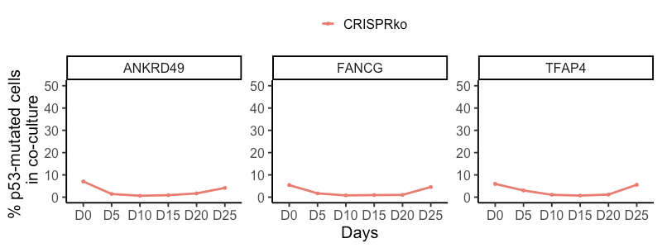
Figure S6: Three CDE+ genes out of five showing no selection for p53 mutant cells under CRISPR-Cas9 knockout of in a co-culture of p53 WT/mutant cells. In the competition assay, where isogenic p53 WT/mutant MOLM13 cell lines were mixed with a ratio of 5:95 and top p53 CDE+ genes were knocked out by CRISPR-Cas9. Change in the percentage of p53 mutant cells in the p53 mutant-WT cells (Y-axis) co-culture with time (X-axis, number of days in co-culture), under the CRISPR-KO of individual selected top p53 CDE+ genes targeting sgRNA. The p-values are calculated using two-sided Wilcoxon Rank Sum tests. Here, the y-axis scale is kept consistent to the main text.

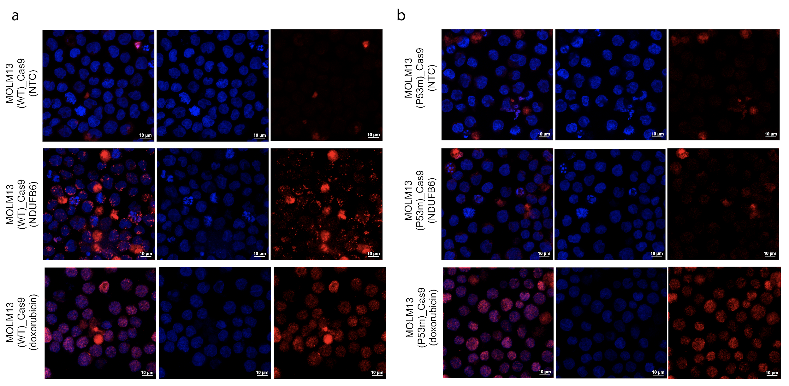
Figure S7: Effect of lentiviral delivered Cas9+sgRNA targeting CDE+ gene on DNA damage: DNA damage in Isogenic P53 (a) wildtype MOLM13 cells vs (b) MOLM13-P53 mutant cells is shown by gH2AX staining with a non-targeting control (top panel), an NDUFB6 sgRNA (middle panel) or with Doxorubicin as a positive control for DNA damage. Images of the cell nucleus marked with DAPI (blue), gH2AX (red) or overlay are shown.

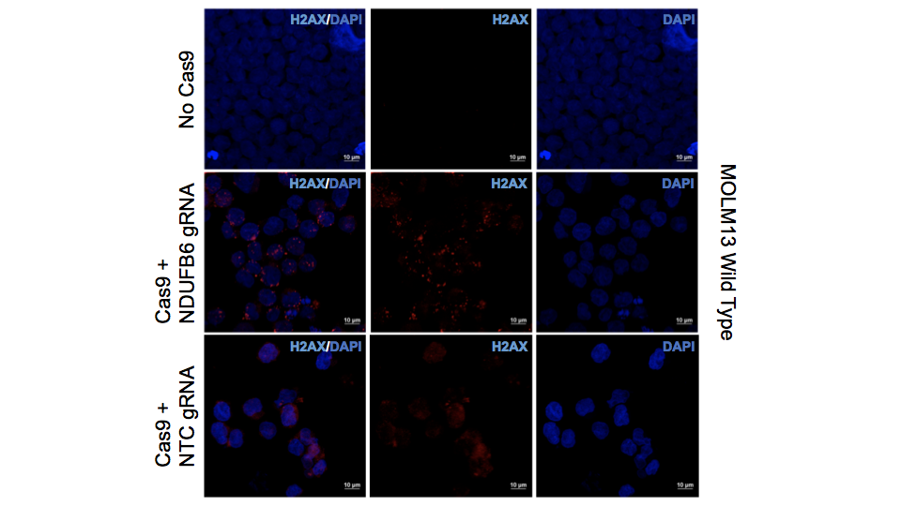

Figure S8: Effect of RNP delivered Cas9+ sgRNA targeting CDE+ gene on DNA damage: DNA damage is shown as measured by gH2AX staining in p53 WT MOLM13 cells with no Cas9, Cas9 + an NDUFB6 sgRNA, or a non-targeting control (NTC). gH2AX foci in all three conditions are enumerated in the violin plot in the right panel.

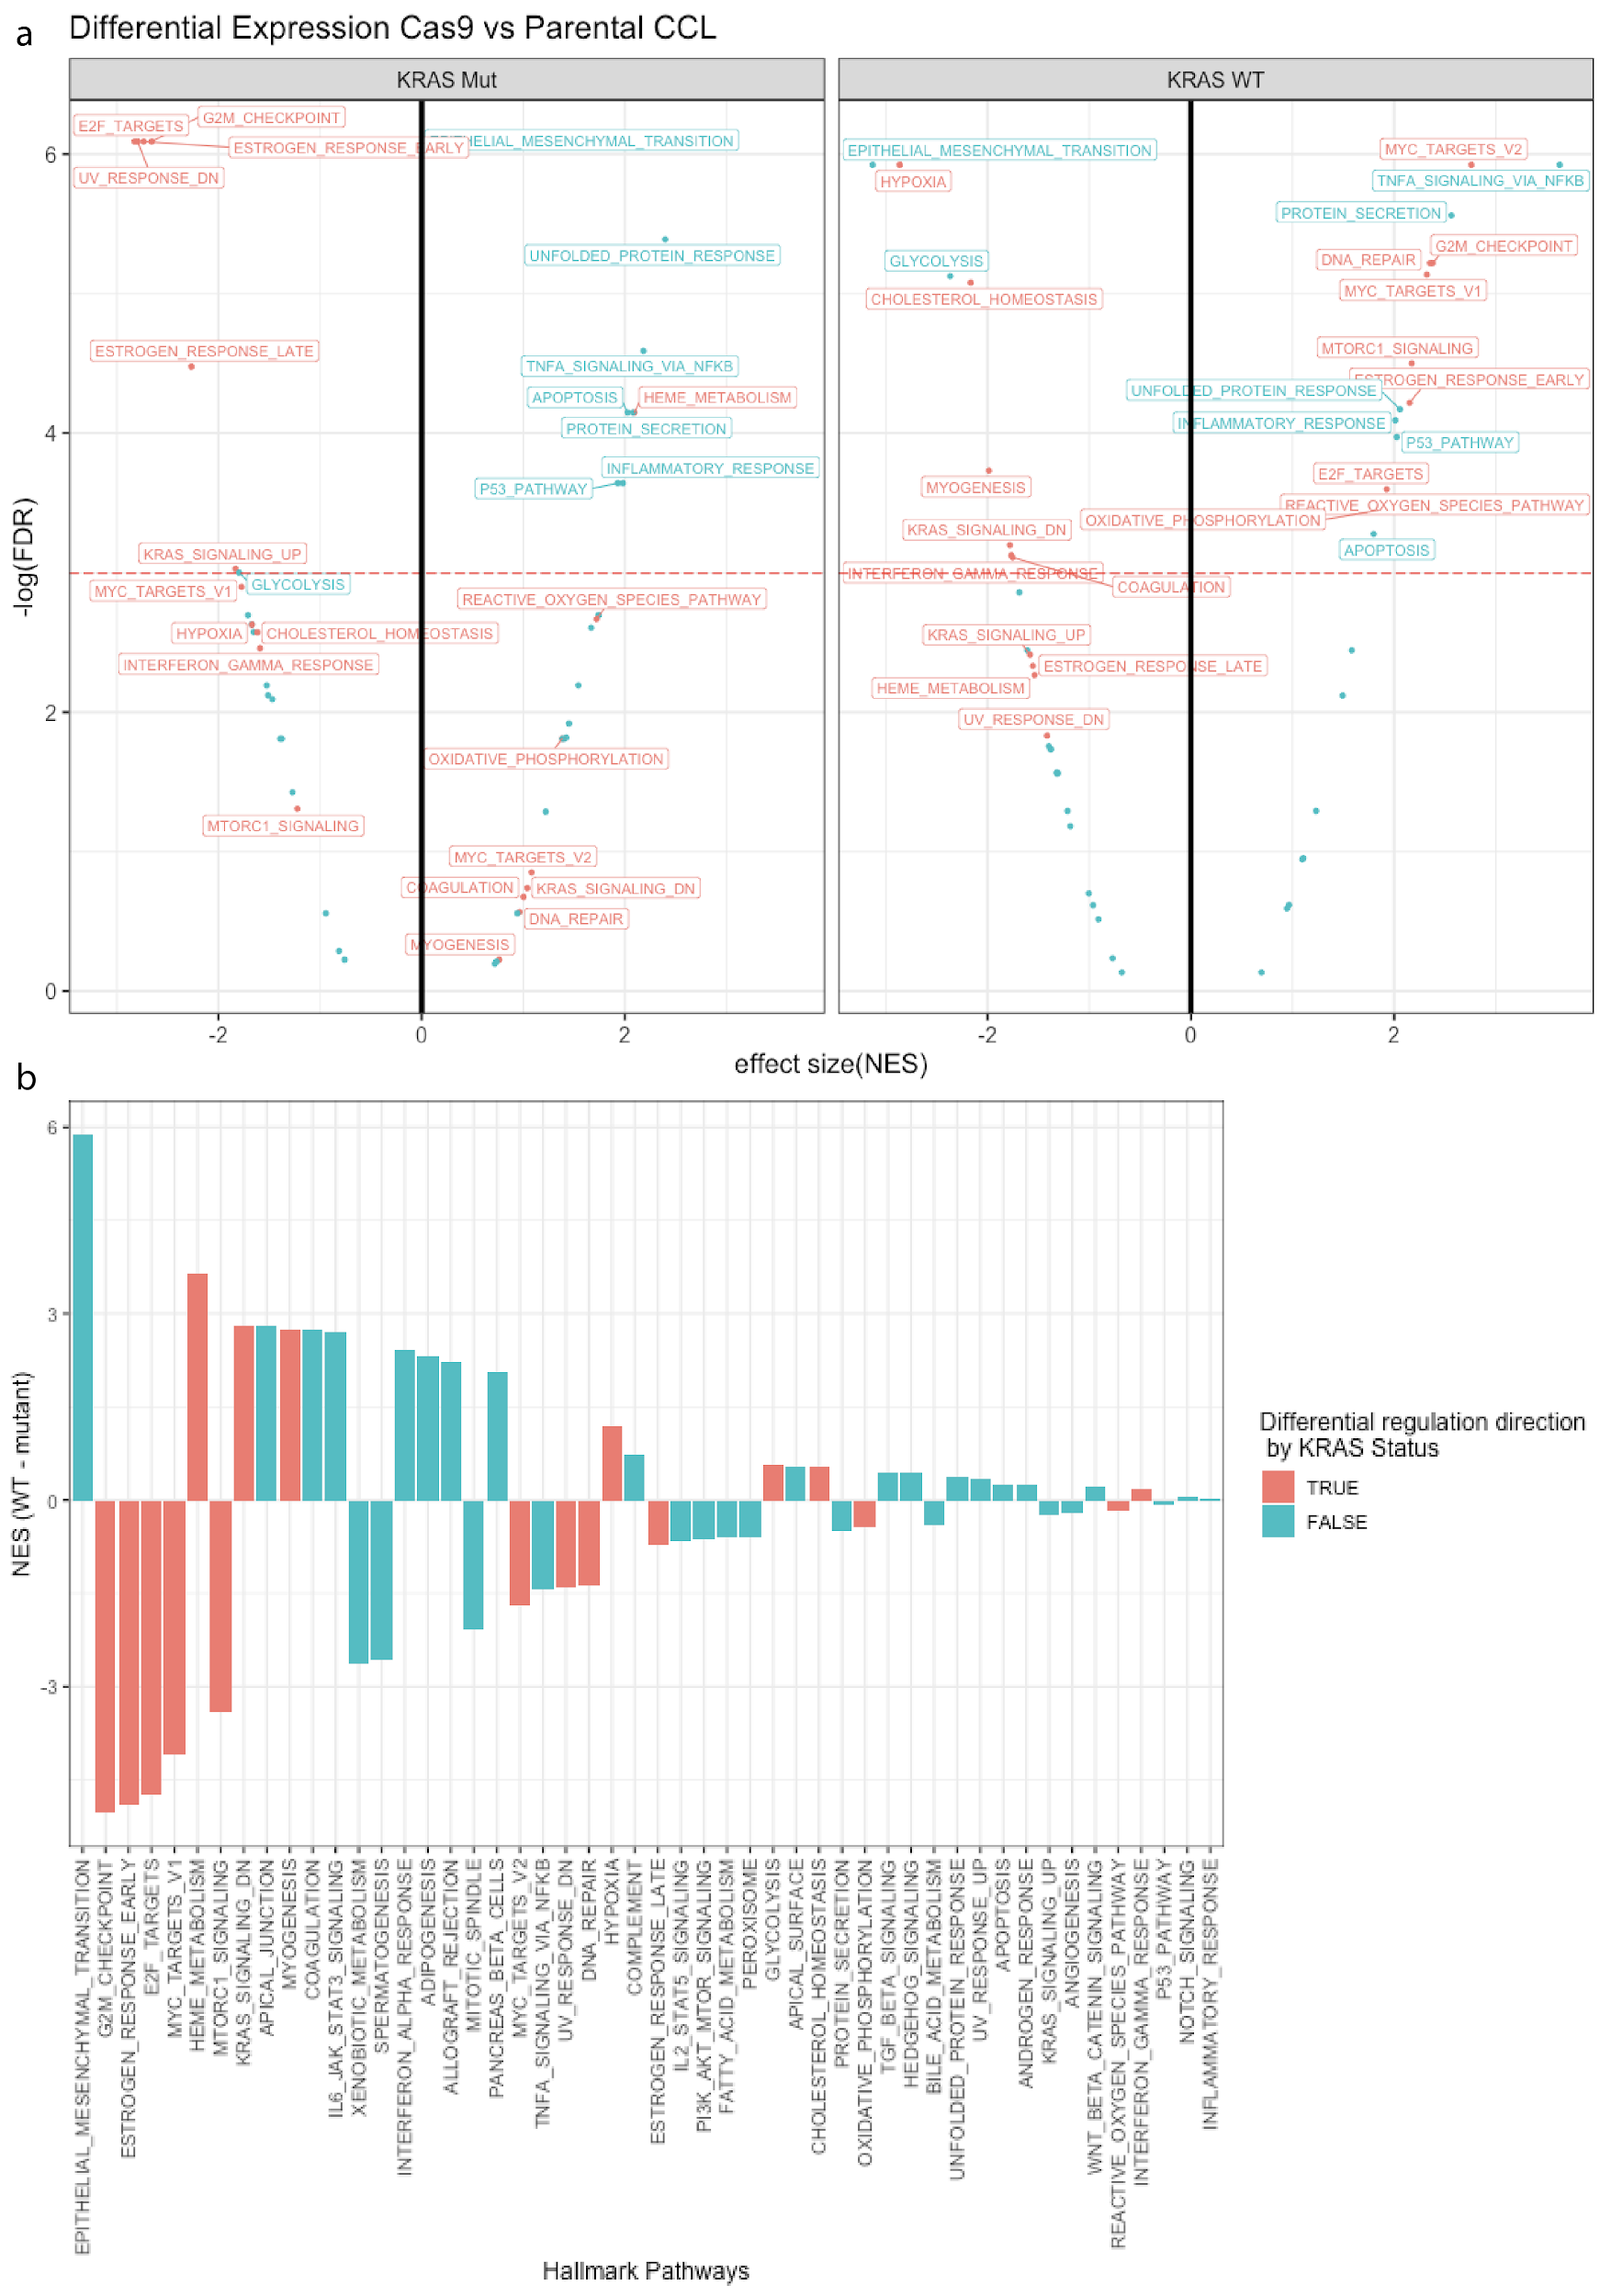

Figure S9: Pathways up/downregulated in KRAS wildtype vs mutant cell lines in response to Cas9 induction. (a) Top enriched hallmark pathways from MSigDB were tested for enrichment using GSEA in differential expressed genes in parental vs Cas9-induced cancer cell lines with KRAS WT (left panel) and mutant (right panel). The normalized enrichment score (x-axis) and significance for enrichment is provided for each pathway. (b) For each hallmark pathway, the difference in NES score in WT and mutant cancer cell lines (x-axis) is provided. Pathways which were significantly up/down regulated in either KRAS WT or mutant are labelled. The pathways whose direction changes by KRAS status are colored orange and the rest are green. Significance was calculated using the GSEA method as implemented in the R package fgsea (Sergushichev et al. 2016).
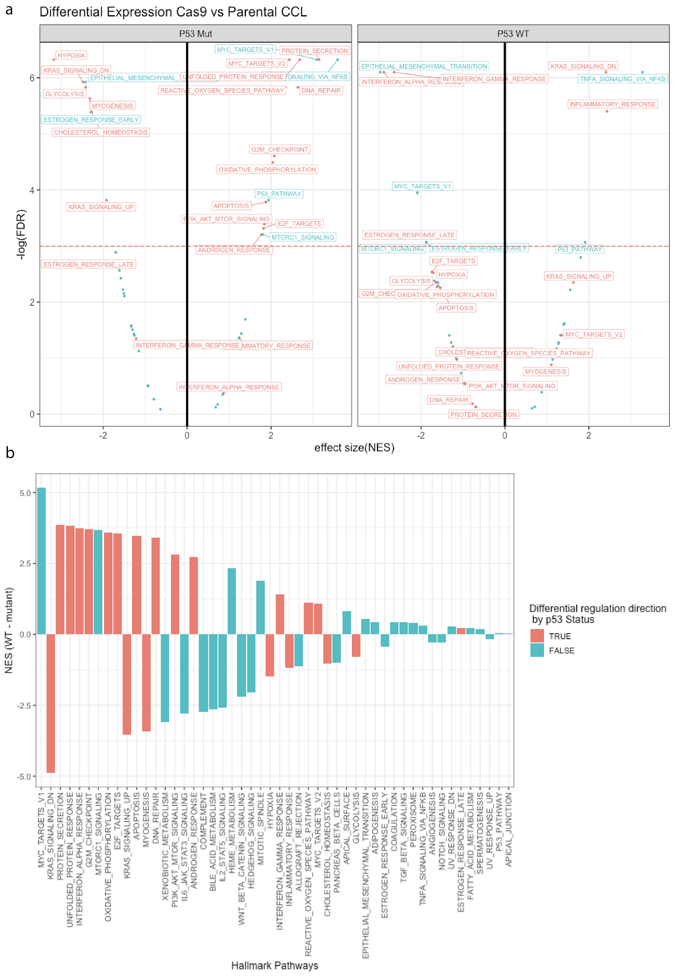
Figure S10: Pathways up/downregulated in p53 wildtype vs mutant cell lines in response to Cas9 induction. (a) Top enriched hallmark pathways from MSigDB were tested for enrichment using GSEA in differential expressed genes in parental vs Cas9-induced cancer cell lines with p53 WT (left panel) and mutant (right panel). The normalized enrichment score (x-axis) and significance for enrichment is provided for each pathway. (b) For each hallmark pathway, the difference in NES score in WT and mutant cancer cell lines (x-axis) is provided. Pathways which were significantly up/down regulated in either p53 WT or mutant are labelled. The pathways whose direction changes by p53 status are colored orange and the rest are green. Significance was calculated using the GSEA method as implemented in the R package fgsea (Sergushichev 2016).
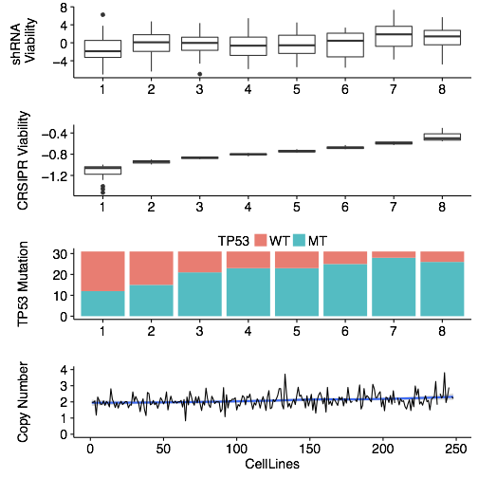
Figure S11: Top CDE+ of p53: The distribution of TAF8 (the top CDE+ gene of p53) post KO/KD viability scores in the CRISPR (top panel) screen as a function of p53 mutation status. The cell lines were divided into 8 bins of equal size, which are ordered by their viability after the CRISPR-KO of TAF8. The fraction of p53 mutant cell lines in each bin is plotted on the second panel. The distribution of TAF8 post shRNA-KD viability scores is displayed on the third panel as a control. The fourth, lowest panel visualizes that the copy number of TAF8 is about the same in the different bins. In the boxplots, the center line, box edges and whiskers denote the median, interquartile range and the rest of the distribution in respective order, except for points that were determined to be outliers using a method that is a function of the interquartile range, as done for standard box plots.

