Supplementary Materials

Development of non-enzymatic glucose electrode based on Au nanoparticles decorated single-walled carbon nanohorns
Hong-Wei Lv, Hui-Ling Peng *, Quan-Fu Li *

College of Electronic Engineering, Guangxi Normal University. Guilin541004. China
*E-mail: penghuiling1008@163.com (Hui-Ling Peng), lear-super@163.com (Quan-Fu Li)

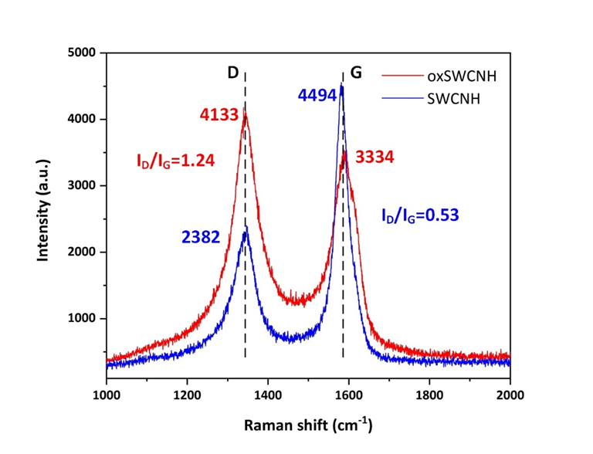
Fig.S1 Raman spectra of oxSWCNHs (red) and SWCNHs (blue). (I_{D}/I_{G}: intensity ratio of D and G peaks)

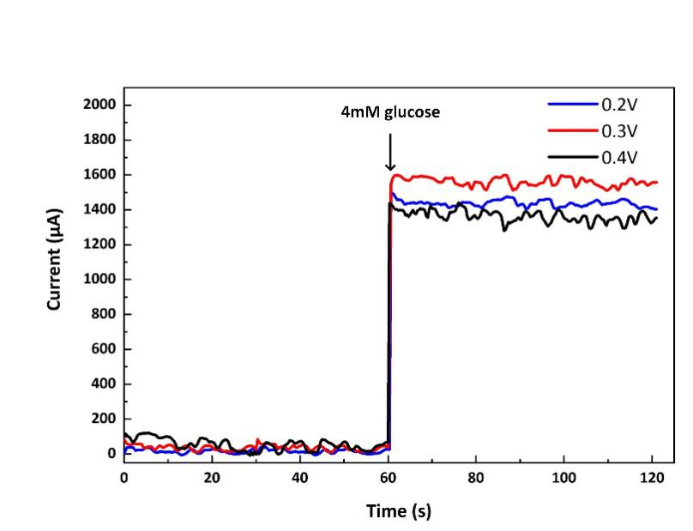
Fig.S2 Amperometric response at 0.2, 0.3, and 0.4 V (vs. Ag/AgCl) of the Au-SWCNHs/Au electrode in a 4 mM glucose solution.
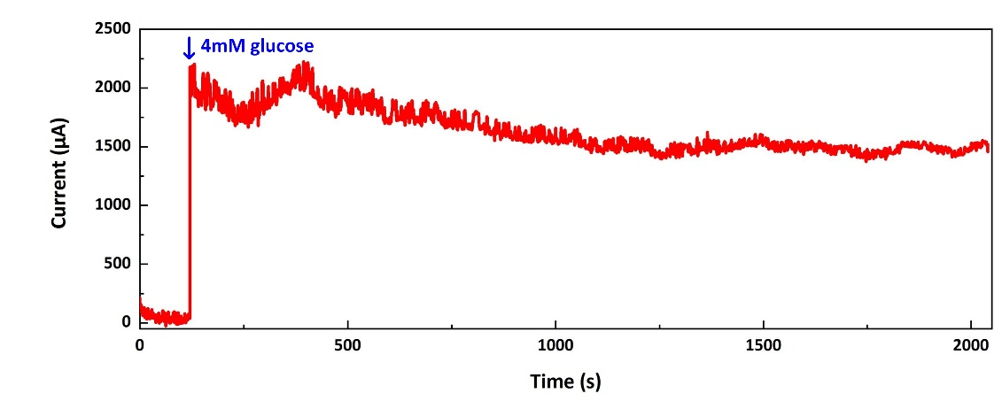
Fig.S3 Amperometric response of the Au-SWCNHs/Au electrode to 4 mM glucose over a large period of time (2000 s).
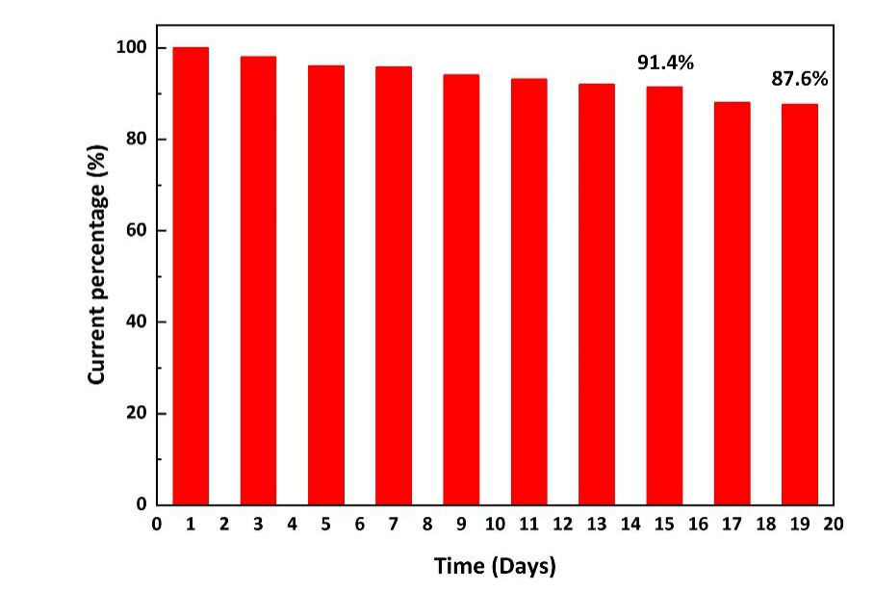
Fig. S4 Stability of the Au-SWCNHs/Au electrode stored in air tight container for 19 days.

