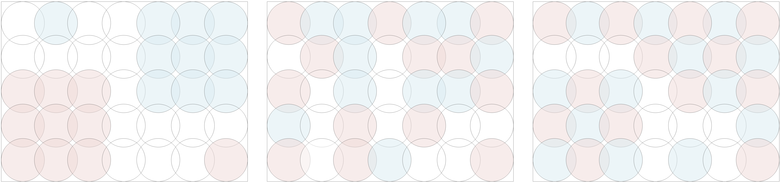
Appendix 2 Demonstration of different type spatial cluster

