Comparative analysis of cyanobacteria species reveals a novel guanidine-degrading enzyme that controls genomic stability of ethylene-producing strains

Bo Wang^{1,2*}, Yao Xu³, Xin Wang^{4,5}, Joshua S. Yuan⁴, Carl H. Johnson³, Jamey D. Young^{2,6}, Jianping Yu^{1*}

Supplementary Information

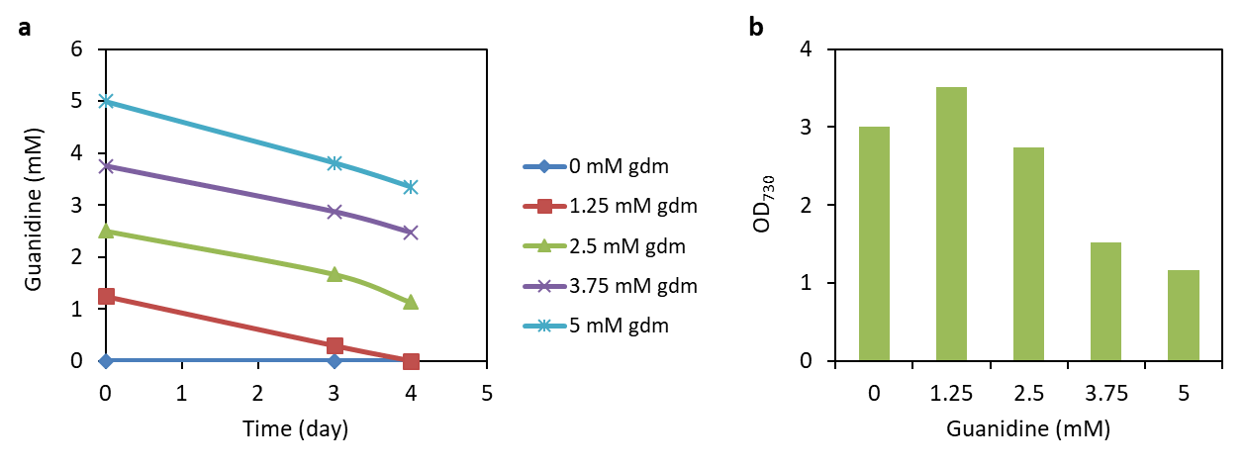
Fig. S1 | Degradation of guanidine by Synechocystis culture with nitrate gradually replaced by guanidine in the medium. Synechocystis 6803 was inoculated with an initial OD₇₃₀ of 0.1 in the mBG11 medium with nitrate adjusted from 17.6 mM to 5 mM (0 mM gdm), and then the nitrate was gradually replaced by the equal molar concentrations of guanidine until the entire 5 mM nitrate was replaced by 5 mM guanidine (5 mM gdm). a, Guanidine concentrations in the culture media. b, OD₇₃₀ of cell cultures three days after inoculation.

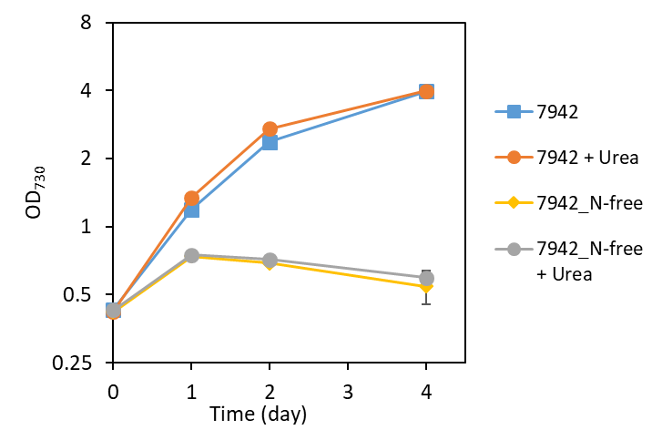
Fig. S2 | Tolerance of Synechococcus 7942 to urea. Cell growth curves of Synechococcus 7942 grown in nitrate-replete or nitrate-deprived BG11 medium (N-free) supplemented with 50 mM NaHCO₃, with or without 5 mM urea, under constant light of 50 μE m⁻² s⁻¹ on a rotary shaker at 150 rpm and 30 ºC. Data represent means and standard derivations from two biological replicates.

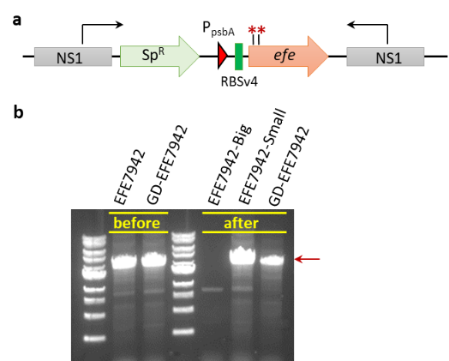

Fig. S3 | Improved genomic stability of the efe-expressing Synechococcus 7942 derivative strain through co-overexpressing sll1077. a, Schematic structure of the EFE expression cassette inserted into the genomes of Synechococcus elongatus strains EFE7942 and GD-EFE7942. Arrows indicate the primers used for PCR verification of genotypes of the efe-expressing strains. Red asterisks indicate sites where mutation occurred causing early termination of the translation of EFE in the randomly chosen bigger EFE7942 colonies pictured in Fig. 6a. b, Colony PCR results showing the genotypes of efe-expressing cells initially grown on agar plates placed at 35 ºC (“before”) and then on agar plates placed at 30 ºC (“after” as depicted in Fig. 6a). DNA fragments were amplified using primers illustrated as black arrows in a. Red arrow indicates the expected size of the PCR product should cells maintain the correct EFE expression cassette.

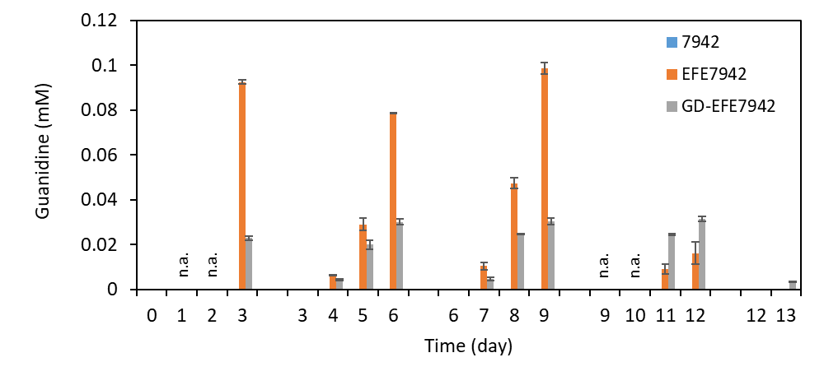
Figure S4. Guanidine accumulative titers in the culture supernatants of Synechococcus strains. Synechococcus strains 7942, EFE7942 and GD-EFE7942 were grown under the same conditions as in Fig. 6b-d. “n.a.” means samples were not saved for analysis of guanidine. Batch #1, day 0 – 3; batch #2, day 3 – 6; batch #3, day 6 – 9; batch #4, day 9 – 12; batch #5, day 12 – 13. Data represent means and standard deviations of two biological replicates.

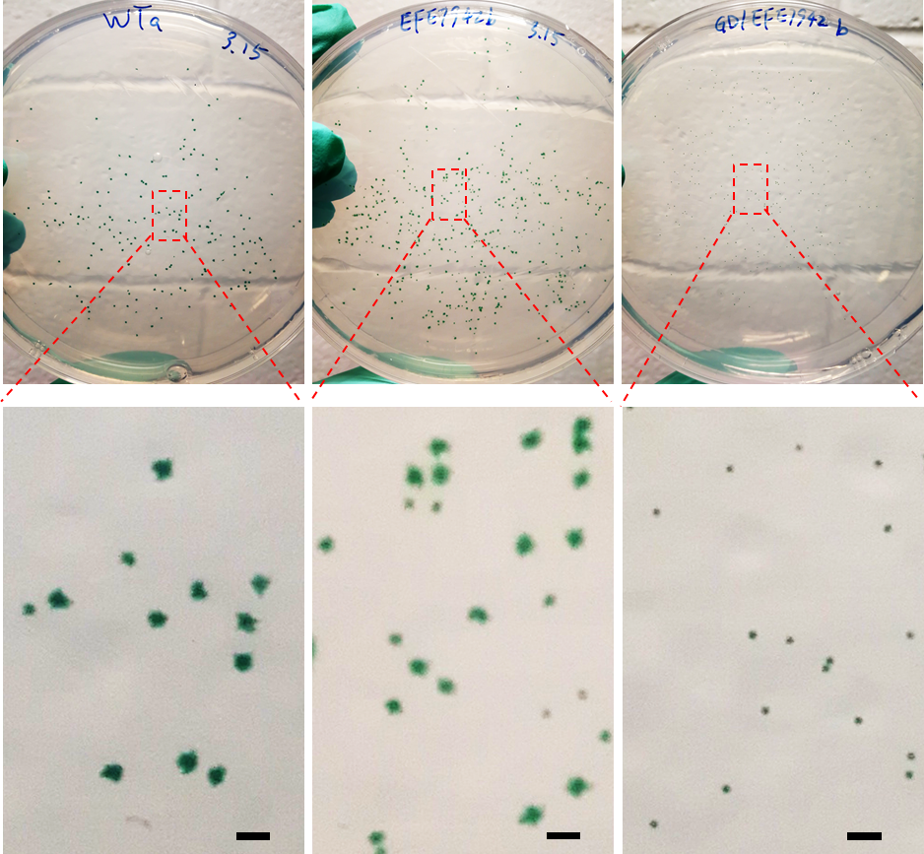

Figure S5. Colonies formed on agar plates spread with diluted 13th day cultures in Fig. 6b-d. Synechococcus strains 7942, EFE7942 and GD-EFE7942 were grown under the same conditions as in Fig. 6b-d were diluted and spread on to BG11 agar plates and incubated under light of ~15 µE m⁻² s⁻¹ at ambient temperature for two weeks. Scale bars indicate 1 mm.

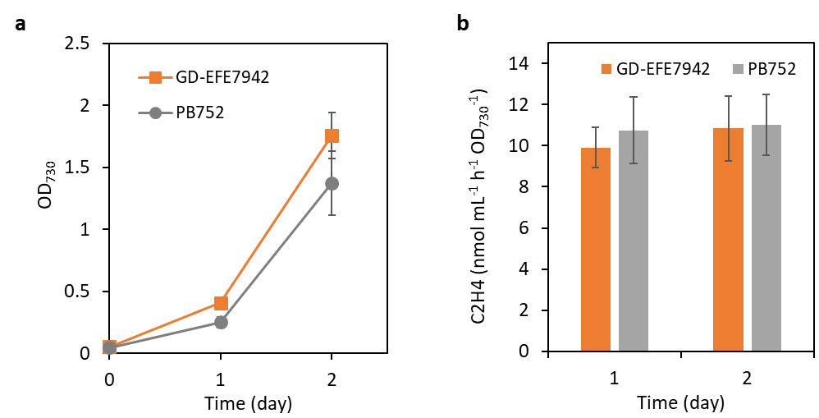
Figure S6. Comparison of ethylene productivities between efe-expressing Synechococcus strain GD-EFE7942 and Synechocystis strain PB752. a, Growth of two cyanobacterial strains. b, Specific ethylene productivities. Strains were inoculated in the mBG11 medium with an initial OD₇₃₀ of about 0.05, under 120 µE m⁻² s⁻¹, 130 rpm, 30 ºC, aerated with 1% CO₂.

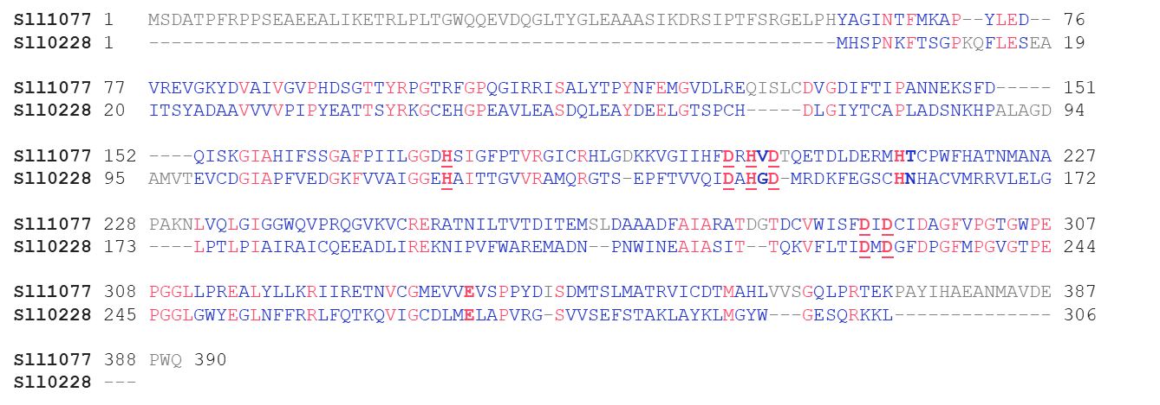
Figure S7. Comparison of protein sequences of Sll1077 and Sll0228 of the Synechocystis 6803 strain. Red letters indicate identical amino acids. Bold letters indicate the conservative putative active cite of agmatinase family proteins¹. Underscored letters indicate the conservative manganese [Mn] ion binding site¹.

Table S1 Comparative proteomics for Synechocystis PCC 6803 and JU547.*
#Locus | Fold Change | pValue | NSAF for PCC 6803 | NSAF for JU547 | Description
EFE_Ethylene-forming | 278 | 0.000263 | < 2.81E-05 | 0.007812 | enzyme OS=Synechocystis sp. (strain PCC 6803)
sp_P73270_SPEB2_SYNY3 | 20.3 | 0.000927 | 2.81E-05 | 5.71E-04 | Sll1077; Probable agmatinase 2 OS=Synechocystis sp. (strain PCC 6803 / Kazusa) GN=speB2 PE=3 SV=1
tr_P73267_P73267_SYNY | 5.34 | 0.008612 | 1.04E-04 | 0.000558 | Sll1080 protein OS=Synechocystis sp. (strain PCC 6803 / Kazusa) GN=sll1080 PE=4 SV=1
tr_P73268_P73268_SYNY | 4.35 | 0.1501 | < 5.36E-05 | 2.33E-04 | Sll1079; Hydrogenase expression/formation protein HypB OS=Synechocystis sp. (strain PCC 6803 / Kazusa) GN=hypB PE=4 SV=1
tr_P73886_P73886_SYNY | 1.69 | 0.047647 | 0.00036 | 6.10E-04 | Ribosome-binding ATPase YchF OS=Synechocystis sp. (strain PCC 6803 / Kazusa) GN=ychF PE=3 SV=1
tr_P74314_P74314_SYNY | 1.67 | 0.016061 | 2.81E-04 | 4.69E-04 | OmpR subfamily OS=Synechocystis sp. (strain PCC 6803 / Kazusa) GN=slr0947 PE=4 SV=1
tr_P73546_P73546_SYNY | 1.55 | 0.025467 | 0.000365 | 0.000566 | Alpha-1,4 glucan phosphorylase OS=Synechocystis sp. (strain PCC 6803 / Kazusa) GN=glgP PE=3 SV=1
sp_P73530_RS1A_SYNY3 | 1.50 | 0.016182 | 1.42E-03 | 2.13E-03 | 30S ribosomal protein S1 homolog A OS=Synechocystis sp. (strain PCC 6803 / Kazusa) GN=rps1A PE=3 SV=1
sp_P21697_PLAS_SYNY3 | 1.48 | 0.007126 | 3.22E-03 | 0.004768 | Plastocyanin OS=Synechocystis sp. (strain PCC 6803 / Kazusa) GN=petE PE=1 SV=1
tr_Q55199_Q55199_SYNY | -1.35 | 0.003676 | 5.25E-04 | 0.00039 | Phosphate-binding protein OS=Synechocystis sp. (strain PCC 6803 / Kazusa) GN=pstS PE=3 SV=1
sp_P27179_ATPA_SYNY3 | -1.40 | 0.001025 | 5.19E-03 | 0.00371 | ATP synthase subunit alpha OS=Synechocystis sp. (strain PCC 6803 / Kazusa) GN=atpA PE=3 SV=1
sp_P36237_RL11_SYNY3 | -1.51 | 0.009794 | 5.56E-03 | 0.003688 | 50S ribosomal protein L11 OS=Synechocystis sp. (strain PCC 6803 / Kazusa) GN=rplK PE=3 SV=1
sp_P27180_ATPD_SYNY3 | -1.52 | 0.014717 | 0.000626 | 0.000412 | ATP synthase subunit delta OS=Synechocystis sp. (strain PCC 6803 / Kazusa) GN=atpH PE=3 SV=1
sp_Q55664_ALF2_SYNY3 | -1.53 | 0.000327 | 5.73E-03 | 3.75E-03 | Fructose-bisphosphate aldolase class 2 OS=Synechocystis sp. (strain PCC 6803 / Kazusa) GN=fbaA PE=1 SV=3
tr_P74769_P74769_SYNY | -1.54 | 0.014917 | 1.91E-03 | 0.001239 | Ssr1528 protein OS=Synechocystis sp. (strain PCC 6803 / Kazusa) GN=ssr1528 PE=4 SV=1
sp_P74410_RS16_SYNY3 | -1.57 | 0.013248 | 1.48E-03 | 0.000947 | 30S ribosomal protein S16 OS=Synechocystis sp. (strain PCC 6803 / Kazusa) GN=rpsP PE=3 SV=1
sp_P42352_RL9_SYNY3 | -1.57 | 0.03309 | 0.003878 | 2.46E-03 | 50S ribosomal protein L9 OS=Synechocystis sp. (strain PCC 6803 / Kazusa) GN=rplI PE=3 SV=2
tr_P73037_P73037_SYNY | -1.58 | 0.015387 | 4.24E-03 | 0.002679 | Peptidyl-prolyl cis-trans isomerase OS=Synechocystis sp. (strain PCC 6803 / Kazusa) GN=ytfC PE=4 SV=1
sp_P73851_SYDND_SYNY3 | -1.68 | 0.030414 | 0.000637 | 0.000379 | Aspartate--tRNA(Asp/Asn) ligase OS=Synechocystis sp. (strain PCC 6803 / Kazusa) GN=aspS PE=3 SV=1
sp_Q55781_FTRV_SYNY3 | -1.69 | 0.007735 | 7.10E-04 | 4.20E-04 | Ferredoxin-thioredoxin reductase, variable chain OS=Synechocystis sp. (strain PCC 6803 / Kazusa) GN=ftrV PE=1 SV=1
sp_P73824_GPX2_SYNY3 | -1.72 | 0.01956 | 1.25E-03 | 7.26E-04 | Hydroperoxy fatty acid reductase gpx2 OS=Synechocystis sp. (strain PCC 6803 / Kazusa) GN=gpx2 PE=1 SV=1
sp_P26533_ATPE_SYNY3 | -1.73 | 0.028933 | 0.000841 | 0.000486 | ATP synthase epsilon chain OS=Synechocystis sp. (strain PCC 6803 / Kazusa) GN=atpC PE=1 SV=3
sp_P73636_RS6_SYNY3 | -1.73 | 0.019332 | 0.000946 | 0.000546 | 30S ribosomal protein S6 OS=Synechocystis sp. (strain PCC 6803 / Kazusa) GN=rpsF PE=3 SV=1
sp_Q55544_APCE_SYNY3 | -1.83 | 0.003729 | 1.14E-02 | 6.24E-03 | Phycobiliprotein ApcE OS=Synechocystis sp. (strain PCC 6803 / Kazusa) GN=apcE PE=1 SV=1
sp_P27183_ATPX_SYNY3 | -1.85 | 0.027033 | 2.02E-03 | 1.09E-03 | ATP synthase subunit b' OS=Synechocystis sp. (strain PCC 6803 / Kazusa) GN=atpG PE=3 SV=1
tr_P73173_P73173_SYNY | -1.90 | 0.007279 | 0.00059 | 0.00031 | PilJ protein OS=Synechocystis sp. (strain PCC 6803 / Kazusa) GN=pilJ PE=4 SV=1
sp_P27181_ATPF_SYNY3 | -1.92 | 0.018123 | 0.002426 | 0.001262 | ATP synthase subunit b OS=Synechocystis sp. (strain PCC 6803 / Kazusa) GN=atpF PE=3 SV=2
tr_P74175_P74175_SYNY | -2.07 | 0.00072 | 1.17E-03 | 0.000564 | HlyD family of secretion proteins OS=Synechocystis sp. (strain PCC 6803 / Kazusa) GN=hlyD PE=4 SV=1
sp_P72689_IF2_SYNY3 | -2.28 | 0.01916 | 0.002611 | 0.001147 | Translation initiation factor IF-2 OS=Synechocystis sp. (strain PCC 6803 / Kazusa) GN=infB PE=3 SV=1
sp_P72656_RNE_SYNY3 | -2.33 | 0.034951 | 0.000748 | 3.21E-04 | Ribonuclease E/G-like protein OS=Synechocystis sp. (strain PCC 6803 / Kazusa) GN=rne PE=3 SV=1
sp_P74615_Y1483_SYNY3 | -2.46 | 0.001977 | 4.62E-04 | 1.88E-04 | Uncharacterized protein sll1483 OS=Synechocystis sp. (strain PCC 6803 / Kazusa) GN=sll1483 PE=3 SV=1
sp_P27589_PETD_SYNY3 | -2.62 | 0.021749 | 0.00048 | 0.000183 | Cytochrome b6-f complex subunit 4 OS=Synechocystis sp. (strain PCC 6803 / Kazusa) GN=petD PE=3 SV=1
tr_P74485_P74485_SYNY | -2.66 | 0.023989 | 1.78E-03 | 6.71E-04 | Sll1863 protein OS=Synechocystis sp. (strain PCC 6803 / Kazusa) GN=sll1863 PE=4 SV=1
sp_P54123_RNJ_SYNY3 | -3.31 | 0.000549 | 6.98E-04 | 2.11E-04 | Ribonuclease J OS=Synechocystis sp. (strain PCC 6803 / Kazusa) GN=rnj PE=3 SV=1
tr_P72758_P72758_SYNY | -5.47 | 4.17E-05 | 0.001329 | 0.000243 | Carbon dioxide concentrating mechanism protein CcmM OS=Synechocystis sp. (strain PCC 6803 / Kazusa) GN=ccmM PE=1 SV=1
* The positive sign in the column of “Fold Change” means the relative abundance of the target protein in JU547 compared to the wild type strain Synechocystis PCC 6803; Negative sign means the relative abundance of the target protein in the wild type strain Synechocystis PCC 6803 compared to JU547.

Table S2 All strains and plasmids used in this study.
Strains |  | Genotype or features | Sources
 | NEB5α | fhuA2 Δ(argF-lacZ)U169 phoA glnV44 Φ80 Δ(lacZ)M15 gyrA96 recA1 relA1 endA1 thi-1 hsdR17 | NEB
 | Synechocystis sp. PCC 6803 | Wild-type | ATCC
 | Synechocystis PB805W | Δsll1077 in Synechocystis sp. PCC 6803 | This study
 | Synechocystis PB806W | Overexpression (OE) of slr1077-His in Synechocystis sp. PCC 6803; inserted between slr1495 and sll1397 | This study
 | Synechocystis PB807W | OE of sll1077-His in Synechocystis sp. PCC 6803 | This study
 | Synechocystis PB808W | OE of sll1077-His in Synechocystis sp. PCC 6803 | This study
 | Synechocystis PB809W | OE of sll1077-His in Synechocystis sp. PCC 6803 | This study
 | Synechocystis PB810W | OE of sll1077-His in Synechocystis sp. PCC 6803 | This study
 | Synechocystis PB811W | OE of sll1077-His in Synechocystis sp. PCC 6803 | This study
 | Synechocystis PB812W | OE of sll1077-His in Synechocystis sp. PCC 6803 | This study
 | Synechocystis PB816W | OE of sll1077-His in Synechocystis sp. PCC 6803 | This study
 | Synechocystis PB817W | OE of sll1077-His in Synechocystis sp. PCC 6803 | This study
 | Synechocystis PB752 | OE of efe in Synechocystis sp. PCC 6803; inserted at the slr0168 neutral site | ²
 | Synechocystis PB816H | OE of and sll1077-His in Synechocystis PB752 | This study
 | Synechocystis PB817H | OE of sll1077 in Synechocystis PB752 | This study
 | Synechococcus sp. PCC 7002 | Wild-type | In Lab
 | Synechococcus elongatus PCC 7942 | Wild-type | In Lab
 | Synechococcus elongatus EFE7942 | OE of efe in Synechococcus elongatus PCC 7942; inserted at neutral site 1, i.e., "Synpcc7942_2498" | This study
 | Synechococcus elongatus GD44 | OE of sll1077 in Synechococcus elongatus PCC 7942; inserted at neutral site 4, i.e., “Synpcc7942_0103” | This study
 | Synechococcus elongatus GD-EFE7942 | OE of sll1077 and efe in Synechococcus elongatus PCC 7942 | This study
Plasmids
 | pBluescript II SK (+) | Amp^{R}, pUC ori | Stratagene
 | pPB305 | sll1077U-Cm^{R}-sll1077D, inserted to the pBluescript II SK (+) vector backbone | This study
 | pPB306 | slr1495-Cm^{R}-P_{tac}-RBSv306-sll1077-His-sll1397, inserted to the pBluescript II SK (+) vector backbone | This study
 | pPB307 | Derivative of pPB306; RBSv306 replaced by RBSv307 | This study
 | pPB308 | Derivative of pPB306; RBSv307 replaced by RBSv308 | This study
 | pPB309 | Derivative of pPB306; RBSv306 replaced by RBSv309 | This study
 | pPB310 | Derivative of pPB306; RBSv306 replaced by RBSv310 | This study
 | pPB311 | Derivative of pPB306; RBSv306 replaced by RBSv311 | This study
 | pPB312 | Derivative of pPB309; XhoI site between sll1077 and His tag deleted | This study
 | pPB316 | Derivative of pPB312; rrnB terminator added downstream of sll1077-His | This study
 | pPB317 | Derivative of pPB316; His tag removed from downstream of sll1077 | This study
 | pJU158 | slr0168-P_{psbA}-RBSv4-efe-T_{T7} -Sm^{R}-slr0168, pUC ori | ³
 | pEFE-FLAG-NS1 | NS1Up- Sm^{R}-P_{psbA}-RBSv4-efe-T_{t7}- NS1Dn | This study
 | pCX0104-LuxAB-FT | Zn⁺⁺-inducible expression of P_{smtA}::luxAB::3×FLAG targeted to NS4 (Cm^{R}) | ⁴
 | pGD6803-NS4 | NS4Dn-P_{tac}-RBSv309-sll1077-T_{rrnB}-Cm^{R}-NS4Up | This study

Table S3. Primers used in this study.

Plasmids | Primers | DNA sequences | Target | Template source
pPB305 | Sll1077U3 | GGGCGAATTGGGTACCggagtttcggttaagtctaag (KpnI) | Sll1077U | S6803 gDNA
 | Sll1077U4 | CACAGGTATCTGCAGaggtagttactagctaaacaac | Sll1077U | S6803 gDNA
 | Sll1077D3 | GAAGCAGTGTGGGATCCTagtaactttaacttgactaattattgc | Sll1077D | S6803 gDNA
 | Sll1077D4 | GAACAAAAGCTGGAGCTCcgagcagaacagttttacc (SacI) | Sll1077D | S6803 gDNA
 | CatU3 | gtaactacctCTGCAGATACCTGTGACGGAAGATCAC | cat | pACYC184
 | CatD4 | aaagttactAGGATCCCACACTGCTTCCGGTAGTC | cat | pACYC184
pPB300 | sll1077U1 | agatataCATATGagcgatgccaccccgtttc | sll1077 | S6803 gDNA
 | sll1077D2 | ggtgCTCGAGttgccagggctcatccactg | sll1077 | S6803 gDNA
pPB306 | sll1077U3 | CAATTTCACACAAggaggatataCATATGagcgatgccaccccgtttc | sll1077 | pPB300
 | sll1077-His-D4 | caattcgcactgaatctccaGTCGACGTTAGCAGCCGGATCTTAGTG | sll1077 | pPB300
pPB307 | TACR4 | GTGTGAAATTGTTATCCGCTCAC | RBS of pPB306d | pPB306d
 | sll1077U307 | AAGGAGGAAACATatgagcgatgccaccccgtttc | RBS of pPB306d | pPB306d
pPB308 | TACR4 | GTGTGAAATTGTTATCCGCTCAC | RBS of pPB306d | pPB306d
 | sll1077U308 | AAGGAGGAACAGCatgagcgatgccaccccgtttc | RBS of pPB306d | pPB306d
pPB309 | TACR4 | GTGTGAAATTGTTATCCGCTCAC | RBS of pPB306d | pPB306d
 | sll1077U309 | AAGGAGAAACAGCatgagcgatgccaccccgtttc | RBS of pPB306d | pPB306d
pPB310 | TACR4 | GTGTGAAATTGTTATCCGCTCAC | RBS of pPB306d | pPB306d
 | sll1077U310 | AAGAAGGAGAAACAGCatgagcgatgccaccccgtttc | RBS of pPB306d | pPB306d
pPB311 | TACR4 | GTGTGAAATTGTTATCCGCTCAC | RBS of pPB306d | pPB306d
 | sll1077U311 | AAGAAGGAGAAACATAGCatgagcgatgccaccccgtttc | RBS of pPB306d | pPB306d
pPB312 | sll1077C-F-3xHis | CACCACCACTAAGATCCGGCTG | sll1077- His | pPB309
 | sll1077C-R-3xHis | GTGGTGGTGttgccagggctcatccactg | sll1077- His | pPB309
pPB313 | sll1077C-F-TAA | TAAGATCCGGCTGCTAAC | sll1077 | pPB309
 | sll1077C-R | TTAttgccagggctcatc | sll1077 | pPB309
pPB316 | Primer rrnBU-sll1077 | TAAGATCCGGCTGCTAACAAGCTTGCCTGATACAGATTAAATCAGAAC | rrnBT1T2 | E. coli NEB5α gDNA
 | Primer rrnBD-SL1 | caattcgcactgaatctccaGTCGACcaggaagagtttgtagaaacg | rrnBT1T2 | E. coli NEB5α gDNA
pPB317 | Primer rrnBU-sll1077 | TAAGATCCGGCTGCTAACAAGCTTGCCTGATACAGATTAAATCAGAAC | rrnBT1T2 | E. coli NEB5α gDNA
 | Primer rrnBD-SL1 | caattcgcactgaatctccaGTCGACcaggaagagtttgtagaaacg | rrnBT1T2 | E. coli NEB5α gDNA
pEFE-FLAG-NS1 |  | Blunt end cloning; no primers used |  | pJU158
pGD7942-NS4 |  | Blunt end cloning; no primers used |  | pPB317
Following primers were used to verify mutation at the slr0168 neutral site of genome of Synechocystis 6803
 | US168e1 | CAAGAGTAGTTCCCTCAACAC
 | US168e2 | CTGAAGGGATTACGCAATAC
Following primers were used to verify the mutation at the slr1495-sll1397 neutral site of genome of Synechocystis 6803
 | VF1a | GTC TCC AGG ATG CGT TAA C
 | VR1a | CGA TGC AAG ATT GAT AGA CAG AG
Following primers were used to verify the mutation at the sll1077 site of genome of Synechocystis 6803
 | Sll1077e1 | ggcaattgttgattgagttg
 | Sll1077e2 | gaggtgaatcttggtgatttg
Following primers were used to verify the mutation at the neutral site 1, i.e., "Synpcc7942_2498" site, of genome of S. elongatus PCC 7942
 | NS13 | GTGCAGCAGCAACTTCAAG
 | NS14 | GTGCGTTCCACAGACATC
 | NS15 | GGCTGCTTGGCAAAAAC
 | NS16 | CCTGTTGTGCTGTTTCGATTG
Following primers were used to verify the mutation at neutral site 4, i.e., “Synpcc7942_0103” site, of genome of S. elongatus PCC 7942
 | 5’NS4 | tcttgctctgacgccttattc
 | 3’NS4 | atcgtcccaagatccagaatgt

1. Sekowska, A.; Danchin, A.; Risler, J. L., Phylogeny of related functions: the case of polyamine biosynthetic enzymes. Microbiology (Reading) 2000, 146 ( Pt 8), 1815-1828.
2. Wang, B.; Eckert, C.; Maness, P. C.; Yu, J., A Genetic Toolbox for Modulating the Expression of Heterologous Genes in the Cyanobacterium Synechocystis sp. PCC 6803. ACS Synth Biol 2018, 7 (1), 276-286.
3. Xiong, W.; Morgan, J. A.; Ungerer, J.; Wang, B.; Maness, P.-C.; Yu, J., The plasticity of cyanobacterial metabolism supports direct CO2 conversion to ethylene. Nature Plants 2015, 1, 15053.
4. Cheah, Y. E.; Xu, Y.; Sacco, S. A.; Babele, P. K.; Zheng, A. O.; Johnson, C. H.; Young, J. D., Systematic identification and elimination of flux bottlenecks in the aldehyde production pathway of Synechococcus elongatus PCC 7942. Metab. Eng. 2020, 60, 56-65.

