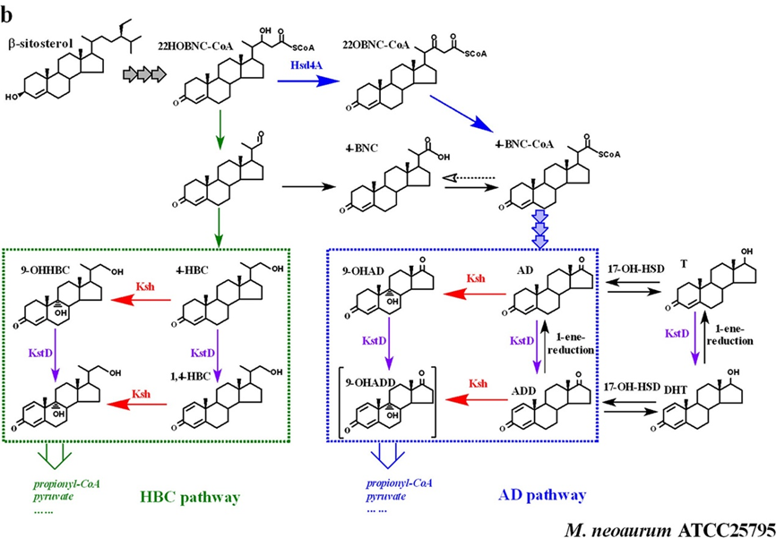
Schematic diagram of sterol catabolism
The scheme is referenced from Liu’s report as follow:
Liu, H.H., Xu, L.Q., Yao, K., Xiong, L.B., Tao, X.Y., Liu, M., Wang, F.Q., Wei, D.Z. (2018). Engineered 3-ketosteroid 9-hydroxylases in mycobacterium neoaurum: an efficient platform for production of steroid drugs. Applied and Environmental Microbiology, 84(14), e02777-17.

