Supplementary Materials
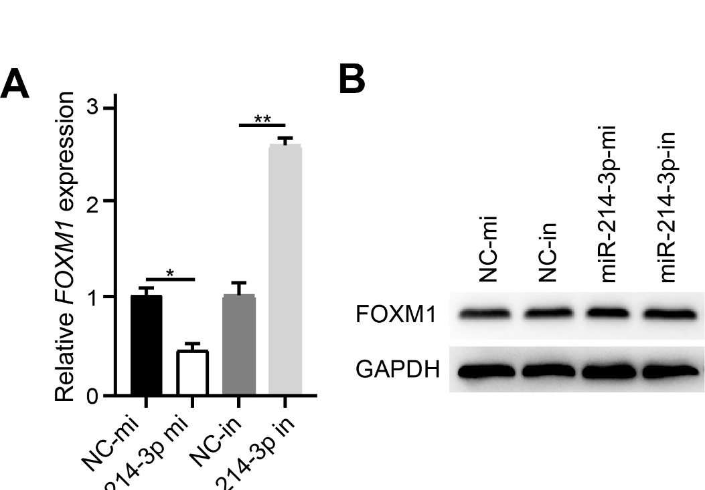
Supplementary Figure 1. FOXM1 is negatively regulated by miR-214-3p. RT-qPCR (A) and western blotting (B) analysis of FOXM1 expression in HaCaT cells transfected with NC-mi, NC-in, miR-214-3p mi, and miR-214-3p in. NC-mi was used as control to analyze the expression of FOXM1. Data are presented as mean ± s.e.m. *p < 0.05, **p < 0.01.

