Supplementary figure
Fig.S1 Forest plot of β-carotene intake and risk of hip fractures under the traditional meta-analysis approach.
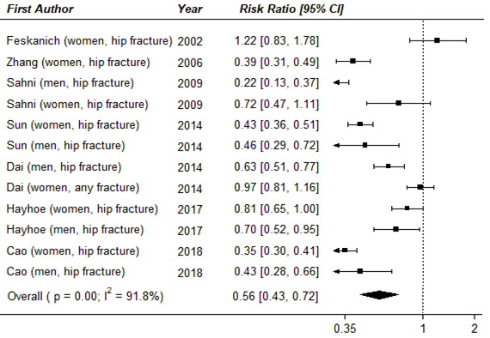

Fig.S2 Forest plot of the association between β-carotene intake and risk of fracture under the traditional meta-analysis approach, stratified analysis by geographic region.

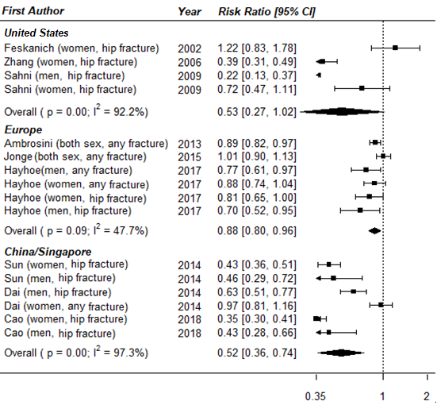

Fig.S3 Forest plot of observational studies examining the association between β-carotene intake and risk of fractures utilizing the traditional meta-analysis approach, stratified by sex.
