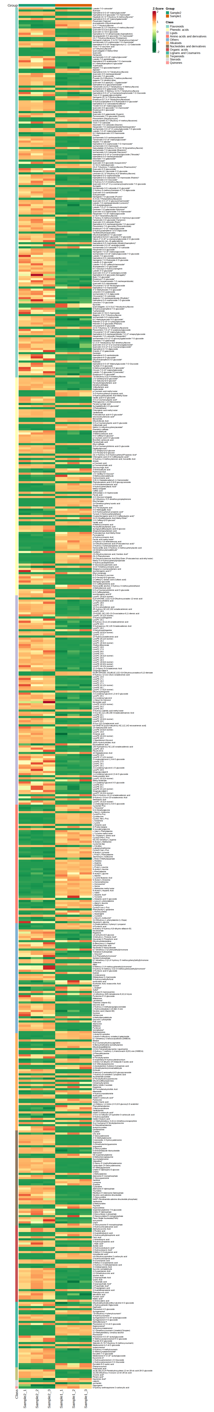
Figure S1 : Differential metabolites dynamic at a lower level after ensiling GM plant. The Z-score indicates the dynamic of the metabolite which increased with the red color and decreased with the green. Sample 1 and 2 are respectively the ensiled GM and the non-ensiled GM
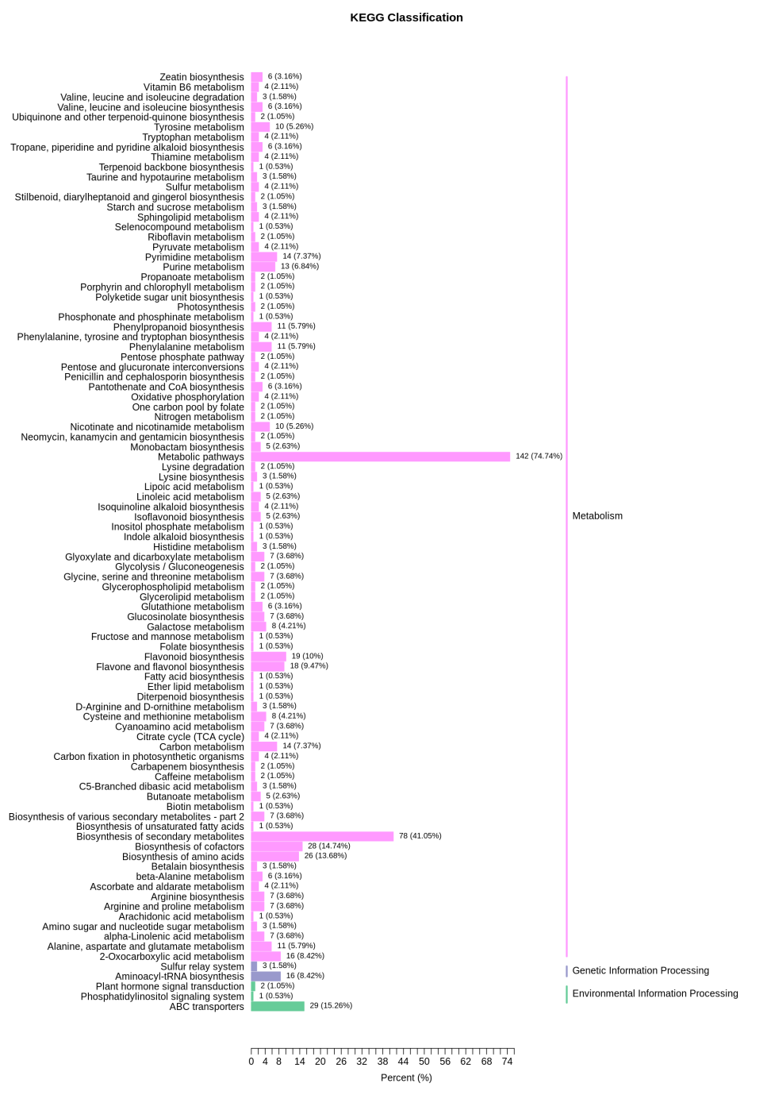
Figure S2: A detailed KEGG classification of differential metabolites.
The Y-axis shows the name of the KEGG pathway. The number of significant differential metabolites and the proportion of the total significant differential metabolites are shown next to the bar plot.

Compounds | Formula | Class I | Class II | CAS | Level | GM | Ensiled GM | VIP | P-value | FC | Log2FC | Type
3,4- DHBAEE | C9H10O4 | Phenolic acids | Phenolic acids | 3943-89-3 | 3 | 9 | 134589 | 1,08 | 3 E-3 | 14954 | 13,89 | up
2- HEPA | C2H7O4P | Organic acids | Organic acids | 22987-21-9 | 2 | 9 | 145148 | 1,08 | 9 E-3 | 16128 | 13,98 | up
3,4'-DHDMOPP | C11H14O5 | Phenolic acids | Phenolic acids | 136196-47-9 | 2 | 9 | 196220 | 1,08 | 3 E-5 | 21802 | 14,41 | up
Vnilloylmalic acid | C12H12O8 | Phenolic acids | Phenolic acids | - | 3 | 9 | 204841 | 1,08 | 23 E-4 | 22760 | 14,47 | up
Sedoheptulose | C7H14O7 | Others | Saccharides | 3019-74-7 | 2 | 9 | 889168 | 1,08 | 34 E-4 | 98796 | 16,59 | up
2-HDNB | C7H4N2O7 | Phenolic acids | Phenolic acids | 609-99-4 | 2 | 9 | 1238054 | 1,08 | 99 E-4 | 137561 | 17,06 | up
L-Arginine | C6H14N4O2 | AA&D | AA&D | 74-79-3 | 1 | 9 | 1526083 | 1,08 | 9 E-4 | 169565 | 17,37 | up
Putrescine | C4H12N2 | Alkaloids | Alkaloids | 110-60-1 | 3 | 9 | 2740104 | 1,08 | 5 E-3 | 304456 | 18,22 | up
Methyl linolenate | C19H32O2 | Lipids | Free fatty acids | 301-00-8 | 1 | 9 | 4112858 | 1,08 | 4 E-2 | 456984 | 18,80 | up
Calactin | C29H40O9 | Steroids | Cardiac glycoside | 20304-47-6 | 1 | 9 | 4934172 | 1,08 | 1 E-3 | 548241 | 19,06 | up
2'-O-Methyladenosine | C11H15N5O4 | AA&D | N&D | 2140-79-6 | 2 | 6680699 | 9 | 1,08 | 8 E-05 | 1 E-06 | 19,50 | down
Xanthosine | C10H12N4O6 | AA&D | N&D | 146-80-5 | 3 | 2165789 | 9 | 1,08 | 11 E-4 | 4 E-06 | 17,87 | down
2-HMPG | C11H21NO10S2 | Others | Glucosinolates | 28463-28-7 | 2 | 1387683 | 9 | 1,08 | 43 E-4 | 6 E-06 | 17,23 | down
IPAG | C16H23N5O5 | N&D | N&D | - | 3 | 1192949 | 9 | 1,08 | 37 E-4 | 7 E-06 | 17,02 | down
8-BN* | C17H14O2 | Others | Others | - | 1 | 904768 | 9 | 1,08 | 34 E-3 | 9 E-06 | 16,61 | down
2-PC * | C17H14O2 | Others | Chromone | 61828-53-3 | 1 | 857318 | 9 | 1,08 | 42 E-3 | 1 E-05 | 16,54 | down
MRAG | C29H36O13 | L&C | Lignans | - | 3 | 656752 | 9 | 1,08 | 28 E-4 | 1 E-05 | 16,15 | down
PGBT | C6H6O3 | Phenolic acids | Phenolic acids | 108-73-6 | 2 | 611048 | 9 | 1,08 | 1 E-3 | 1 E-05 | 16,05 | down
5-HMF | C6H6O3 | Others | AC | 67-47-0 | 2 | 521823 | 9 | 1,08 | 24 E-4 | 2 E-05 | 15,82 | down
DHCS | C19H34N4O3 | Alkaloids | Phenolamine | - | 3 | 451999 | 9 | 1,08 | 8 E-4 | 2 E-05 | 15,62 | down
Table S1: Top 10 Differential metabolites of ensiled and non-ensiled GM

VIP: Variable importance in the projection
FC: Fold_Change

3,4-DHBAEE: Dihydroxybenzoic acid ethyl ester
2-HEPA: Hydroxyethylphosphonic acid
3,4'-DHDMOPP: 3,4'-Dihydroxy-3',5'-dimethoxypropiophenone
2-HDNB: 2-Hydroxy-3,5-dinitrobenzoic acid
2-HMPG: 2-Hydroxy-2-methylpropylglucosinolate
IPAG: Isopentenyladenine-7-N-glucoside
8-BN*: 8-(Benzyloxy)-1-Naphthol*
2-PC * : 2-(2-Phenylethyl)chromone*
MRAG : Medioresinol-4'-O-(6'''-acetyl) glucoside
PGBT : Phloroglucinol; 1,3,5-Ben-Zenetriol
5-HMF: 5-Hydroxymethylfurfural
DHCS : Dihydrocaffeoylspermine
AA&D : Amino acids and derivatives
N&D : Nucleotides and derivatives
L&C : Lignans and coumarins
AC: Aldehyde compounds
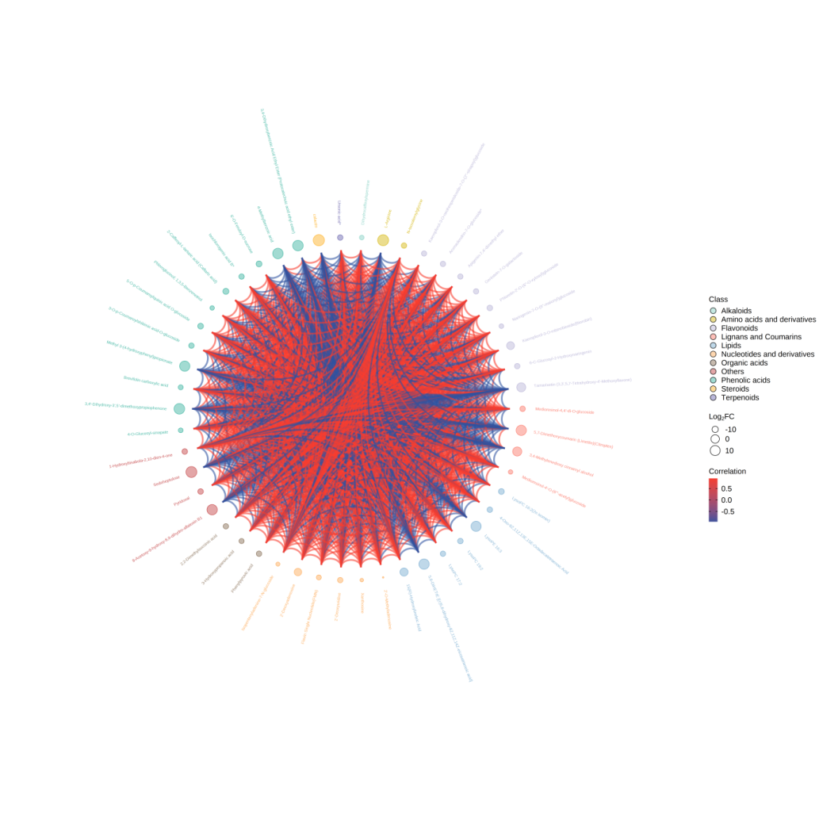
Figure S3 : Chord diagram of top 50 differential metabolites. The outermost layer shows the metabolite ID. The second layer shows log2FC value, The larger the dot, the larger the log2FC value; The color for the first and second layer represent Level 1 metabolite classification. The chords in the inner most layer reflect the Pearson correlation between the connected metabolites. Red chords represent positive correlation and the blue chords represent negative correlation. Only metabolites with |r| ≥ 0.8 and p < 0.05 are plotted.
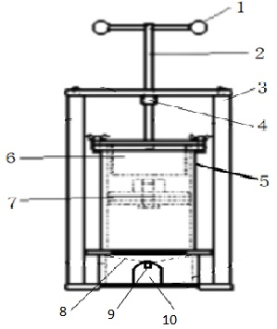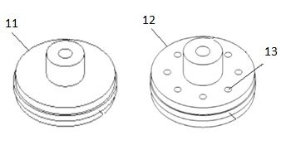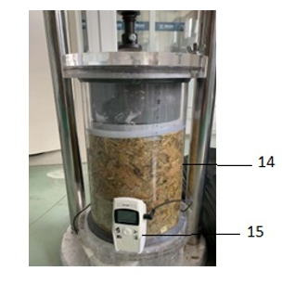

Figure S4 : New design of anaerobic can silage

The cans silage or fermentation tank (Figure S3) was built with a compressor plate (12) set on the top of the tank lid, sliding towards the bottom of the tank. The compression was ensured by a mobile and perforated plate (13) providing pressure and air removal from the tank. The compression was guided by an outer steeling device comprising a handle (1), a screw (2), a N-shaped bracket (3), a nud (4) and a bottom plate. The lower part of the tank is provided with a hole plate (8), a funnel arranged below the hole plate (9), and a water outlet (10) arranged at the bottom of the tank, led by a funnel. The tank can finally be closed with a solid lid (11), not enabling air circulation. The can was finally mounted with all the components (14) including the plant inside, with a real time thermometer (15). The fermentation tank has high compaction density, good airtightness and can retain exudate, the structure is simple, durable, reusable, low cost, easy to operate and handle.

