Supporting Information

Novel core-shell structured ironbark-like TiO₂ as fillers for excellent discharged energy density of nanocomposites
Zhijie Wu,^{1,2} Yafei Hou,^{1,2,}* Hui Chen,^{1,2} Peng Du,^{1,2} Laihui Luo,^{1,2} and Weiping Li^{1,2,}*
¹Department of Microelectronics Science and Engineering, School of Physical Science
²Laboratory of Clean Energy Storage and Conversion, Ningbo University, Ningbo, 315211, P.R. China
*Electronic mail: houyafei@nbu.edu.cn, liweiping@nbu.edu.cn

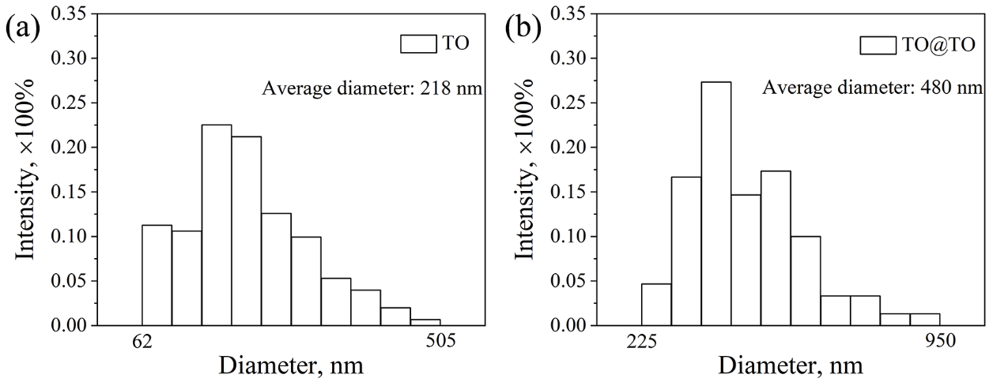
Fig. S1 Statistical analysis on the size distribution of a TO NWs, b ironbark-like TO@TO.

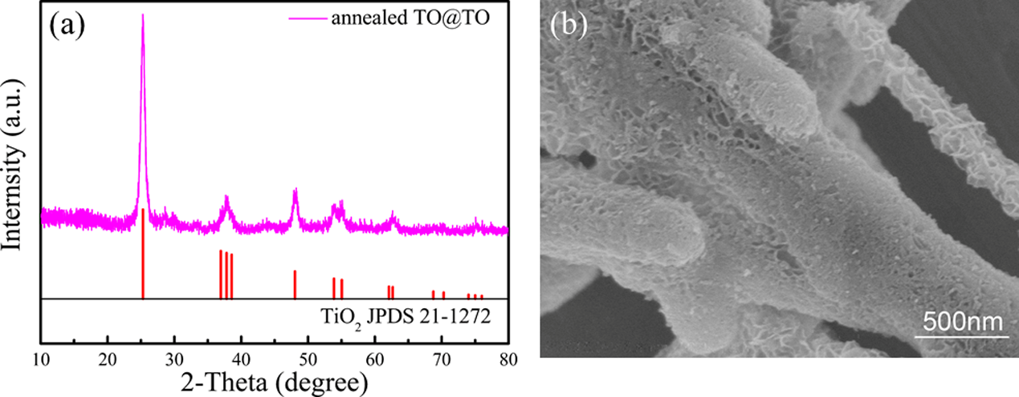

Fig. S2 a The XRD pattern and b SEM images of annealed TO@TO

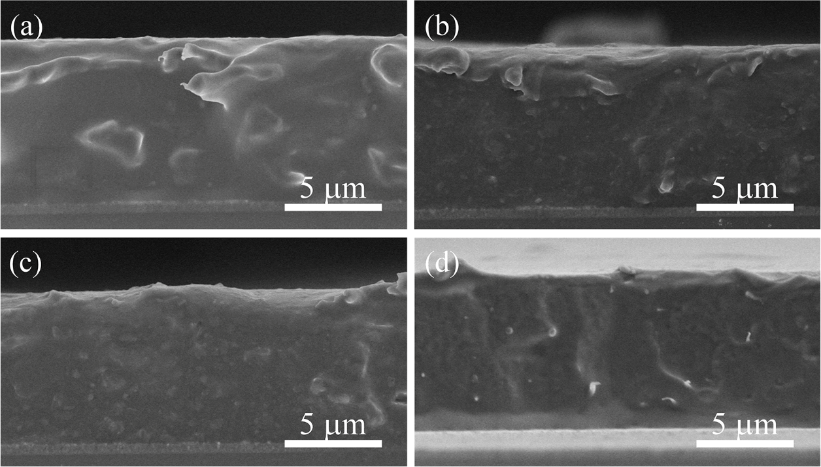
Fig. S3 SEM images of freeze-fractured cross-sectional morphology for a pure PVDF, and (b-d) x vol%
TO@TO/PVDF nanocomposite (x=0.5, 1 and 2)

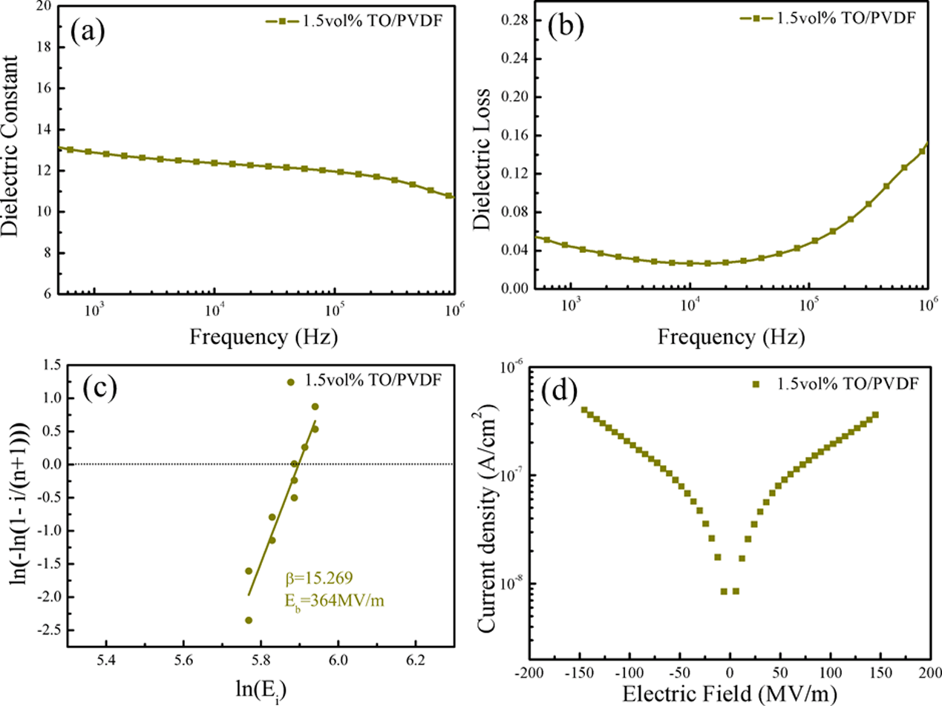

Fig. S4 Frequency dependence of a dielectric constant, b dielectric loss, c Weibull distribution, and d leakage currents of of 1.5 vol.% TO/PVDF composite film
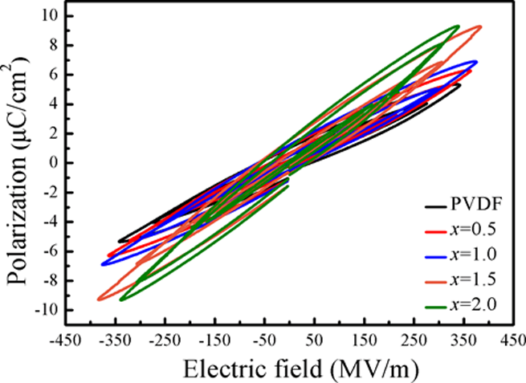

Fig. S5 P−E curves of pure PVDF and x vol.% TO@TO/PVDF composite films under different applied fields at room temperature

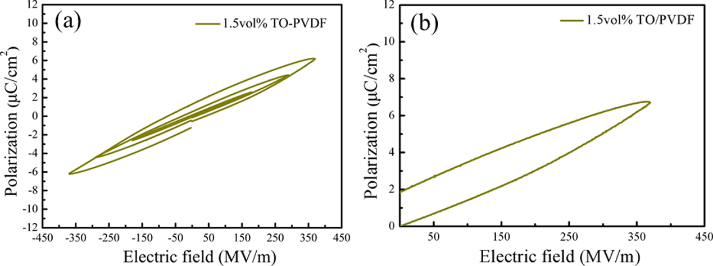

Fig. S6 a P−E curves of 1.5 vol.% TO/PVDF nanocomposite films under different applied fields, b P−E curves of 1.5 vol.% TO/PVDF nanocomposite films at the maximum applied field
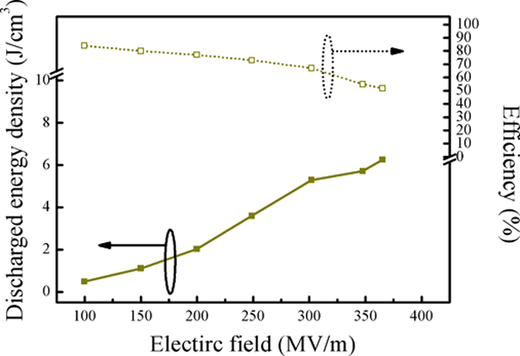

Fig. S7 Discharged energy density and discharged efficiency of 1.5 vol.% TO NWS /PVDF nanocomposite films as a function of the breakdown strength

