Supplementary Material for

Polyphenylene sulfide quasi-solid-state electrolyte for limited Li metal battery
Haitao Zhou†*¹, Chongchen Yu†¹, Hongquan Gao¹, Jianchun Wu*^{1,4}, Menghao Liu¹, Dong Hou¹, Minghui Zhang³, Zifu Xu³, Jianhong Yang¹, and De Chen*²
¹ School of Materials Science and Engineering, Jiangsu University, 212013, Jiangsu Province, P. R. China
² Department of Chemical Engineering, Norwegian University of Science and Technology, N-7491, Trondheim, Norway
³ Ampreus (Wuxi) Co., Ltd., Wuxi, 214187, Jiangsu Province, P. R. China
⁴ Key Laboratory of Radiation Physics and Technology, Ministry of Education; Institute of Nuclear Science and Technology, Sichuan University, Chengdu, 610064, P. P. China

Figs
Figure S1.
Figure S1. Formation energy versus the numbers of Cl atoms complexed with the TCBQ molecules.

Figure S2.
Figure S2. XRD patterns of the PPS powder, lithiated PPS powder, and PPS-SPEs with 5 wt% TCBQ and 6 wt% PTFE for film forming.

Figure S3.
Figure S3.The magnification of the SEM image of the PPS- SPE surface.

Figure S4.
Figure S4. The Li diffusion pathway and energy barrier on PPS exposed (200) plane surface functionalized by TCBQ.

Figure S5.
c
b
a
f
e
d
Figure S5. EIS Nyquist and Bode spectra of (a, d) all-solid-state PPS-SPE, (b, e) PPS-SPE with solvent (FEC:DEC=1:2 vol%) (c, f) PPS-QSSE with LiBF₄ in FEC: DEC=1:2 vol% (the added LiBF₄ concentration per PPS solid volume was 4.7×10⁻⁴ mol cm⁻³) for the measurement of Li ion conductivities at 25 °C.

Figure S6.

Figure S6. Galvanostatic charge/discharge (GCD) curves of the HVLCO-graphite battery using PPS-QSSE with ultralow salt concentration electrolyte (0.05 M LiBF₄ in FEC: DEC=1:2 vol%, a lean electrolyte condition of 4 μL mAh⁻¹) at 0.1 C. The cathode loadings is 2.2 mAh g⁻¹ supplied by Ampreus (Wuxi) Co., Ltd.).

Figure S7.

Figure S7. FIB-SEM of the cross-section of PPS-QSSE after cycling in LIB.

Figure S8.
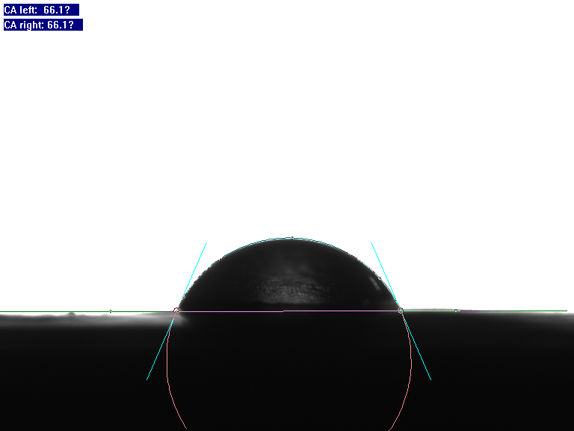
Figure S8. Electrolyte contact angle test for PPS-SPE.

Figure S9
a
b
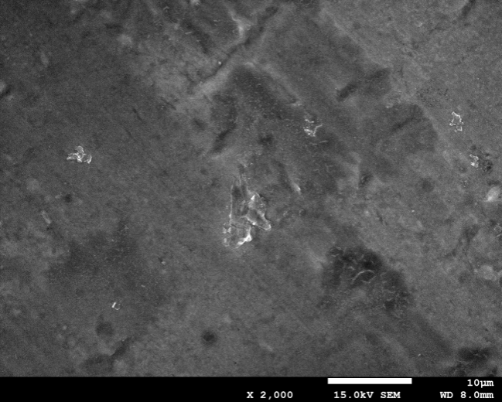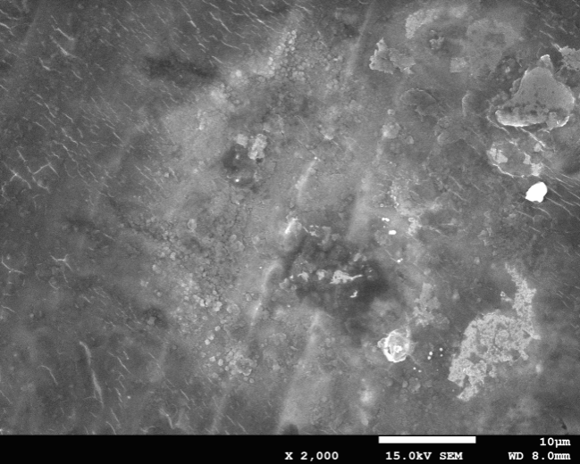
Without TCBQ
With TCBQ
d
c
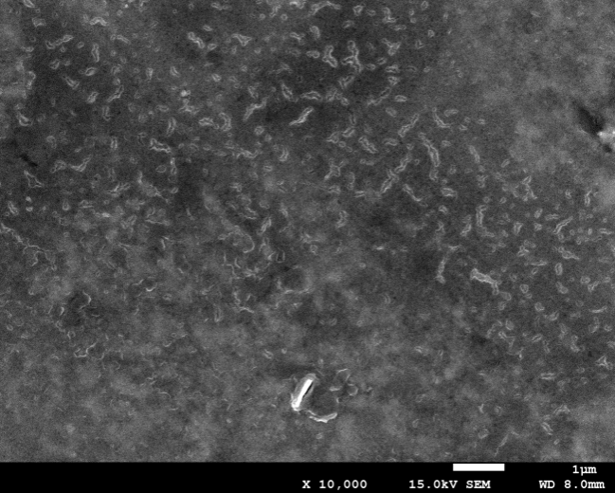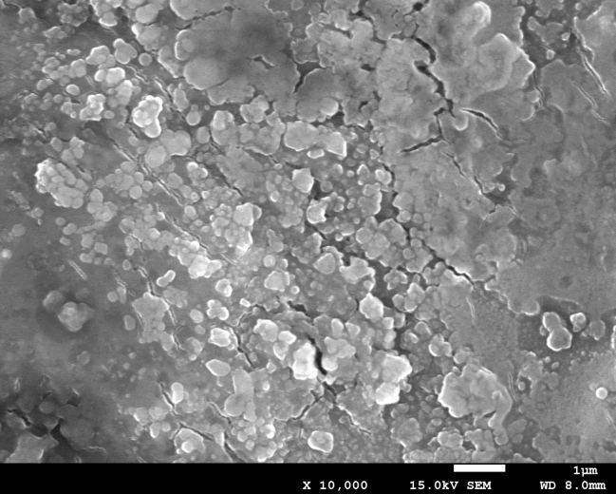
With TCBQ
Without TCBQ
f
e

Figure S9. Cycling voltammetry (CV) of Al/Li cells assembled by using PPS-QSSE (a) with and (b) without TCBQ and tested by applying the Al foil as the working electrode and Li metal as the counter and reference electrode. SEM images of the CV cycled Al foils taken out of the cells using PPS-QSSE (c) with and (d) without TCBQ. (e) High magnification SEM image of the Al sample for (c) image. (f) High magnification SEM image of the Al sample for (d) image.

Figure S10

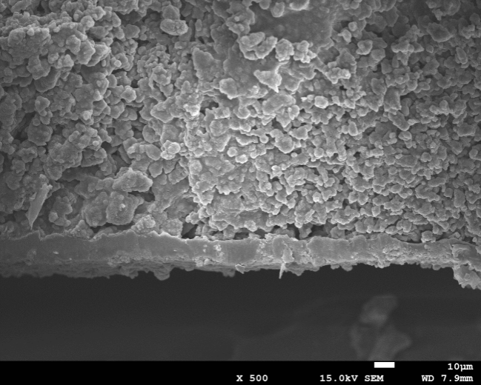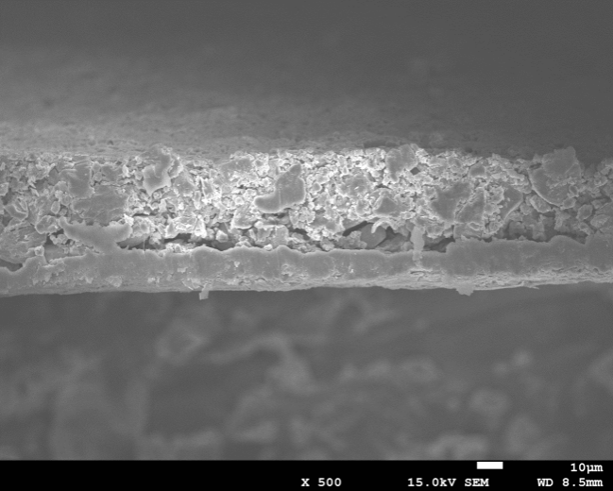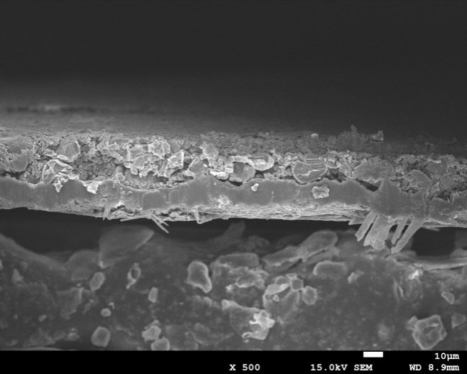
d
With PE separator
Without TCBQ
With TCBQ
c
b
a

Figure S10. SEM images of the cross-section of the HVLCO cathodes after 40 cycles in HVLCO-Li cell. (a) HVLCO cathode sample cycled with PE separator. (b) HVLCO cathode sample cycled using PPS-QSSE with TCBQ. (c) HVLCO cathode sample cycled using PPS-QSSE without TCBQ. (d) Comparison of the XPS spectra of the cycled HVLCO cathodes from the cells using PPS-QSSEs with/without TCBQ and commercial PE separator. The pulverization and corrosion on the Al current collector can be observed for the sample without TCBQ.

Figure S11
b
a

Figure S8. (a) TG and (b) DSC results of the PPS-SPE film with TCBQ with temperature range of 30-500 °C at a heating rate of 10 °C min⁻¹ under Ar atmosphere.

Figure S12

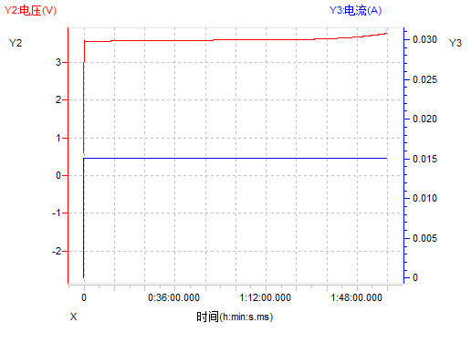
b
a

Figure S9. (a) Schematic representation of Li-plating on Cu foil procedure. After the Li-plating procedure, the LFP cathode for Li-plating will be removed and the cell was resealed for making the HVLCO-Li-Cu battery. (b) Galvanostatic charge curve of the Li-plating on Cu foil using LFP cathode.

Figure S13.
d
c
b
a
Figure S10. SEM image of Li-plating on Cu foil (a) using the PE separator with the dual-salt LiDFOB/LiBF₄ electrolyte at a current density of 1 mA cm⁻² for 2h and using the PPS-QSSE with the dual-salt electrolyte at (b) 1 mA cm⁻² for 2h, (c) 0.2 mA cm⁻² for 10h, and (d) 1 mA cm⁻² for 2h.

Figure S14

Figure S11. Galvanostatic charge and discharge (GCD) cycling of the Li–Li cells assembled with PPS-QSSE and PE with dual-salt electrolyte at 2 mA cm⁻² and constant capacity of 1 mAh cm⁻².

Figure S15.
Figure S15. GDC curves of NCM523-Li-Cu cell with the Li-plated Cu anode at 2 mA cm⁻² for 3 h (N/P =3). At the current rates of 0.1C, 0.2C, 0.4C, 0.5C and 1C, the discharge capacities were 160, 156, 148, 140 and 130 mAh g⁻¹, respectively, between 3 to 4.35 V. The 1C (3 mA cm⁻²) capacity was 81% of the value at 0.1 C.

Figure S16
Figure S16. Cycling performance of HVLCO-Li-Cu cells with PPS-QSSE and Li-plated Cu foil anodes using different plating current densities.
Figure S17
f
e
d
c
b
a
Figure S17. GCD curves changes of different solvent-free LNMO cells with PPS-QSSEs and (a) Li-plated Cu (1 mAh cm⁻²), (b) Li metal anode with thickness of 150 µm, or (c) graphite anode supplied by Ampreus (Wuxi) Co., Ltd. at 0.2 C (1 C=120 mAh g⁻¹) for long-term cycling. (d) Cycling performance of solvent-free LNMO cells with different anodes at 0.5C. GCD curves changes of different solvent-free LNMO cells with (a) anode free Cu, (b) Li metal anode with thickness of 150 µm at 0.5 C (1 C=120 mAh g⁻¹) for long-term cycling.
Figure S18
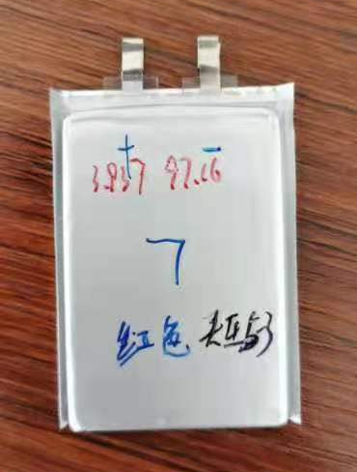
Figure S18. The demo of the 1 Ah solid-state pouch cell with PPS-QSSE electrolyte fabricated by Ampreus (Wuxi) Co., Ltd..

Table S1 Summary of the lifespan and current density for solid-state Li metal batteries with limited Li in literature
Film supporting strategy | The second penetration phase | Li anode areal capacity  (mAh cm⁻²) | Cathode areal capacity (mAh  cm⁻²) | N/P ratio (R) | Cycle life (C) | Cycling current density(charge C/discharge D) | C/R | Ref.
PPS-SPE (35 μm) | dual-salt LiDFOB/LiBF₄ electrolyte (total 4 μL cm⁻² including the Li-plating | 2 | HVLCO~ 3.5 | 0.57 | 53 | 0.5C/0.5D  1.75 Am cm⁻² | 96 | This work
 |  | 6 | NCM523~3 | 2 | 90 | 0.5C/1D  3 Am cm⁻² | 45
 |  | 30 (150 μm) | HVLCO~ 2.2 | 13.6 | 200 | 0.5C/1D  3 Am cm⁻² | 14
 |  | 0 anode free Cu | 5V LNMO~  1.5 | / | 12 | 0.2C/0.2D | /
 |  | 30 (150 μm) | 5V LNMO~  1.5 | 20 | 350 | 0.5C/0.5D  0.75 Am cm⁻² | 17.5
LiF@PiM SICs coating on Celgard 2500 (~27 μm) | LiPF₆ in  EC/DMC | 6.18 | NCM622~1.44 | 5 | 300 | 0.7C/D 1.0 mA cm⁻² | 60 | Nature Materials  (2020)¹
LLZTO–PCE(900 μm) | LiPF₆ in  EC/DEC | 0.41 | LFP~0.37 | 1.1 | 32 | 0.1C/D | 29 | Advanced Materials  (2020)²
 |  | 0.97 | LFP~0.36 | 2.7 | 67 |  | 25
 |  | 1.85 | LFP~0.35 | 5.3 | 172 |  | 32
 |  | 1.95 | LFP~0.33 | 5.9 | 186 |  | 31
 |  | 0.39 | NCM~0.33 | 1.2 | 26 |  | 22
SPI-LAGP-SPI  (~150 μm) | the SPI with LiTFSI LiBOB dual salts (100 μL, ) | 20 (100 μm ) | NCA~0.4 | 50 | 100 | 0.5C/D | 2 | Journal of Materials Chemistry A (2020)³
LAGP-PEO(150μm) | LiTFSI in DOL/DME | 50 (250 μm ) | LFP~0.68 | 73 | 100 | 0.5C/D | 1.4 | Advanced Materials  (2020)⁴
β-Li₃PS₄  (50 μm ) |  | 24 (120 μm) | NCM~1.78 | 13.5 | 211 | 0.16 C/D | 15.6 | Nature Energy (2020)⁵
LLZO(2000 μm) | PEO-LiTFSI | 2.7 | NCA~0.3 | 9 | 50 | 0.1 C/D | 5.5 | Nature Communications(2020)⁶
AlF₃-Poly-DOL | LiTFSI in EC/DMC | 5 | NCM~3 | 1.66 | 60 | 0.1 C/D | 36 | Advanced Materials  (2020)⁷
Anionic borate network polymer (~80–100 µm) |  | 150 (750 μm) | LFP~0.2 | 750 | 100 | 0.5 C/D | 0.13 | Advanced Materials  (2020)⁸
LAGP | LiFSI in TEGDME | Unclear | LFP~0.85 | / | 100 | 0.1 C/D | / | Energy Storage Materials (2019)⁹
LLZTO (400μm) | PEO/LiTFSI in acetonitrile | Unlimited Li | LFP~0.22 | / | 200 | 0.2 C/D | / | Energy Storage Materials (2019)¹⁰
LLZTO(80μm) | LiTFSI in FEC | unclear | NCM~1.68 | / | 150 | 0.1 C/D | / | Journal of Power Sources (2019)¹¹

Table S2 Summary of the lifespan and current density for liquid electrolyte Li metal batteries with limited Li in literature
Separator | Electrolyte | Li anode areal capacity  (mAh cm⁻²) | Cathode areal capacity (mAh  cm⁻²) | N/P ratio (R) | Cycle life (C) | Cycling current density (charge C/discharge D) | C/R | Ref.
Celgard 2500 (25μm) | MOF-coating on Li metal  LiPF₆ in  EC/DEC  (9 μL mAh⁻¹) | 10 | LCO~4 | 2.5 | 190 | 0.1C-0.5D | 76 | Matter  (2020)¹²
 |  | 4 |  | 1 | 120 | 0.2C-0.5D | 120
Clegard2325(25μm) | LiFSI in FDMB | 10 | NCM523~1.6 | 6 | 420 | 1/3 C/D | 70 | Nature Energy  (2020)¹³
 |  | 4 |  | 2.5 | 210 |  | 84
PE | LiFSI in TEP/BTFE(75 µL) | 10 | NCM811~4 | 2.5 | 200 | 1/10C-1/3D | 80 | Nature Energy  (2020)¹⁴
Single  glass fiber(~25μm) | LiTFSI in FEC/FDMA(70~120μL) | 5.25 | NCM811~3.5 | 1.5 | 500 | 0.25 C/D | 333 | Nature Communications  (2020)¹⁵
Clegard2250(25μm) | LiPF₆ in  EC/DMC  (20μL mAh⁻¹) | 10 | LCO~2.8 | 3.57 | 100 | 0.5 C/D | 28 | Nature Communications  (2020)¹⁶
Clegard2400(25μm) | LiPF₆ in  EC/DEC | Plating 10 mAh cm⁻² on LiTiO₃ layer | NCM811~1.5 | 6.67 | 200 | 2 C/D | 30 | Advanced Energy Materials  (2019)¹⁷
 |  |  | LMO~2.3 | 4.34 | 150 | 1 C/D | 35
Clegard2250(25μm) | LiPF₆ in  EC/DEC  (80μL) | 6 | LFP~1.53 | 3.92 | 130 | 0.1C-0.5D | 33 | Nano Lett. (2019)¹⁸
Clegard2400(25μm) | LiPF₆ in  EC/DEC  (40μL) | 9 | NCM523~3.8 | 2.37 | 120 | 0.3 C/D | 50 | Advanced Materials  (2020)¹⁹
 |  |  | NCM811~3.4 | 2.64 | 200 |  | 76
PE | LiFSI in DME/TTE(75 µL ) | 90 (450μm) | LCO~2.6 | 173 | 300 | 0.24 C 0.73 D | 1.7 | Advanced Materials  (2020)²⁰
PP | LiPF₆ in  EC/DMC/TEGDME(12 µL mAh⁻¹) | 50 (250μm) | NCM523~1 | 50 | 250 | 0.5 C/D | 5 | Small  (2020)²¹

Table S3. Typical parameters used to calculate the specific energy/energy density of LMBs

Components Parameters | Value
Cathode | HVLCO cathode | NCM523 cathode | LNMO cathode
Discharge capacity | 180 mAh g⁻¹ at 0.2 C | 160 mAh g⁻¹ at 0.2 C | 120 mAh g⁻¹ at 0.2 C
Voltage window | 3.0-4.4 V | 3.0-4.35 V | 3-4.9 V
Discharge energy | 708 Wh kg⁻¹ | 592 Wh kg⁻¹ | 564 Wh kg⁻¹
Active material loading | 96% | 96% | 75%
Area weight (each side) | 18.3 mg cm⁻² | 19.1 mg cm⁻² | 16 mg cm⁻²
Areal capacity (each side) | 3.5 mAh cm⁻² | 3 mAh cm⁻² | 1.5 mAh cm⁻²
Electrode press density | 4.2 g cm⁻³ | 3.4 g cm⁻³ | 2.4 g cm⁻³
Electrode thickness (each side) | 44 μm | 56 μm | 67 μm
Al foil thickness | 10 μm | 10 μm | 10 μm
Li anode
Specific capacity | 3,860 mAh g⁻¹ | 3,860 mAh g⁻¹ | 3,860 mAh g⁻¹
Li thickness (each side) | 15 μm | 45 μm | 0 μm
Area capacity (each side) | 2 mAh cm⁻² | 6 mAh cm⁻² | 0 mAh cm⁻²
N/P ratio | 0.57 | 3 | /
Cu foil thickness | 9 μm | 9 μm | 9 μm
Electrolyte electrolyte/capacity | 3 g Ah⁻¹ | 3 g Ah⁻¹ | 3 g Ah⁻¹
PPS-QSSE thickness | 40 μm | 40 μm | 40 μm
PPS-QSSE density | 1.2 g cm⁻³ | 1.2 g cm⁻³ | 1.2 g cm⁻³
Package foil Thickness | 115 µm | 115 µm | 115 µm
Package foil and tabs mass | 1 g | 1 g | 1 g
Cell | (1.0 Ah level) | (1.0 Ah level) | (1.0 Ah level)
Layers | 8 | 8 | 8
Average voltage | 3.9 V | 3.7 V | 4.7 V
Capacity | 1.0 Ah | 1.0 Ah | 1.0 Ah
Volume | 3.7×10⁻³ L | 5.4×10⁻³ L | 7.8×10⁻³ L
Mass | 12.4 g | 13.8 g | 22.0 g
Energy density | 1049 Wh L⁻¹ | 683 Wh L⁻¹ | 602 Wh L⁻¹
Specific energy | 318.6 Wh kg⁻¹ | 267.9 Wh kg⁻¹ | 213 Wh kg⁻¹

Reference

1 Fu, C. et al. Universal chemomechanical design rules for solid-ion conductors to prevent dendrite formation in lithium metal batteries. Nature Materials 19, 758-766, doi:10.1038/s41563-020-0655-2 (2020).
2 Chen, S. et al. All-Solid-State Batteries with a Limited Lithium Metal Anode at Room Temperature using a Garnet-Based Electrolyte. Advanced Materials n/a, 2002325, doi:https://doi.org/10.1002/adma.202002325 (2020).
3 Cheng, Z. et al. An in situ solidifying strategy enabling high-voltage all-solid-state Li-metal batteries operating at room temperature. Journal of Materials Chemistry A, doi:10.1039/D0TA08590A (2020).
4 Li, A. et al. Nacre-Inspired Composite Electrolytes for Load-Bearing Solid-State Lithium-Metal Batteries. Advanced Materials 32, 1905517, doi:https://doi.org/10.1002/adma.201905517 (2020).
5 Randau, S. et al. Benchmarking the performance of all-solid-state lithium batteries. Nature Energy 5, 259-270, doi:10.1038/s41560-020-0565-1 (2020).
6 Wang, M. J., Carmona, E., Gupta, A., Albertus, P. & Sakamoto, J. Enabling “lithium-free” manufacturing of pure lithium metal solid-state batteries through in situ plating. Nature Communications 11, 5201, doi:10.1038/s41467-020-19004-4 (2020).
7 Zhao, C.-Z. et al. Rechargeable Lithium Metal Batteries with an In-Built Solid-State Polymer Electrolyte and a High Voltage/Loading Ni-Rich Layered Cathode. Advanced Materials 32, 1905629, doi:https://doi.org/10.1002/adma.201905629 (2020).
8 Shin, D.-M. et al. A Single-Ion Conducting Borate Network Polymer as a Viable Quasi-Solid Electrolyte for Lithium Metal Batteries. Adv. Mater. 32, 1905771, doi:https://doi.org/10.1002/adma.201905771 (2020).
9 Liu, Q. et al. Enhanced ionic conductivity and interface stability of hybrid solid-state polymer electrolyte for rechargeable lithium metal batteries. Energy Storage Materials 23, 105-111, doi:https://doi.org/10.1016/j.ensm.2019.05.023 (2019).
10 Chi, S.-S. et al. Solid polymer electrolyte soft interface layer with 3D lithium anode for all-solid-state lithium batteries. Energy Storage Materials 17, 309-316, doi:https://doi.org/10.1016/j.ensm.2018.07.004 (2019).
11 Zhang, B. et al. Solid-state lithium metal batteries enabled with high loading composite cathode materials and ceramic-based composite electrolytes. Journal of Power Sources 442, 227230, doi:https://doi.org/10.1016/j.jpowsour.2019.227230 (2019).
12 Xu, Y. et al. Ion-Transport-Rectifying Layer Enables Li-Metal Batteries with High Energy Density. Matter 3, 1685-1700, doi:https://doi.org/10.1016/j.matt.2020.08.011 (2020).
13 Yu, Z. et al. Molecular design for electrolyte solvents enabling energy-dense and long-cycling lithium metal batteries. Nature Energy 5, 526-533, doi:10.1038/s41560-020-0634-5 (2020).
14 Xiao, J. et al. Understanding and applying coulombic efficiency in lithium metal batteries. Nature Energy 5, 561-568, doi:10.1038/s41560-020-0648-z (2020).
15 Wang, Q. et al. Interface chemistry of an amide electrolyte for highly reversible lithium metal batteries. Nature Communications 11, 4188, doi:10.1038/s41467-020-17976-x (2020).
16 Yin, Y.-C. et al. Metal chloride perovskite thin film based interfacial layer for shielding lithium metal from liquid electrolyte. Nature Communications 11, 1761, doi:10.1038/s41467-020-15643-9 (2020).
17 Lee, J., Shin, M., Hong, D. & Park, S. Efficient Li-Ion-Conductive Layer for the Realization of Highly Stable High-Voltage and High-Capacity Lithium Metal Batteries. Advanced Energy Materials 9, 1803722, doi:10.1002/aenm.201803722 (2019).
18 Wang, H. et al. Wrinkled Graphene Cages as Hosts for High-Capacity Li Metal Anodes Shown by Cryogenic Electron Microscopy. Nano Letters 19, 1326-1335, doi:10.1021/acs.nanolett.8b04906 (2019).
19 Zhang, W. et al. Colossal Granular Lithium Deposits Enabled by the Grain-Coarsening Effect for High-Efficiency Lithium Metal Full Batteries. Advanced Materials 32, 2001740, doi:https://doi.org/10.1002/adma.202001740 (2020).
20 Ren, X. et al. Designing Advanced In Situ Electrode/Electrolyte Interphases for Wide Temperature Operation of 4.5 V Li||LiCoO2 Batteries. Advanced Materials n/a, 2004898, doi:https://doi.org/10.1002/adma.202004898 (2020).
21 Xiao, D. et al. Regulating the Li+-Solvation Structure of Ester Electrolyte for High-Energy-Density Lithium Metal Batteries. Small 16, 2004688, doi:https://doi.org/10.1002/smll.202004688 (2020).

* Email: [haitao19850@ujs.edu.cn] (H. Zhou); [jcwu@ujs.edu.cn] (J.Wu); Postal address: School of Materials Science and Engineering, Jiangsu University, No. 301, Xuefu Road, Zhenjiang, 212013, Jiangsu Province, (P. R. China) Tel. +86 0511 88780856 Fax: +86 0511 88780856 Email: [de.chen@ntnu.no] (D. Chen) Postal address: Department of Chemical Engineering, Norwegian University of Science and Technology, N-7491, Trondheim, Norway. E-mail: de.chen@ntnu.no; Fax: +47 735 95047; Tel: +47 735 93149 † Dr. H. Zhou and Chongchen Yu contributed equally to this work.

