Mercury uptake by Paspalum distichum L in relation to the mercury distribution pattern in rhizosphere soil
Su Xu¹, Ping Gong^{1#}, Wen Ding¹, Shengchun Wu^{1,2}, Xinwei Yu^{3**}, Peng Liang^{1,2*}

¹School of Environmental and Resource Sciences, Zhejiang A&F University, Lin’an, Zhejiang Province 311300, China
²Key Laboratory of Soil Contamination Bioremediation of Zhejiang Province, Zhejiang A&F University, Lin’an, Zhejiang Province 311300, China
³Key Laboratory of Health Risk Factors for Seafood of Zhejiang Province, Zhoushan Municipal
Center for Disease Control and Prevention, Zhoushan 316021, China

*Corresponding author. E-mail: liangpeng@zafu.edu.cn (Peng Liang); tel.: +86-571-58602246; fax: +86-571-63740889

**Co-Corresponding author. E-mail: xwyu0716@163.com (Xinwei Yu); tel.: +86-580-2080950; fax: +86-580-2080950

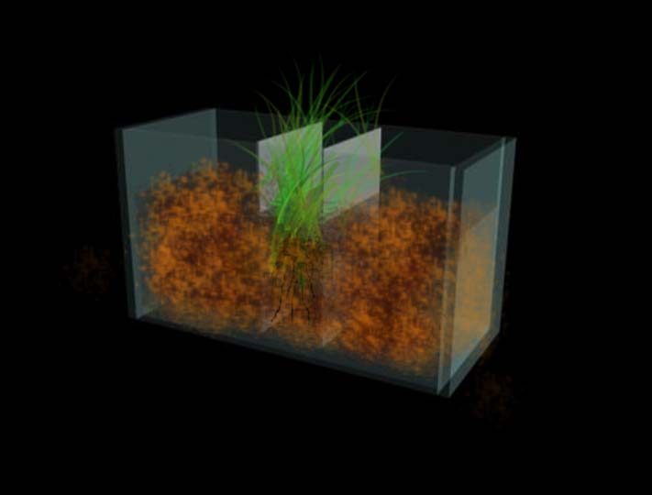
Fig. S1 Structure of rhizosphere box

Fig. S2 Chemical fraction of Hg in two kinds of soil (A:GXS; B HZS)

Fig. S3 Soil pH value during the sampling period with five horizontal distribution gradients in two kinds of soil. (A: GXS; B: HZS)

Fig. S4 Soil DOC concentrations during the sampling period with five horizontal distribution gradients in two kinds of soil. (A: GXS; B: HZS)

