Supporting Information

*for*

**Ambient Environment Adaptive Elastomer Constructed by Microphase Separation and Segment Complexation of Triblock Copolymers**

*Weijie Wang*, *Caihong Zhang*, *Hao Huang*, *Bing Xue, Shuguang Yang \**

State Key Laboratory for Modification of Chemical Fibers and Polymer Materials, Center for Advanced Low-dimension Materials, College of Materials Science and Engineering, Donghua University, Shanghai 201620, P. R. China

*To whom correspondence should be addressed: [shgyang@dhu.edu.cn](mailto:shgyang@dhu.edu.cn)

**Table of Contents**

**1. Supporting Video**

**Video S1** Drawing of SAS/SES (A3E) complex.

**Video S2** Swing of SAS/SES (A3E) strip when the finger approached.

**2. Experiment Section**

**Material**

**Synthesis process**

**Scheme S1** Synthesis route for SAS and SES triblock copolymers.

**Characterization**

**Table S1** Molecular information of SAS and SES triblock copolymers.

**3. Supporting Figures**

**Figure S1**GPC evolution curves of the different molecular weight PS-PtBA-PS triblock copolymers.

**Figure S2** FT-IR spectra of triblock copolymer PS-PtBA-PS and SAS triblock copolymers.

**Figure S3** 1H NMR spectra of SAS.

**Figure S4** GPC evolution curve of SES.

**Figure S5** SAXS curves of triblock copolymers **a)** SES and **b)** SAS.

**Figure S6 a)** Stress-strain curves and **b)** IR spectra of SAS/SES complexes before and after alkaline solution (pH 13) treatment.

**Figure S7** TGA curves of SAS/SES complex (A3E) incubated with different humidity at 25 ℃.

**Figure S8** Damping capacity in each cycle as a function of strain at relative humidity RH 25%, RH 55%, and RH 90% conditions.

**2. Experimental Section**

***Materials.*** N3-PEO40k-N3 was purchased from Sinopeg Chemical Reagent Co. with the molecular weight *M*n = 40 000 and PDI = 1.01. 3-Butyn-1-ol (98%), 4-dimethylaminopyridine (DMAP, 98%), *N,N′*-diisopropylcarbodiimide (DIPC, 98%), *N,N,N′,N″,N″*-pentamethyl diethylenetriamine (PMDETA, 95%) were purchased from Adamas and used as received. Trifluoroacetic acid (TFA, 98%), 1,4-dioxane (99%), were purchased from Greagent and used with no further purification. Toluene and dichloromethane (DCM) were treated by solvent purification system. CuBr (98%, Maklin) was washed with acetic acid and acetone, filtered and stored under nitrogen atmosphere. 2,2'-Azobis(2-methylpropionitrile) (AIBN, 98%, Macklin) was recrystallized with ethanol. Styrene (99%, Aladdin) and *tert*-butyl acrylate (98%, Macklin) were purified by passing a basic alumina column. *S*-1-Dodecyl-*S'*-(*α*,*α*'-dimethyl-*α*''-acetic acid) trithiocarbonate (RAFT-COOH) and *S,S'*-bis(*α*,*α*'-dimethyl-*α*''-acetic acid)-trithioccarbonate (HOOC-RAFT-COOH) were prepared referring the reported reference.[1]

***Synthesis process***

Triblock copolymers polystyrene-*b*-poly(acrylic acid)-*b*-polystyrene (SAS) and polystyrene-*b*-poly(ethylene oxide)-*b*-polystyrene (SES) were synthesized apply reversible addition fragmentation chain transfer (RAFT) polymerization. The synthesis routes for SAS and SES are shown in **Scheme S1**. SAS triblock copolymers were prepared by hydrolysis of the PS-PtBA-PS triblock copolymers. The PS-PtBA-PS triblock copolymers were synthesized by two steps RAFT polymerization. First, by RAFT polymerizing styrene to obtain the macromolecular RAFT agent PS-RAFT-PS. Then polymerizing *tert*-butyl acrylate to obtain PS-PtBA-PS triblock copolymer. SES triblock copolymer was prepared by first synthesis the RAFT-PEO-RAFT macromolecular RAFT agent by “click chemistry”, then obtained the target SES by polymerizing styrene.

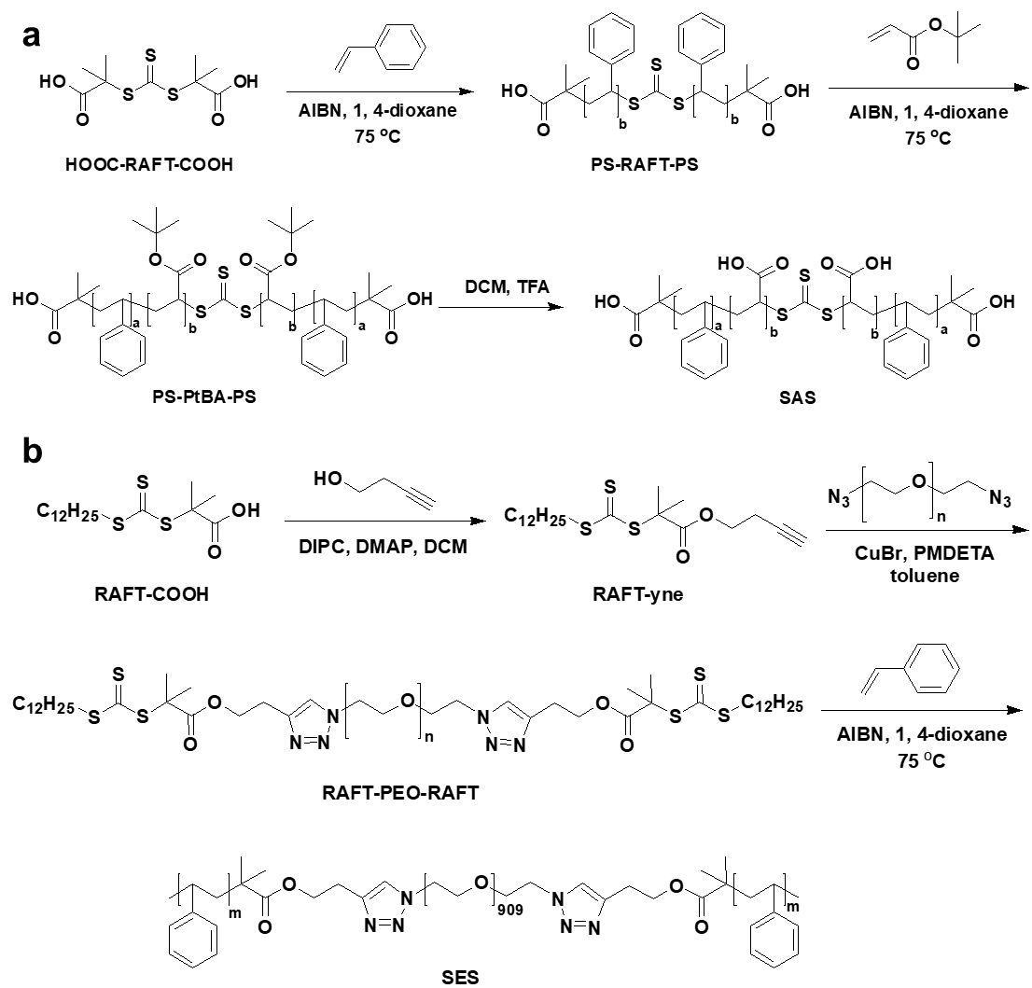

**Scheme S1** Synthesis route for SAS and SES triblock copolymers.

***Characterization.***

*1H Nuclear Magnetic Resonance (1H NMR)* spectra were acquired using DMSO and DMF as co-solvent (99% D, J&K Chemicals) with a Bruker 600 MHz NMR spectrometer. The 1H NMR spectra were referenced to the residual proton impurities in DMSO at *δ* 2.5 ppm.

*Gel Permeation Chromatography (GPC)* was performed using Waters Instrument (515/2410/2487) with THF as the eluent at a flow rate of 1.0 mL min-1 at 40 ℃ and using polystyrenes as standards.

*Fourier Transform Infrared* (FT-IR) spectra were recorded on a Bruker spectrometer (Vertex 70) with a Single-Bounce ATR attachment.

**The results of the synthesis**

The structure of target triblock copolymers SAS was confirmed by GPC, FT-IR, and 1H NMR (**Figure S1-S3**). The GPC evolution curves are monodispersed, indicating the correct of PS-PtBA-PS triblock. In the FT-IR spectra, the C=O absorbance peak shifted from 1721 cm-1 to 1697 cm-1, and the *tert*-butyl groups disappeared at 1365 cm-1. In addition, in 1H NMR spectra, the peak of the *tert*-butyl groups at around 1.40 ppm disappeared. The IR and NMR result illustrate the *tert*-butyl groups are hydrolyzed. GPC curve of SES triblock copolymer shows a monodisperse peak (**Figure S4**), meaning the accuracy of SES triblock. The molecular information of SAS and SES triblock copolymers is shown in **Table S1**.

**Table S1** Molecular information of SAS and SES triblock copolymers.

|  |  |  |  |
| --- | --- | --- | --- |
| **No.** | **Block information** | **PDI** | **PS fraction (wt.%)** |
| A1 | S10kA28kS10k | 1.49 | 42 |
| A2 | S10kA52kS10k | 1.60 | 28 |
| A3 | S10kA65kS10k | 1.57 | 24 |
| A4 | S10kA120kS10k | 1.61 | 14 |
| E | S15kE40kS15k | 1.09 | 43 |

**3. Supporting Figures**



**Figure S1** GPC evolution curves of the different molecular weight PS-PtBA-PS triblock copolymers.



**Figure S2** FT-IR spectra of triblock copolymer PS-PtBA-PS and SAS triblock copolymers.

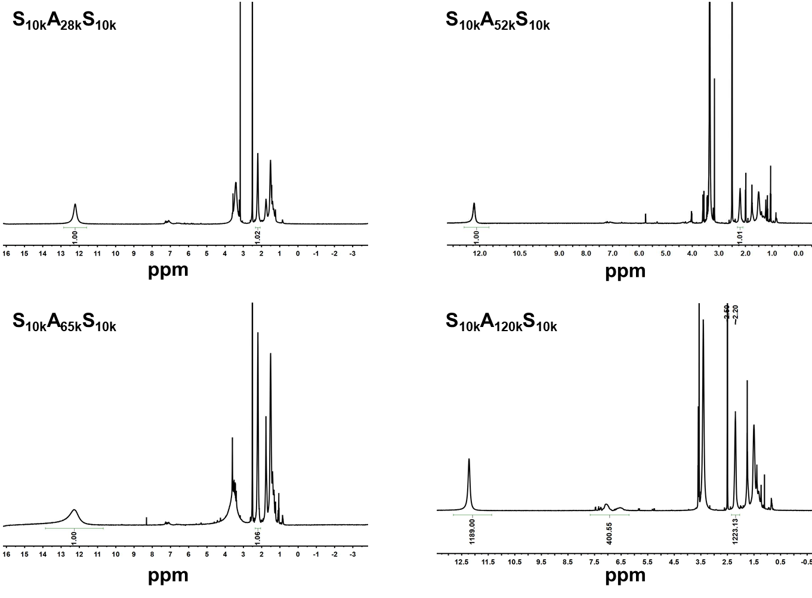

**Figure S3** 1H NMR spectra of SAS.



**Figure S4** GPC evolution curve of SES.

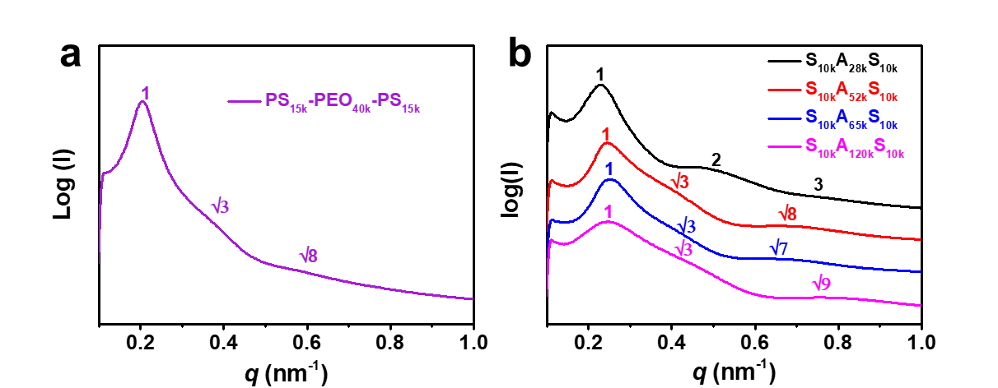

**Figure S5** SAXS curves of triblock copolymers **a)** SES and **b)** SAS.

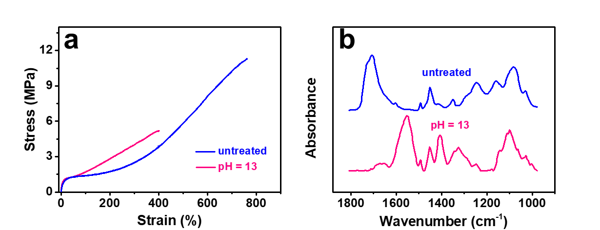

**Figure S6 a)** Stress-strain curves and **b)** IR spectra of SAS/SES complex (A3E) before and after alkaline solution (pH 13) treatment.



**Figure S7** TGA curves of SAS/SES complex (A3E) incubated with different humidity at 25 ℃.



**Figure S8** Damping capacity in each cycle as a function of strain at relative humidity RH 25%, RH 55%, and RH 90% conditions, which indicates the ability to absorb energy of elastomer A3E.

**Reference**

[1] J. T. Lai, D. Filla, R. Shea, *Macromolecules* **2002**, *35*, 6754.