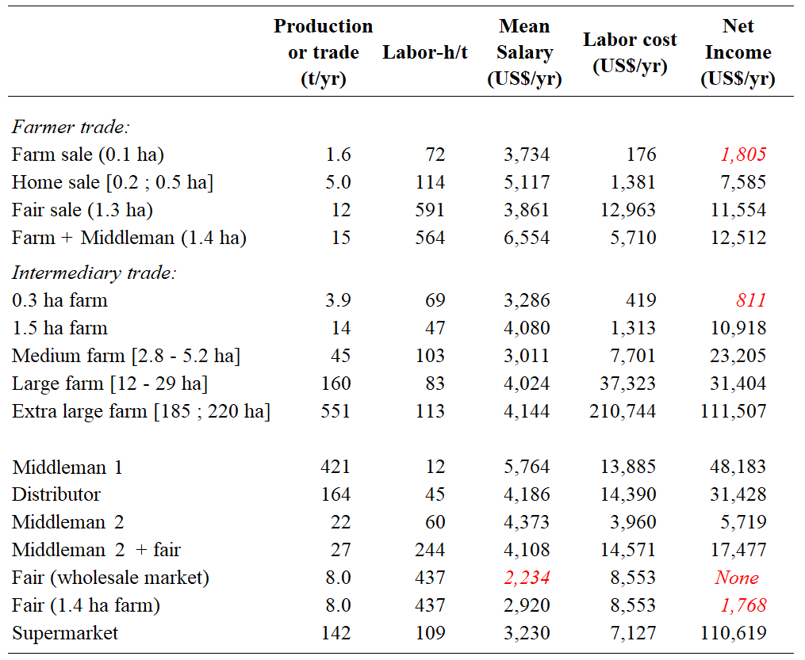
Table 1. Production or trade, labor-h/t required and mean intermediary wages, total labor costs and income for each stakeholder in the tambatinga supply chain. Values in red represent mean salaries or net incomes lower than the minimum annual salary in Brazil, which was US$ 2,537.00 in 2016. The word “Fair” refers to open-air markets.
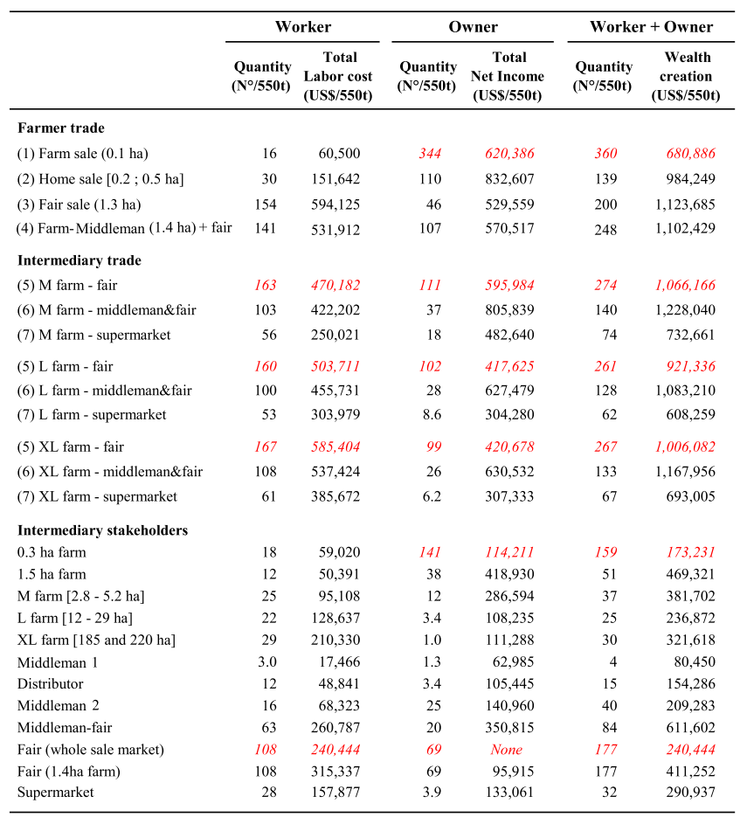
Table 2. Economic outcomes to produce 550 t of fish through 7 different supply chains.
Worker quantity is the number of workers and owners working 44 hours/week required to produce or sell 550 t of fish. Total labor cost is the sum of all the workers’ salaries, including social insurance computed as 42% of the total salary of permanent workers, required to produce 550 t. Owner quantity is the number of farms’ and intermediaries’ owners required/550t. Total net income is the sum of the net income of farms and intermediaries required /550t. Wealth creation is the sum of the total labor costs and owner net income. Red numbers stand for workers’ wage or owner’s net income below the minimum salary in Brazil. The word “Fair” refers to open-air markets.

