The ARRIVE Guidelines Checklist
Animal Research: Reporting In Vivo Experiments
Carol Kilkenny¹, William J Browne², Innes C Cuthill³, Michael Emerson⁴ and Douglas G Altman⁵
¹The National Centre for the Replacement, Refinement and Reduction of Animals in Research, London, UK, ²School of Veterinary Science, University of Bristol, Bristol, UK, ³School of Biological Sciences, University of Bristol, Bristol, UK, ⁴National Heart and Lung Institute, Imperial College London, UK, ⁵Centre for Statistics in Medicine, University of Oxford, Oxford, UK.

 |  | ITEM | RECOMMENDATION | Section/  Paragraph
 |  |  |  | Title
 |  |  |  | Abstract
 | INTRODUCTION
 | 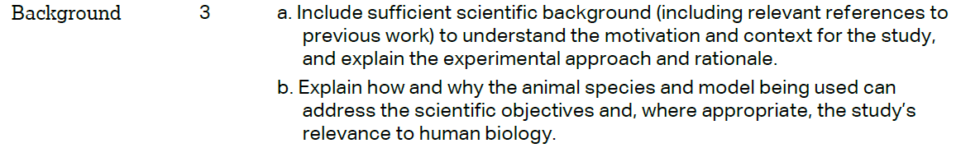 |  |  | Section “Background”  Paragraphs 1-3  Paragraphs 4
Section “Background”
Paragraphs 5
 | METHODS
Section “Methods”
Paragraphs 2
 | 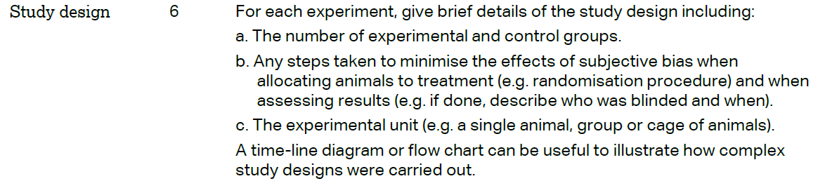 |  |  | Section “Methods”  Paragraphs 3
 | 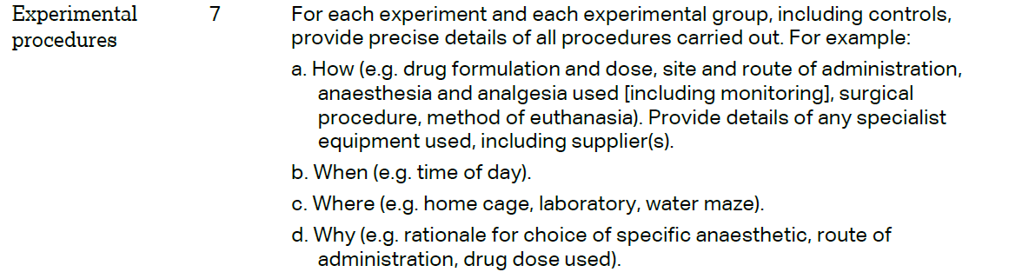 |  |  | Section “Methods”  Paragraphs 4-7
 | 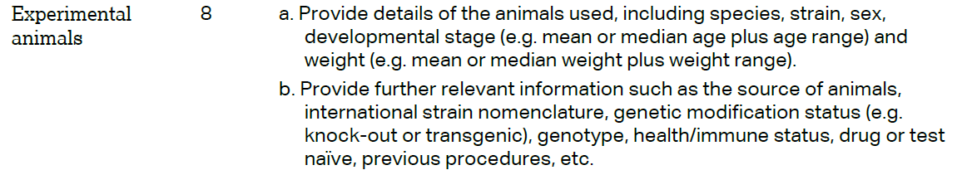 |  |  | Section “Methods”  Paragraphs 1
The ARRIVE guidelines. Originally published in PLoS Biology, June 2010¹
 | 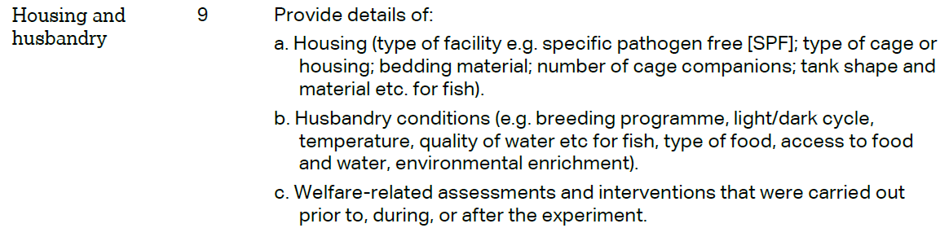 | Section “Methods”  Paragraphs 1
 | 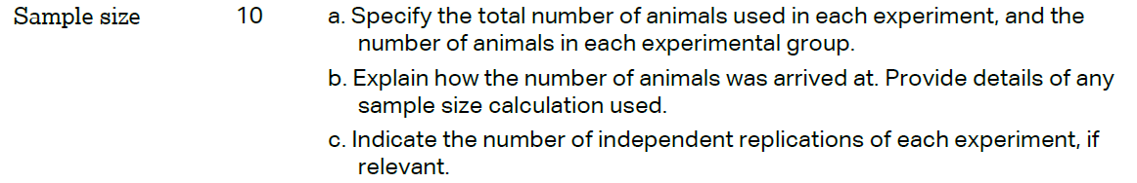 | Section “Methods”  Paragraphs 1
 | 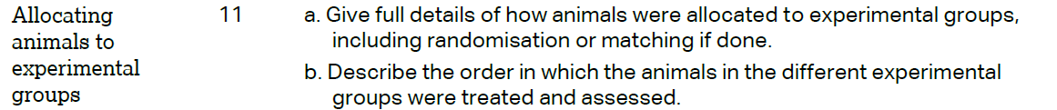 | Section “Methods”  Paragraphs 1
Section “Methods”
Paragraphs 5-13
 | 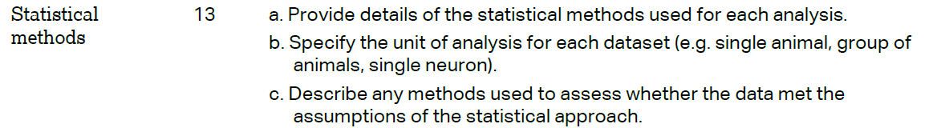 | Section “Methods”  Paragraphs 14
 | RESULTS
Section “Results”
Paragraphs 2
Section “Results”
Paragraphs 3-6, 8-13
Section “Results”
Paragraphs 3-6, 8-13
 |  | N/A
 | DISCUSSION
 | 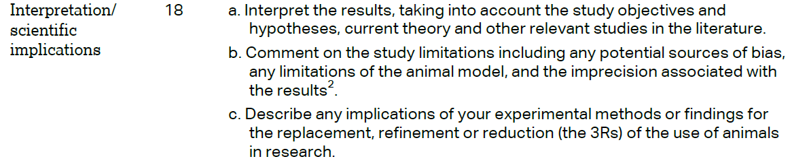 | Section “Discussion”  Paragraphs 1-6
 |  | N/A
Section
“Declaration”
Paragraphs 5
