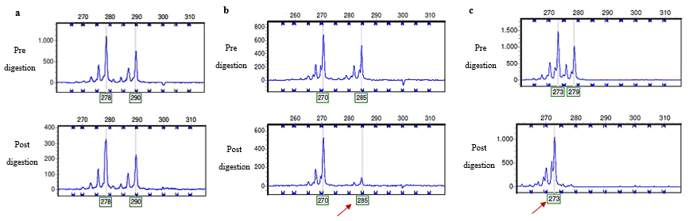

Supplementary Figure 1. Types of X-chromosome inactivation identified in the cohort.
(a) Heterozygous females with random X chromosome inactivation (50:50); it is possible to visualize both allele peaks in the pre- and postdigestion analyses; however, the height difference between the postdigestion peaks indicates that one of the chromosomes is preferentially active (blue arrow).
(b) Heterozygous females with skewed X chromosome inactivation (90:10); it is possible to visualize both allele peaks in the pre- and postdigestion analyses; however, the height difference between the postdigestion peaks indicates that one of the chromosomes is preferentially active (red arrow).
(c) Heterozygous female with a complete skewing of the X chromosome inactivation (100:0); both allele peaks are visible in the pre-digestion analysis, but only one peak is present in the post-digestion analysis, representing the allele located in the inactive X chromosome (red arrow).

Figure SEQ Figura \* ARABIC 2. Sanger sequencing for variant validation plus segregation analyses. In all cases, the variant was validated in heterozygous state (a-h). In three cases, parents were not available (a-c). In five cases, Sanger sequencing was performed in genomic samples of the trio (proband, mother and father) for validation and segregation analysis, and all variants were de novo (d-h).

