Copper nanoparticles hold promise in the effective management of maize diseases without impairing environmental health

Lham Dorjee¹, Robin Gogoi¹, Rajesh Kumar², Deeba Kameel¹, Ankita Verma²
¹Division of Plant Pathology, ²Division of Agricultural Chemicals
ICAR-Indian Agricultural Research Institute, New Delhi-110 012, India
Corresponding author’s email: r.gogoiiari@gmail.com

Supplementary Figure 1 Concentration-dependent percent growth inhibition of (A) Rhizoctonia solani f. sp. sasakii, (B) Bipolaris maydis, (C) Fusarium verticillioides, (D) Macrophomina phaseolina, and (E) Sclerotium roflsii in vitro exposed to chemically synthesized copper nanoparticles. Data (Mean±Standard errors) with different letters are significant in each graph (ANOVA, LSD, P≤0.01)

(A)

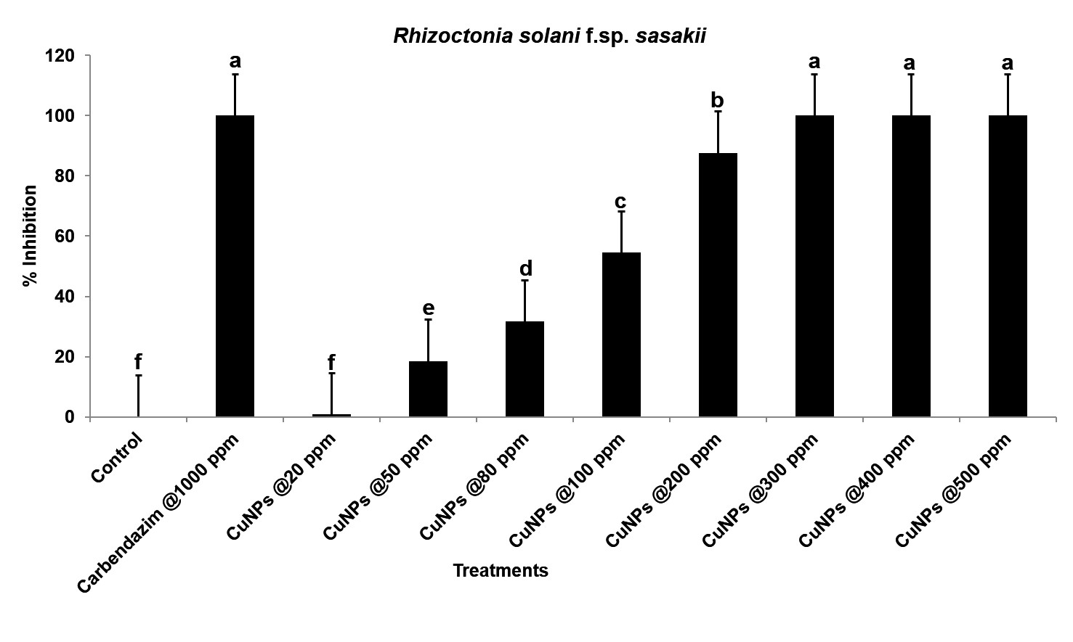

(B)

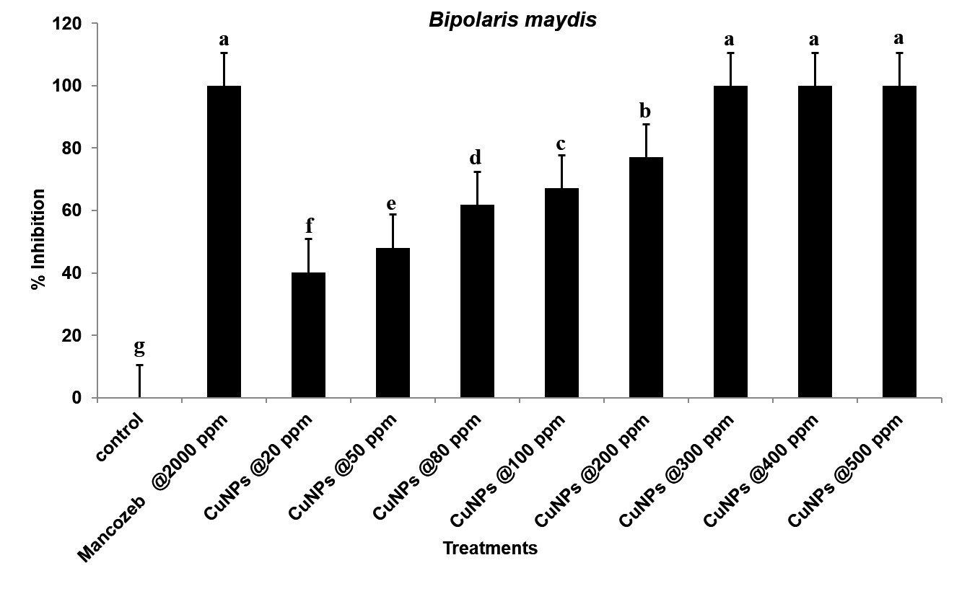
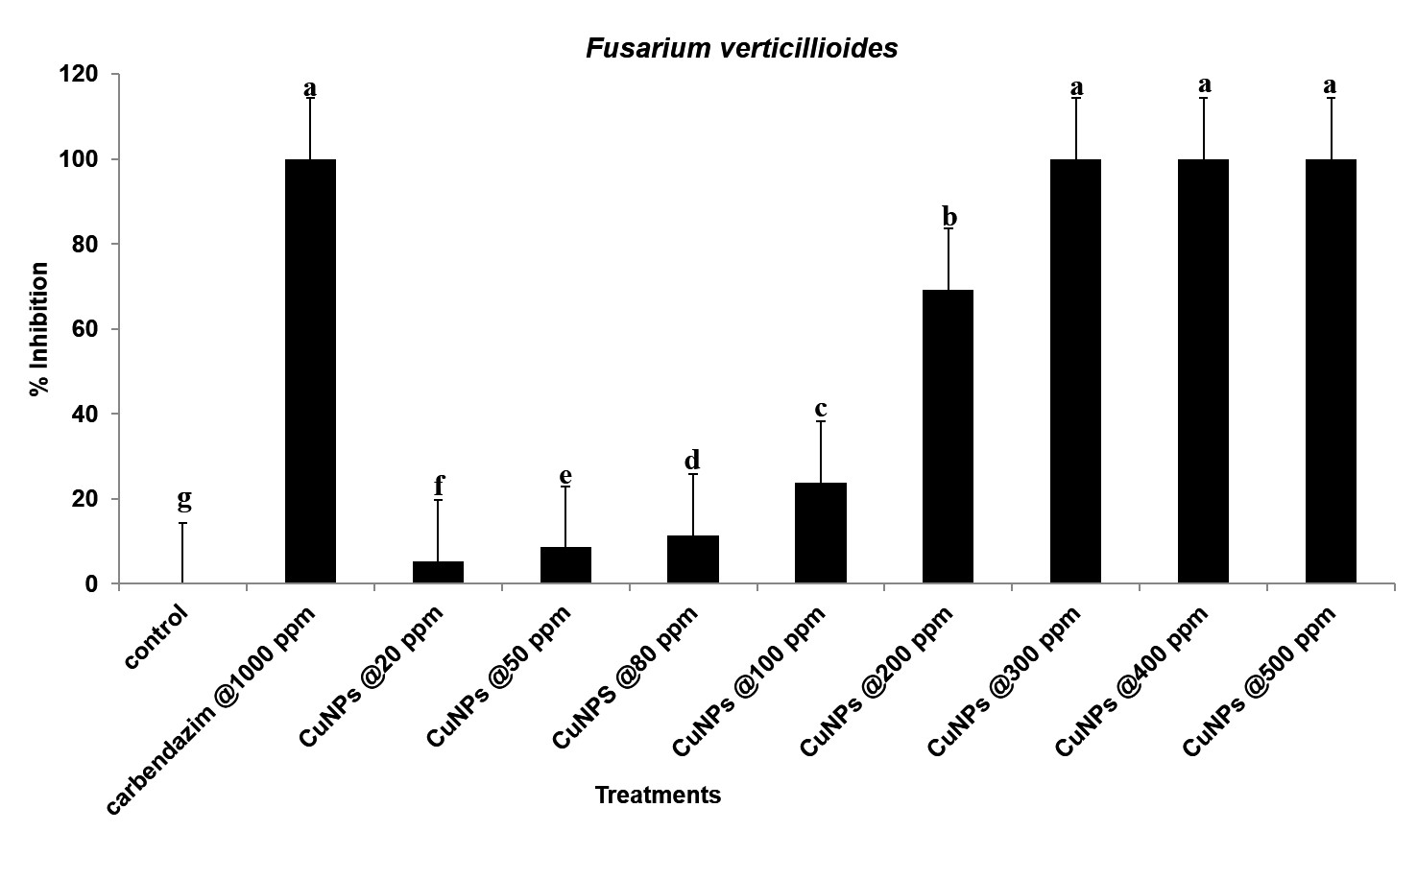
(C)

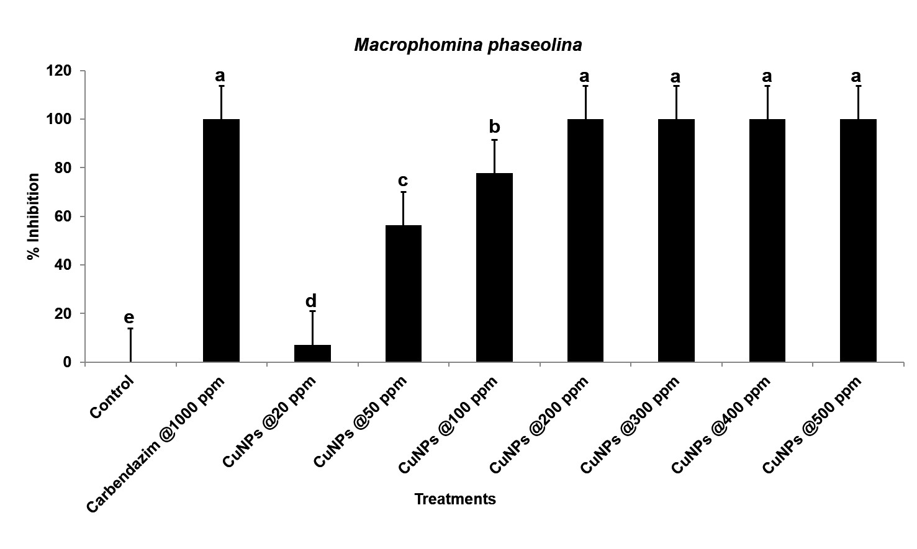
(D)

(E)
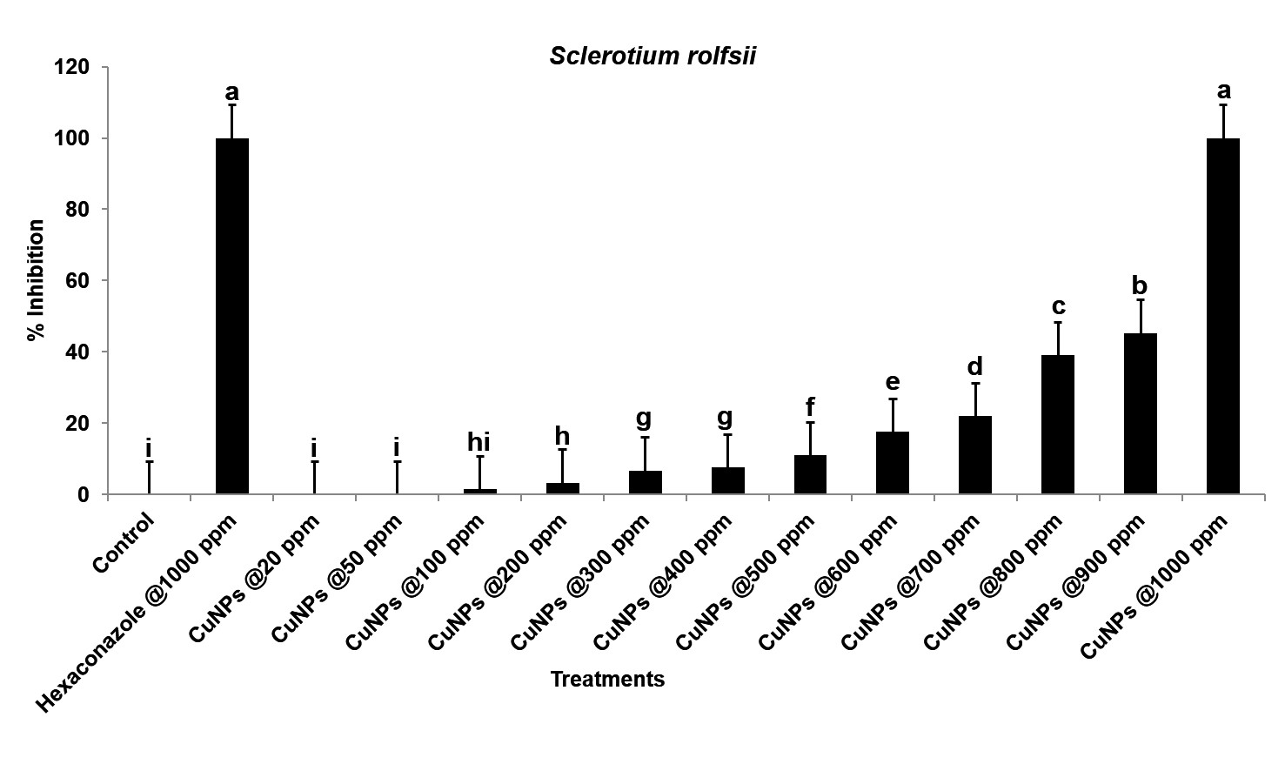

Table 1 Efficacy of synthesized copper nanoparticles on phytopathogenic bacteria
Erwinia carotovora |  |  | Ralstonia solanacearum
Treatment | Optical density  at 600 nm* | CFU/ml  (1OD =1× 10⁹) | Treatment | Optical density  at 600 nm* | CFU/ml  (1OD =1× 10⁹)
Control | 3.05±0.209 ab | 3.05 × 10⁹ | Control | 2.34±0.184 a | 2.34 × 10⁹
Strep @200 ppm | 1.16±0.005 i | 1.16 × 10⁹ | Strep @200 ppm | 0.14±0.021 g | 0.13 × 10⁹
COC @ 1000 ppm | 0.25±0.084 j | 0.25× 10⁹ | COC @ 1000 ppm | 1.28±0.023 d | 1.26 × 10⁹
CN 10 ppm | 3.20±0.049 a | 3.20 × 10⁹ | CN 10 ppm | 2.18±0.048 ab | 2.17 × 10⁹
CN 20 ppm | 2.80±0.063 bc | 2.80 × 10⁹ | CN 20 ppm | 2.08±0.011 ab | 2.08 × 10⁹
CN 30 ppm | 2.54±0.167 cd | 2.54 × 10⁹ | CN 30 ppm | 1.98±0.032 bc | 1.98 × 10⁹
CN 40 ppm | 2.25±0.051 de | 2.24 × 10⁹ | CN 40 ppm | 1.78±0.012 c | 1.78 × 10⁹
CN 50 ppm | 2.03±0.093 ef | 2.02 × 10⁹ | CN 50 ppm | 1.71±0.018 c | 1.71 × 10⁹
CN 60 ppm | 1.95±0.064 f | 1.95 × 10⁹ | CN 60 ppm | 1.35±0.130 d | 1.35 × 10⁹
CN 70 ppm | 1.91±0.154 fg | 1.90 × 10⁹ | CN 70 ppm | 1.11±0.103 de | 1.10 × 10⁹
CN 80 ppm | 1.63±0.066 gh | 1.63 × 10⁹ | CN 80 ppm | 0.93±0.134 e | 0.93 × 10⁹
CN 90 ppm | 1.46±0.001 h | 1.46 × 10⁹ | CN 90 ppm | 0.85±0.162 e | 0.84 × 10⁹
CN 100 ppm | 1.16±0.070 i | 1.16 × 10⁹ | CN 100 ppm | 0.54±0.072 f | 0.53 × 10⁹

*Data are the mean of three replications. (Data) Mean ± Standard errors followed by different letters indicate a significant difference (ANOVA, LSD, P<0.01). CN: Copper nanoparticles. Strep: Streptomycin, COC: Copper Oxychloride CFU: Colony Forming Unit
Table 2 Effect of synthesized copper nanoparticles (CuNPs) on the growth of beneficial fungi
Treatment | Trichoderma virens |  | Chaetomium globosum |  | Paecilomyces lilacinus
 | Radial growth (cm)* | Inhibition  (%) | Radial growth (cm)* | Inhibition (%) | Radial growth (cm)* | Inhibition (%)
Control | 7.00±0.0 | 0.00 (0.00±0.0)# d | 7.00±0.0 | 0.00 (0.00±0.0)# f | 7.00±0.0 | 0.00(0.00±0.0)# g
Carbendazim@1000 ppm | 0.00±0.0 | 100.00 (90±0.0) a | 0.00±0.0 | 100.00 (90±0.0) a | 2.86±0.033 | 59.05 (50.19±0.278) c
CN 20 ppm | 7.00±0.0 | 0.00 (0.00±0.0) d | 5.30±0.424 | 24.24 (29.04±4.333) d | 7.00±0.0 | 0.00 (0.00±0.0) g
CN 50ppm | 7.00±0.0 | 0.00 (0.00±0.0) d | 6.00±0.029 | 14.23 (22.15±0.341) e | 7.00±0.0 | 0.00 (0.00±0.0) g
CN 80 ppm | 6.03±0.120 | 13.81 (21.73±1.405) c | 5.63±0.101 | 19.52 (26.18±1.045) de | 7.00±0.0 | 0.00 (0.00±0.0) g
CN 100 ppm | 2.88±0.233 | 58.81 (50.07±1.949) b | 4.71±0.087 | 32.76 (34.89±0.757) c | 6.82±0.096 | 2.52 (7.42±3.798) g
CN 200 ppm | 0.20±0.058 | 97.14 (80.45±1.471) a | 0.83±0.033 | 88.10 (69.79±0.418) b | 6.30±0.101 | 10.00 (18.33±1.435) f
CN 300 ppm | 0.00±0.00 | 100.00 (90.00±0.0) a | 0.00±0.0 | 100.00 (90.00±0.0) a | 5.65±0.362 | 19.29 (25.68±3.811) e
CN 400 ppm | 0.00±0.00 | 100.00 (90.00±0.0) a | 0.00±0.0 | 100.00 (90.00±0.0) a | 3.42±0.096 | 51.10 (45.61±0.786) d
CN 500 ppm | 0.00±0.00 | 100.00 (90.00±0.0) a | 0.00±0.0 | 100.00 (90.00±0.0) a | 2.23±0.0.073 | 68.10 (55.59±0.639) b
CN 600 ppm |  |  |  |  | 0.00±0.0 | 100.00 (90.00±0.0) a

*Data are the mean of three replications. Data (Mean ± Standard errors) followed by different letters in each column indicate a significant difference (ANOVA, LSD, P<0.01). #Data within parentheses are Angular transformed value ± Standard errors. CN: Copper nanoparticles, Carbendazim: carbendazim 50%

Supplementary Figure 2 Concentration-dependent growth inhibition of (A) Bacillus subtilis and (B) Pseudomonas putida in vitro exposed to synthesized copper nanoparticles. Data (Mean±Standard errors) with same letters are insignificant from each other and with different letters are significant in each graph (ANOVA, LSD, P≤0.01). COC: Copper Oxychloride (Blitox), Streptomycin: Streptomycin Sulphate

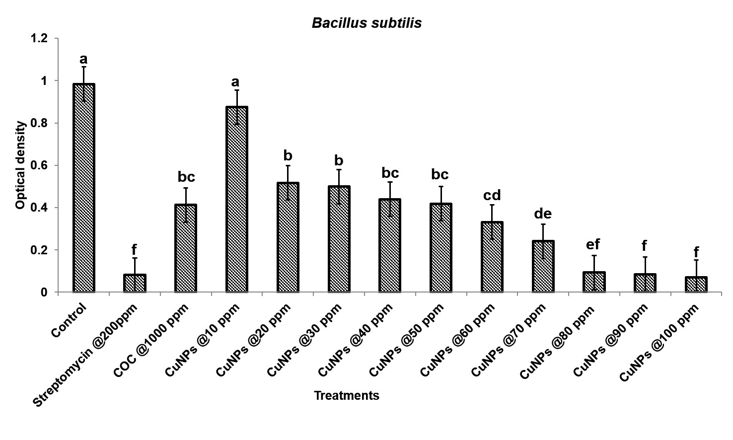
(A)

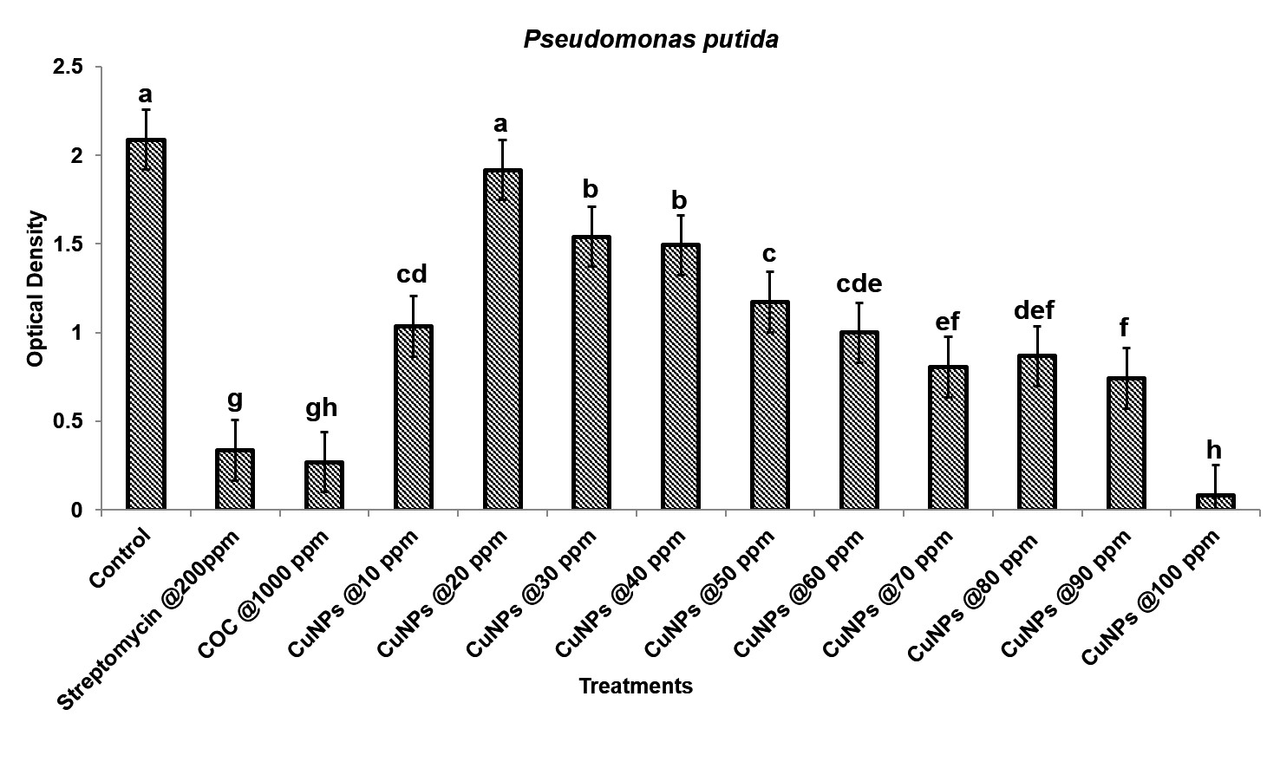
(B)

Supplementary Table 3 Dehydrogenase activity of soil treated with copper nanoparticles (CuNPs) and copper oxychloride (COC) at different time intervals

Treatment | Dehydrogenase activity(µg TPF g soil⁻¹ hr⁻¹)
 | COC |  |  | CuNPs
 | 1st day* | 15th day* | 30th day* | 1st day* | 15th day* | 30th day*
Control | 47.56±9.6 | 47.35±9.6 | 46.41±9.6 | 47.41±9.6 | 47.09±9.6 | 46.72±9.6
200 ppm | 51.23±9.6 | 52.86±9.6 | 47.35±9.6 | 53.43±9.6 | 70.89±9.6 | 61.92±9.6
400 ppm | 54.27±9.6 | 50.50±9.6 | 48.72±9.6 | 61.77±9.6 | 64.60±9.6 | 61.61±9.6

*Data are the mean of three replications. Data (Means ± Standard errors) (ANOVA, LSD, P≤0.05)

Supplementary Table 4 Alkaline phosphatase activity of soil treated with CuNPs and copper
Oxychloride (COC) at different time intervals

Treatment | Alkaline phosphatase activity (µg pNPP g soil⁻¹ hr⁻¹)
 | COC |  |  | CuNPs
 | 1st day** | 15th day** | 30th day** | 1st day** | 15th day** | 30th day**
Control | 316.52±1.47 | 313.70±1.47 | 311.82±1.47 | 317.46±1.47 | 315.58±1.47 | 314.64±1.47
200 ppm | 466.80±1.47 | 445.19±1.47 | 490.28±1.47 | 667.79±1.47 | 784.25±1.47 | 772.04±1.47
400 ppm | 497.79±1.47 | 540.06±1.47 | 472.43±1.47 | 653.70±1.47 | 832.15±1.47 | 713.81±1.47

*Data are the mean of three replications. Data (Means ± Standard errors) (ANOVA, LSD, P≤0.05)
Supplementary Table 5 Urease activity of soil treated with CuNPs and (COC) at different time
Intervals

Treatment | Urease activity (µg NH₄ g soil⁻¹ hr⁻¹)
 | COC |  |  | CuNPs
 | 1st day** | 15th day** | 30th day** | 1st day** | 15th day** | 30th day**
Control | 3.582±1.2 | 3.532±1.2 | 3.378±1.2 | 3.523±1.2 | 3.494±1.2 | 3.290±1.2
200 ppm | 3.669±1.2 | 3.727±1.2 | 3.465±1.2 | 3.756±1.2 | 3.844±1.2 | 3.523±1.2
400 ppm | 3.698±1.2 | 3.758±1.2 | 3.494±1.2 | 3.814±1.2 | 3.931±1.2 | 3.669±1.2

*Data are the mean of three replications. Data (Means ± Standard errors) (ANOVA, LSD, P≤0.05)

