Supplemental Material

Problems in measuring the JTC-bias in patients with psychotic disorders with the fish task: A secondary analysis of a baseline assessment of a randomized controlled trial

This supplement contains supporting information for the above-mentioned manuscript.

 | Summary Statistics
2 | Table S1. Summary Statistics for Draws to Decision
2 | Table S2. Summary Statistics for PANSS total
2 | Table S3. Summary Statistics for PANSS P06
2 | Table S4. Summary Statistics for PANSS Positive Factor (Wallwork)
2 | Table S5. Summary Statistics for PSYRATS Delusional Conviction
 | Distribution of Variables included in the Analyses
3 | Figure S1. Distribution of DTD in the total sample
3 | Figure S2. Distribution of DTD in the Patient Sample
4 | Figure S3. Distribution of DTD in healthy controls
4 | Figure S4. Distribution of DTD in Subjects who showed the JTC-bias
5 | Figure S5. Distribution of DTD in Subjects who did not show the JTC-bias
5 | Figure S6. Distribution of PANSS total in the Patient Sample
6 | Figure S7. Distribution of PANSS total in Subjects who showed the JTC-bias
6 | Figure S8. Distribution of PANSS total in Subjects who did not show the JTC-bias
7 | Figure S9. Distribution of PANSS P06 in the Patient Sample
7 | Figure S10. Distribution of PANSS P06 in Subjects who showed the JTC-bias
8 | Figure S11. Distribution of PANSS P06 in Subjects who did not show the JTC-bias
8 | Figure S12. Distribution of PANSS Positive Factor (Wallwork) in the Patient Sample
9 | Figure S13. Distribution of PANSS Positive Factor (Wallwork) in Subjects who showed the JTC-bias
9 | Figure S14. Distribution of PANSS Positive Factor (Wallwork) in Subjects who did not show the JTC-bias
10 | Figure S15. Distribution of PSYRATS Delusional Conviction in the Patient Sample
10 | Figure S16. Distribution of PSYRATS Delusional Conviction in Subjects who showed the JTC-bias
11 | Figure S17. Distribution of PSYRATS Delusional Conviction who did not show the JTC-bias

Summary statistics
Table S1.
Summary Statistics for Draws to Decision assessed with the Fish Task
 | N | Min | Max | M | SD | Skewness |  | Kurtosis
 | Statistic | Statistic | Statistic | Statistic | Statistic | Statistic | Std. Error | Statistic | Std. Error
Total Sample | 351 | 1 | 11 | 3.15 | 2.669 | 1.419 | .130 | 1.503 | .260
Patients | 300 | 1 | 11 | 3.10 | 2.700 | 1.522 | .141 | .007 | .281
Controls | 51 | 1 | 11 | 3.49 | 2.477 | .756 | .333 | .027 | .656
JTC-bias YES | 182 | 1 | 2 | 1.20 | .404 | 1.487 | .180 | .213 | .358
JTC-bias NO | 169 | 3 | 11 | 5.25 | 2.471 | 1.143 | .187 | .485 | .371

Table S2.
Summary Statistics for PANSS total
 | N | Min | Max | M | SD | Skewness |  | Kurtosis
 | Statistic | Statistic | Statistic | Statistic | Statistic | Statistic | Std. Error | Statistic | Std. Error
Patients | 300 | 37 | 97 | 64.87 | 11.427 | .318 | .141 | .007 | .281
JTC-bias YES | 161 | 41 | 97 | 66.98 | 12.278 | .279 | .191 | -.354 | .380
JTC-bias NO | 139 | 37 | 922 | 62.42 | 9.844 | .039 | .206 | .108 | .408
Notes: PANSS = Positive and Negative Syndrome Scale

Table S3.
Summary Statistics for PANSS P06 Persecutory delusions
 | N | Min | Max | M | SD | Skewness |  | Kurtosis
 | Statistic | Statistic | Statistic | Statistic | Statistic | Statistic | Std. Error | Statistic | Std. Error
Patients | 300 | 1 | 7 | 3.48 | 1.480 | -.328 | .141 | -.690 | .281
JTC-bias YES | 161 | 1 | 7 | 3.53 | 1.529 | -.273 | .191 | -.721 | .380
JTC-bias NO | 139 | 1 | 6 | 3.42 | 1.424 | -.434 | .206 | .012 | .408
Notes: PANSS = Positive and Negative Syndrome Scale

Table S4.
Summary Statistics for PANSS Positive Factor (Wallwork)
 | N | Min | Max | M | SD | Skewness |  | Kurtosis
 | Statistic | Statistic | Statistic | Statistic | Statistic | Statistic | Std. Error | Statistic | Std. Error
Patients | 300 | 7 | 23 | 11.65 | 2.725 | .622 | .141 | .424 | .281
JTC-bias YES | 161 | 7 | 19 | 11.79 | 2.448 | .365 | .191 | -.100 | .380
JTC-bias NO | 139 | 7 | 23 | 11.50 | 3.015 | .829 | .206 | .654 | .408
Notes: PANSS = Positive and Negative Syndrome Scale

Table S5.
Summary Statistics for PSYRATS Delusional Conviction
 | N | Min | Max | M | SD | Skewness |  | Kurtosis
 | Statistic | Statistic | Statistic | Statistic | Statistic | Statistic | Std. Error | Statistic | Std. Error
Patients | 300 | 0 | 4 | 2.57 | 1.224 | -.812 | .141 | -.248 | .281
JTC-bias YES | 161 | 0 | 4 | 2.59 | 1.272 | -.758 | .191 | -.411 | .380
JTC-bias NO | 139 | 0 | 4 | 2.54 | 1.169 | -.912 | .206 | .012 | .408
Notes: PSYRATS = Psychotic Symptoms Rating Scales

Distribution of DTD
Figure S1.
Distribution of DTD in the total sample
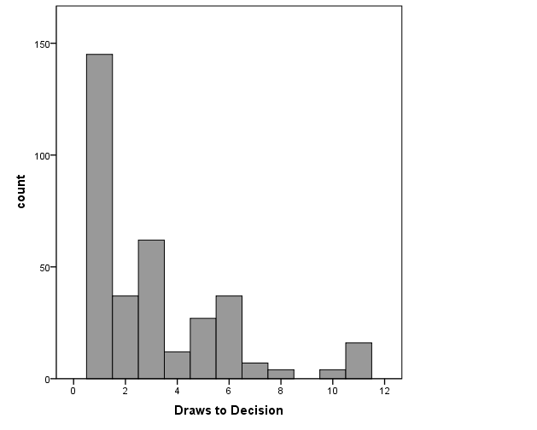
Notes: DTD = Draws to decision

Figure S2.
Distribution of DTD in the Patient Sample
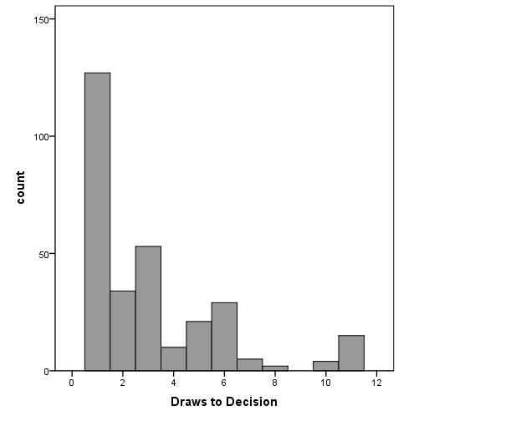
Notes: DTD = Draws to decision
Figure S3.
Distribution of DTD in healthy controls
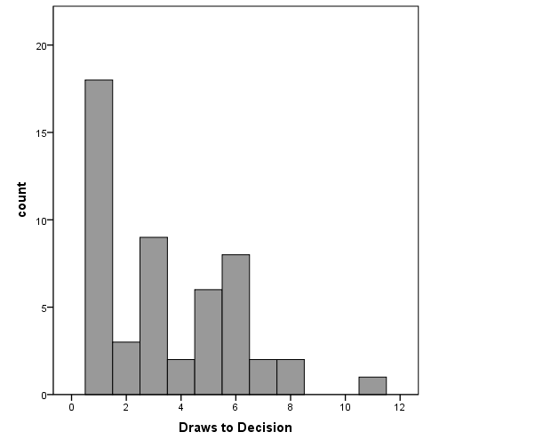
Notes: DTD = Draws to decision

Figure S4.
Distribution of DTD in Subjects who showed the JTC-bias
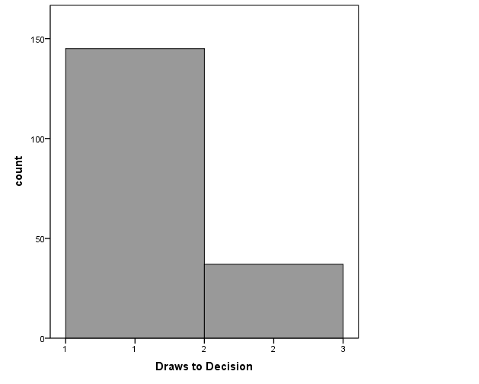
Notes: DTD = Draws to decision, JTC = jumping to conclusions

Figure S5.
Distribution of DTD in Subjects who did not show the JTC-bias
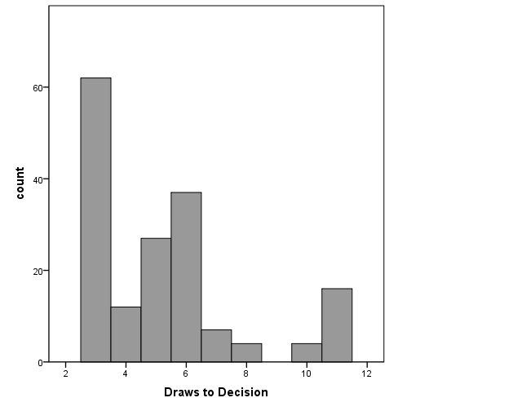
Notes: DTD = Draws to decision, JTC = jumping to conclusions

Distribution of PANSS total
Figure S6.
Distribution of PANSS total in the Patient Sample
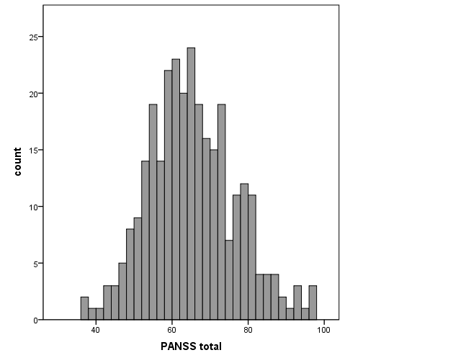
Notes: PANSS = Positive and Negative Syndrome Scale

Figure S7.
Distribution of PANSS total in Subjects who showed the JTC-bias
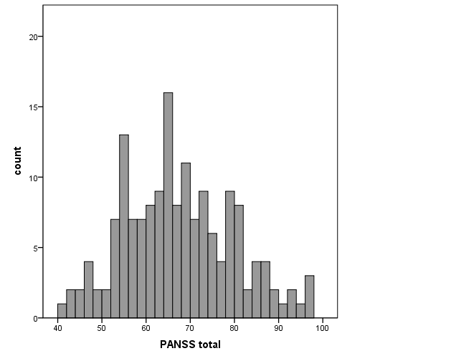
Notes: PANSS = Positive and Negative Syndrome Scale

Figure S8.
Distribution of PANSS total in Subjects who did not show the JTC-bias
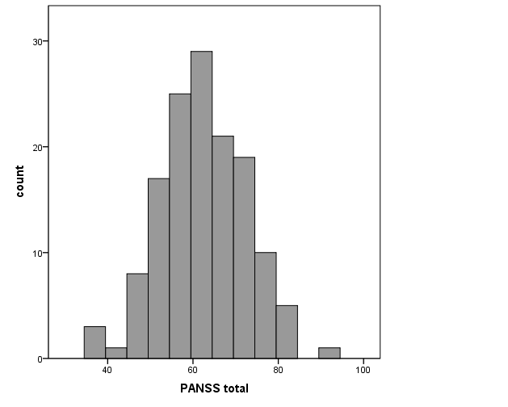
Notes: PANSS = Positive and Negative Syndrome Scale, JTC = Jumping to conclusions

Distribution of PANSS P06

Figure S9.
Distribution of PANSS P06 item in the Patient Sample
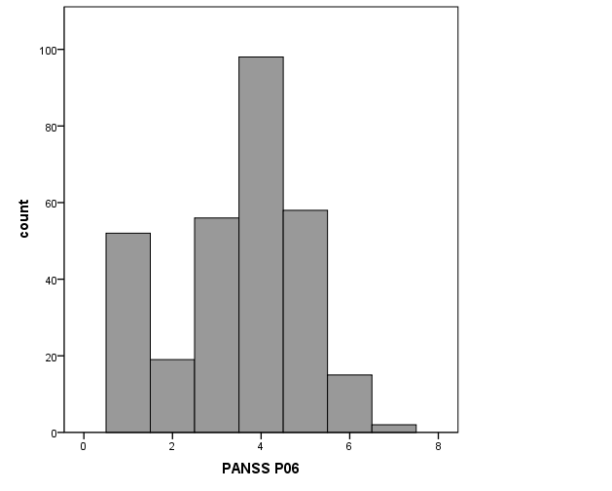
Notes: PANSS = Positive and Negative Syndrome Scale

Figure S10.
Distribution of PANSS P06 item in Subjects who showed the JTC-bias
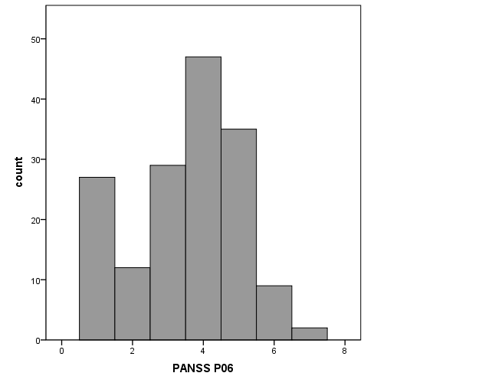
Notes: PANSS = Positive and Negative Syndrome Scale, JTC = jumping to conclusions

Figure S11.
Distribution of PANSS P06 item in Subjects who did not show the JTC-bias

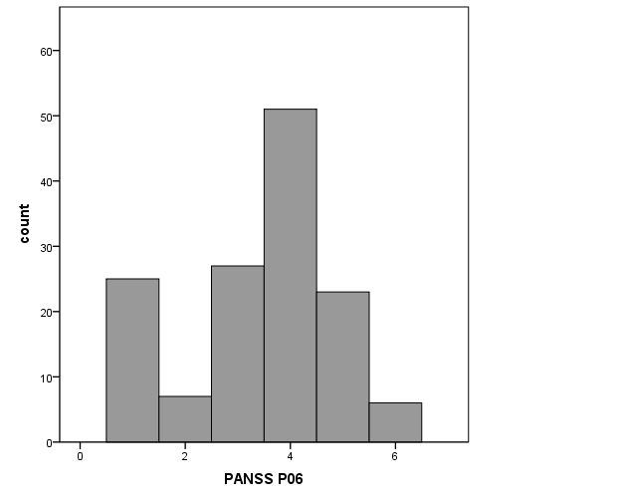
Notes: PANSS = Positive and Negative Syndrome Scale, JTC = Jumping to conclusions

Distribution of PANSS Positive Factor (Wallwork)

Figure S12.
Distribution of PANSS Positive Factor (Wallwork) in the Patient Sample 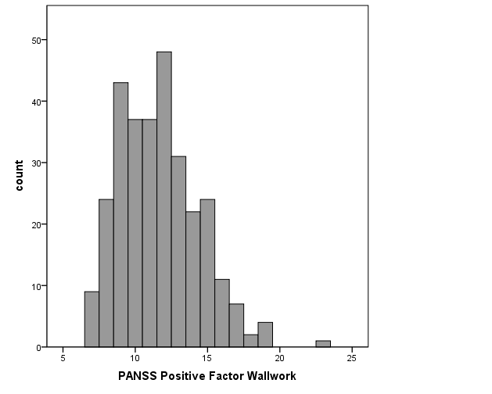
Notes: PANSS = Positive and Negative Syndrome Scale

Figure S13.
Distribution of PANSS Positive Factor (Wallwork) in Subjects who showed the JTC-bias
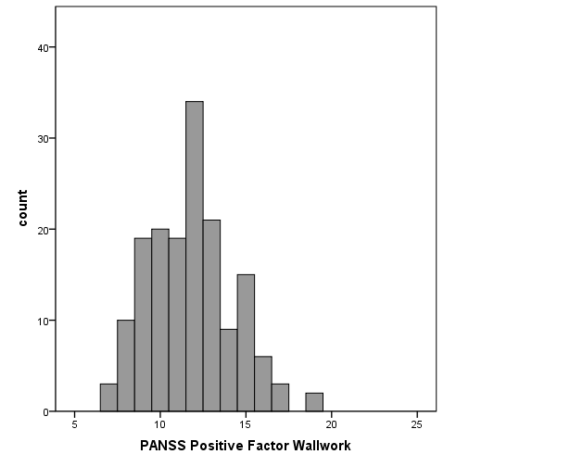
Notes: PANSS = Positive and Negative Syndrome Scale, JTC = Jumping to conclusions

Figure S14.
Distribution of PANSS Positive Factor (Wallwork) in Subjects who did not show the JTC-bias
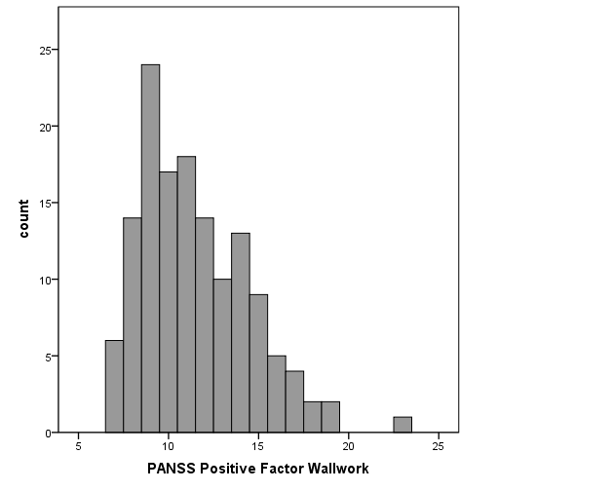
Notes: PANSS = Positive and Negative Syndrome Scale, JTC = Jumping to conclusions

Distribution of PSYRATS Delusional Conviction

Figure S15.
Distribution of PSYRATS Delusional Conviction in the Patient Sample
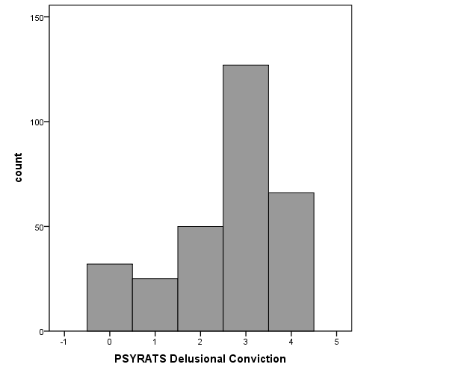
Notes: PSYRATS = Psychotic Symptoms Rating Scales

Figure S16.
Distribution of PSYRATS Delusional Conviction in Subjects who showed the JTC-bias
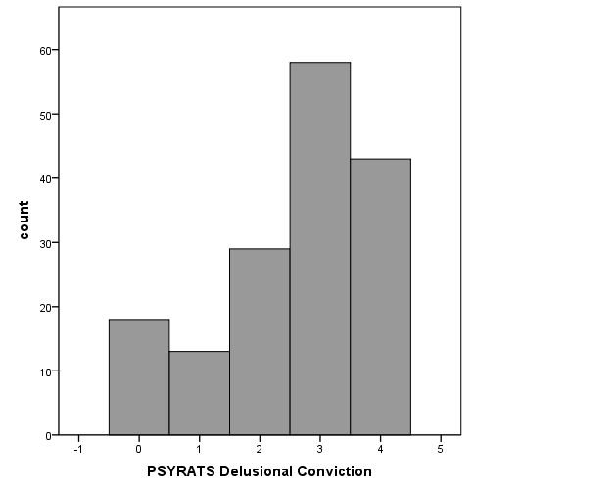
Notes: PSYRATS = Psychotic Symptoms Ratings Scale, JTC = Jumping to conclusions

Figure S17.
Distribution of PSYRATS Delusional Conviction who did not show the JTC-bias
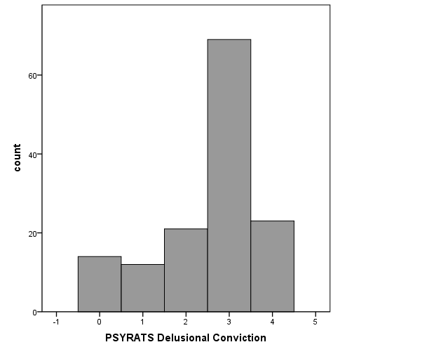

Notes: PSYRATS = Psychotic Symptoms Ratings Scale, JTC = Jumping to conclusions

