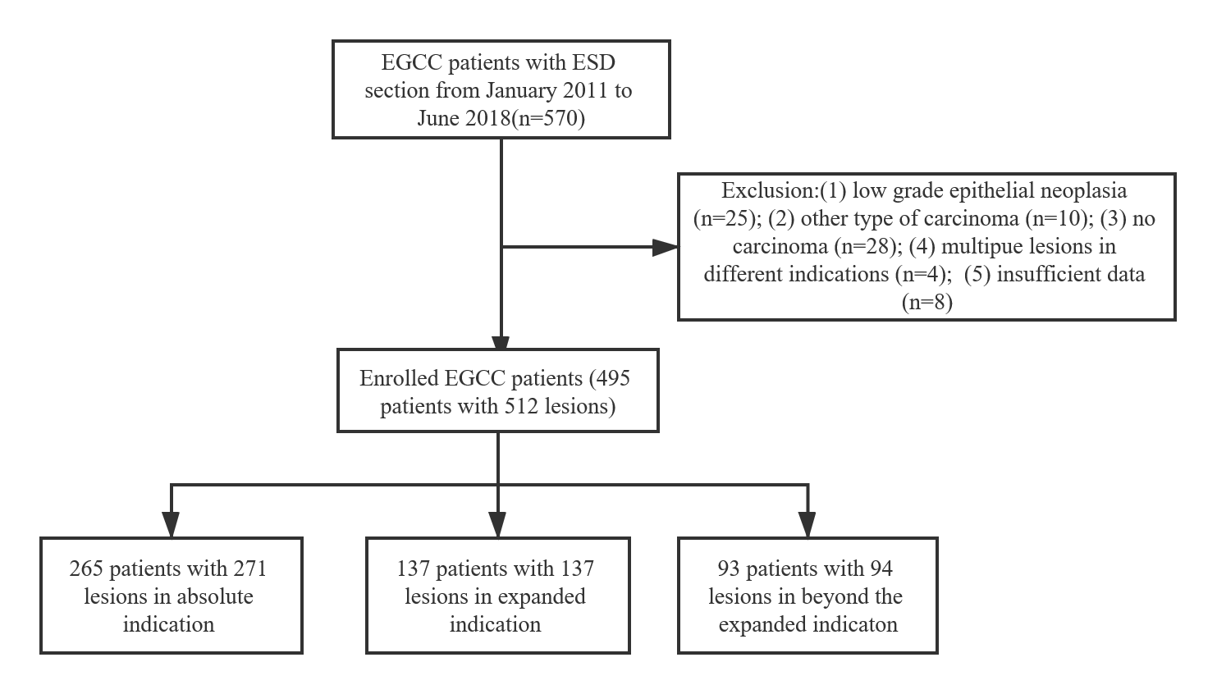

Supplementary Figure 1. Flow diagram for the patients in this study.

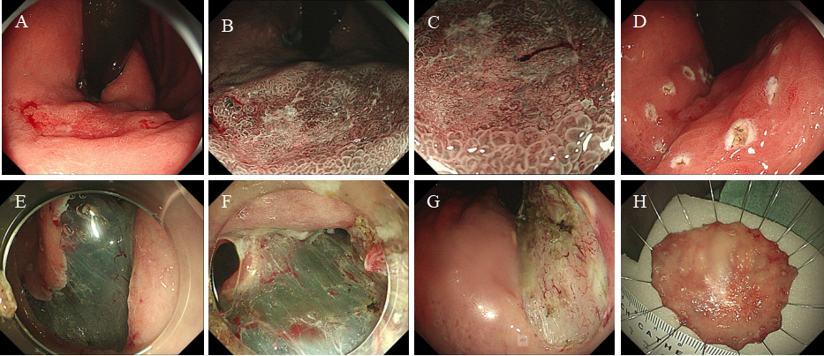

Supplementary Figure 2 The endoscopic submucosal dissection for early gastric cardiac cancer. A: White-light endoscopy (WLE) image of an early gastric cardiac cancer. B: The edge of the tumor lesion in magnifying endoscopy with narrow-banding imaging (ME-NBI). C: The destructive microstructures and fine reticular microvascular morphology in ME-NBI. D: Marking the edge of tumor margin. E: Cut around the marking points. F: Submucosal dissection. G: Wound surface after dissection. H：The resected specimen.

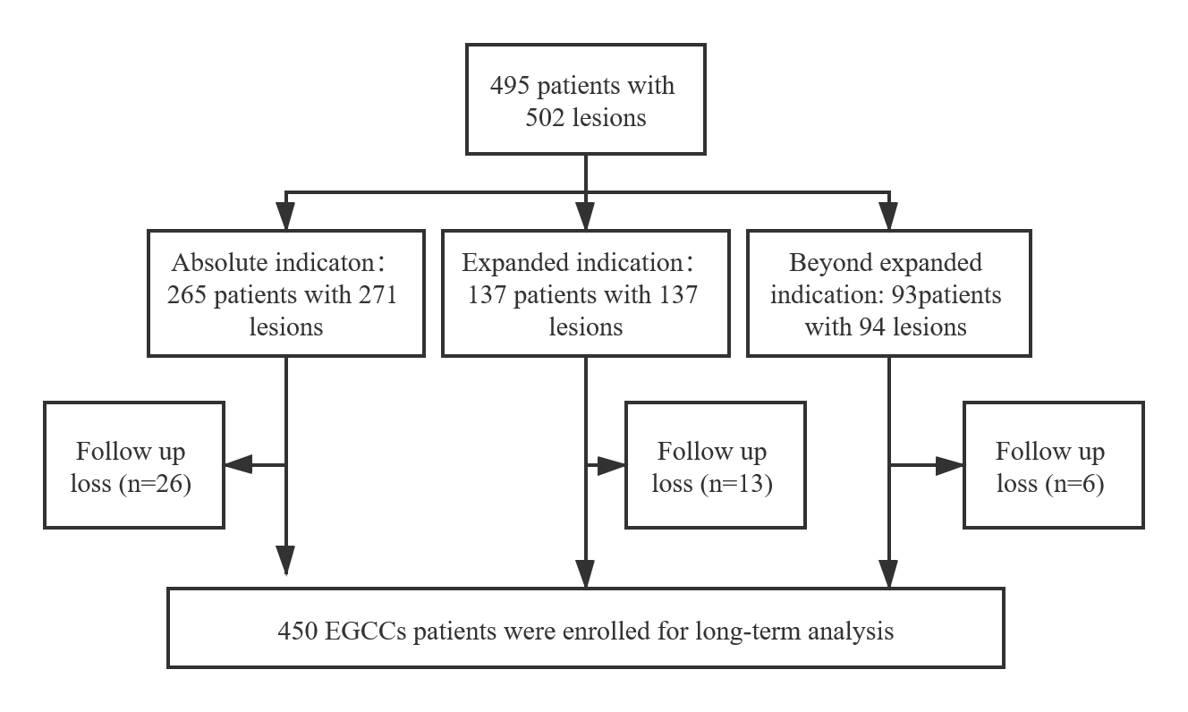
Supplementary Figure 3 Patient treatment flow chart

Supplementary table 1 Disease specific survival at 3 and 5 years among BEI patients with or without additional surgery after ESD for EGCC which were divided into three risk categories according to the eCura system

