A highly contiguous genome assembly of a major forest pest, the Eurasian spruce bark beetle Ips typographus

Daniel Powell, Ewald Groβe-Wilde, Paal Krokene, Amit Roy, Amrita Chakraborty, Christer Löfstedt, Heiko Vogel, Martin N Andersson and Fredrik Schlyter

Supporting Information

Supplementary Figure 1. Workflow diagram of the gene model prediction pipeline for the I. typographus genome.

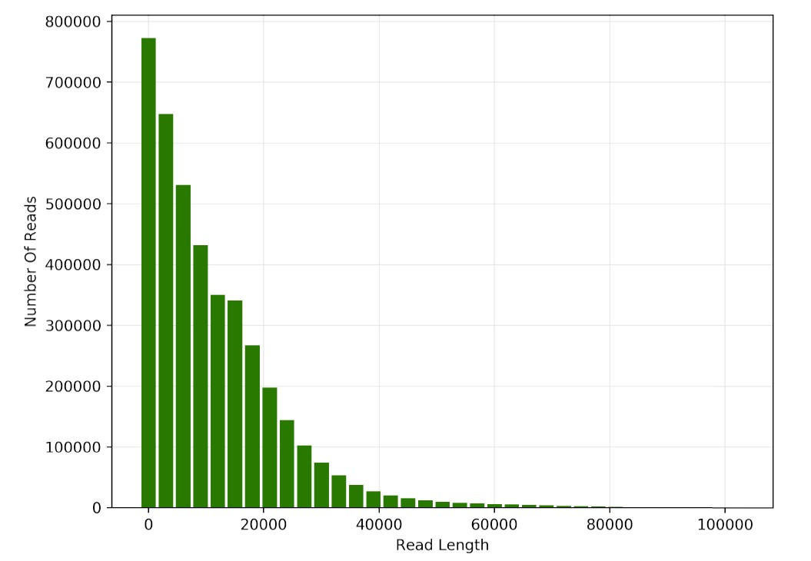
Supplementary Figure 2. Read length distribution from PacBio sequencing of the I. typographus genome.

Supplementary Figure 3. Cumulative Annotation Edit Distance (AED) scores for gene models produced using the MAKER3 pipeline. Almost 80% of the gene models have an AED score of 0.5 or less. The AED score is a metric assigned to a gene model by MAKER3 and is a measure of the degree of fit that model has with the supporting evidence.

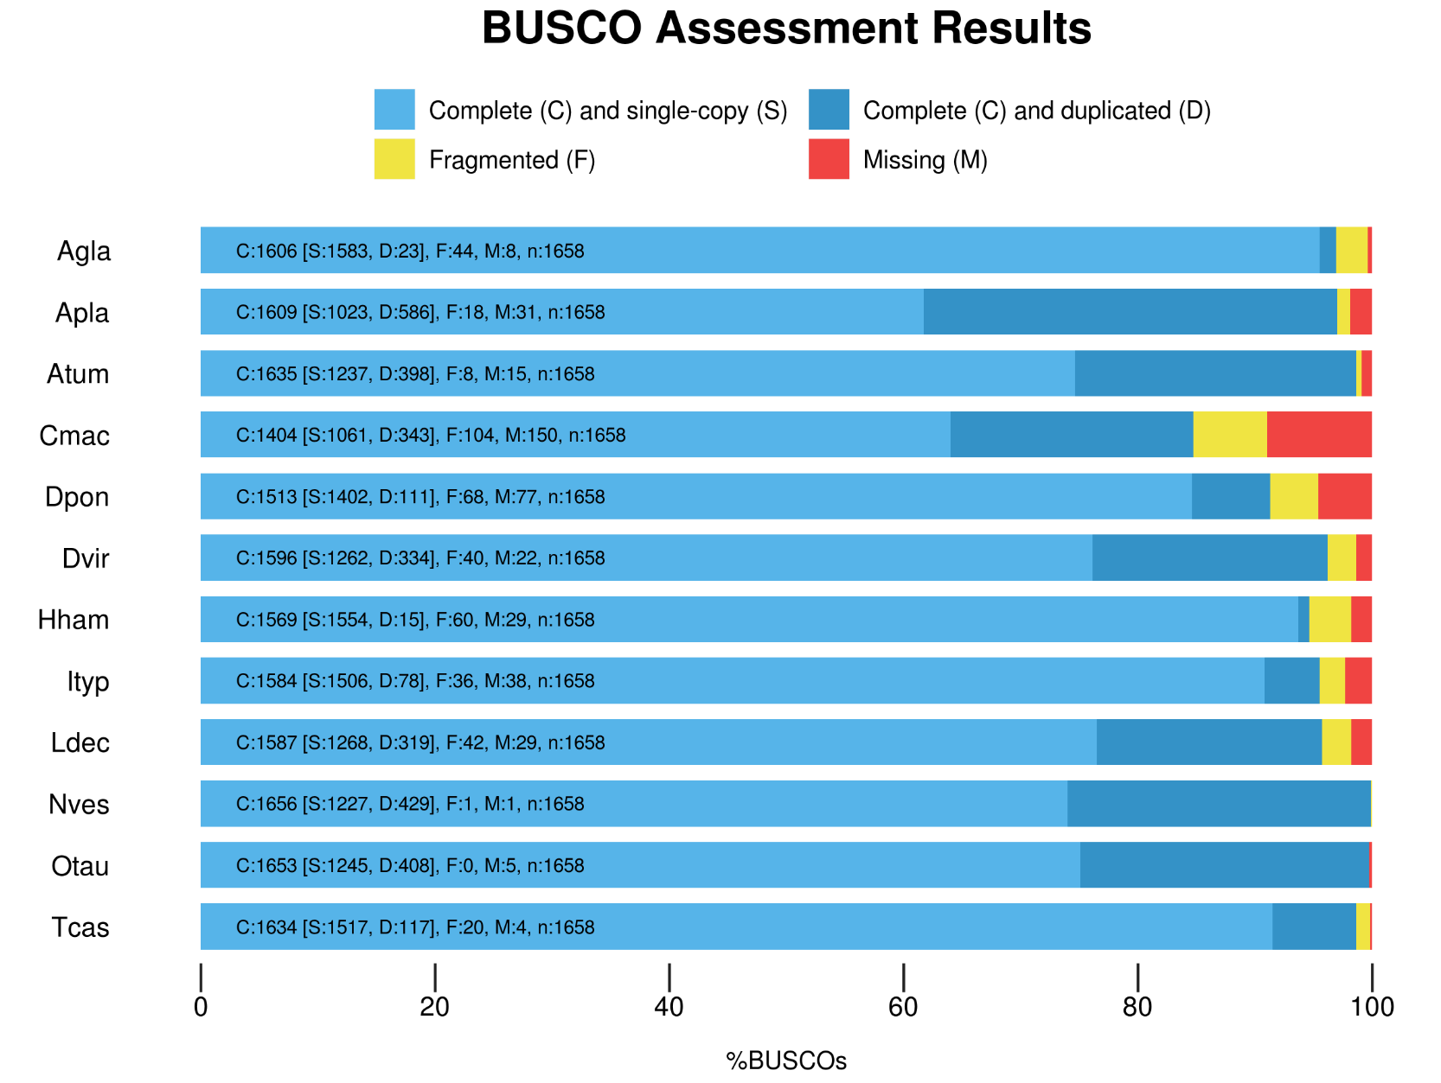
Supplementary Figure 4. Completeness estimates of I. typographus (Ityp) gene models and comparison with other published coleopteran gene sets using BUSCO tool searches against the Insecta dataset of 1,658 genes. Atum, Aethina tumida; Apla, Agrilus planipennis; Agla, Anoplophora glabripennis; Cmac, Callosobruchus maculatus; Dpon, Dendroctonus ponderosae; Dvir, Diabrotica virgifera; Hham, Hypothenemus hampei; Ityp, Ips typographus; Ldec, Leptinotarsa decemlineata; Nves, Nicrophorus vespilloides; Otau, Onthophagus taurus; Tcas, Tribolium castaneum.

Supplementary Table 1. Details of RNA-Seq samples used in this study.
Sample ID | Description | Number of PE reads | % Mapping to genome
L1 | larvae stage 1 | 171,286,469 | 95.76%
L2 | larvae stage 2 | 159,867,283 | 94.62%
L3 | larvae stage 3 | 159,565,350 | 93.79%
P | pupae | 160,837,226 | 93.98%
AFM | adult beetle (male & female) | 181,374,351 | 93.59%
AMFG | fed adult male gut | 187,490,572 | 93.25%
AMFH | fed adult male head | 173,389,571 | 92.18%
CFFB | callow female beetle fat body | 245,181,256 | 93.95%
CFG | callow female beetle gut | 189,231,418 | 95.26%
CFH | callow female beetle head | 159,092,068 | 89.57%
CMFB | callow male beetle fat body | 184,072,277 | 93.12%
CMG | callow male beetle gut | 174,127,755 | 94.95%
CMH | callow male beetle head | 188,654,217 | 92.25%

Supplementary Table 2. Summary of published genomes used in this study.
Coleoptera > Polyphaga |  |  | Taxonomy |  |  | Genome Stats
Species | ID | # Prot seqs | Superfamily | Subfamily | Common Name | Scaffold N50 | Total Size | Genbank Accession
Aethina tumida | Atum | 17,463 | Cucujoidea | Nitidulinae | Small hive beetle | 298,879 | 234 Mb | GCF_001937115.1
Agrilus planipennis | Apla | 22,159 | Buprestoidea | Agrilinae | Emerald ash borer | 1,113,421 | 353 Mb | GCF_000699045.2
Anoplophora glabripennis | Agla | 22,343 | Chrysomelidae | Lamiinae | Asian longhorned beetle | 678,234 | 706 Mb | GCF_000390285.2
Callosobruchus maculatus | Cmac | 31,345 | Chrysomelidae | Bruchinae | Cowpea weevil | 212,245 | 1.007 Gb | GCA_900659725.1
Dendroctonus ponderosae | Dpon | 13,457 | Curculionoidea | Scolytinae | Mountain pine beetle | 628,732 | 252 Mb | GCF_000355655.1
Diabrotica virgifera virgifera | Dvir | 28,061 | Chrysomeloidea | Galerucinae | Western corn rootworm | 489,108 | 2.418 Gb | GCF_003013835.1
Hypothenemus hampei | Hham | 19,222 | Curculionoidea | Scolytinae | Coffee berry borer | 44,715 | 162 Mb | GCA_013372445.1
Ips typographus | Ityp | 23,937 | Curculionoidea | Scolytinae | Eurasian spruce bark beetle | 6,654,004 | 236 Mb | This study
Leptinotarsa decemlineata | Ldec | 19,038 | Chrysomeloidea | Chrysomelinae | Colorado potato beetle | 139,046 | 641 Mb | GCF_000500325.1
Nicrophorus vespilloides | Nves | 19,577 | Staphylinoidea | Nicrophorinae | Burying beetle | 122,407 | 195 Mb | GCF_001412225.1
Onthophagus taurus | Otau | 21,668 | Scarabaeoidea | Scarabaeinae | Taurus scarab | 337,157 | 267 Mb | GCF_000648695.1
Tribolium castaneum | Tcas | 18,534 | Tenebrionoidea |  | Red flour beetle | 4,456,720 | 165 Mb | GCF_000002335.3

Supplementary Table 3. Contig size statistics from PacBio sequencing of the I. typographus genome.
Minimum contig length | Number of contigs | Total contig length
All | 272 | 236,816,287
10 KB | 272 | 236,816,287
25 KB | 252 | 236,352,854
50 KB | 190 | 234,082,415
100 KB | 164 | 232,251,227
250 KB | 101 | 222,160,924
500 KB | 72 | 212,556,464
1 MB | 36 | 186,489,602
2.5 MB | 20 | 161,077,642
5 MB | 14 | 136,853,431
10 MB | 5 | 71,627,877

Supplementary Table 4. Identification of telomeric regions (TTAGGG_{N}) in the I. typographus genome assembly.
Contig ID Location Contig Size (Mb)
IpsContig1 | Reverse (end of sequence) | 16.86
IpsContig2 | Forward (start of sequence) | 16.77
IpsContig3 | Forward (start of sequence) | 14.31
IpsContig4 | Forward (start of sequence) | 12.83
IpsContig5 | Reverse (end of sequence) | 10.84
IpsContig23 | Forward (start of sequence) | 2.1
IpsContig51 | Forward (start of sequence) | 0.76
IpsContig93 | Reverse (end of sequence) | 0.28
Telomeres found: 8 (5 forward, 3 reverse)

Supplementary Table 5. Gene ontology enrichment of the 811 orthologous gene clusters unique to Ips typographus when compared with Dendroctonus ponderosae, Hypothenemus hampei and Anoplophora glabripennis.
GO ID | # Clusters | GO Description | GO Category | FDR
GO:0003964 | 17 | RNA-directed DNA polymerase activity | MF | 1.07738e-20
GO:0046051 | 2 | UTP metabolic process | BP | 0.000447
GO:0004518 | 5 | nuclease activity | MF | 0.000461
GO:0045739 | 3 | positive regulation of DNA repair | BP | 0.000719
GO:0007166 | 3 | cell surface receptor signalling pathway | BP | 0.000874
GO:0006313 | 6 | transposition, DNA-mediated | BP | 0.000889
GO:0015074 | 5 | DNA integration | BP | 0.001372
GO:0031936 | 2 | negative regulation of chromatin silencing | BP | 0.001454
GO:0042803 | 2 | protein homodimerization activity | MF | 0.002154

Supplementary Table 6. Extended gene model annotation statistics for the Ips typographus genome.
Total sequence length | 236,816,287
Number of genes | 23,923
Number of exons | 121,796
Number of introns | 97,873
Number of CDS | 23,923
Overlapping genes | 5,676
Contained genes | 2,154
Total gene length (bp) | 132,911,182
Total exon length (bp) | 39,477,432
Total intron length (bp) | 93,629,496
Total CDS length (bp) | 29,963,361
Shortest gene (bp) | 135
Shortest exon (bp) | 1
Shortest intron (bp) | 4
Shortest CDS (bp) | 108
Longest gene (bp) | 318,767
Longest exon (bp) | 85,977
Longest intron (bp) | 125,082
Longest CDS (bp) | 75,285
Mean gene length (bp) | 5,556
Mean exon length (bp) | 324
Mean intron length (bp) | 957
Mean CDS length (bp) | 1,252
Percent of genome covered by genes | 56

