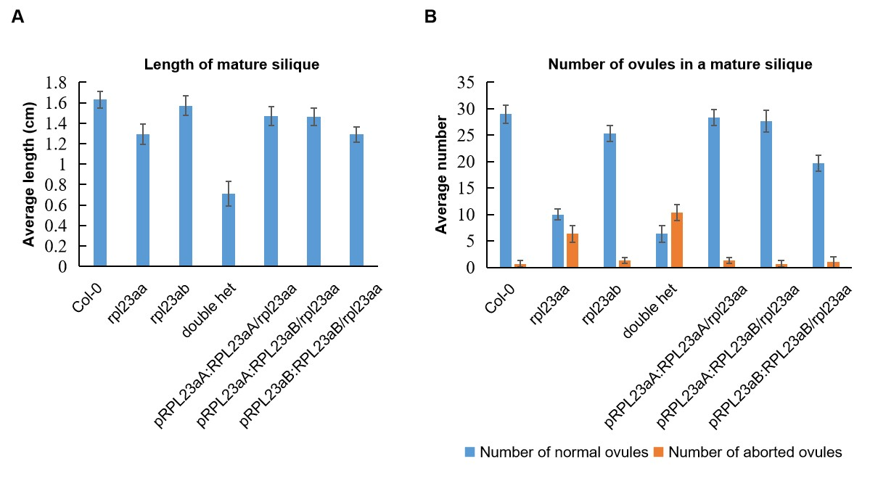
Figure S4. Statistic of length of mature silique and number of ovules in a mature silique. (A) average length of mature siliques from Col-0, rpl23aa, rpl23ab, double heterozygote, pRPL23aA::RPL23aA/rpl23aa, pRPL23aA::RPL23aB/rpl23aa, and pRPL23aB::RPL23aB/rpl23aa plant. (B) average number of normal and aborted ovules.

