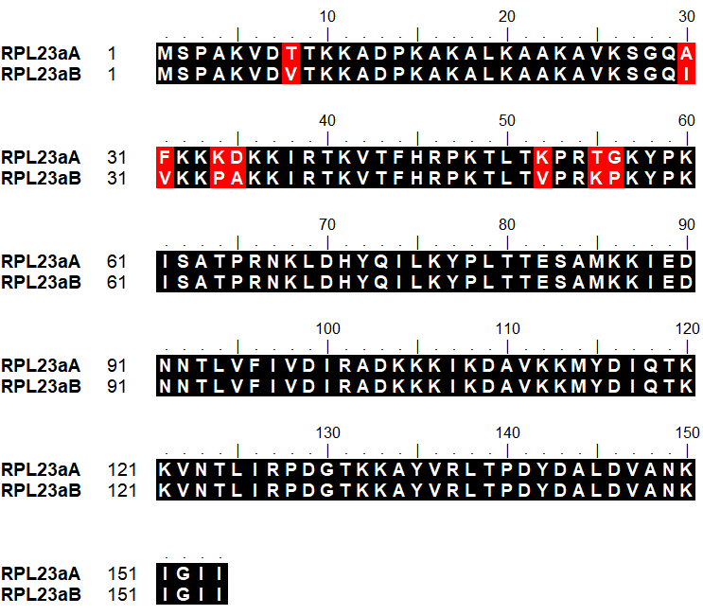
Figure S1. Amino acid sequence alignment between RPL23aA and RPL23aB. RPL23aA and RPL23aB are 95% identical in amino acid sequences. The black background indicates identical amino acids. The different amino acids are in red highlight.

