Comparative analysis of latex transcriptomes reveals the potential mechanisms underlying the rubber molecular weight variations among Hevea brasiliensis clones RRIM600 and Reyan7-33-97
Shichao Xin, Yuwei Hua, Ji Li, Xuemei Dai, Xianfeng Yang, Jinu Udayabhanu, Huasun Huang* and Tiandai Huang*

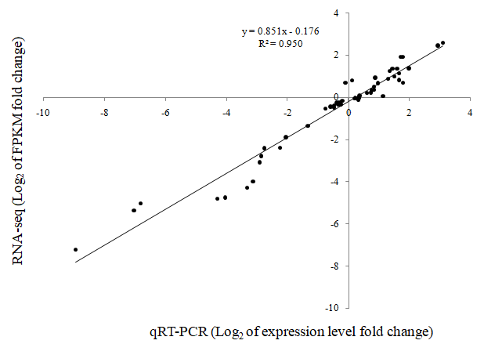

Fig. S2. Correlation analyses of the RNA-Seq (FPKM) and qRT-PCR results. The values of log₂ of expression levels fold change in qRT-PCR (x-axis) were plotted against the values of log₂ of FPKM fold changes in transcriptome data (y-axis) for the 17 selected genes in four latex samples.

