Graphical Abstracts

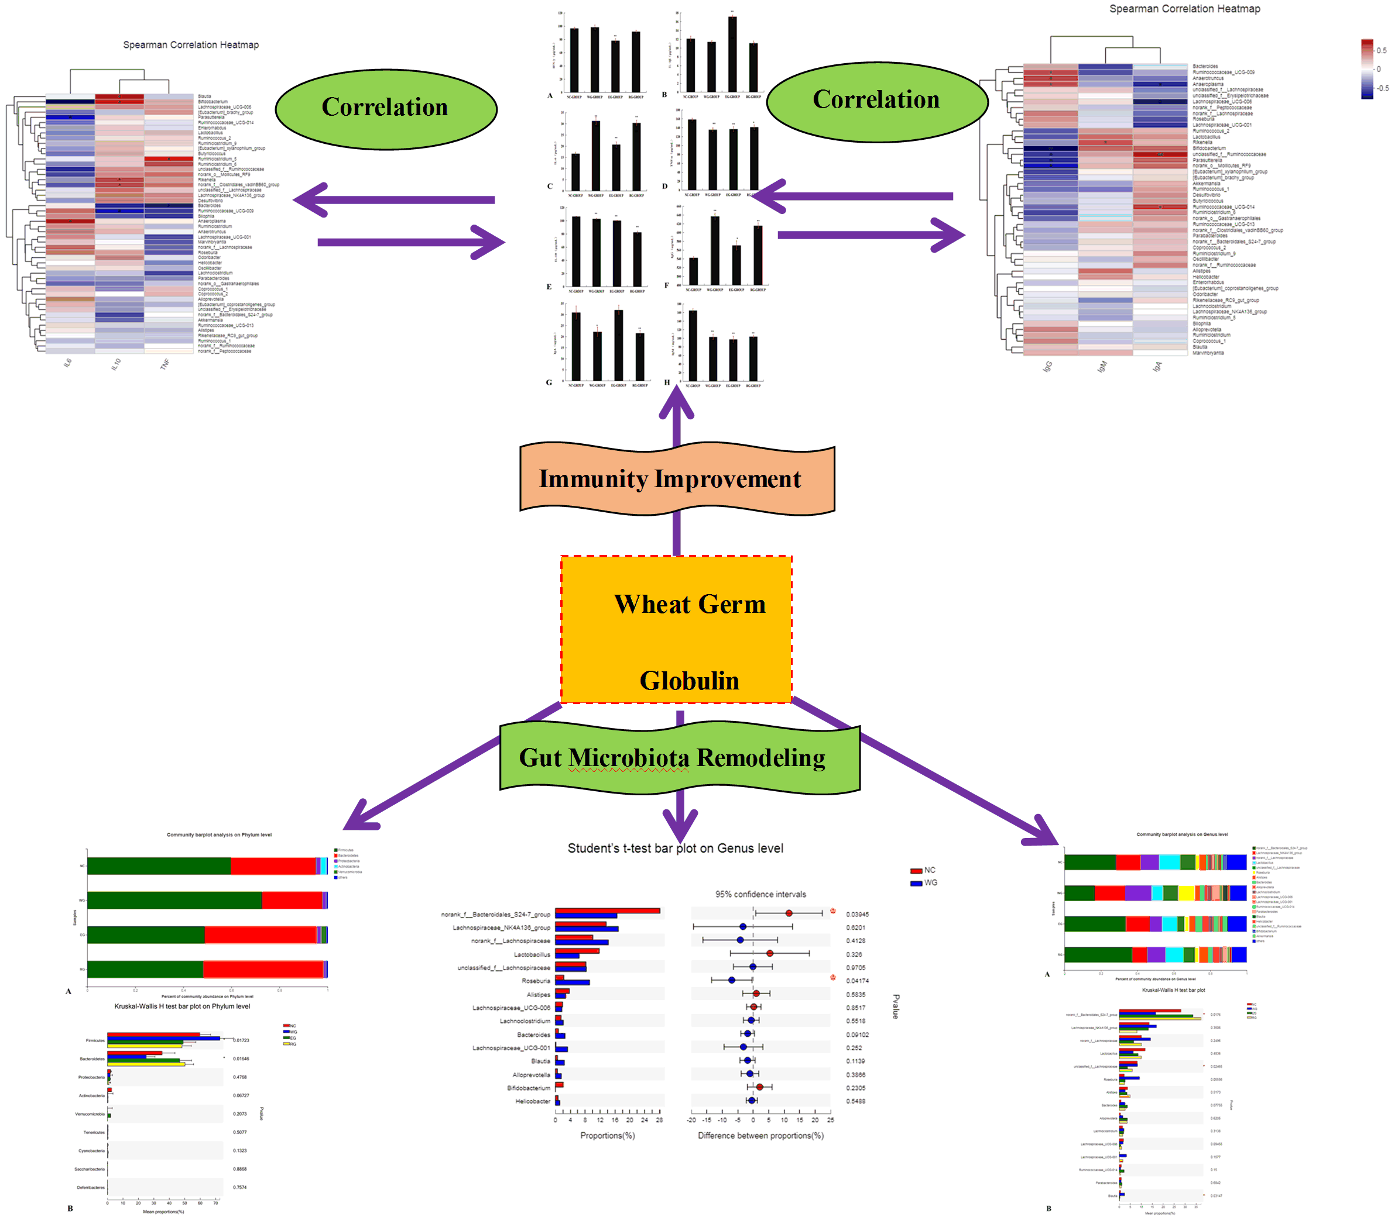
Immunity Improvement and Gut Microbiota Remodeling of Mice by Wheat Germ Globulin

