Table S1 The compositions of cellular fatty acid contents (%) of strains HHU K3-1^{T} and two reference strains.
Taxa: 1, Actirhodobacter atrilutea HHU K3-1^{T}; 2, Parapontixanthobacter aurantiacus MCCC 1A09962^{T}; 3, Pelagerythrobacter marensis KCTC 22370^{T}.
Fatty acid | 1 | 2 | 3
Straight-chain  C_{12:0}  C_{13:0}  C_{14:0}  C_{15:0}  C_{16:0}  C_{17:0}  C_{18:0} | -  -  0.2  -  8.9  2.7  0.2 | 4.0  0.5  2.7  -  23.7  4.4  2.6 | -  -  0.3  -  7.8  0.8  0.7
Unsaturated  C_{15:1}ω6c  C_{16:1}ω5c  C_{17:1}ω6c  C_{17:1}ω8c  C_{18:1}ω5c  C_{18:1}ω9c | 0.2  0.6  24.0  1.8  1.3  - | 0.1  -  0.1  3.9  -  0.2 | -  0.9  7.7  -  2.8  -
Branched  iso-C_{15:0}  iso-C_{16:0}  iso-C_{17:0}  iso-C_{18:1} H  anteiso-C_{15:0}  anteiso-C_{17:1}ω9c  anteiso-C_{17:0} | 0.6  0.2  0.5  0.1  0.9  0.1  1.4 | 0.1  0.3  0.3  -  0.2  -  0.3 | -  -  -  -  -  -  -
Hydroxy  C_{14:0} 2-OH  C_{15:0} 2-OH  C_{16:0} 2-OH  11-methyl-C_{18:1}ω7c | 1.8  3.0  0.4  4.9 | -  -  -  0.1 | 2.1  0.6  1.5  28.2
Summed features  3  8  9 | 12.3  33.5  0.5 | 27.4  14.1  - | 6.9  39.0  0.2

All data are from this study. Values are percentages of total fatty acids; -, not detected. Summed features represent groups of two or three fatty acids that cannot be separated by using the Microbial Identification System. Summed Feature 3 consists of C_{16:1}ω7c/C_{16:1}ω6c; summed feature 8 consists of C_{18:1}ω7c and/or C_{18:1}ω6c; Summed Feature 9 consists of iso-C_{17:1}ω9c and/or 10-methyl-C_{16:0}.

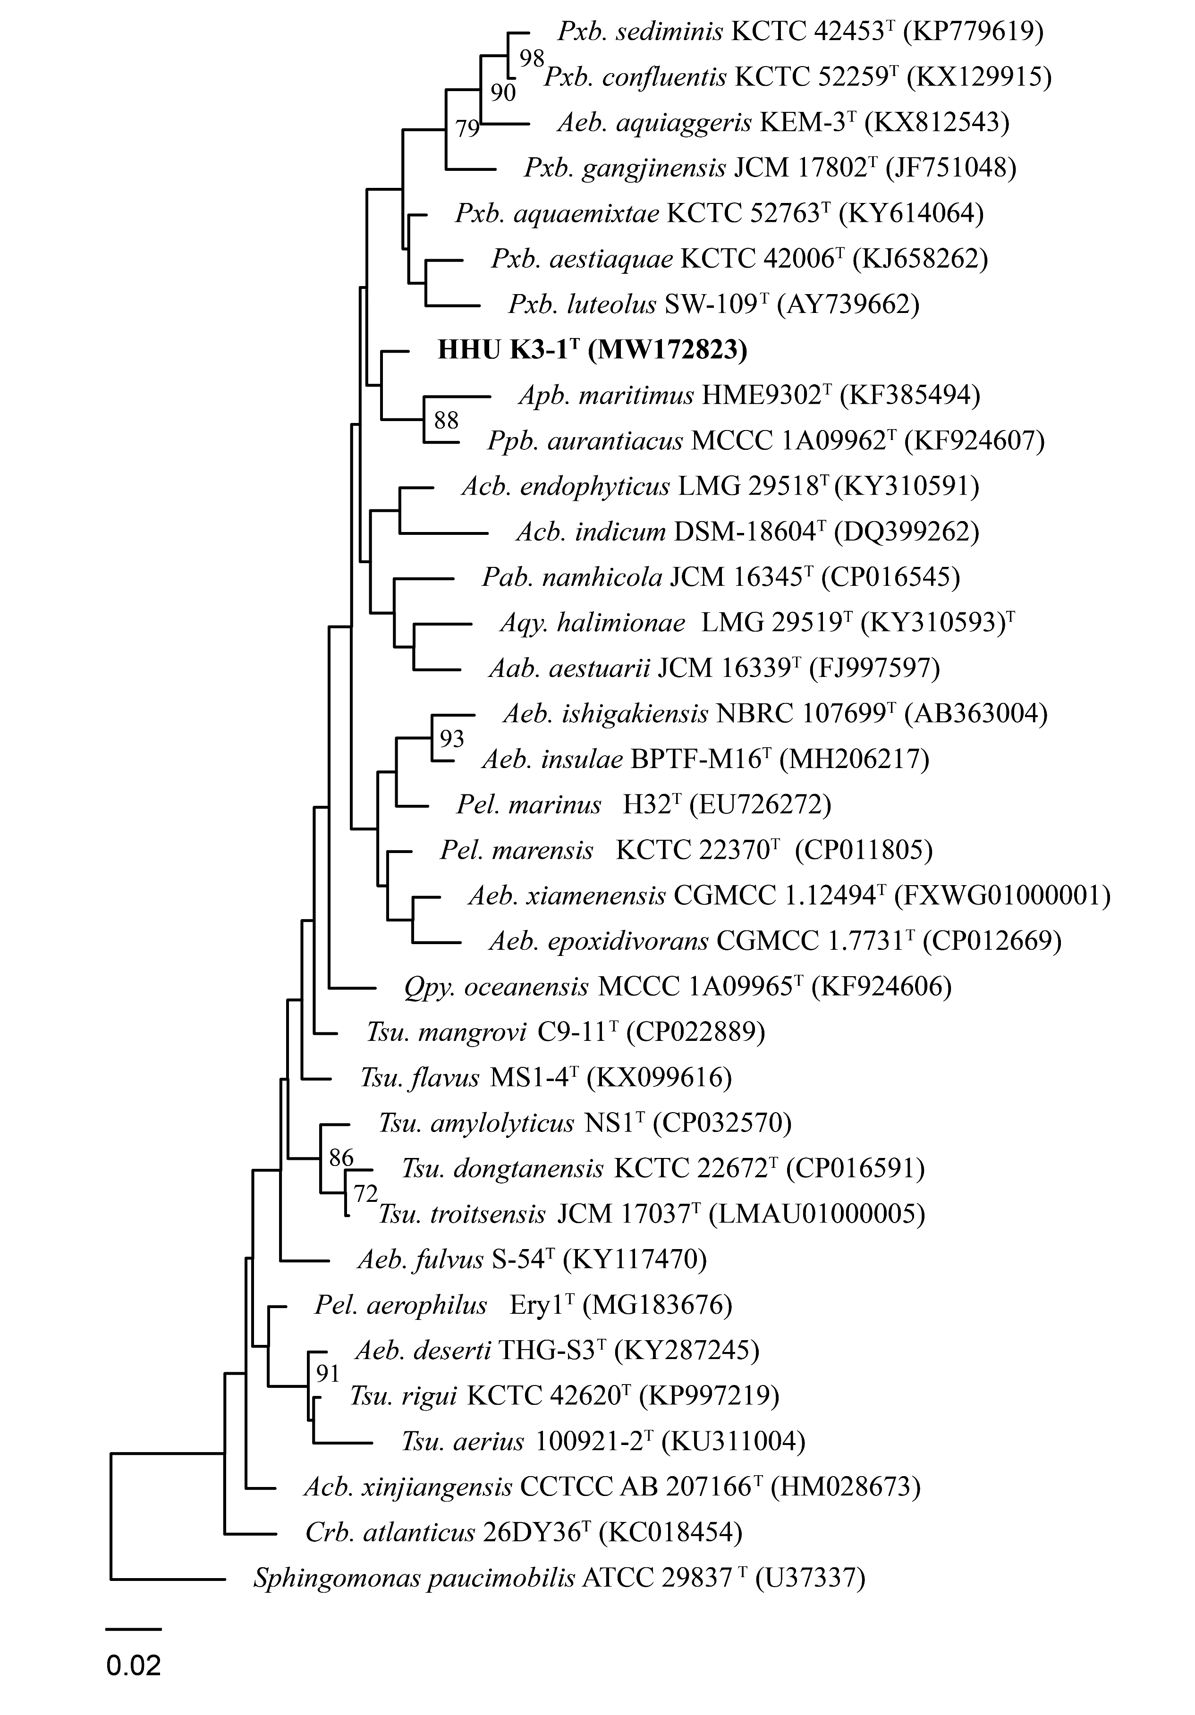
Fig. S1 Maximum-likelihood phylogenetic tree based on 16S rRNA gene sequences showing the position of strain HHU K3-1^{T}. Bootstrap values (expressed as percentages of 1000 replications) of above 70% are shown at the branch points nodes. Sphingomonas paucimobilis ATCC 29837^{T} is used as out group. Bar, 0.02 substitutions per nucleotide position.
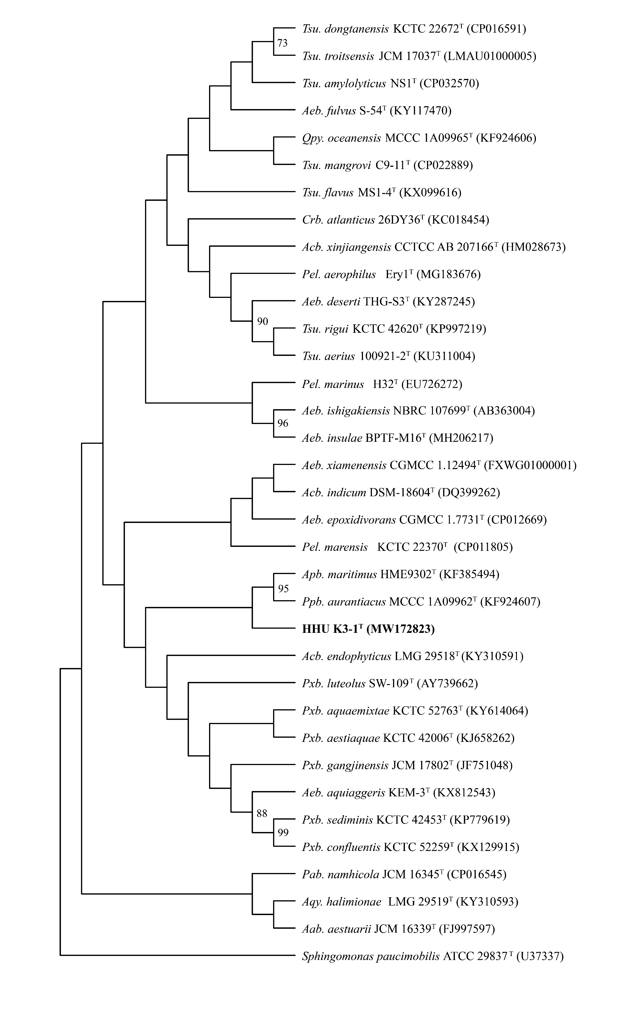
Fig. S2 Maximum-parsimony phylogenetic tree based on 16S rRNA gene sequences showing the position of strain HHU K3-1^{T}. Bootstrap values (expressed as percentages of 1000 replications) of above 70% are shown at the branch points nodes. Sphingomonas paucimobilis ATCC 29837^{T} is used as out group.

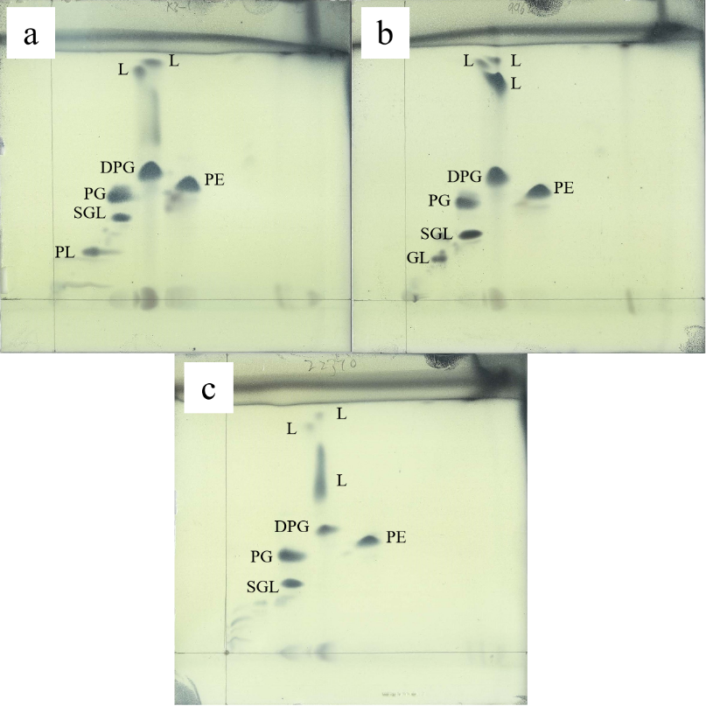
Fig. S3 Two-dimensional thin-layer chromatogram of polar lipids of: a, HHU K3-1^{T}; b, Parapontixanthobacter aurantiacus MCCC 1A09962^{T}; c, Pelagerythrobacter marensis KCTC 22370^{T}.
DPG, diphosphatidylglycerol; PE, phosphatidylethanolamine; PG, phosphatidylglycerol; SGL, sphingoglycolipid; PL, unidentified polar lipid; GL, unidentified glycolipid; L, unidentified lipid.

