Fig. S1 Evidence for successful induction of the FAN mouse model

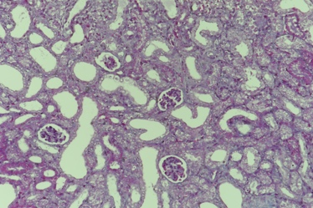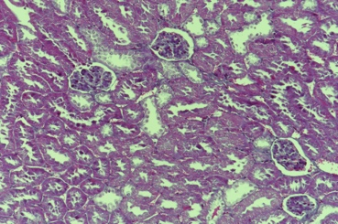

WT

a

b

FAN



(a) Masson staining was performed to evaluate the tubulointerstitial lesions in murine renal tissues (magnification, ×200) on day 7. (b) Urine protein/creatinine ratio in mice on day 2. All data are expressed as mean ± SD (n = 6). \**P* < 0.05, \*\**P* < 0.01.