Phosphorus deficiencies invoke lipids-like enrich in sweetpotato rhizosphere to stimulate bacterial inositol phosphate metabolism
Xiaoya Zhu, Jing Wang, Qiangqiang Zhang, Peng Zhao, Ming Liu, Rong Jin, Aijun Zhang, Zhonghou Tang*
Xuzhou Sweetpotato Research Center, Xuzhou Institute of Agricultural Sciences Jiangsu, China/ /National Agricultural Experimental Station for Soil Quality, Xuzhou, China

Number of figures: 3

* Corresponding author: Zhonghou Tang
Tel: +86-0516-82028152
Email: zhonghoutang@sina.com

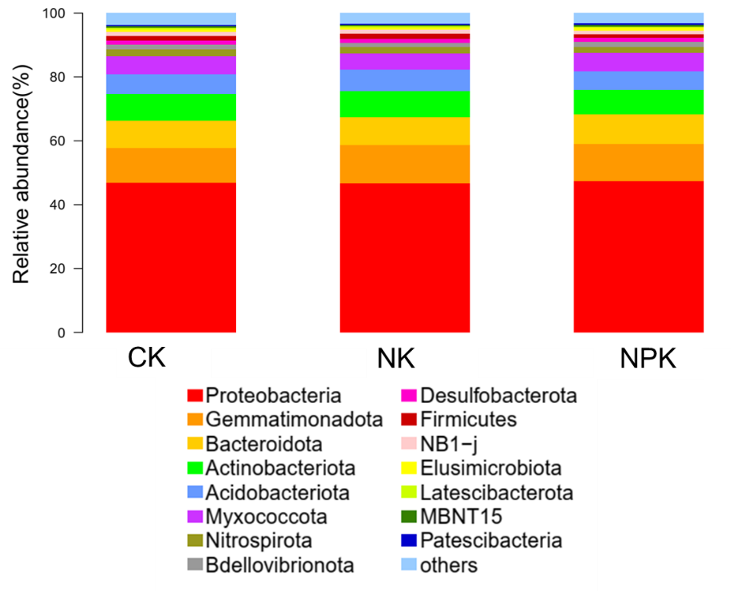
Fig. S1 Top 15 dominant phylum of bacterial community Shangshu 19 rhizosphere among different treatments. Note: CK, NK and NPK represent non fertilization treatment, nitrogen and potassium application treatment and nitrogen, phosphorus and potassium application treatment, respectively. Same below

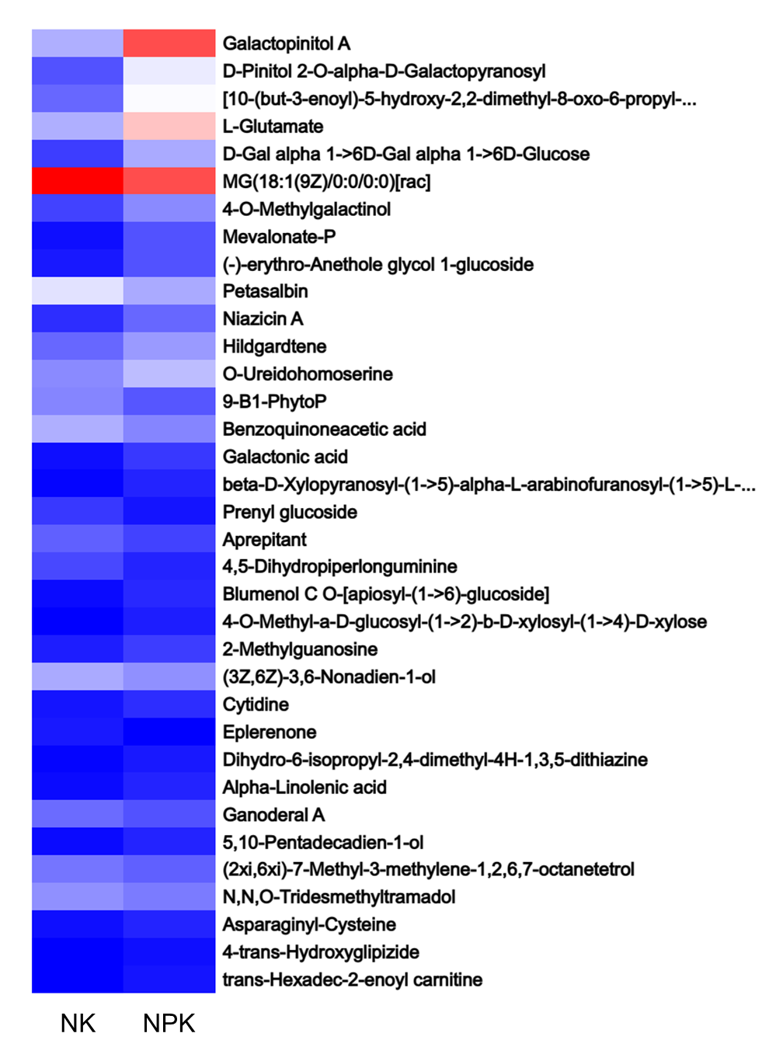
Fig. S2 Differentially expressed metabolites (DEMs) (A) of Shangshu 19 rhizosphere

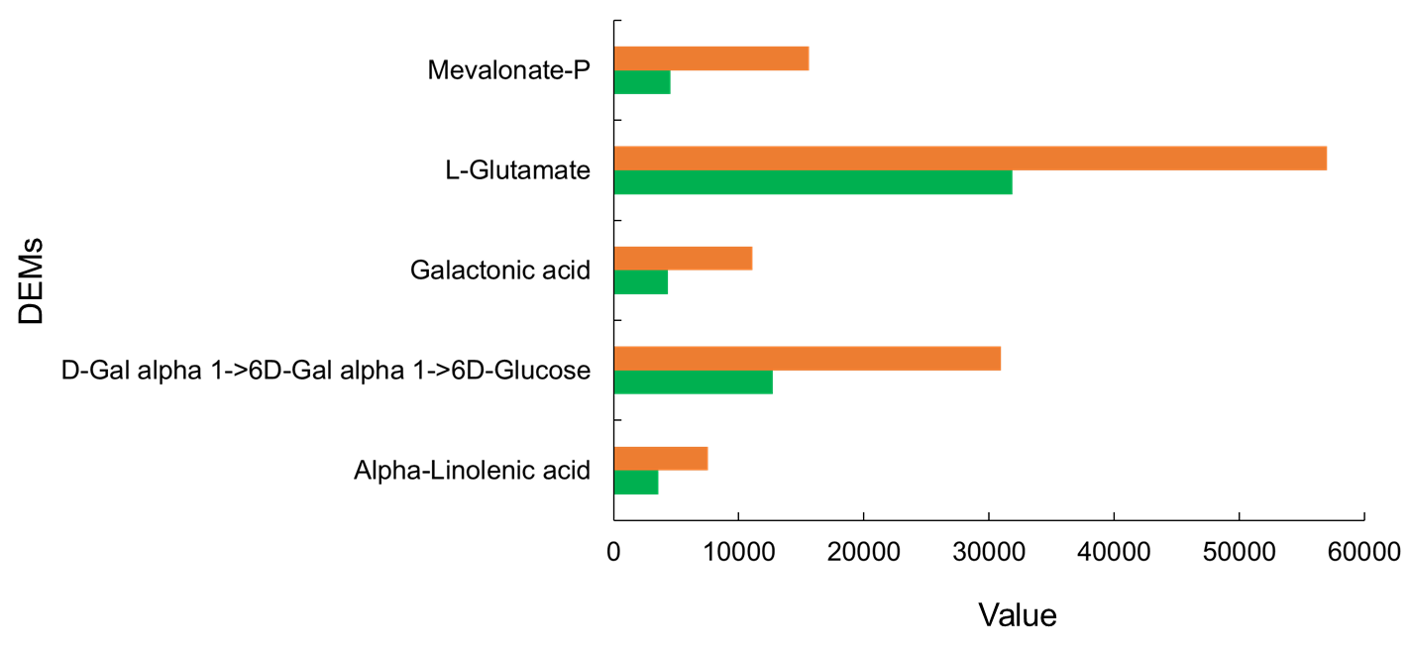
Fig. S3 KEGG enriched differentially expressed metabolites (DEMs) of Shangshu 19 rhizosphere

