Appendix Table and Figure of raw data
Table S1: The cases of Hong Kong and Singapore

 | Singapore |  |  |  | Hong Kong
 | Local |  | Imported |  | Local |  | Imported
Age | cases | standardized incidence rate | cases | standardized incidence rate | cases | standardized incidence rate | cases | standardized incidence rate
0-4 | 1 | 12.3 | 2 | 1.66 | 0 | 0.00 | 0 | 0.00
5-9 | 0 | 0 | 0 | 0.00 | 0 | 0.00 | 0 | 0.00
10-14 | 1 | 0 | 0 | 1.49 | 0 | 0.00 | 0 | 0.00
15-19 | 0 | 5.05 | 1 | 0.00 | 0 | 0.00 | 1 | 6.99
20-24 | 2 | 0 | 0 | 2.41 | 4 | 4.53 | 1 | 5.00
25-29 | 11 | 0 | 0 | 11.62 | 5 | 5.17 | 0 | 0.00
30-34 | 7 | 16.3 | 4 | 7.67 | 2 | 1.98 | 0 | 0.00
35-39 | 15 | 18.8 | 5 | 15.22 | 6 | 5.49 | 2 | 8.09
40-44 | 13 | 3.77 | 1 | 13.19 | 2 | 1.86 | 1 | 4.12
45-49 | 6 | 7.43 | 2 | 6.01 | 5 | 4.35 | 1 | 3.84
50-54 | 13 | 3.70 | 1 | 12.97 | 5 | 4.09 | 0 | 0.00
55-59 | 6 | 18.8 | 5 | 6.07 | 10 | 7.47 | 7 | 23.11
60-64 | 6 | 0 | 0 | 6.81 | 10 | 8.66 | 5 | 19.12
65-69 | 1 | 5.39 | 1 | 1.45 | 8 | 8.92 | 3 | 14.77
70-74 | 3 | 8.43 | 1 | 6.82 | 7 | 11.88 | 2 | 14.99
75-79 | 2 | 0 | 0 | 6.60 | 6 | 14.87 | 0 | 0.00
80-84 | 0 | 0 | 0 | 0 | 4 | 10.94 | 0 | 0.00
85+ | 0 | 0 | 0 | 0 | 4 | 9.78 | 0 | 0.00
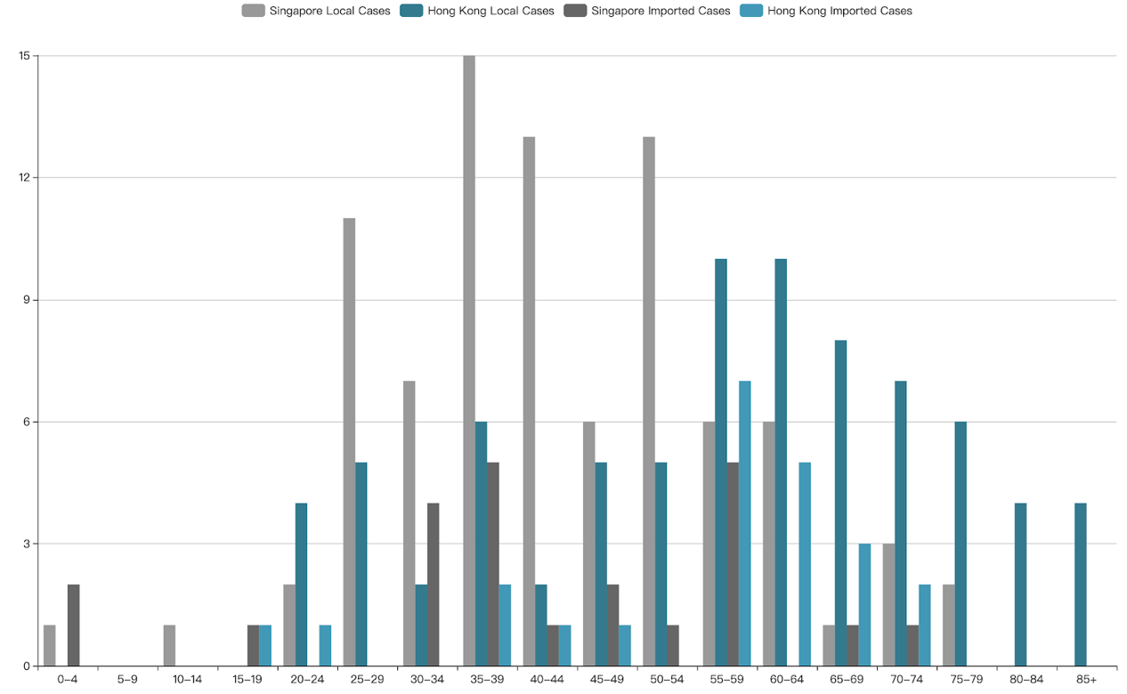
Figure S1. Histogram of local/imported case numbers by age distribution in HK and Singapore

