Supplementary Information

Supplementary Table 1. Input variables for the Features II, PRS + Features II, Features III, and PRS + Features III models. Abbreviations: body mass index (BMI), C-reactive protein (CRP), glycated hemoglobin (HbA1c), insulin-like growth factor 1 (IGF-1) and polygenic risk score (PRS).

 | Machine Learning Model
Input Variables | 1) Features II | 2) PRS + Features II | 3) Features III | 4) PRS + Features III
Genetic |  | PRS |  | PRS
Demographics | Age | Age | Age | Age
 | Father’s history | Father’s history | Father’s history | Father’s history
 | Sibling history | Sibling history | Sibling history | Sibling history
 | Ethnicity | Ethnicity | Ethnicity | Ethnicity
Clinical Measurements | BMI | BMI | BMI | BMI
Laboratory values | HbA1c | HbA1c | HbA1c | HbA1c
 | CRP | CRP | CRP | CRP
 | IGF-1 | IGF-1 | IGF-1 | IGF-1
Medical History | Smoking status | Smoking status | Smoking status | Smoking status
 |  |  | Number of same sex partners | Number of same sex partners
 |  |  | Diabetes diagnosis | Diabetes diagnosis
 |  |  | Diabetes medication | Diabetes medication

Supplementary Table 2. Performance metrics of the Features II, PRS + Features II, Features III, and PRS + Features III models. Abbreviations: Area under the receiver operating characteristic (AUROC); diagnostic odds ratio (DOR); likelihood ratio positive (LR+), likelihood ratio negative (LR-), polygenic risk score (PRS).

 | Features II only | PRS + Features II | Features III only | PRS + Features III
AUROC | 0.742  (0.708, 0.774) | 0.788  (0.758, 0.819) | 0.742  (0.708, 0.774) | 0.788  (0.758, 0.819)
Sensitivity | 0.800  (0.736, 0.864) | 0.800  (0.736, 0.864) | 0.800  (0.736, 0.864) | 0.800  (0.736, 0.864)
Specificity | 0.560  (0.553, 0.567) | 0.629  (0.622, 0.636) | 0.560  (0.553, 0.567) | 0.629  (0.622, 0.636)
DOR | 5.095  (4.694, 5.496) | 6.783  (6.382, 7.184) | 5.095  (4.694, 5.496) | 6.783  (6.382, 7.184)
LR+ | 1.819  (1.676, 1.974) | 2.157  (1.986, 2.341) | 1.819  (1.676, 1.974) | 2.157  (1.986, 2.341)
LR- | 0.357  (0.259, 0.492) | 0.318  (0.231, 0.438) | 0.357  (0.259, 0.492) | 0.318  (0.231, 0.438)

Supplementary Figure 1. SHapely Additive ExPlanations plots of the (A) Features I, (B) PRSs + Features I, (C) Features II, (D) PRS + Features II model, and (E) Minimal Features models.

A
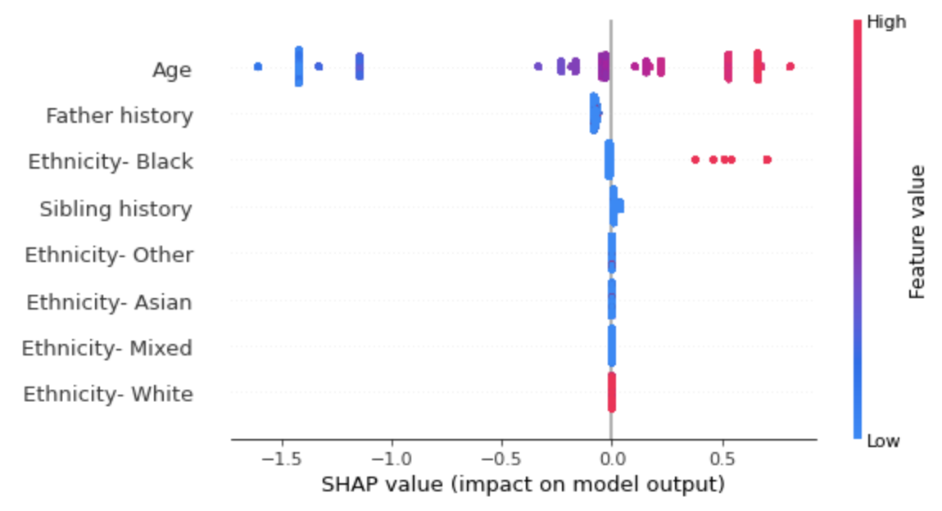

B
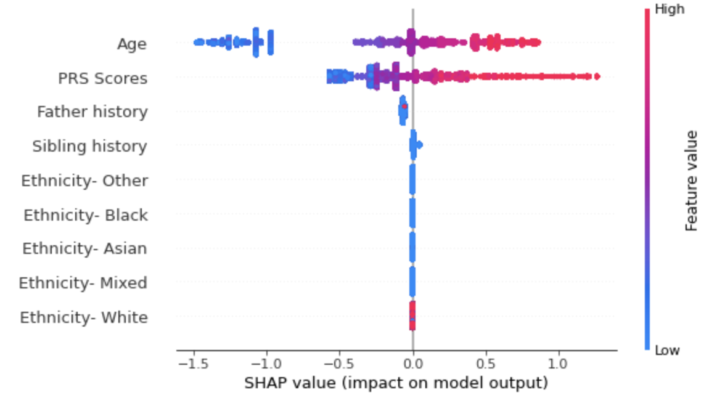

C
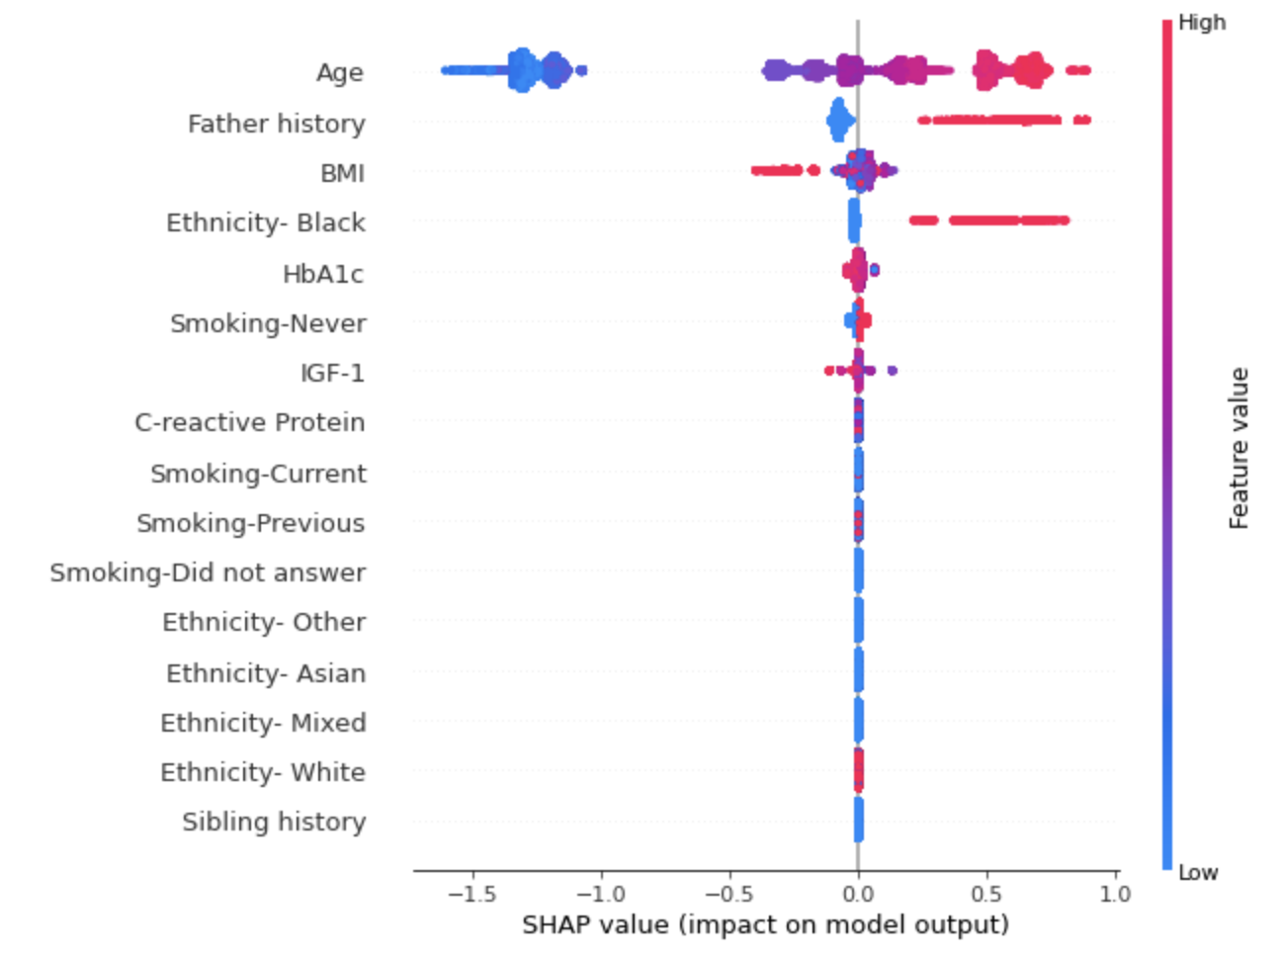

D
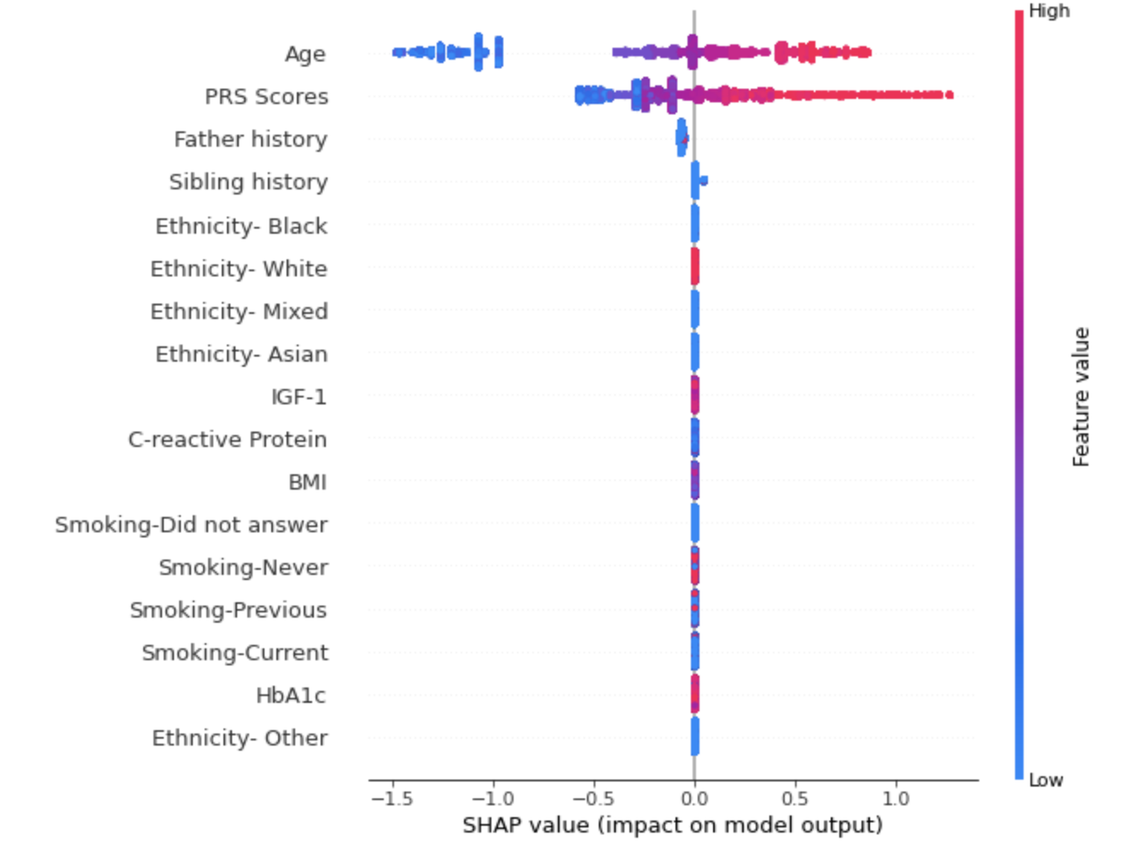

E

