Supplementary Information for “Bayesian inference of physicochemical quality elements of tropical lagoon Nokoué (Benin)”
Romuald HOUNYEME ^{1,2,3*}, Maxime Logez ^{2†}, Daouda MAMA ^{3†} and Christine Argillier ^{1,2}
1* ED251, Aix-Marseille University, CEREGE, Europole de l’Arbois BP80, Aix-en-Provence, 13545, France.
2 UMR RECOVER, INRAE, Aix Marseille Univ, Aix-en-Provence, 13182, France..
3 LHA-INE, University of Abomey-Calavi, 01BP: 526, Cotonou, Benin.

*Corresponding author(s). E-mail(s): romualdaurel1@yahoo.fr ;
Contributing authors: maxime.logez@inrae.fr ; mkdaouda@yahoo.fr; christine.argillier@inrae.fr ;
† These authors contributed equally to this work.

Supporting Information Text
A1-
Measured variables (Units) | Min-Max | Methods
Depth(m) | 0.15-5.25 | Secchi disk
Water temperature (ºC) | 23-39.4 | Direct measurement by multi-parameter pH/Oximeter WTW 340i and multi-thermometer
Transparency(m) | 0.1-1.4 | Secchi disk
Turbidity (NTU) | 1.41-192 | Colorimeter HACH DR/890, Method 8025
Conductivity (mS/cm) | 0.07-67200 | Direct measurement by multi-parameter pH/Oximeter WTW 340i and Radiometer Pionneer 30 portable conductivity meter
Salinity (psu) | 0-33.2 | Direct measurement by multi-parameter pH/Oximeter WTW 340i and Radiometer Pionneer 30 portable conductivity meter
pH | 3.9-9.04 | Direct measurement by multi-parameter pH/Oximeter WTW 340i and portable pH meter Pionneer 10 from Radiometer Analytical
Dissolved oxygen (mg/L) | 0.45-10.72 | Direct measurement by multi-parameter pH/Oximeter WTW 340i and portable oximeter HI9143-Microprocessor Auto cal-HANNA
BOD (mg/L) | 1-29 | Oxytop respirometric method in a thermostatic chamber
COD (mg/L) | 3.67-540.63 | AFNOR NF T90-101, Colorimètre, colorimeter, potassium dichromate method
Kjeldahl nitrogen (TKN) (mg/L) | 0.19-8.44 | Spectrophotometric method HACH LANGE DR 2800  NitraVer®5 Nitrate Reagent for 10mL sample, cat 21061-69Pk/100  NitriVer®2 Nitrite Reagent for 10mL sample, cat 21075-69Pk/100  Colorimetric method (cadmium reduction method for Nitrates; diazotization  method nitrites, the Nessler Method for ammonium and nitrogen Kjeldahl) and test cards method for assaying ammonium ions
Ammonium (NH4+) (mg/L) | 0.01-2.29
Nitrates (NO₃⁺) (mg/L) | 0.0-5.5
Nitrites (NO₂⁻) (mg/L) | 0.0-3.34
Dry organic matter content (D.O.) | 0.72-26 | Loss on ignition method.
Orthophosphates (PO₄³⁻) (mg/L) | 0.01-2.41 | Ascorbic acid method
Total phosphorus (PT) (mg/L) | 0.21-73.75
Granulometry | 4.5-95 | Sieving
Suspended matter (SS) (mg/L) | 0.0-115 | Colorimeter HACH DR/890, Method 8025
TDS | 0.09-22546.2 | Portable Conductometer Pionneer 30 from Radiometer
Table 1: Measurement methods, analyses, and associated variables
A2-
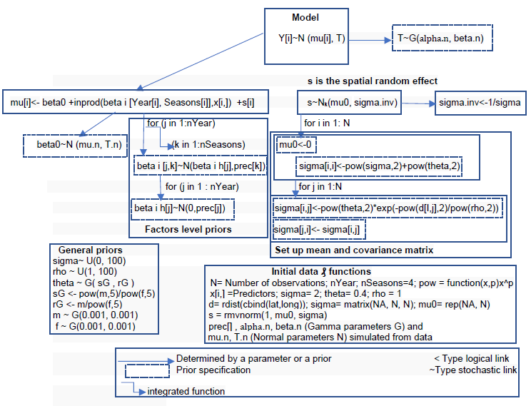
Fig 1: Structure of the spatialtemporal hierarchical model: (Submodel 1: The design framework for submodel 1 comes from the hierarchical Bayesian mixed regression model with a between-subjects factor from Kruschke (2015, 2011). Based on this conceptual framework, and after modification and adaptation, the specification of submodel 1 will consider two factors at different levels (factor=Year, factor=Seasons), and the predictors. The index i runs through the rows of the data table and N is the total number of observations. data values, y[i] (where y is the dependent variable), are assumed to be normally distributed around the predicted mean mu[i]. The other elements that make up the predicted mean mu[i] are the deviations of each of the predictors according to the two factors, priors ranked on each type of deviation, so that the variance of the deviations is estimated. As for the prior distributions required by this submodel 1, they are of normal type (N) for all the coefficients "beta" of the model and of type gamma (G) for the ''T'' variances as well as the ''prec'' precisions. Submodel 2: Spatial dependence can be modeled by a covariance matrix constructed using the moving average method (Chagneau et al., 2011) . The script of this submodel 2 is a simple spatial hierarchical model in JAGS (Adapted from the Parnell script) (Andrew, 2020). The development of this part of the model required the longitudinal and latitudinal coordinates of the sampling points (X and Y), the "mvtnorm" package (Genz et al., 2020) via R's rmvnorm function to generate a covariance matrix, to make the calculation of integrals and the definition of prior distributions more explicit.
A3-

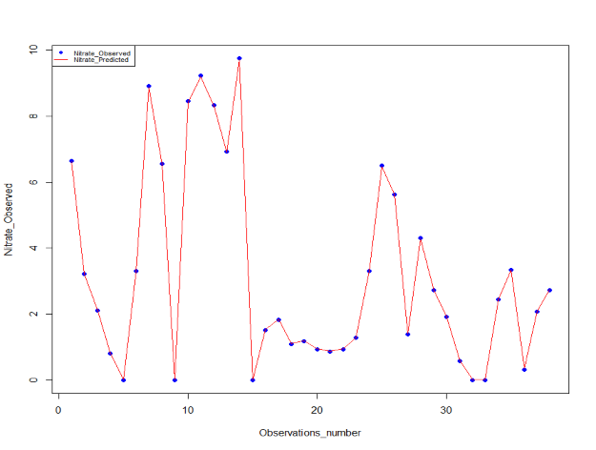
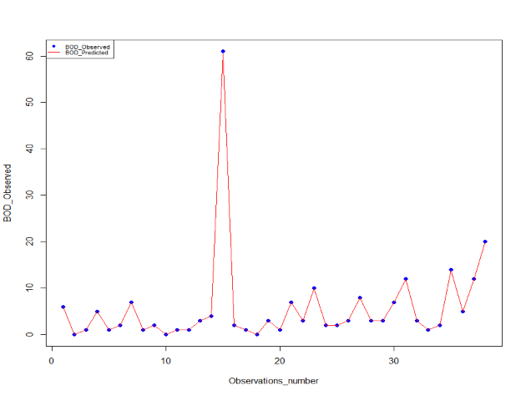
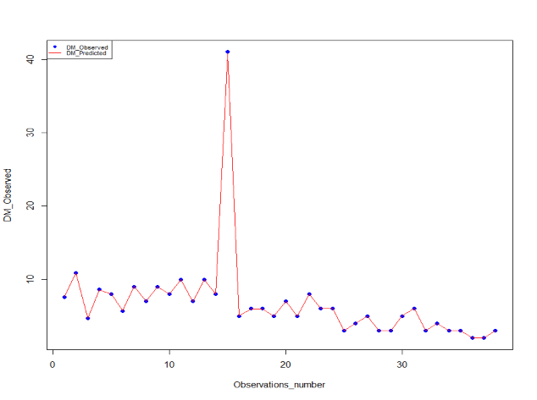
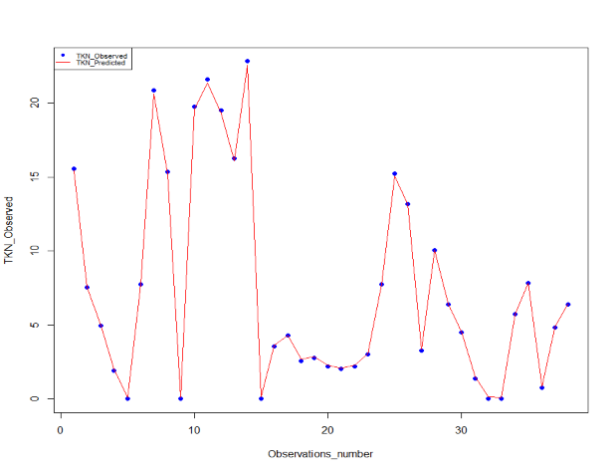

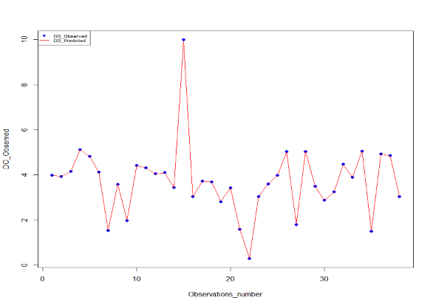
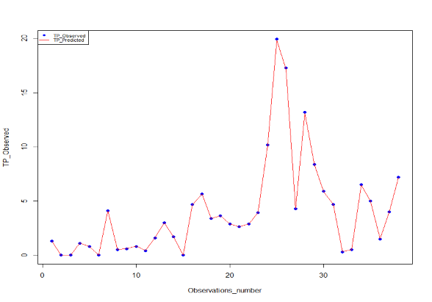
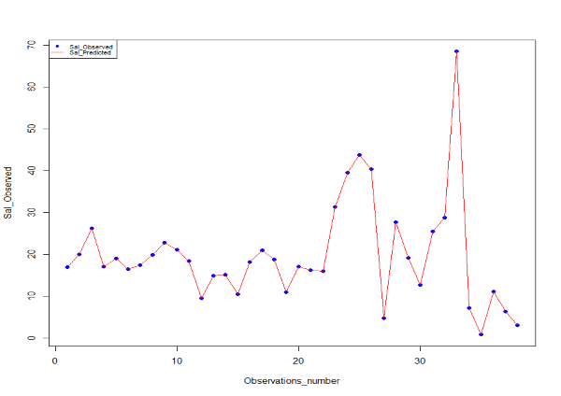
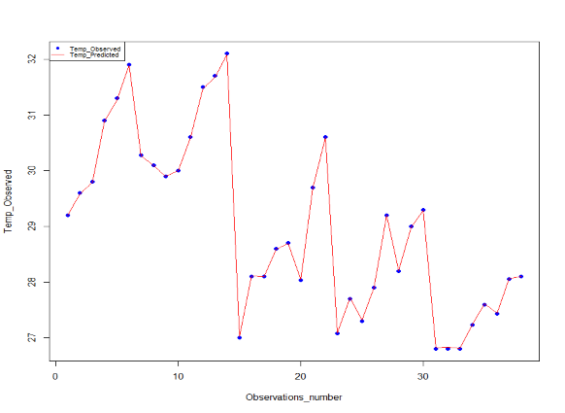
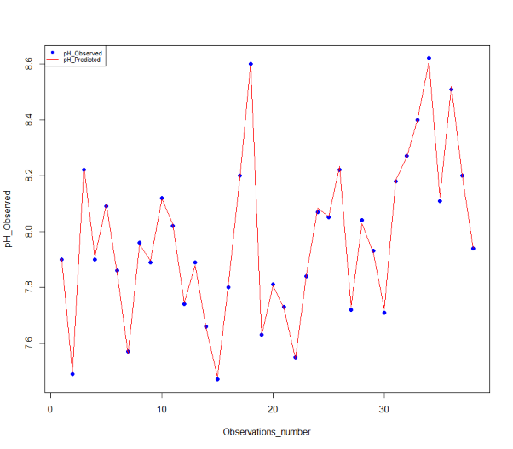
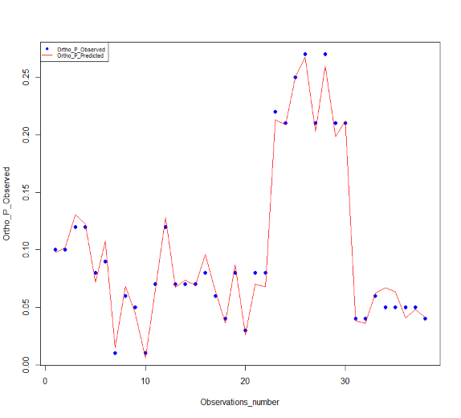
Fig 2: Validation results of relevant selected physicochemical parameters
Link to data:

- Romuald HOUNYEME, & MAMA Daouda. (2021). Dataset related to article "Bayesian inference of physico-chemical quality elements of a tropical lagoon Nokoué" (Version 4) [Data set]. Zenodo. https://doi.org/10.5281/zenodo.5865635

- HOUNYEME ROMUALD. (2022). R Script for "Bayesian inference of physico-chemical quality elements of a tropical lagoon Nokoué". Zenodo. https://doi.org/10.5281/zenodo.5865897

REFERENCES:
Andrew, P. (2020). Simple spatial hierarchical model in JAGS.
Chagneau, P., Mortier, F., Picard, N., and Bacro, J.-N. (2011). A Hierarchical Bayesian Model for Spatial Prediction of Multivariate Non-Gaussian Random Fields. Biometrics 67, 97–105.
Genz, A., Bretz, F., Miwa, T., Mi, X., Leisch, F., Scheipl, F., Bornkamp, B., Maechler, M., and Hothorn, T. (2020). mvtnorm: Multivariate Normal and t Distributions.
Kruschke, J. (2015). Doing Bayesian Data Analysis: A Tutorial with R, JAGS, and Stan (US: Academic Press).
Kruschke, J.K. (2011). Faire l’analyse des données bayésiennes: conception de parcelles divisées dans JAGS (version préliminaire).

