Cellulose nanofiber, Lignin, and Hemicellulose as value-added products from recycled Old Corrugated Box (OCB)

Sumit S. Lal, Ajit P. Patil, Ganesh A. Phalak and Shashank T. Mhaske

Department of Polymer and Surface Engineering,
Institute of Chemical Technology (ICT), Matunga, Mumbai, India.

Supplementary information (SI):
SI-I Pre-treatment of OCB raw material:

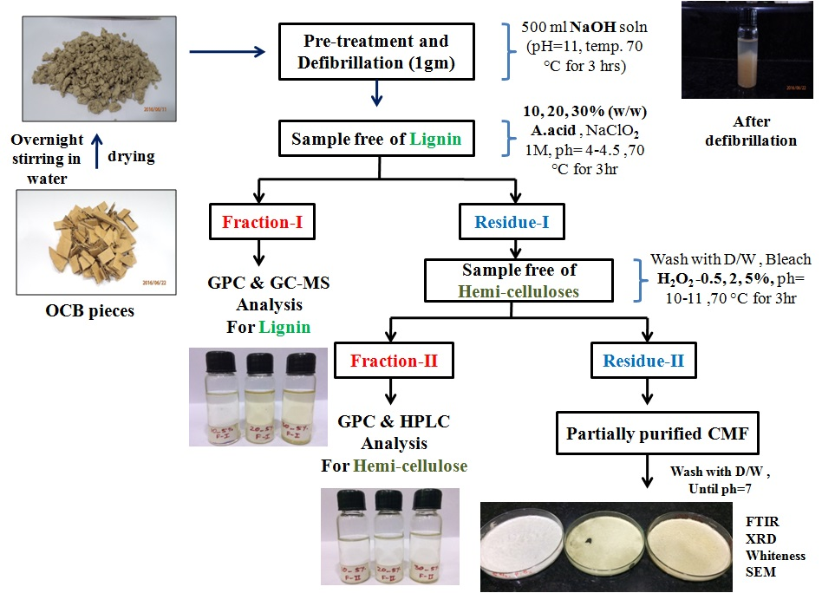

SI-II Change in color of fractions collected after acetic acid and H₂O₂ pre-treatment:

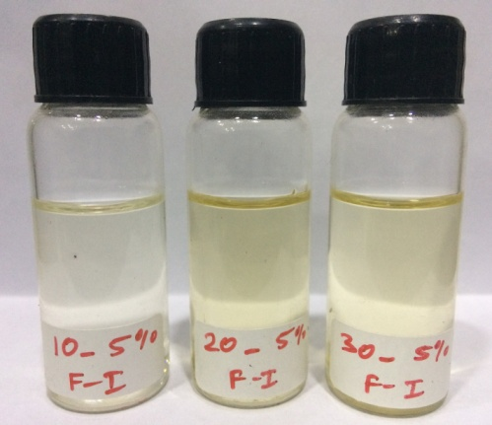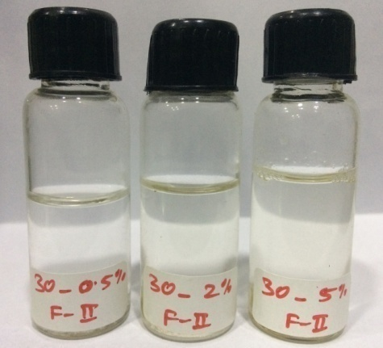

SI-III L*a*b* color space value of OCB raw and H₂O₂ (0.5%, 2%, & 5%) treated OCB fibers:

Sample | Percent reflectance | ΔE | WI
OCB raw | 25.45 | --- | 33.19
Treated 0.5% | 47.85 | 4.13 | 57.29
Treated 2% | 47.97 | 5.03 | 59.63
Treated 5% | 44.60 | 4.20 | 54.76
ΔE, color difference; WI, whiteness index

SI-IV Total ion chromatogram of the (a) 10%, (b) 20% and (c) 30% acetic acid treated fraction-I:

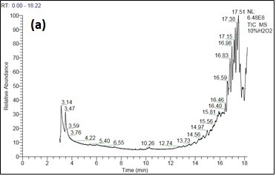
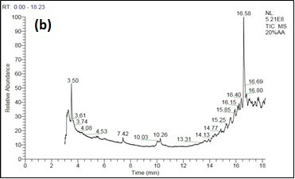

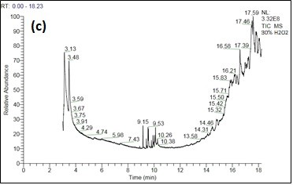

SI-V Total Lignin content in OCB Raw:

Sample | Lignin content  (%) | Lignin content  (Avg. %)
OCB Raw-01 | 23 | 28.15 (± 3.48)
OCB Raw-02 | 29.48
OCB Raw-03 | 31.71
OCB Raw-04 | 30.22
OCB Raw-05 | 26.34

SI-VI HPLC analysis of hemicellulose fraction obtained after (a) 0.5%, (b) 2% and (c) 5% bleach treatment:

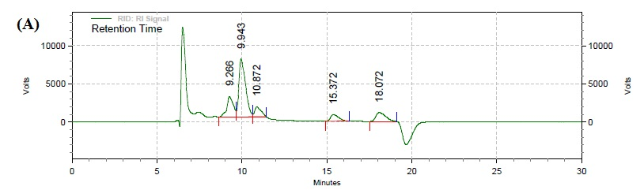
(a)

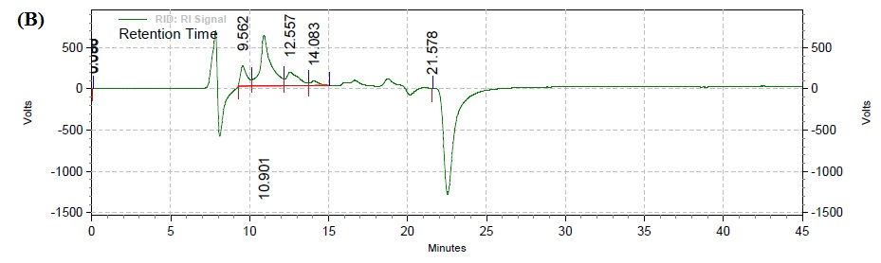
(b)

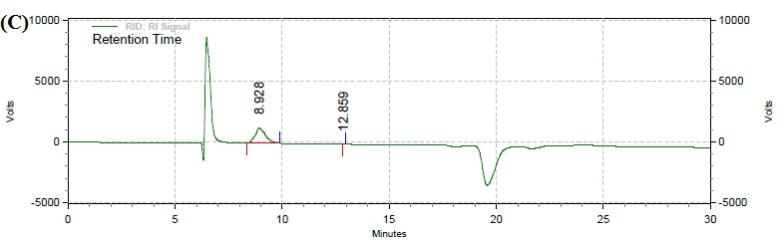
(c)

SI –VII Composition of known compounds with respect to standards in fraction-II after bleach treatment:

 | Sr. No. |  | H₂O₂ (%) |  | Peaks |  | Retention time (min) |  | RT of known compound
1 |  | 0.5 |  | 1 |  | 9.26 |  | ----
 |  |  |  | 2 |  | 9.94 |  | Glucose
 |  |  |  | 3 |  | 10.87 |  | Arabinose
 |  |  |  | 4 |  | 15.37 |  | ----
 |  |  |  | 5 |  | 18.07 |  | ----
2 |  | 2 |  | 1 |  | 9.56 |  | Glucose
 |  |  |  | 2 |  | 10.90 |  | Arabinose
 |  |  |  | 3 |  | 12.55 |  | ----
 |  |  |  | 4 |  | 14.08 |  | Xylose
 |  |  |  | 5 |  | 21.57 |  | ----
3 |  | 5 |  | 1 |  | 8.92 |  | ----
 |  |  |  | 2 |  | 12.85 |  | ----

