Additional data for article
Captions
Table S1. ANOVA of the models.
Table S2. The wavelength assignments of the lignin, cellulose and hemicellulose related bands.
Table S3. The yields of xylose (X1) and XOS (X2-X6) from extracted xylan of sorghum pith, rind and whole stem.
Fig. S1. The correlation between the released p-coumaric acid and the recovered xylan of pith (A), rind (B) and whole stem (C).
Fig. S2. FTIR spectra of raw and pretreated pith (A), rind (B) and whole stem (C).
Fig. S3. SEM images of untreated and pretreated sorghum sample. Raw pith (A), raw rind (D), raw whole stem (G), NaOH-ethanol pretreated pith (B), NaOH-ethanol pretreated rind (E), NaOH-ethanol pretreated whole stem (H), NaOH pretreated pith (C), NaOH pretreated rind (F) and NaOH pretreated whole stem (I).
Fig. S4. X-ray diffractograms of untreated and pretreated sorghum samples.

Table S1. ANOVA of the models.
Pith:
Source | Sum of Squares | DF | Mean Square | F-value | P-value
P-coumaric acid
Model | 12245.85 | 14 | 874.70 | 52.42 | < 0.0001 | significant
A-NaOH | 9049.72 | 1 | 9049.72 | 542.37 | < 0.0001
B-Ethanol | 589.68 | 1 | 589.68 | 35.34 | < 0.0001
C-Tempertature | 268.47 | 1 | 268.47 | 16.09 | 0.0013
D-Time | 339.63 | 1 | 339.63 | 20.35 | 0.0005
AB | 10.60 | 1 | 10.60 | 0.6350 | 0.4388
AC | 72.93 | 1 | 72.93 | 4.37 | 0.0553
AD | 29.43 | 1 | 29.43 | 1.76 | 0.2054
BC | 11.53 | 1 | 11.53 | 0.6908 | 0.4198
BD | 244.30 | 1 | 244.30 | 14.64 | 0.0019
CD | 5.13 | 1 | 5.13 | 0.3075 | 0.5880
A² | 1596.78 | 1 | 1596.78 | 95.70 | < 0.0001
B² | 57.60 | 1 | 57.60 | 3.45 | 0.0843
C² | 58.47 | 1 | 58.47 | 3.50 | 0.0823
D² | 6.39 | 1 | 6.39 | 0.3828 | 0.5460
Residual | 233.60 | 14 | 16.69
Lack of Fit | 228.68 | 10 | 22.87 | 18.59 | 0.0063 | significant
Pure Error | 4.92 | 4 | 1.23
R² | 0.9813
Adjusted R² | 0.9626
Predicted R² | 0.8938
Hemicellulose
Model | 1566.63 | 14 | 111.90 | 17.76 | < 0.0001 | significant
A-NaOH | 1170.98 | 1 | 1170.98 | 185.80 | < 0.0001
B-Ethanol | 127.86 | 1 | 127.86 | 20.29 | 0.0005
C-Tempertature | 1.47 | 1 | 1.47 | 0.2332 | 0.6366
D-Time | 2.31 | 1 | 2.31 | 0.3672 | 0.5542
AB | 1.17 | 1 | 1.17 | 0.1851 | 0.6736
AC | 4.93 | 1 | 4.93 | 0.7820 | 0.3915
AD | 3.61 | 1 | 3.61 | 0.5728 | 0.4617
BC | 32.09 | 1 | 32.09 | 5.09 | 0.0405
BD | 93.51 | 1 | 93.51 | 14.84 | 0.0018
CD | 24.65 | 1 | 24.65 | 3.91 | 0.0680
A² | 63.71 | 1 | 63.71 | 10.11 | 0.0067
B² | 9.82 | 1 | 9.82 | 1.56 | 0.2325
C² | 40.91 | 1 | 40.91 | 6.49 | 0.0232
D² | 37.21 | 1 | 37.21 | 5.90 | 0.0291
Residual | 88.23 | 14 | 6.30
Lack of Fit | 87.13 | 10 | 8.71 | 31.61 | 0.0023 | significant
Pure Error | 1.10 | 4 | 0.2757
Cor Total | 1654.87 | 28
R² | 0.9467
Adjusted R² | 0.8934
Predicted R² | 0.6957
Rind:
Source | Sum of Squares | DF | Mean Square | F-value | P-value
P-coumaric acid
Model | 18566.46 | 14 | 1326.18 | 39.44 | < 0.0001 | significant
A-NaOH | 13563.65 | 1 | 13563.65 | 403.37 | < 0.0001
B-Ethanol | 513.26 | 1 | 513.26 | 15.26 | 0.0016
C-Temperature | 152.65 | 1 | 152.65 | 4.54 | 0.0513
D-Time | 654.16 | 1 | 654.16 | 19.45 | 0.0006
AB | 101.30 | 1 | 101.30 | 3.01 | 0.1046
AC | 1.30 | 1 | 1.30 | 0.0386 | 0.8470
AD | 6.43 | 1 | 6.43 | 0.1911 | 0.6687
BC | 1.39 | 1 | 1.39 | 0.0414 | 0.8417
BD | 251.06 | 1 | 251.06 | 7.47 | 0.0162
CD | 13.40 | 1 | 13.40 | 0.3984 | 0.5381
A² | 3277.73 | 1 | 3277.73 | 97.48 | < 0.0001
B² | 171.32 | 1 | 171.32 | 5.09 | 0.0405
C² | 115.61 | 1 | 115.61 | 3.44 | 0.0849
D² | 40.52 | 1 | 40.52 | 1.20 | 0.2909
Residual | 470.76 | 14 | 33.63
Lack of Fit | 464.43 | 10 | 46.44 | 29.33 | 0.0026 | significant
Pure Error | 6.33 | 4 | 1.58
Cor Total | 19037.22 | 28
R² | 0.9753
Adjusted R² | 0.9505
Predicted R² | 0.8590
Hemicellulose
Model | 464.23 | 10 | 46.42 | 12.43 | < 0.0001 | significant
A-NaOH | 147.63 | 1 | 147.63 | 39.53 | < 0.0001
B-Ethanol | 225.33 | 1 | 225.33 | 60.33 | < 0.0001
C-Temperature | 3.55 | 1 | 3.55 | 0.9514 | 0.3423
D-Time | 29.27 | 1 | 29.27 | 7.84 | 0.0119
AB | 35.88 | 1 | 35.88 | 9.61 | 0.0062
AC | 3.40 | 1 | 3.40 | 0.9115 | 0.3524
AD | 0.0196 | 1 | 0.0196 | 0.0052 | 0.9430
BC | 3.57 | 1 | 3.57 | 0.9565 | 0.3410
BD | 14.90 | 1 | 14.90 | 3.99 | 0.0611
CD | 0.6724 | 1 | 0.6724 | 0.1800 | 0.6764
Residual | 67.23 | 18 | 3.73
Lack of Fit | 66.45 | 14 | 4.75 | 24.54 | 0.0035 | significant
Pure Error | 0.7737 | 4 | 0.1934
Cor Total | 531.46 | 28
R² | 0.8735
Adjusted R² | 0.8032
Predicted R² | 0.6212
Whole stem:
Source | Sum of Squares | DF | Mean Square | F-value | P-value
P-coumaric acid
Model | 13421.69 | 14 | 958.69 | 39.35 | < 0.0001 | significant
A-NaOH | 10038.13 | 1 | 10038.13 | 412.01 | < 0.0001
B-Ethanol | 534.40 | 1 | 534.40 | 21.93 | 0.0004
C-Temperature | 275.33 | 1 | 275.33 | 11.30 | 0.0047
D-Time | 355.67 | 1 | 355.67 | 14.60 | 0.0019
AB | 34.28 | 1 | 34.28 | 1.41 | 0.2553
AC | 75.26 | 1 | 75.26 | 3.09 | 0.1007
AD | 5.00 | 1 | 5.00 | 0.2050 | 0.6576
BC | 0.9506 | 1 | 0.9506 | 0.0390 | 0.8463
BD | 222.01 | 1 | 222.01 | 9.11 | 0.0092
CD | 3.46 | 1 | 3.46 | 0.1420 | 0.7120
A² | 1847.33 | 1 | 1847.33 | 75.82 | < 0.0001
B² | 77.75 | 1 | 77.75 | 3.19 | 0.0957
C² | 38.85 | 1 | 38.85 | 1.59 | 0.2273
D² | 9.95 | 1 | 9.95 | 0.4083 | 0.5331
Residual | 341.09 | 14 | 24.36
Lack of Fit | 335.26 | 10 | 33.53 | 23.01 | 0.0042 | significant
Pure Error | 5.83 | 4 | 1.46
Cor Total | 13762.78 | 28
R² | 0.9752
Adjusted R² | 0.9504
Predicted R² | 0.8590
Hemicellulose
Model | 1097.38 | 14 | 78.38 | 19.23 | < 0.0001 | significant
A-NaOH | 626.41 | 1 | 626.41 | 153.69 | < 0.0001
B-Ethanol | 218.79 | 1 | 218.79 | 53.68 | < 0.0001
C-Temperature | 0.3502 | 1 | 0.3502 | 0.0859 | 0.7737
D-Time | 3.82 | 1 | 3.82 | 0.9371 | 0.3494
AB | 15.44 | 1 | 15.44 | 3.79 | 0.0719
AC | 10.82 | 1 | 10.82 | 2.66 | 0.1255
AD | 0.4096 | 1 | 0.4096 | 0.1005 | 0.7559
BC | 18.23 | 1 | 18.23 | 4.47 | 0.0528
BD | 11.22 | 1 | 11.22 | 2.75 | 0.1193
CD | 11.46 | 1 | 11.46 | 2.81 | 0.1158
A² | 167.27 | 1 | 167.27 | 41.04 | < 0.0001
B² | 9.27 | 1 | 9.27 | 2.27 | 0.1537
C² | 0.6986 | 1 | 0.6986 | 0.1714 | 0.6851
D² | 1.72 | 1 | 1.72 | 0.4210 | 0.5269
Residual | 57.06 | 14 | 4.08
Lack of Fit | 56.14 | 10 | 5.61 | 24.48 | 0.0037 | significant
Pure Error | 0.9175 | 4 | 0.2294
Cor Total | 1154.44 | 28
R² | 0.9506
Adjusted R² | 0.9011
Predicted R² | 0.7186

Table S2. The wavelength assignments of the lignin, cellulose and hemicellulose related bands.
Wavenumber (cm⁻¹) | Wavelength Assignment
3432 | O₂-H_{2。。。}O₆ intramolecular stretching modes in cellulose
1732 | C=O vibration of esters, ketones, aldehydes in hemicellulose and/or lignin
1513 | Aromatic skeletal ring in lignin
1399 | C-H deformation in cellulose and hemicellulose
1254 | C-O stretch in lignin and C-O linkage in guaiacyl aromatic groups
1162 | C-O-C vibrations in cellulose and hemicellulose
1106 | Aromatic skeletal and C-O stretch in lignin
1048 | C-O stretch in cellulose and hemicellulose
896 | C-H deformation in cellulose

Table S3. The yields of xylose (X1) and XOS (X2-X6) from extracted xylan of sorghum pith, rind and whole stem.
Source | Xylanase | X1 (%) | XOS (%)
 |  |  | X2 | X3 | X4 | X5 | X6
Pith | EpXYN1 | 3.70 | 15.92 | 9.93 | 4.44 | 0.54 | 0.36
 | EpXYN3 | 2.74 | 10.00 | 7.12 | 0.72 | 0.77 | 0.23
 | XynII | 0.84 | 6.87 | 6.71 | n.d.ª | 0.10 | 0.09
Rind | EpXYN1 | 3.20 | 15.33 | 10.67 | 6.32 | 0.27 | 0.12
 | EpXYN3 | 2.11 | 5.92 | 8.56 | n.d. | 0.86 | n.d.
 | XynII | 0.55 | 6.24 | 6.24 | n.d. | n.d. | 0.50
Whole stem | EpXYN1 | 3.03 | 14.91 | 9.11 | 5.32 | 0.22 | 0.72
 | EpXYN3 | 4.31 | 11.79 | 4.84 | 0.44 | 0.17 | 0.11
 | XynII | 0.82 | 8.02 | 7.94 | n.d. | n.d. | n.d.
ª n.d., not detected.
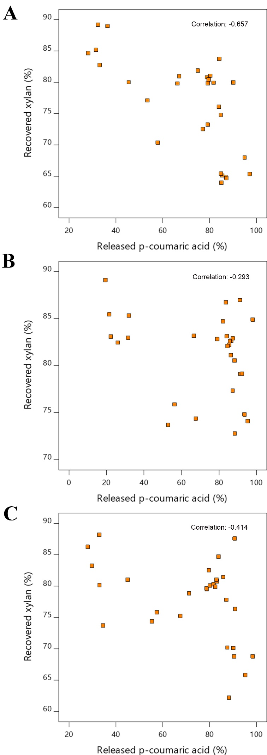

Figure S1

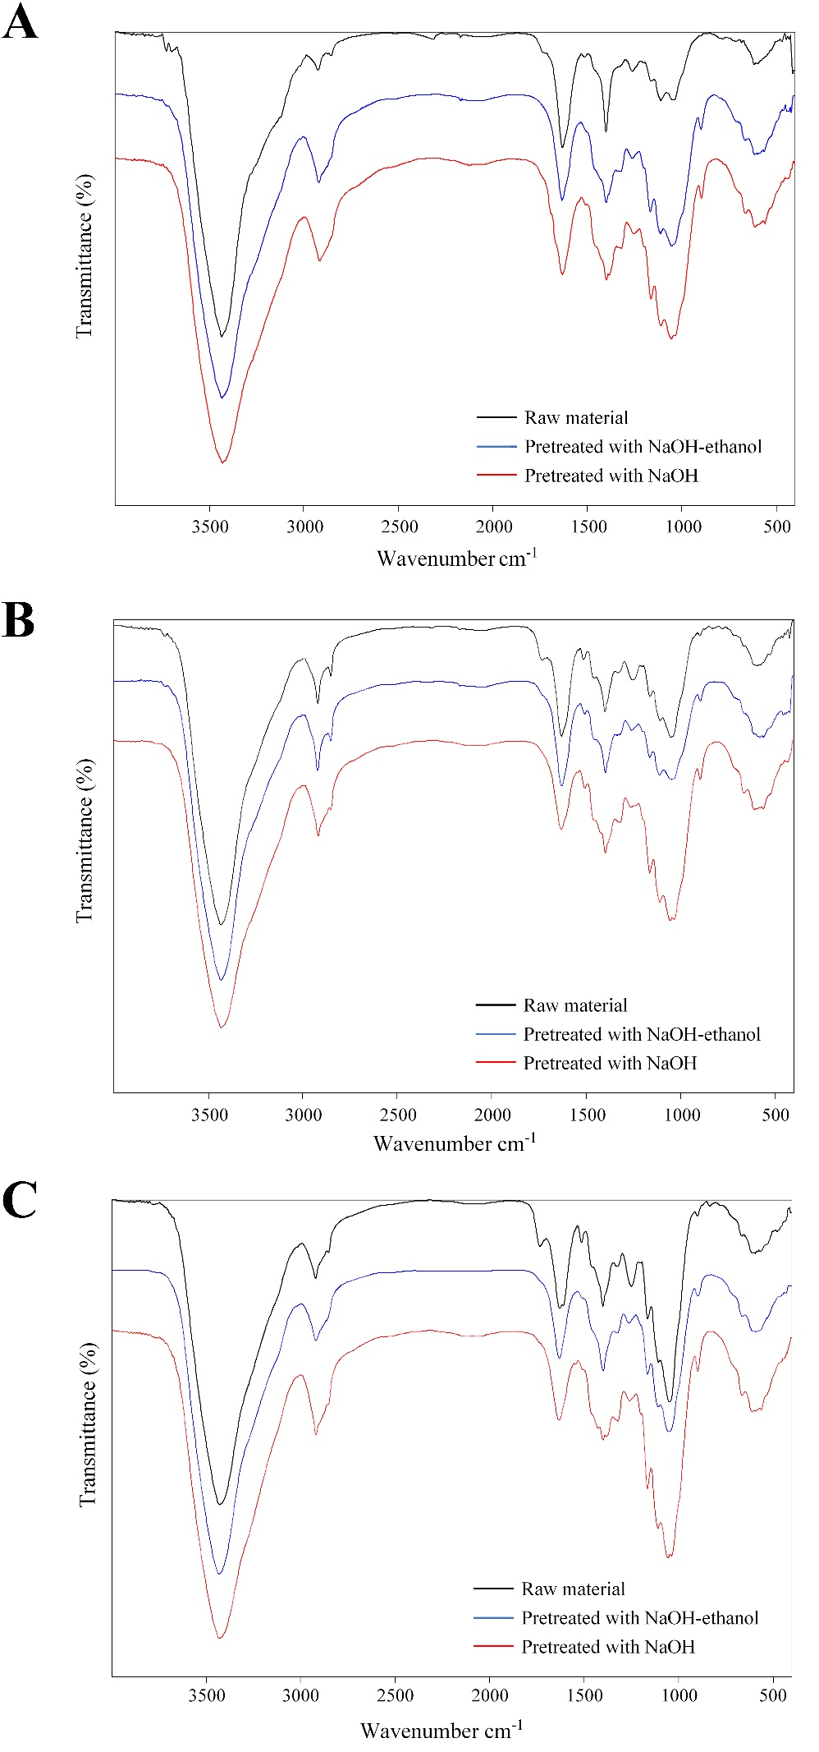
Figure S2

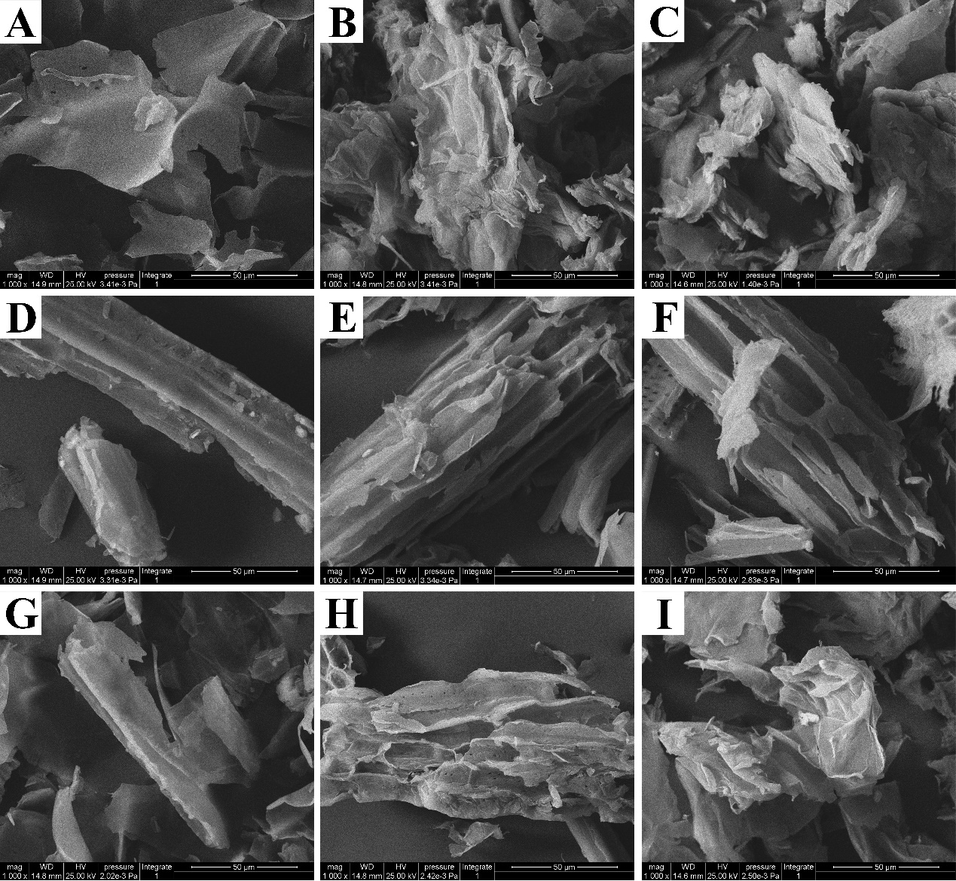
Figure S3

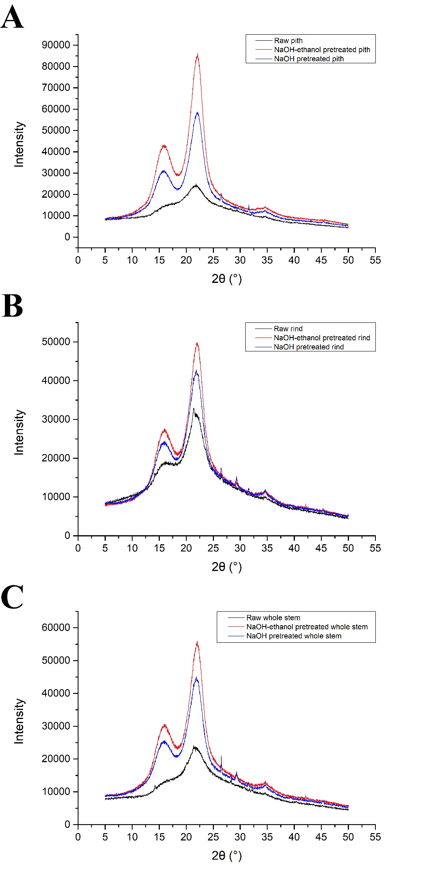
Fig. S4

