Graphical Abstract

This article reports a novel NIR responsive tumor vaccine in situ (HA-PDA@IQ/DOX HG) for photothermal immunotherapy. We first prepared HA-PDA NPs by oxidative polymerization using hyaluronic acid as stabilizer. Meanwhile, immune adjuvants (Imiquimod, IQ) and doxorubicin (DOX) was loaded into HA-PDA NPs in the process of synthesis. After encapsulated into thermal-sensitive hydrogel, the resultant HA-PDA@IQ/DOX HG not only exhibited multiple ablation performance upon NIR irradiation, but also superior immune activation function. This work puts a highlight on the design and development of tumor vaccine in situ for laser immunotherapy.
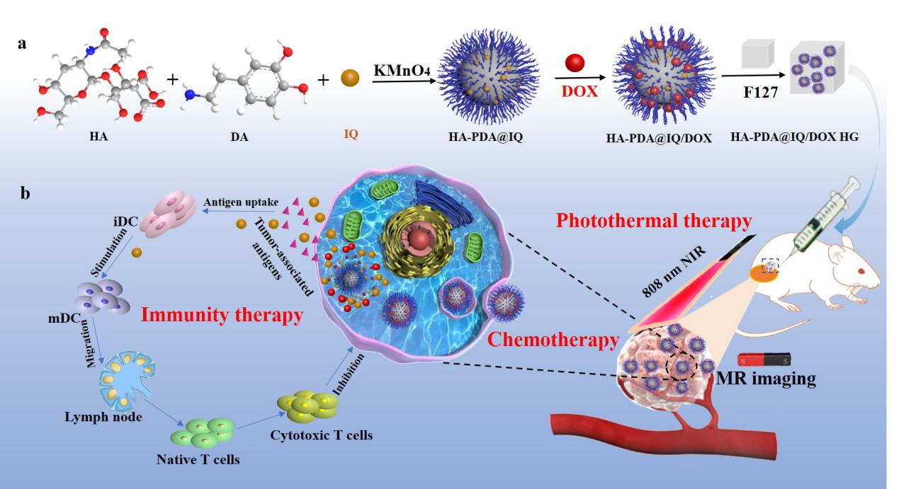
Scheme 1. Schematic illustration of preparation process of HA-PDA@IQ/DOX HG (a) and in vivo anti-tumor applications (b).

