Supplementary Information
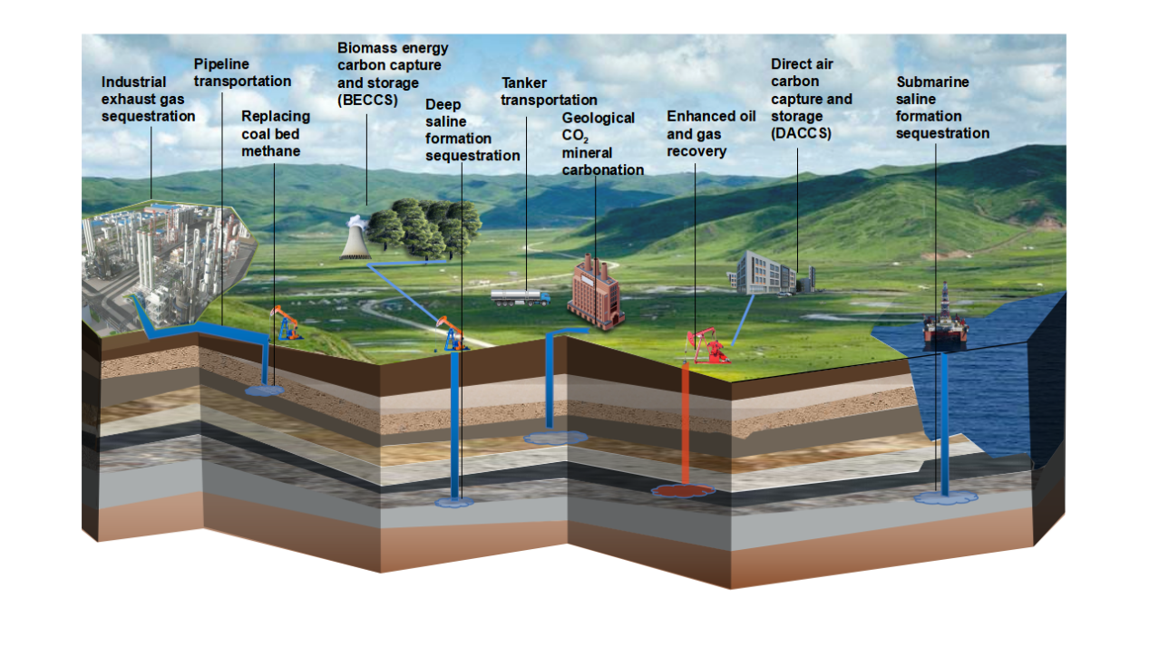
Supplementary Information Fig. S1. Schematic diagram of CO₂ capture and storage (CCS) technology and main types.

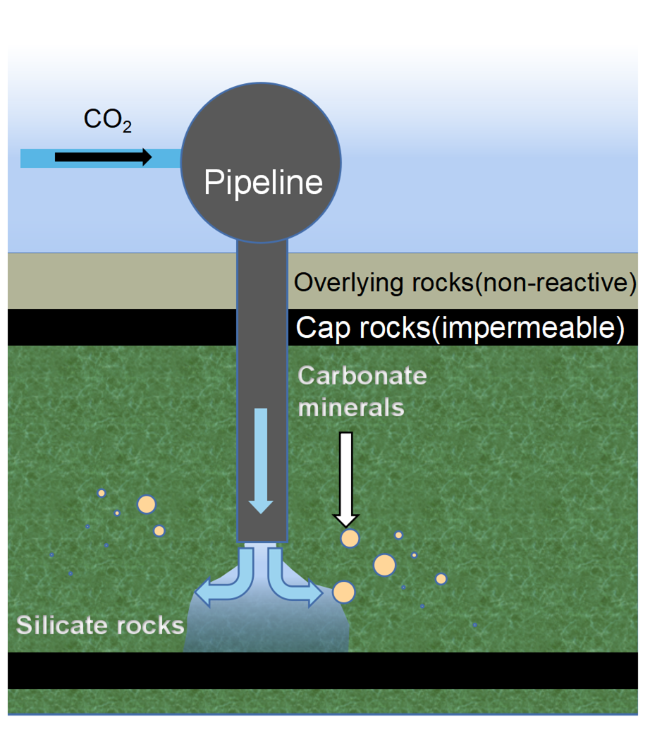
Supplementary Information Fig. S2. Schematic diagram of the mineral carbonation operation.

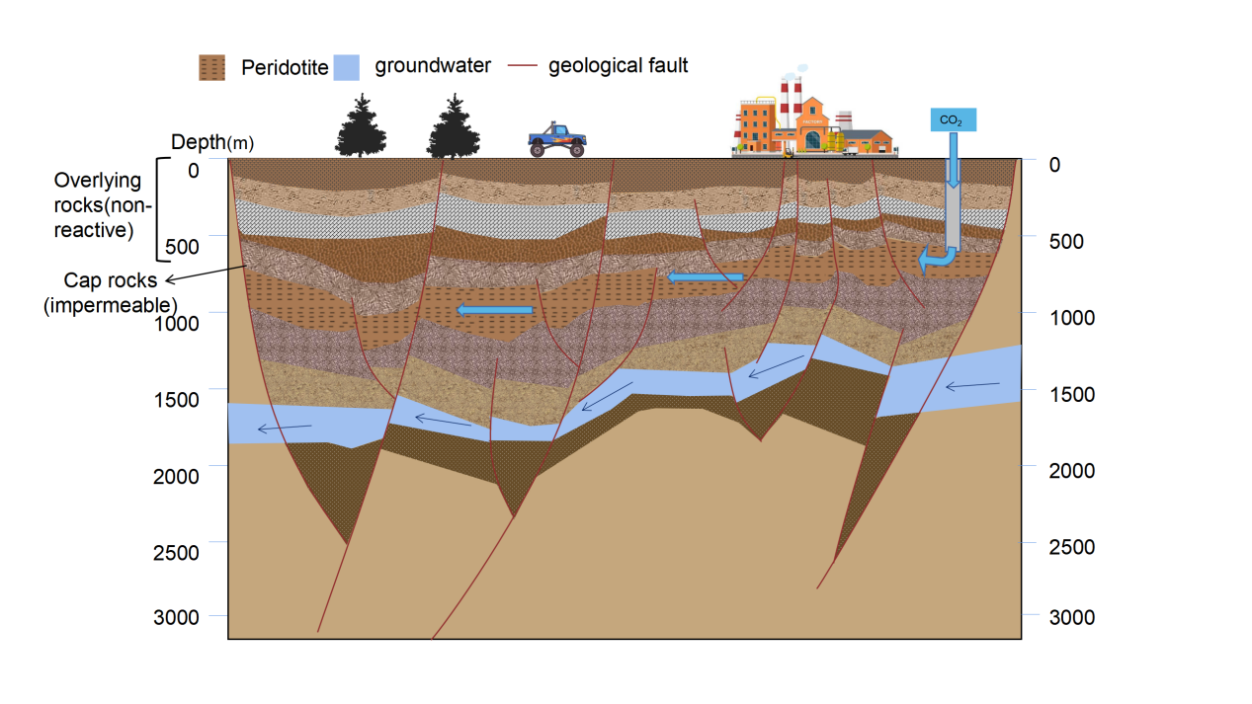
a 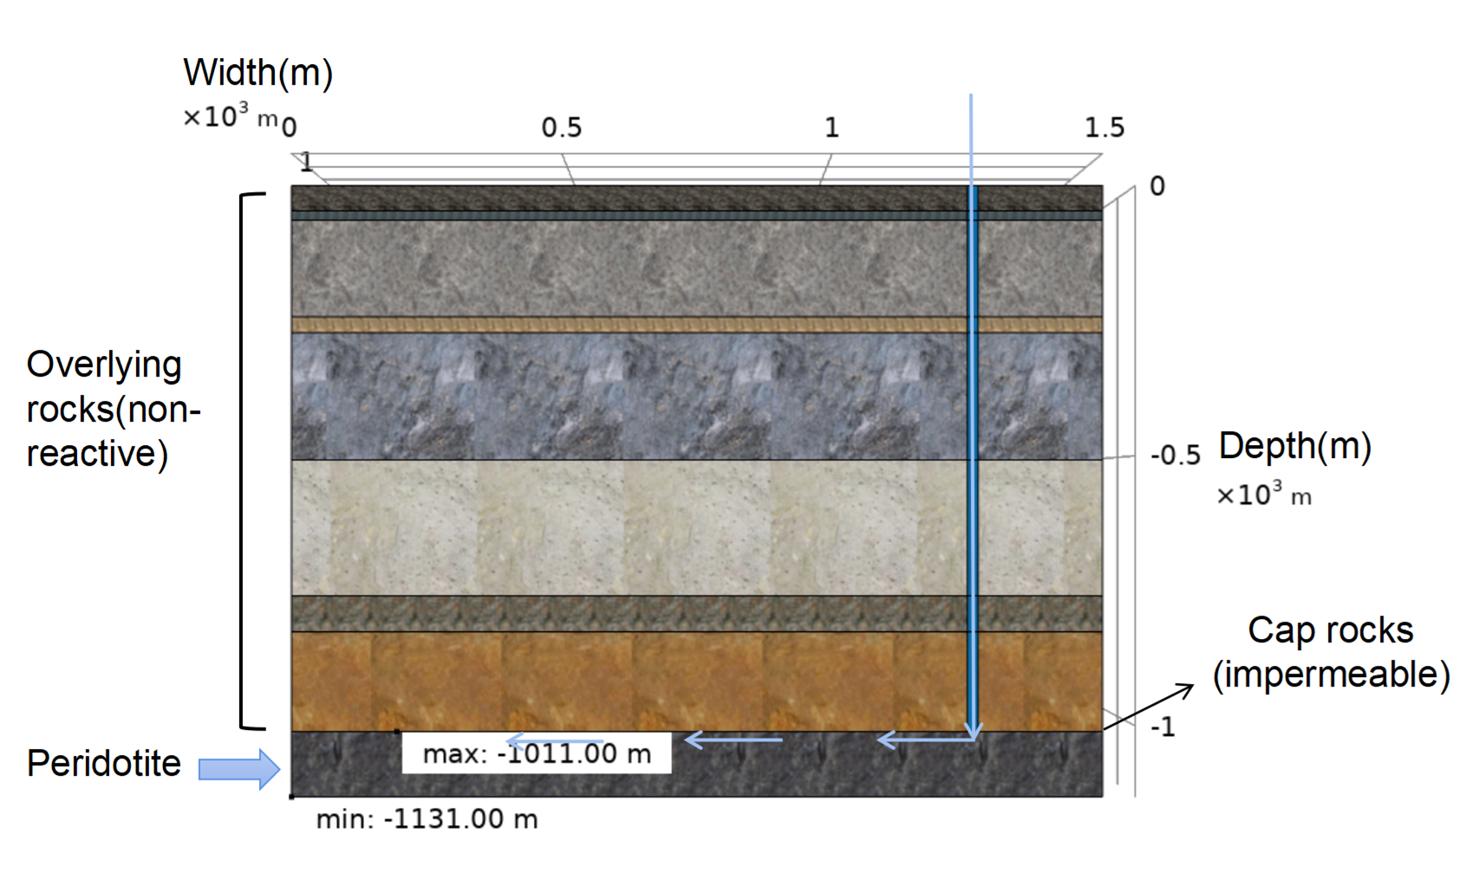
b
Supplementary Information Fig. S3. Stratigraphy Vertical section.a. Schematic diagram of the overall stratigraphic section; b. Schematic diagram of local stratigraphic section.

Supplementary Information Table. S1 .The typical parameters of peridotite used in the modelling.
Parameter | Value
Density of peridotite | 3210kg/m³
Porosity of peridotite | 1%
Permeability of peridotite | 1×10⁻¹³m²
Thermal conductivity of peridotite | 2W/(m·ºC)
Heat capacity of peridotite | 1036J/(kg·ºC)
Effective grain size of peridotite | 7mm
Exothermic heat of the carbonation reaction | 760kJ/kg Mg₂SiO₄

Supplementary Information Table. S2.The expenses and benefits of CCS with geological mineral CO₂ carbonation for current general case and future best case(calculated at 0.6 RMB/kWh electricity price, $1 = 6.6RMB).
Case | Cost components | Items | Price (unit:$/t CO₂, negative numbers indicate expenses, positive numbers indicate benefits)
Current general case | Expenses | Carbon capture + tanker transport 35km | -26.550
 |  | No cost-sharing facility with typical case of sequestration technology | -8.838
 | Benefits | Electricity gains,thermoelectric efficiency at 4% | +1.218
 |  | Value of avoided carbon emissions,thermoelectric efficiency at 4%, at the price of China's current carbon emission allowance | +0.038
 |  | Policy subsidies, at the price of China's current carbon emission allowance | +9.091
 | Total CCS cost | Add above items | -25.041
Future best case | Expenses | Carbon capture + tanker transport 35km | -26.550
 |  | Surrounded by cost-sharing facilities with the improved temperature conditions for sequestration technology | -2.926
 | Benefits | Electricity gains,thermoelectric efficiency at 10% | +3.055
 |  | Value of avoided carbon emissions,thermoelectric efficiency at 10%, calculated at the subsidized price $50 / t CO₂ for CO₂ geological storage in the United States in 2026 (the price of carbon emission allowance that China may reach in the future) | +0.517
 |  | Policy subsidies, at the price of carbon emission allowance that China may reach in the future | +50.000
 | Total CCS cost | Add above items | +24.096

