The Supplementary materials for：
Bioclogging alleviation for constructed wetland based on the interaction among biofilm growth and hydrodynamics

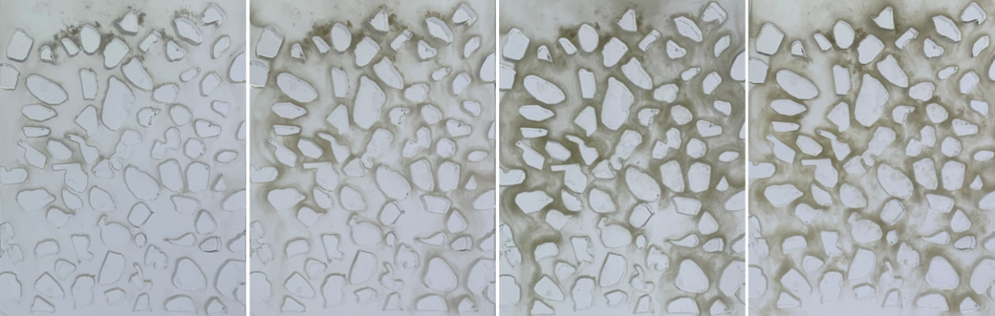
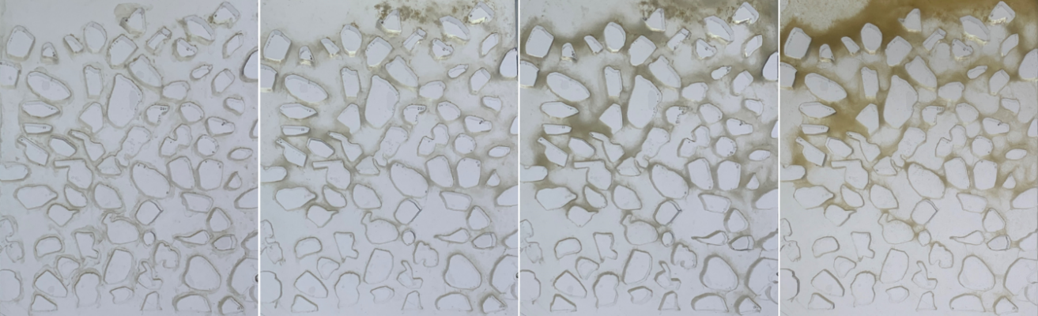
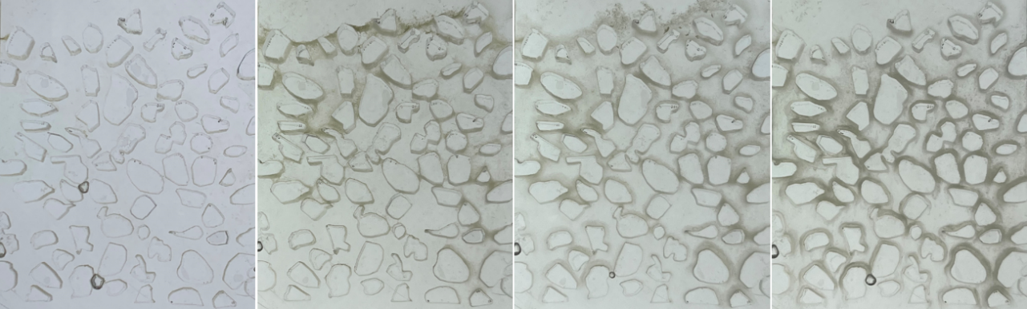

Fig.S1 The photo of the biofilm development in the PMFC

Fig.S2 the biofilm development with the time

Fig.S3 the biomass distribution vertically in the columns

