Table S1 Migratory data of three females O. t. dybowskii from Kessler et al. 2013
Bird | Body mass  (kg) | Year | Season | Start date | End date | Duration  (days) | Distance  (km) | Total speed  (km/day) | Flying speed  (km/h)
01 | 3.40 | 2007 | Autumn | 13-16 Oct | 4-12 Dec | 49-60 | 1954 | 33-40 | 59 ± 2
 |  | 2008 | Spring | 24-26 Mar | 28-31 May | 63-68 | 1966 | 29-31 | 62
 |  |  | Autumn | 17-19 Oct | 4-6 Nov | 16-20 | 1852 | 93-116 | 59 ± 6
 |  | 2009 | Spring | 12-14 Mar | 1 Jun | 79-81 | 1932 | 24
02 | 3.50 | 2008 | Autumn | 12 Oct | 31 Oct | 19 | 1836 | 97 | 87 ± 10
 |  | 2009 | Spring | 5 Apr | 9-13 May | 34-38 | 1860 | 49-55 | 80 ± 6
03 | 3.60 | 2008 | Autumn | 17 Oct | 18-20 Dec | 62-64 | 2044 | 32-33 | 76 ± 12
 |  | 2009 | Spring | 5 Apr | 9 Jun | 65 | 2100 | 32 | 60 ± 9

Table S2 Seasonal differences in great bustard by sex. The tests used were Mann–Whitney U-tests or t test.
 | Sex | Spring migration  ($\overline{x}$ ± SD) | n | Autumn migration  ($\overline{x}$ ± SD) | n | Test value | p value
Distance (km) | Male | 981.00 ± 83.14 | 6 | 903.28 ± 46.42 | 11 | t = -1.37 | p = 0.203
 | Female | 1939.62 ± 87.32 | 6 | 1906.13 ± 91.57 | 6 | t = -0.648 | p = 0.532
Duration (days) | Male | 13.42 ± 10.57 | 6 | 14.60 ± 16.02 | 11 | W = 34 | p = 0.961
 | Female | 61.69 ± 15.38 | 6 | 36.99 ± 19.84 | 6 | t = -2.4097 | p = 0.038
Total speed (km/day) | Male | 114.65 ± 66.03 | 6 | 124.79 ± 112.76 | 11 | W = 30 | p = 0.808
 | Female | 33.44 ± 9.40 | 6 | 65.82 ± 32.51 | 6 | W = 31.5 | p = 0.037
Flight speed (km/h) | Male | 65.69 ± 5.65 | 6 | 69.56 ± 9.09 | 11 | t = 1.082 | p = 0.297
 | Female | 65.23 ± 9.68 | 5 | 68.64 ±11.94 | 6 | t = 0.523 | p = 0.613
Travel speed (km/day) | Male | 208.63 ± 97.28 | 6 | 173.75 ± 107.45 | 11 | t = -0.681 | p = 0.510
 | Female | 207.30 ± 66.58 | 2 | 212.82 ± 50.22 | 2
Stopover numbers | Male | 1.33 ± 0.82 | 6 | 1.64 ± 1.50 | 11 | t = 0.539 | p = 0.598
 | Female | 2.50 ± 0.71 | 2 | 4.50 ±3.54 | 2
Stopover duration (days) | Male | 6.01 ± 5.84 | 8 | 3.10 ± 5.54 | 18 | W = 63.5 | p = 0.816
 | Female | 20.77 ± 14.95 | 5 | 5.41 ± 5.81 | 9
P-values ≤ 0.05 are presented in bold

Table S3 Areas of 95% KDE home range (km²) of O. t. dybowskii
ID | 2018 winter | 2019 summer | 2019 winter | 2020 summer
NO.1 | 1261.21 | 816.48 | 177.38 | 645.53
NO.2 | 14.90 | 237.33 | 19.42 | 138.65
NO.3 | 96.08 | 649.47 | 26.50 | 1377.80
NO.4 | 19.36 | 841.79 | 27.05 | 2110.22

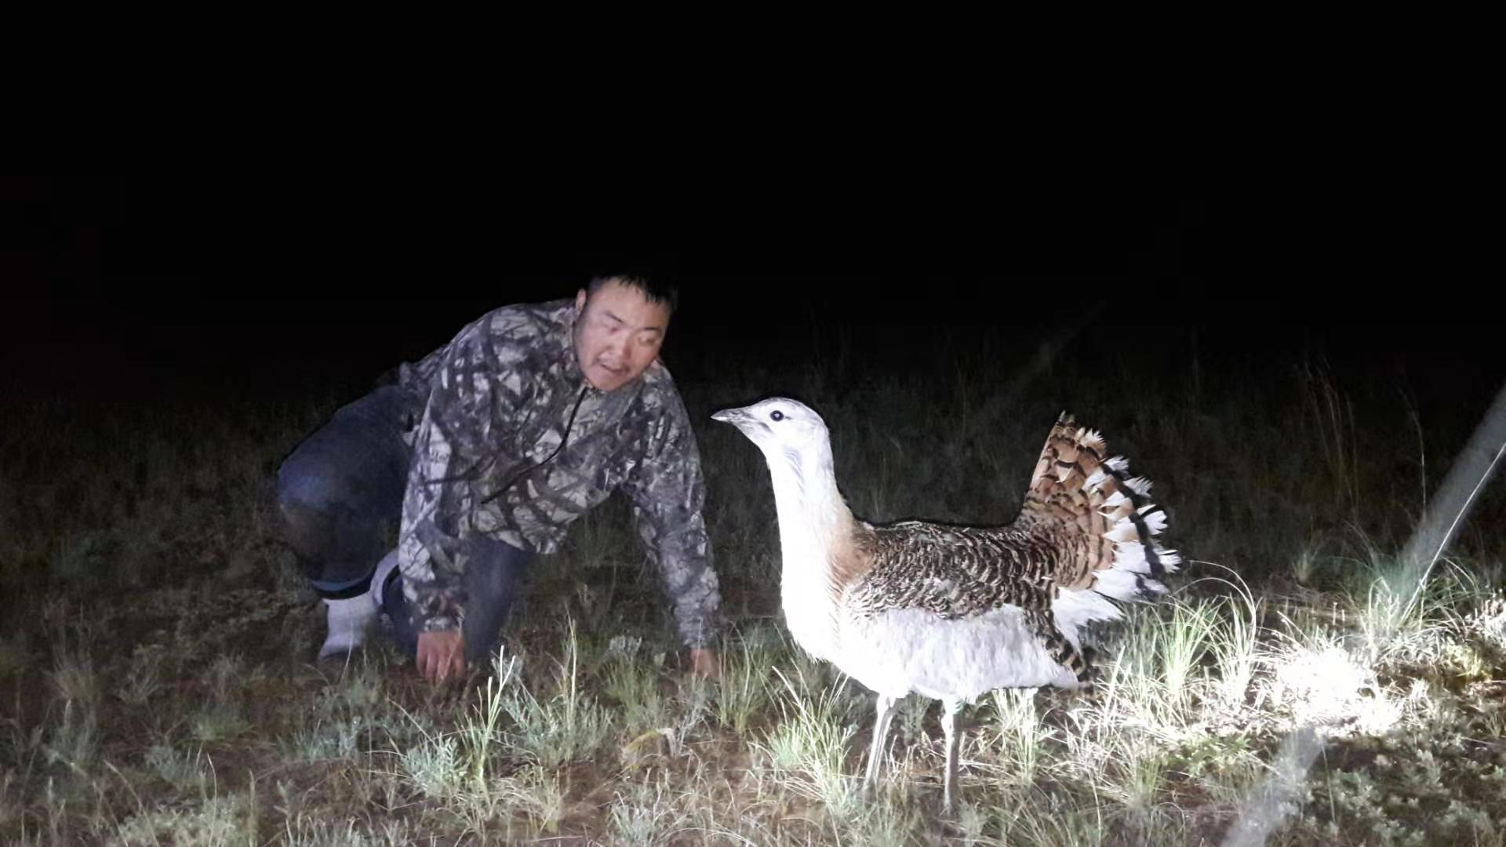
Figure S1. The largest male Great bustard (NO.6) trapped in Dashbalbar in 2019 (Photo by Gankhuyag Purev-Ochir).

