**Supplemental information**

|  |  |  |
| --- | --- | --- |
|  |  |  |
|  |  |  |
|  |  |  |
|  |  |  |
|  |  |  |

**Figure S1 Rarefaction curves of dolphin blow samples.** The majority of samples was sampled to saturation.

|  |  |  |
| --- | --- | --- |
|  |  |  |
|  |  |  |

**Figure S2 Rarefaction curves of pool water samples.** The majority of samples was sampled to saturation.

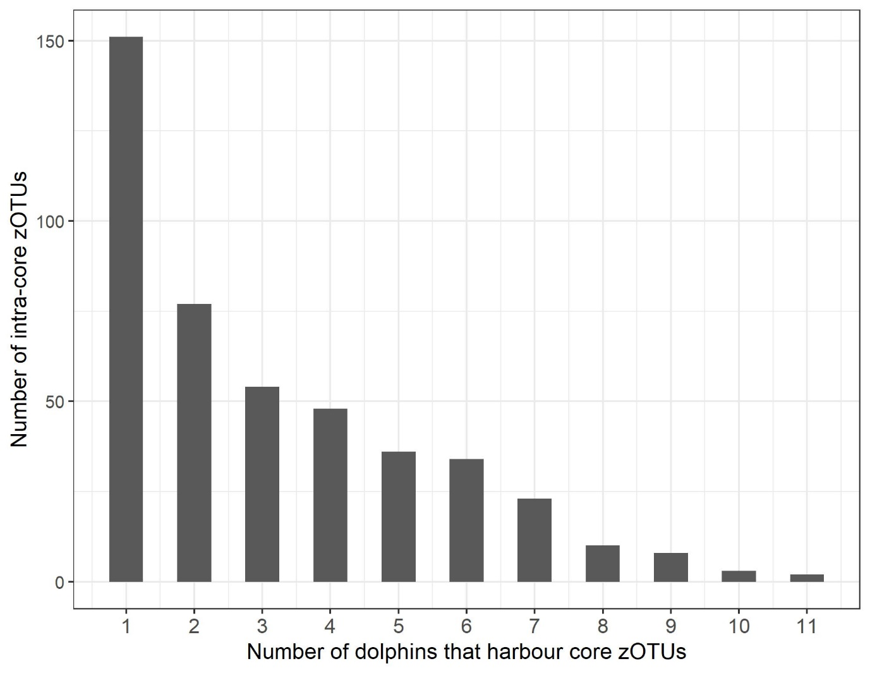**F****igure S3 Frequency histogram showing the presence of 466 intra-core zOTUs across 11 bottlenose dolphins**. Although a large number of intra-core zOTUs is present, only a minority is shared by most dolphins.

**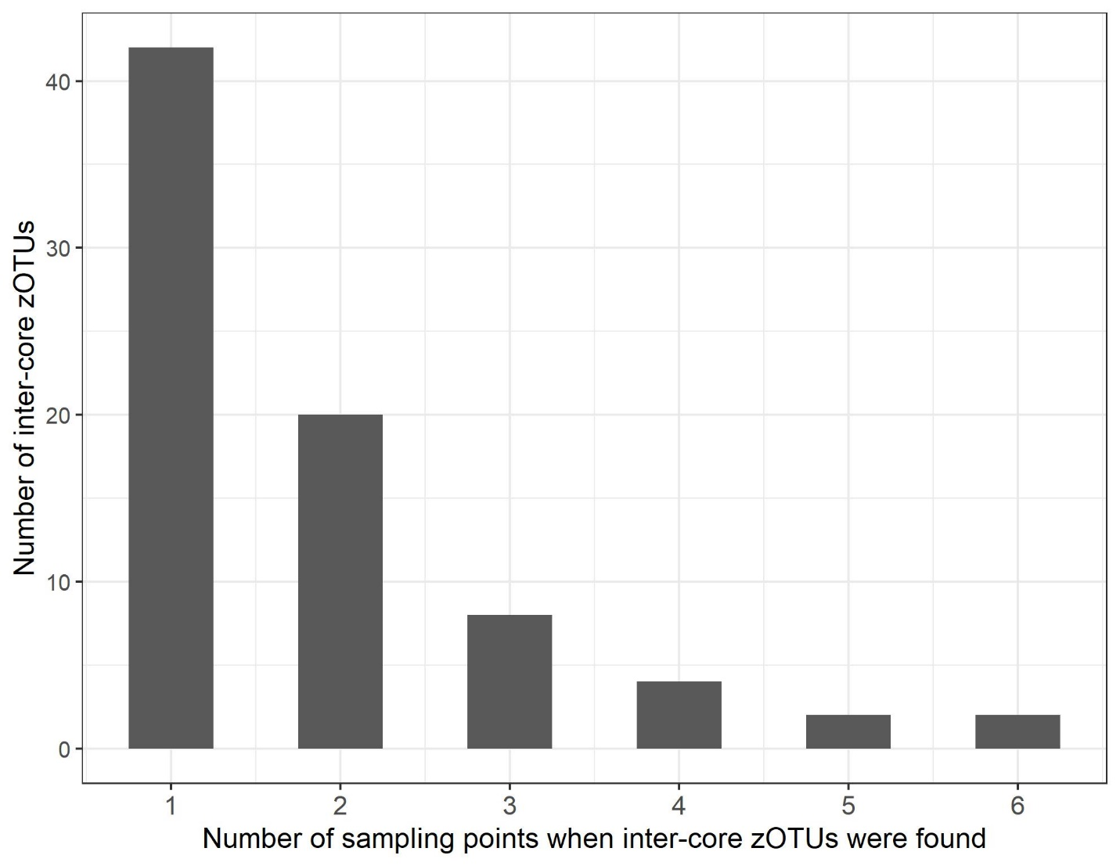****Figure S4 Frequency histogram showing the presence of 77 inter-core zOTUs across ten dolphins** in week 2, 6, 11, 19, 28, 37. More than half of the inter-core zOTUs were only present at one sampling point.