Supplementary Material

Table S1 Primers used in this study.
Primers | Sequence (5’-3’)
inositol-synthetic pathway
TbIPS-F | GCGCGGCAGCCTCGAGATGCCGGCAGTGCGTACGAA
TbIPS-R | CCGAGCTCACCACTAGTTTAGCTGCCTACGCCACGC
EcIMP-F | GCGCGGCAGCCTCGAGATGCATCCGATGCTGAACATCGCC
EcIMP-R | CCGAGCTCACCACTAGTTTAACGCTTCAGAGCGTCGC
gene deletion
Δpgi-up-F | cattttcagccttggcacaa
Δpgi-up-R | GGCCTACATATCGACGATGATAGCAATACTCTTCTGATTT
Δpgi-down-F | aaatcagaagagtattgctatcatcgtcgatatgtaggcc
Δpgi-down-R | GGCAAAAATGCCATACAGAAC
ΔpfkA-up-F | TATATAGCGCGTTACGCATG
ΔpfkA-up-R | TCCGAAATCAGACTACCTCTGAACTTTGGAATGCAAAATG
ΔpfkA-down-F | AGAGGTAGTCTGATTTCGGAAAAAGGCAGATTCCTTTACC
ΔpfkA-down-R | GTGACTGACGAATCACCACG
ΔpykF-up-F | TCATGCCAACTATCAGCATA
ΔpykF-up-R | CACAAAAGCAATAGACAGTCTTAGTCTTTAAGTTGAGAAGGATGGGAG
ΔpykF-down-F | GACTAAGACTGTCTATTGCTTTTGTGAATTAATTTGTATATCGAAGCGCCCTG
ΔpykF-down-R | GAGCTGCGTCATCTTTAGCA
Δzwf-up-F | agaaacgattcaccgtcggt
Δzwf-up-R | ATAAAGGATAAGCGCAGATAGTCATTCTCCTTAAGTTAAC
Δzwf-down-F | gttaacttaaggagaatgactatctgcgcttatcctttat
Δzwf-down-R | CTGGATAGTGTTCATAAGGC
Δpgm-up-F | atccgacattttacggcgta
Δpgm-up-R | tacgcgtttttcagaacttccattgctttgtcctttgtct
Δpgm-down-F | agacaaaggacaaagcaatggaagttctgaaaaacgcgta
Δpgm-down-R | gttctttttcgttcccgcct
zwf regulation
zwf-RBSL1-up-F | GATGTAAAGAGACTCACGGGTAATG
zwf-RBSL1-up-R | GAGAAGCCTTTGGAACTTGGTACGACAAGTTAACTAACCCGGTAC
zwf-RBSL1-down-F | GTCGTACCAAGTTCCAAAGGCTTCTCATGGCGGTAACGCAAACAGC
zwf-RBSL1-down-R | TCCAGCATCGCGCCGAGACGGCTGAATG
zwf-RBSL2-up-F | GATGTAAAGAGACTCACGGGTAATG
zwf-RBSL2-up-R | GGTGCTGTAATAAAGGTGCTGGTGCAAGTTAACTAACCCGGTAC
zwf-RBSL2-down-F | GCACCAGCACCTTTATTACAGCACCATGGCGGTAACGCAAACAGC
zwf-RBSL2-down-R | TCCAGCATCGCGCCGAGACGGCTGAATG
zwf-RBSL3-up-F | GATGTAAAGAGACTCACGGGTAATG
zwf-RBSL3-up-R | AGGGTCGGCTTGCTTATTATACTCCGAAGTTAACTAACCCGGTAC
zwf-RBSL3-down-F | CGGAGTATAATAAGCAAGCCGACCCTATGGCGGTAACGCAAACAGC
zwf-RBSL3-down-R | TCCAGCATCGCGCCGAGACGGCTGAATG
zwf-RBSL4-up-F | GATGTAAAGAGACTCACGGGTAATG
zwf-RBSL4-up-R | TGGCTTATCCTAGATACGTGAGCGTAAGTTAACTAACCCGGTAC
zwf-RBSL4-down-F | ACGCTCACGTATCTAGGATAAGCCAATGGCGGTAACGCAAACAGC
zwf-RBSL4-down-R | TCCAGCATCGCGCCGAGACGGCTGAATG
zwf-RBSL5-up-F | GATGTAAAGAGACTCACGGGTAATG
zwf-RBSL5-up-R | GACTATTCCCCTGAAATGGTAAGAAAGTTAACTAACCCGGTAC
zwf-RBSL5-down-F | TCTTACCATTTCAGGGGAATAGTCATGGCGGTAACGCAAACAGC
zwf-RBSL5-down-R | TCCAGCATCGCGCCGAGACGGCTGAATG

Fig. S1 SDS-PAGE for expressions of IPS and IMP by optimizing plasmid expression systems.
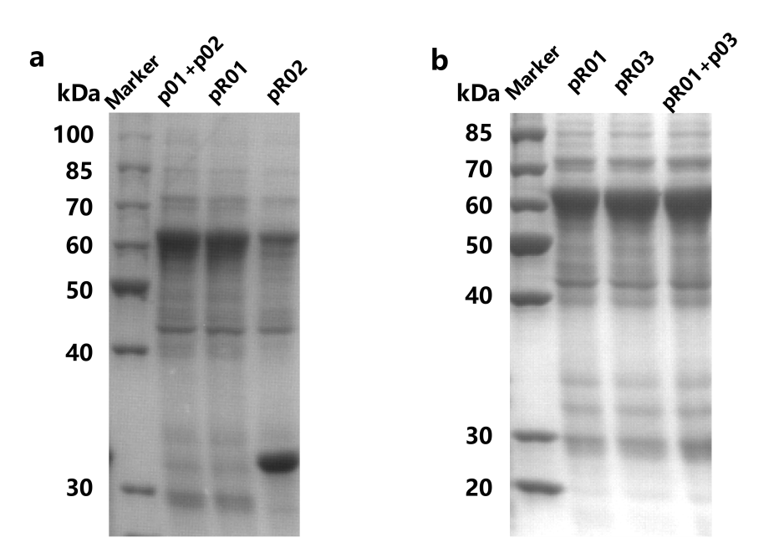

Fig. S2 The expressions of key enzymes of engineered strain R04 in 1-L fermenter for high-density fermentation
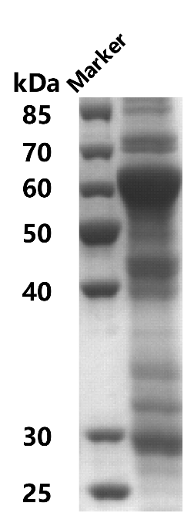

Fig. S3 Inositol production by strains R12, R14 and R15. a SDS-PAGE showing the expression of IPS (approximately 60 kDa) and IMP (approximately 30 kDa). b Production of inositol by strains R14, R12 and R15 cultivated in high-density fermentation and in shaken flasks, respectively. The columns correspond to “concentration of inositol”, and the lines and symbols correspond to “stoichiometric yield”. The recombinant strains were induced and harvested, then suspended in a bioconversion mixture containing 50 mM glucose. The bioconversions were performed at 37 °C and 220 rpm for 10 h.
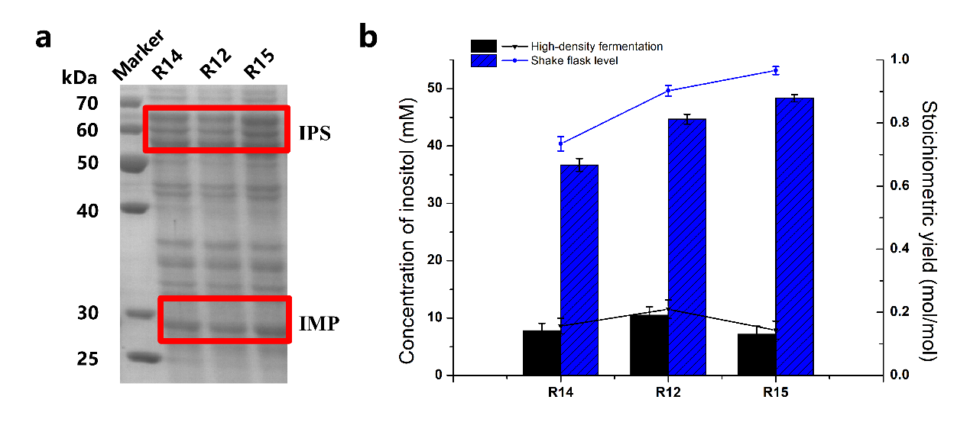

Fig. S4 Comparison of strains R01 and R04. a Production of inositol in strains R01 and R04 transformed with plasmids p01 and p02. The recombinant strains were induced and harvested, then suspended in a bioconversion mixture containing 50 mM glucose. The bioconversions were performed at 37 °C and 220 rpm for 10 h. b High-density fermentation of strains R01 and R04. Cells were cultured in LB medium at 37 °C. Then, this seed solution was inoculated into 500 mL inorganic medium with glycerol and glucose as mixed carbon source in a 1-L fermenter.

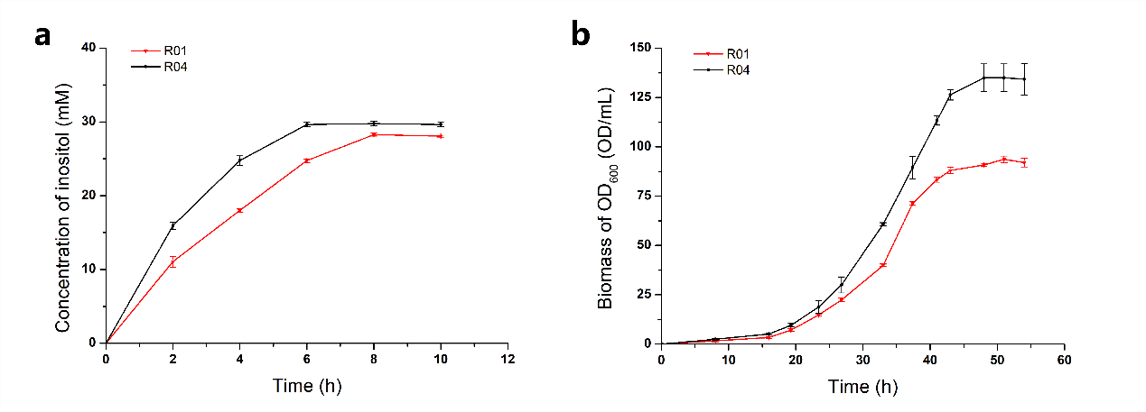

Fig. S5 HPLC chromatograms of G-6P, glucose and inositol. The x-axis shows retention time and the y-axis the refractive index detector (RID) signal.

