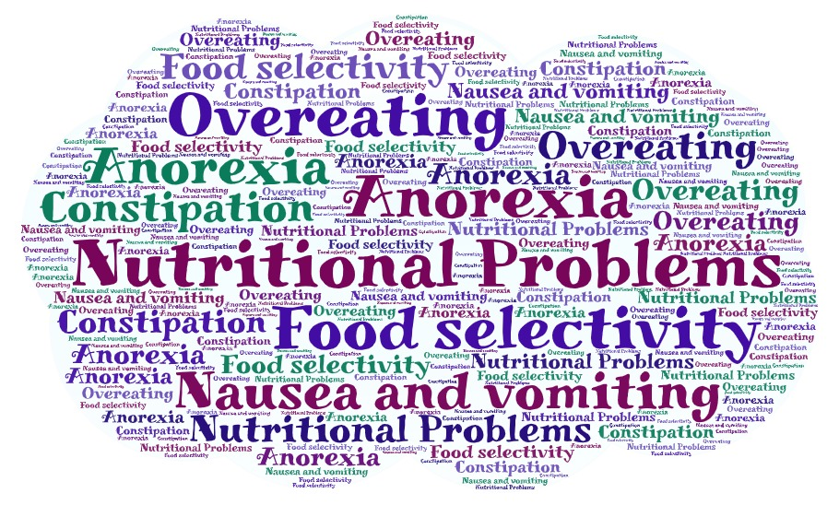
Figure 1: Nutritional problems in children

