Supplementary Table 1: International Classification of Diseases (ICD) 9th and 10th revision codes used to identify patients with acute coronary syndrome.

ICD-9 | ICD-10
410.00, 410.01, 410.02, 410.10,  410.11, 410.12, 410.20, 410.21,  410.22, 410.30, 410.31, 410.32,  410.40, 410.41, 410.42, 410.50,  410.51, 410.52, 410.60, 410.61,  410.62, 410.70, 410.71, 410.72,  410.80, 410.81, 410.82, 410.90,  410.91, 410.92, 411.1, 411.81,  411.89, 413.1 | I21.A, I21.A1, I21.A9, I21.0, I21.1  I21.2, I21.3, I21.4, I21.9, I22.0,  I22.1, I22.2, I22.8, I22.9, I20.0, I20.1, I24.0, I24.8, I24.9

Supplementary Table 2: EHR data used to evaluate data missingness, differences in symptoms, time-to-treatment, and cluster analysis

Feature | Sub-categories | Unit | Feature missingness | Cluster analysis
Vital signs | Body temperature | ∘C | ✓ | ✓
 | Systolic blood pressure | mm Hg | ✓ | ✓
 | Diastolic blood pressure | mm Hg | ✓ | ✓
 | Respiratory rate | beats/min | ✓ | ✓
 | SpO2 | mm Hg | ✓ | ✓
 | Heart rate | beats/min | ✓
Basic Metabolic Panel | Blood urea nitrogen | mg/dL | ✓
 | Creatinine | mg/dL | ✓
 | Glucose | mg/dL | ✓
ACS Symptoms | Chest pain |  |  | ✓
 | Dyspnea |  |  | ✓
 | Dizziness |  |  | ✓
 | Nausea |  |  | ✓
 | Diaphoresis |  |  | ✓
 | Epigastric pain |  |  | ✓
 | Unexplained fatigue |  |  | ✓
 | Jaw pain |  |  | ✓
 | Palpitation |  |  | ✓
 | Shoulder pain |  |  | ✓
 | Abdominal pain |  |  | ✓
 | Coughing |  |  | ✓
Medications | Antiplatelets
 | Anticoagulation (Heparin)
 | Opiates
 | Beta blockers
 | Low molecular weight Heparin
 | Calcium channel blockers
 | ACE inhibitors
 | Direct Thrombin inhibitors
 | Glycoprotein IIb/IIIa
 | Factor Xa inhibitors
 | Anti-ischemic/Anti-anginal

Supplementary Table 3: Marginal Structural Models to determine associations between primary symptoms (chest pain and dyspnea) and sensitive variables (sex and race). When predicting symptoms with race, the model was adjusted for age and sex. When predicting symptoms with sex, the model was adjusted for age and race.
Predictor | Outcome | Causal Odds Ratio | 95% CI | P-value (two-tail)
Female | Dyspnea | 1.033 | (0.943 - 1.132) | 0.483
Female | Chest pain | 0.967 | (0.884 - 1.058) | 0.465
African American | Dyspnea | 0.651 | (0.556 - 0.763) | <0.0001*
African American | Chest pain | 0.639 | (0.547 - 0.746) | <0.0001*
Asian | Dyspnea | 0.692 | (0.494 - 0.971) | 0.033⋅
Asian | Chest pain | 0.699 | (0.503 - 0.972) | 0.033⋅
Caucasian | Dyspnea | 1.438 | (1.346 - 1.536) | <0.0001*
Caucasian | Chest pain | 1.529 | (1.433 - 1.632) | <0.0001*
‘∗’ or ‘·’ associated with numbers in the table indicating that these values are either significant ‘∗’ or marginally significant ‘·’. Significance codes (Bonferroni-adjusted p-value 0.05/14 = 0.00375): 0; “*” = 0.00375; “·” = 0.05; Abbreviations used: CI - Confidence Interval; P>|z| - two-tail probability value

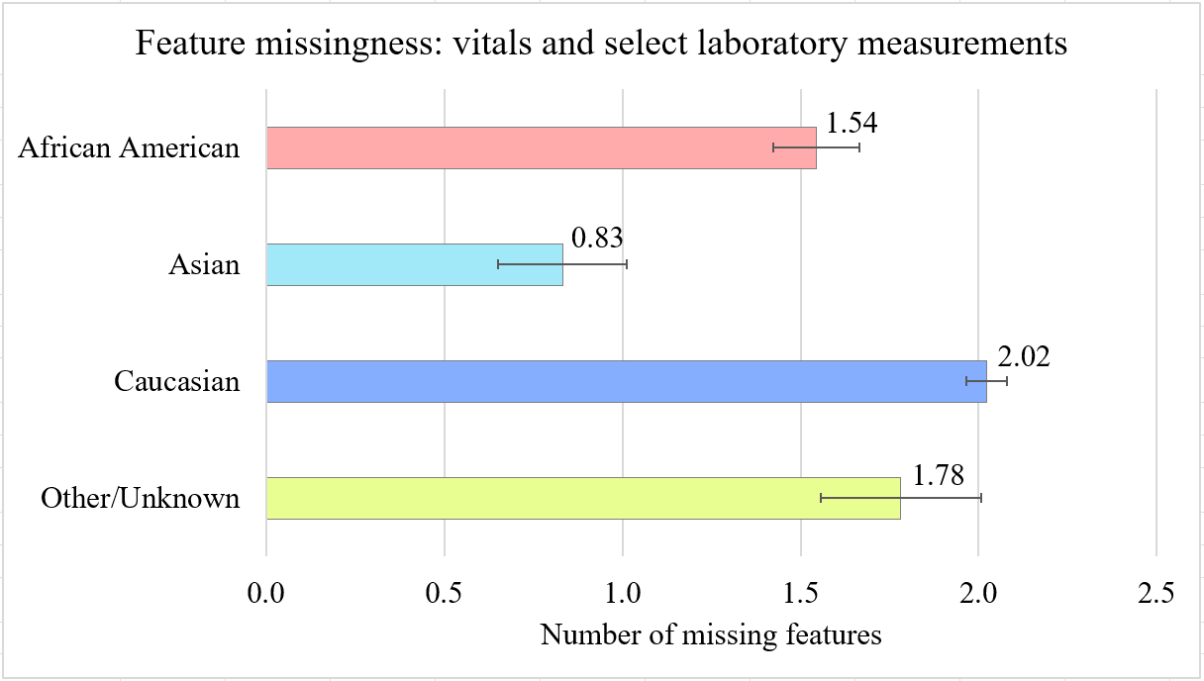
Supplementary Figure 1: Graph depicting missingness of EHR data based on vital signs and basic metabolic panel (BMP) of patient visits categorized by race. The mean values and 95% confidence intervals are presented.

Supplementary Table 4: Time-to-treatment differences across the clusters:
Z-test
Group A | Group B | z-statistics | P-value (one-tail) | Cohen’s d
2 | 3 | -9.42 | < 0.0001* | -0.534
3 | 0 | 8.23 | < 0.0001* | 0.481
2 | 1 | -8.16 | < 0.0001* | -0.287
1 | 0 | 6.68 | < 0.0001* | 0.249
1 | 3 | -3.84 | < 0.0001* | -0.202
2 | 0 | -0.91 | 0.18 | -0.039
Mann-Whitney U-Test
Group A | Group B | p-value | Rank-biserial r
3 | 2 | < 0.0001* | 0.40
3 | 0 | < 0.0001* | 0.38
1 | 2 | < 0.0001* | 0.18
1 | 0 | < 0.0001* | 0.17
3 | 1 | < 0.0001* | 0.19
0 | 2 | 0.256 | 0.02
Cluster description: chest pain and no dyspnea (cluster 0), no dominant symptom and almost no chest pain and dyspnea (cluster 1), nearly all chest pain and dyspnea (cluster 2), all with dyspnea and almost all without chest pain (cluster 3). ‘∗’ or ‘·’ associated with numbers in the table indicating that these values are either significant ‘∗’ or marginally significant ‘·’. Significance codes (Bonferroni-adjusted p-value 0.05/14 = 0.00357): 0; “*” = 0.00357; “·” = 0.05; Abbreviations used: CI - Confidence Interval; P>|z| - two-tail probability value

Supplementary Table 5: Differences in the proportion of visits receiving no pharmacological treatment
Z-test
Group A | Group B | z-statistics | P-value (one-tail) | Cohen’s d
1 | 0 | 8.58 | < 0.0001 | 0.300
2 | 0 | 4.89 | < 0.0001 | 0.197
3 | 0 | 4.42 | < 0.0001 | 0.237
2 | 1 | -4.00 | < 0.0001 | -0.129
Mann-Whitney U-Test
Group A | Group B | p-value | Rank-biserial r
1 | 0 | < 0.0001 | 0.100
2 | 0 | < 0.0001 | 0.055
3 | 0 | < 0.0001 | 0.062
1 | 2 | < 0.0001 | 0.045
Cluster description: all chest pain and no dyspnea (cluster 0), no dominant symptoms, and almost no chest pain and dyspnea (cluster 1), almost all with dyspnea and chest pain (cluster 2), all with dyspnea and almost all without chest pain (cluster 3).
‘∗’ or ‘·’ associated with numbers in the table indicating that these values are either significant ‘∗’ or marginally significant ‘·’. Significance codes (Bonferroni-adjusted p-value 0.05/14 = 0.00375): 0; “*” = 0.00375; “·” = 0.05; Abbreviations used: CI - Confidence Interval; P>|z| - two-tail probability value

